**Development of Microcontroller Based Automation of Distribution System**

Sunil Jeurkar[1], Ritesh Jengthe[2], Rishabh Hardas[3]

[1][2][3]Students, Department Of Electrical Engineering, K.D.K College of Engineering , Nagpur

[1][suniljeurkar@gmail.com](mailto:suniljeurkar@gmail.com)

[2][riteshjengthe@gmail.com](mailto:riteshjengthe@gmail.com)

[3][rishabhhardas@gmail.com](mailto:rishabhhardas@gmail.com)

***Abstract****:****Computer aided monitoring, control and management of the electrical distribution system is being adopted by Electric power utilities all over the world to provide a better service to the end consumer. To reduce the rate of outages, most electrical companies have reconfigured their grid from radial to open loop, so once the faulty section is isolated, alternative sources can restore power to the healthy portion of the grid. This task of isolation is achieved by introducing automation switches for the distribution system which are controlled from remotely located central control room. In this manner, quality and continuity of service to the customer are vastly improved as is user convenience. Therefore, the focus of electric research and development activities worldwide is to automate the electric power distribution system utilizing recent advancement in the area of Information Technology and data communication system. This paper presents a cheap but efficient method to achieve the aforesaid objectives.***

**Introduction**

In the present scenario, the base stations(33KV substations)know very little about the loading and physical health of the distribution (11/415KV) transformers as well as the associated feeders which is one of the main cause of inefficient power distribution. Due to the absence of monitoring there are frequent chances of overloading of these transformers and low voltage at the consumer end which ultimately lead to breakdown of the transformers and feeders. [1]

Due to the absence of switches at strategic locations in the distribution system, it is impossible to disconnect a particular section of load while continuing the supply to the rest. The only solution to this problem is the installation of a circuit breaker for a main 11KV line at a 33KV substation. However, these circuit breakers are actually provided as a means of protection to completely isolate the downstream networks in the event of a fault. Using this as a tool for load management is not desirable, as it disconnects the power supply to a very large segment of consumers.

In the event of a fault in any feeder section downstream, the circuit breaker at the 33KV substation trips (opens). As a result there is a blackout over a large section of the distribution network. Hence there is a need of a system which will have a finer resolution.

This will also help us to drastically bring the rate of breakdown of transformers, which is as high as 20% in India as compared to just 2% of some developed nations.

If the faulty feeder segment could be precisely identified, it would be possible to substantially reduce the blackout area, by re-routing the power to the healthy feeder segments through the operation of switches placed at strategic location in various feeder segments.

**Benefits of Distribution Automation**

* Reduceoverloading and power loss to overcome prevailing power shortages and defer construction of distribution facilities.
* Improved reliability of supply by reduction in the number and duration of the outages and improved quality of services.
* Improved financial performance of the utility by improved cash flow, safeguarding revenues and preventing theft of power.

The Institute of Electrical and Electronic Engineers (IEEE) has defined Distribution Automation System (DAS) as “a system that enables an electric utility to remotely monitor, coordinate and operate distribution components, in a real-time mode from remote locations”[1]. The distribution automation system is based on an integrated technology, which involves collecting data and analyzing information to make control decisions, implementing the appropriate control decisions in the field, and also verifying that the desired result is achieved. The location, from where control decisions are initiated, is generally called Distribution Control Centre (DCC). There are two key software elements – Master Distribution Automation Software and Engineering Analysis Software at the DCC. The master DA software acquires the system data (both static and dynamic) and converts it into an information system. The engineering analysis software provides the control decision utilizing the system information, available at the DCC. The decision making feature of the distribution automation distinguishes it from the normal Supervisory Control and Data Acquisition (SCADA) system. Power Distribution Automation is an emerging field in the area of electrical engineering.

Distribution Automation system is beneficial in day-to-day operation and maintenance of distribution network. The other benefits of the distribution automation are: reduced technical and commercial losses, improved cash flow, lower electric service restoration time, reduction in equipment damage, better availability of system information, improved operational planning, remote load control and shedding, and enhanced power quality and reliability.

**Remote Terminal Unit(R.T.U. )**

AnRemote Terminal Unit (RTU) is a Microprocessor / Microcontroller controlled device used to interface the various power system components and their operation to the DCC. It gathers local information and transmits it to the DCC and italso accepts commands and logging requests sent to it by the DCC. In this way the DCC can control and monitor the distribution networks by interfacing with the various RTUs. It has a capability to exchange the information with Intelligent Electronic Devices (IEDs) such as IED meter and IED relays. RTU can also be designed to support standard protocols in order to support any third party software.

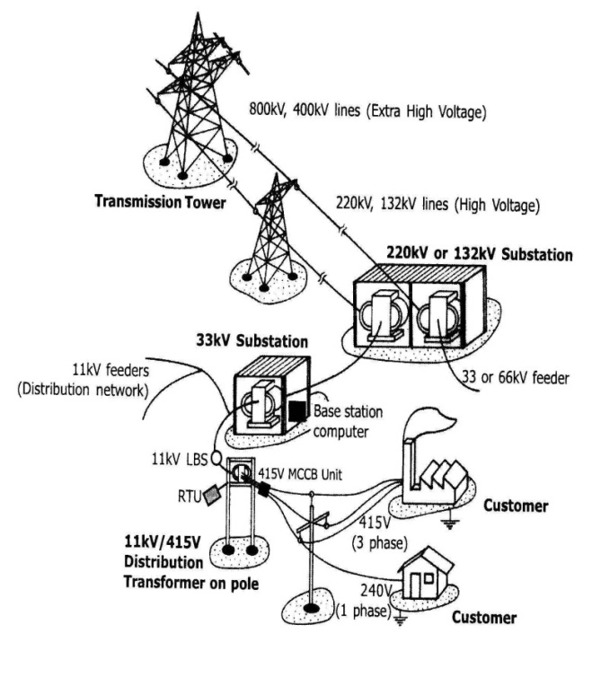

**Figure 1 Typical Power Transmission and Distribution Scenario**

Commercially, the RTU must be capable of performing the following functions: **[3]**

* Collecting, Processing and Transmitting the changes in status, analog values from various sensors and accumulator values.
* Receiving and processing digital and analog commands from the master station(s).
* Accepting polling messages from the master station(s).
* Supporting data transmission rates from 50 to 9600 bits per second

**DATA COLLECTION, TRANSMISSION AND THE APPLICATION OF MODULATION AND DEMODULATION MODULE (MODEM)**

Data transmission includes all the features required to transmit the collected and processeddata from the substation/process location to the base station (Distribution Control Centre) and is configured to transmit commands and set points from the control centre to large number of remotely located devices. This acquired data can be used locally by the device or can be sent to a similar device placed remotely. The data can also be sent to another device on another substation or it can be transmitted from the substation to many other databases for analysis by operators, engineers, planners, and administration. Presently there is a wide range of technologies which are capable of performing the tasks of a DA system, Public telephone communication (dedicated lines) and Power Line Carrier Communication (PLCC) being the notable examples.

**Figure2:TheDistributionAutomationScheme[3]**

**Power Line Carrier Communication (PLCC)**

Power Line Carrier Communication involves the transmission of data over power lines.

Since power lines are designed to carry high voltages, coupling circuits and Line trap are usually made use of to block the 50/60Hz voltage from the communications circuit and impress the high frequency communication signal on the line. Also, the fact that power lines are actually designed to carry low frequency signals imposes some technical challenges at the high frequency needed for communication. Of importance also are the huge noises and ever varying levels of impedance and attenuation attendant in the power line.

**Advantagesof P.L.C.C..**

In order to completely analyze the advantages and disadvantages of PLCC technology, we look into its basic application that is access to telecommunication networks. From the viewpoint of economy, the use of a preinstalled wire system is recommended[3]. This helps in reducing a lot of time & money. So this is the biggest advantage of the PLCC technology.

In many places PLCC is being successfully used to provide high speed internet connections. This has helped in taking the internet to far remote places, where it was impossible to take the service by conventional means.

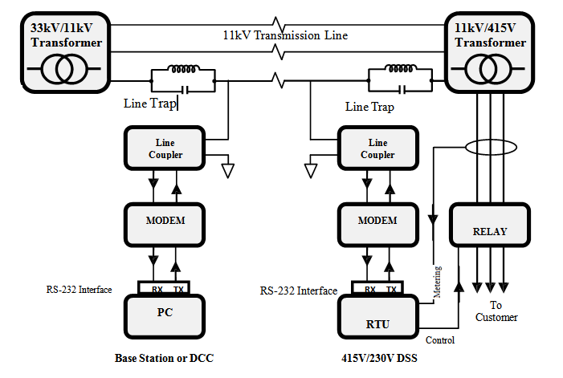Power line communication is quite different in characteristics than the conventional dedicated wirings. Comparatively, it is a harsh medium and data transfer through it can create a lot of problems. Household appliances like halogen tubes, washing machines, televisions, etc. can become prone to an unpredictable noise and interference in the transmission.

**Conclusion**

To provide efficient and reliable power to the electricity consumers, it is essential to automate the current system to monitor and control the electricity distribution. This kind of automation is also necessary to convey the real time data of various distribution substations (loading and physical health) to the base station so that in times of need, proper action can be implemented.

When this automation scheme is fully implemented, it will allow automation judgement and control of electric power to consumers. The use of microcontroller has been shown to be a good platform upon which the distribution automation can be developed. Its flexibility in programming allows easy future modification and implementations.

The Distribution Automation scheme is recommended for all appropriate utilities responsible for electric power distribution management in order to ensure a better quality of service to consumers of electricity in India.

**References**

1. *S.S. Venkata , Anil Partwa , Richard E Brown ,Richard D Chrisie* “ What Future Distribution Engineers Need to Learn “ IEEE Transactions On Power Systems, VOL. 19, NO. 1, Feb 2004
2. *Neha Gaur , Priyanka Gaur* “ Automation Power Distribution System : Present Status “ Academic Open Internet Journals June 2012
3. *I.A. Adejumobi , I.G. Adebayo and A.J. Olanipekun*  “Development of Microcontroller-based Electric Power Distribution Automation System “ Journal of Innovative Research in Engineering and Science 2(1), March, 2011.
4. *V. Thiyagarajan & T.G. Palanivel* “ An Efficient Monitoring Of Substation Using Micro-Controller Based Monitoring System “ International Journal of Research and Reviews in Applied Sciences July 2010