Study of Safety Instrumented System (SIS) for Batch Process System
Ms. Vijaya Patil^{#1}, Ms. Sarita Bhole^{*2}
#First-EE Department, P.I.G. College of Engineering, RTM Nagpur University, Nagpur, India.
*Second- M.Tech, First Sem, Power Electronics, R.K.D.F. College Of Institute, R.G.P.V. University, Bhopal, MP, India
¹vaijju@gmail.com
²saritabhole9@gmail.com

Abstract— This paper addresses the effectiveness of safety instrumented functions (SIF) to reveal any failures undetected by automatic diagnostics. safety integrity level (SIL) is determined by a SIF's average probability of failure on demand (PFD_{avg}). There is an ongoing change in the industry in which old analogue instrumentation and control (I&C) systems are replaced with new digital ones. New digital systems enable more complex control tasks and especially their application to safety instrumented systems (SIS) has created a need for new verification methods such as model checking. Our goal is to study the applicability of model checking methods to a real safety instrumented system used in industry and to evaluate whether such a system can be modelled on a level which, on one hand, enables veriﬁcation of relevant safety properties and, on the other hand, keeps the size of the model feasible. A central objective is also to create a general methodology for applying model checking to analysing safety instrumented systems

Keywords- Safety instrumented System (SIS),SIF,SIL Batch process

1. INTRODUCTION

Safety instrumented systems (SIS) are the most flexible and one of the most common engineered safeguards used in process plants today. The design of SIS, in accordance with current practice, is a risk based process where the selected equipment and associated maintenance and testing procedures are tailored to specific requirements of an application. This risk-based approach yields superior designs that provide the required risk reduction while minimizing cost. SIS design has become a more complex process due to the need to understand more than traditional instrumentation and control engineering.
Sensors
Logic Solver
Actuator

Fig.1 Structure of Safety Instrumented System

A SIS is a system comprising sensors, logic solvers and actuators for the purposes of taking a process to a safe state when normal predetermined set points are exceeded, or safe operating conditions are violated. SISs are also called emergency shutdown (ESD) systems, safety shutdown (SSD) systems, and safety interlock systems. Although such systems may contain pneumatics. The scope of a SIS encompasses all instrumentation and controls that are responsible for bringing a process to a safe state in the event of an unacceptable deviation or failure. The Safety Instrumented System (SIS) plays a vital role in providing a protective layer around industrial process systems. Whether called an SIS, emergency or safety shutdown system, or a safety interlock, its purpose is to take process to a “safe state” when pre-determined set points have been exceeded or when safe operating conditions have been transgressed. A SIS is comprised of safety functions with sensors, logic solvers and actuators. Fig.1 shows its basic components:
• Sensors for signal input and power
• Input signal interfacing and processing
• Logic solver with power and communications
• Output signal processing, interfacing and power
• Actuators (valves, switching devices) for final control function

2. SIF: SAFETY INSTRUMENTED FUNCTIONS.

A Safety Instrumented Function (SIF) is a safety function with a specified Safety Integrity Level which is implemented by a SIS in order to achieve or maintain a safe state. A SIF’s sensors, logic solver, and final elements act in concert to detect a hazard and bring the process to a safe state. Here’s an example of a SIF: A process vessel sustains a buildup of pressure which opens a vent valve. The specific safety hazard is overpressure of the vessel. When pressure rises above the normal set points a pressure-sensing instrument detects the increase. Logic (PLC, relay, hard-wired, etc.) then opens a vent valve to return the system to a safe state. In fact, the increased availability and use of this reliability data has allowed the traditional example above to be improved using HIPPS (High Integrity Process Pressure System) to eliminate even the risk of venting to the environment. When HIPPS is implemented, the system controls are so thorough and reliable that there is no need to vent, or use a relief valve. Like the safety features on an automobile, a SIF may operate continuously like a car’s steering, or intermittently like a car’s air bag.
3. NEED FOR SAFETY INSTRUMENTED SYSTEM

Managing and equipping industrial plant with the right components and sub-systems for optimal operational efficiency and safety is a complex task. Safety Systems Engineering (SSE) describes a disciplined, systematic approach, which encompasses hazard identification, safety requirements specification, safety systems design and build, and systems operation and maintenance over the entire lifetime of plant. The foregoing activities form what has become known as the “safety Life-cycle” model, which is at the core of current and emerging safety related system standards.

4. UNDERSTANDING RISK

All safety standards exist to reduce the risk, which is inherent wherever manufacturing or processing occurs. The goal of eliminating risk and bringing about a state of absolute safety is not attainable. More realistically risk can be categorized as being negligible, tolerable or unacceptable. The foundation for any modern safety system then is to reduce risk to an acceptable or tolerable level. In this context safety can be defined as “freedom from unacceptable risk.
Formula for risk is
RISK= HAZARD FREQUENCY X HAZARD CONSEQUENCE

4.1. RISK AND RISK REDUCTION METHODS

Safety can be defined as “freedom from unacceptable risk”. This definition is important because it highlights the fact that all industrial processes involve risk. Absolute safety, where risk is completely eliminated, can never be achieved; risk can only be reduced to an acceptable level. Therefore all risks should be dealt with on the ALARP basis, i.e. the target is to ensure that risk is reduced to As Low As Reasonably Practicable.
Safety Methods employed to protect against or mitigate harm/damage to personnel, plant and the environment, and reduce risk include:
- Changing the process or engineering design
- Increasing mechanical integrity of the system
- Improving the Basic Process Control System (BPCS)
- Developing detailed training and operational procedures
- Increasing the frequency of testing of critical system components
- Using a safety Instrumented System
- Installing mitigating equipment

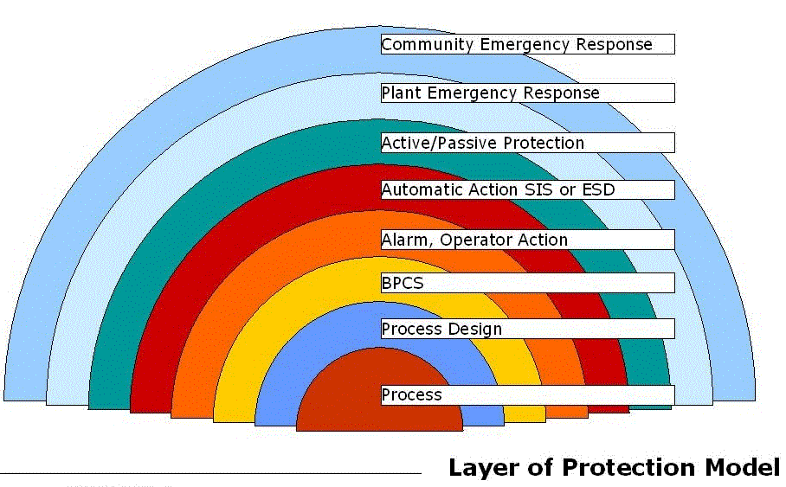
Fig.2 layer of Protection Model

Fig.2 illustrates the above measures in terms of employing protective layers (equipment and/or administrative controls) to reduce risk to an acceptable level. The amount of risk reduction for each layer is dependent on the nature of the risk and the amount of risk reduction afforded by the applicable layer employed. Protective layers can be further classified as either Prevention or Mitigation layers. The former are put in place to stop hazardous occurrences and the latter are designed to reduce the consequences after hazardous events have occurred. In the case illustrated in figure 1, the protective layers are further sub-divided into in-plant and external areas. Methods that provide layers of protection should be Independent, reliable, auditable and designed specifically for the risk involved

5. STANDARDS – IEC 61508, IEC 61511 AND ANSI/ISA S84 ,IEC 61508

Functional Safety of Electrical, Electronic and Programmable Electronic Safety related Systems is a generic standard on which sector specific safety standards are to be based. For the process sector IEC61511 is in draft form and ANSI/ISA S84 [2] (the USA equivalent) is already published. The IEC 61508 standards is fast becoming the European norm, and can apply to a range of Electrical/Electronic/Programmable Electronic (E/E/PES) safety-related systems including:
- Emergency Shut-Down (ESD) systems,
- Fire and gas systems,
- Turbine control,
- Gas burner management,
- Dynamic positioning
- Railway signaling systems,
- Machinery guarding & interlock systems.
IEC 61508 is a seven-part standard that provides specific guidelines on the functional safety of E/E/PES safety-related systems. Developed by the International Electrotechnical Commission (IEC, Geneva, Switzerland), the standard directs the disciplined management of all components of Safety Related Systems, from sensors and logic solvers, to the response function applications that will take the process to a safe state when predetermined variables are reached. The standard applies to the entire life cycle of the safety system, from initial concept, through specification, design, operation and use, to final decommissioning. Parts 1 to 3 of the standard provide guidance on the management, development, deployment, and operation of the E/E/PES system hardware and software. Parts 4 to 7 of the standard deal specifically with definitions, applications and additional related information. The following provides an outline of each part of the standard with the relevant section

6. SAFETY LIFE-CYCLE MODEL

The core of IEC 61508 is the Safety Life-cycle which specifies the structured and auditable management of safety related systems from first concept through to eventual de-commissioning

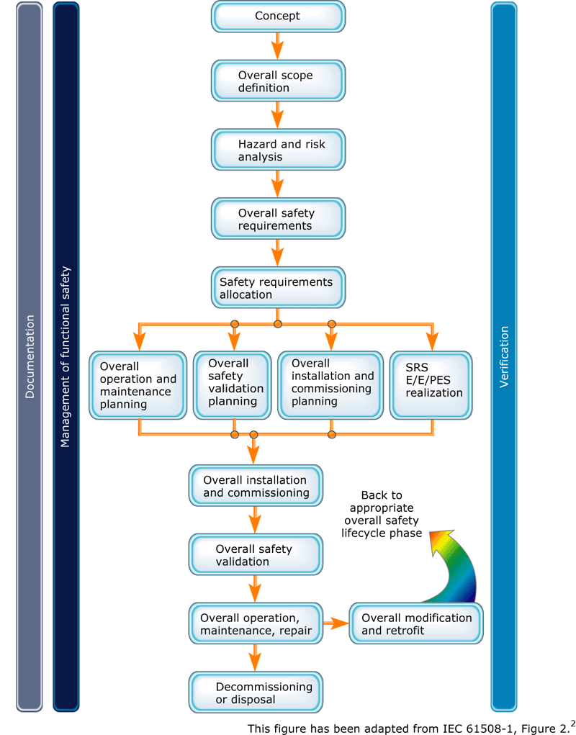 Fig.3.Sfety life Cycle

A detailed treatment of each part of the safety life cycle and how each step is carried out is beyond the scope of this article. However, a simplified sequential approach to developing safety-related systems is outlined below, followed by an example methodology for determining safety Integrity Level (SIL) for a SIS. Simplified steps in developing the Safety-related System
1. Formulate the conceptual design of the process and define the overall scope
2. Identify process hazards and risks via a hazard analysis and risk assessment
3. Identity non-SIS layers of protection
4. Determine the need for additional protection i.e. a SIS Where a SIS is identified as being required...
5. Determine the target SIL (using qualitative and/or quantitative methods)
6. Develop safety requirement specification 7. Develop SIS conceptual designs to meet SRS
8. Develop detailed SIS design
9. Install the SIS
10. Perform Commissioning and pre-startup testing
11. Develop operation and maintenance procedures
12. Conduct pre-startup safety review
13. Carry out operation and maintenance of SIS
14. Record and re-assess any modification to SIS
15. Carry out decommissioning procedures at the end of the life of the SIS.

7. SAFETY INTEGRITY LEVEL (SIL) AND AVAILABILITY

Safety Integrity Level (SIL) is a statistical representation of the safety availability of an SIS at the time of process demand. It is at the heart of acceptable SIS design and includes the following factors:
- Device integrity
- Diagnostics
- Systematic and common cause failures
- Testing
- Operation
- Maintenance
The safety availability (i.e. proportion of time that the system is operational) of a SIS depends on:
- Failure rates and Failure modes of components
- Redundancy
- Voting scheme(s) adopted
- Testing frequency
When the hazards identification and risk assessment phase concludes that a SIS is required, the level of risk reduction afforded by the SIS and the target SIL has to be assigned. The effectiveness of a SIS as an independent protective layer is described in terms of the probability it will fail to perform its required function when it is called upon to do so. This is called its Probability of Failure on Demand (PFD). In practice, the average Probability of Failure on Demand (PFDavg) is used. Table 1 shows the relationship between PFDavg, required safety system Availability, Mean Time Between Failure (MTBF) and SIL.
Table 1 – IEC 61508 SIL and related Measures
SIL | Availability | PFD  (avg) | MTBF
4 | >99.99% | 10⁻⁵ to <10⁻⁴ | 100000-10000
3 | 99.9% | 10⁻⁴ to <10⁻³ | 10000 to 1000
2 | 99-99.9% | 10⁻³ to <10⁻² | 1000 to 100
1 | 90-99% | 10⁻² to <10⁻¹ | 100 to 10

The assignment of a SIL is a corporate decision based on risk management and risk tolerance philosophy. IEC 61508 requires that the assignment of SIL be carefully performed and documented, and provides both qualitative and quantitative guidance tables.

CONCLUSION

It is conclude that, the safety life cycle is an engineering process intended to optimize the safety of plants process. With the amount of “streamlining” and outsourcing in today’s market, plant staff is stretched farther than ever. The mandates of S84 will make the problem worse by placing ever-increasing demands on these overworked personnel. An intelligent method of managing the safety lifecycle has never been more important than it is today. A database approach maximizes quality and accuracy of a SIS design and minimizes the effort required both in the upfront design and implementation and in the long term with periodic testing and management of change.

REFERENCES

[1] IEC 61508 Parts 1-7: 1998,
Functional Safety of Electrical/Electronic/Programmable
Electronic Safety-Related Systems, International Electrotechnical Commission, Geneva, Switzerland.
[2] ANSI/ISA Standard S84.01-1996,
Application of Safety Instrumented Systems to the Process Industries, International Society for Measurement & Control, Research Triangle Park, NC, (1996)
[3]IEC61508 – 1999 “Functional Safety: Safety Instrumented System for the process industry sector”.
[4] IEC61511 – 2004 “Functional Safety of electrical/electronic/programmable electronic safety related systems”
[5] “Practical Safety Instrumentation & Emergency Shut-Downs Systems for the Process Industries”, IDC Technologies, Dave MacDonald
[6]Scott, M.D. & Adler C.B, How to Select a Safety PLC, ISA Automation West Conference,
2003.
[7]. Dieter, G. E., Engineering Design A Materials and Processing Approach, McGraw-Hill,
1983
[8]. Goble, W.M., Control Systems Safety Evaluation & Reliability, 2nd Edition, ISA, 1998
[9]. Barringer, H. P, Life Cycle Cost and Good Practices, NPRA Maintenance Conference,
1998
[10]. Marszal, E & Scharpf, E, Safety Integrity Level Selection – Systematic Methods Including
Layer of Projection Analysis, 2002, ISA, Research Triangle Park, NC 16 of 16
[11]. Construction Industry Institute, Analysis of Pre-Project Planning Effort and Success
Variables For Capital Facility Projects, SD105

