**protection of transmission line using numerical relay**

Authres name:-

Roshan A. Wairagade mob-9860448902([email-rawiragade09@gmail.com](mailto:email-rawiragade09@gmail.com))

Sachin m.chavan mob-9175372150

Sushil V. Manwatkar mob-9503518277

Sushant r.gajbhiye

Electrical Engineering

K.D.K.C.E. Nagpur

ABSTRACT

An electrical power system consists of generators, transformers, transmission and distribution lines, etc. Short circuits and various abnormal conditions often occur in a power system. The heavy current associated with short circuits is likely to cause damage to the equipment, if suitable protective relays and circuits breakers are not provided for the protection of each section of the power system.

Overcurrent relay is a very important protection device in power system. This protection is essential in order to avoids faults caused by any failure in the system and to ensure continuous power delivery. The overcurrent relays initiate the corrective mechanism to determine the operation time of the relay. Thus, the conventional overcurrent relays must have high reliability and accuracy to detect any fault currents present and minimizes the operation time. The entire system will be tremendously affected if the relays fail to trip or cause mal-tripping.

Protection of three-phase transmission line using the conventional overcurrent relays not have accuracy and precision . Hence protection against various faults which risk for developing high current in the transmission line the modern digital relay called as Numerical relay is proposed.

Introduction

Overview

An Over Current Relay is a type of protective relay which operates when the load current exceeds a preset value. In a typical application the over current relay is used for over current protection, connected to a current transformer and calibrated to operate at or above a specific current level .This project will attempt to design and fabricate of over current protection panel for three phase transmission line using numerical relay. In order to design it, first we require three phase supply , secondly numerical relay , fault circuit to create a fault .

Objective

The objective of this project is to protect the Three Phase Transmission line from over load power. Modern numerical relays often incorporate the logic for combined single and three-phase auto-reclosing scheme; single phase to earth faults initiate single-phase tripping and reclosure, and all the other faults initiate three-phase tripping and reclosure.

This is for selecting our desired voltage on the load side. We can avoid over voltage and over current problem numerical relay technique. In this project protection of the transmission line is controlled automatically with help of microcontroller.

Need Of Transmission Line Protection

In an electric power system comprising of different complex interacting elements, there always exist of possibility of disturbance and fault. The advent of large generating stations and highly interconnecting power system make early fault detection and rapid equipment isolation imperative to maintain system stability. An overhead transmission line is one of the main components in every electric power system.

The transmission line is exposed to the environment and the possibility of experiencing faults on the transmission line (50% of total) is generally higher than that on other main components. Line faults are the most common faults, they may be triggered by lightning strokes, trees may fall across lines, fog and salt spray on dirty insulators may cause the insulator strings to flash over, and ice and snow loadings may cause insulator strings to fail mechanically.

Design Of Protection Panel Using Numerical Relay

Block Diagram Of Protection Panel For 3-Phase Transmission Line:-

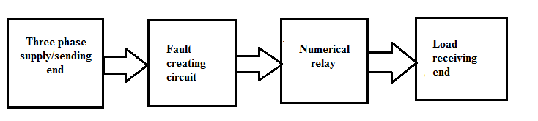Fig. 3.1 Block diagram for design of panel

In our project we are using three phase supply as a sending end and fault is created by fault creating circuit . Fault creating circuit is as shown in fig3.1 below. The overcurrent protection numerical relay senses the fault overcurrent and contactors get open circuited and protect the receiving end or load from overcurrent.

Fault Creating Circuit

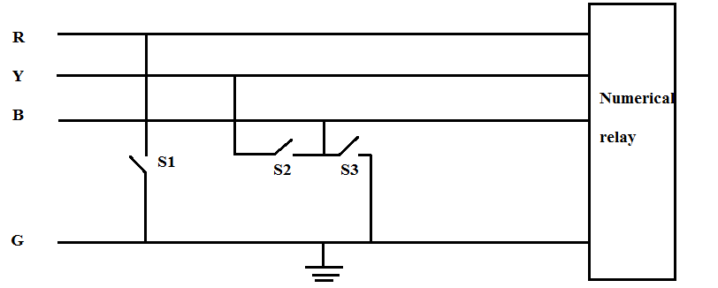

Fig.3.2 Connection for fault creating circuit

Operation of fault creating circuit:-

When switch S1 is close LG fault is occur.

When switch S2 is closed LL fault is occurs.

When switches S2&S3 closed same time then LLG fault occurs .

Definitions of faults created by fault creating circuit[6]:-

**1)** Single line to ground (LG) fault: - The single line to ground fault occurs when one conductor falls to ground or contacts the neutral conductor.

**2)** Line to line(LL) fault:- A line to line fault occurs when two conductors are short circuited.

**3)** Double line to ground (LLG or DLG):- The double line to ground fault occurs when two conductors are fall to ground or contacts the neutral at same time.

Numerical Relay **:**Conventional electromechanical and static relays are hard wired relays. Their wiring is fixed, only their setting can be manually changed. Numeric relays are programmable relays. The characteristics and behaviour of the relay are can be programmed. They have numerous advantages. They have small burden on CT’s and PT’s. They can process and display the signals efficiently, accurately and fast as possible manner



Pic.4.2 :- Numerical relay[8]

Specification:-

Type : PNA 442

C.T. sec: 5amps

Aux supply: 85 to 275 volts AC/DC

Over current setting range: 50% to 200% in steps of 1%

Definite minimum time: 0.00 to 150 sec

High set element :200% to 3000%

Definite minimum time:0.00 to 150 sec

High set element :50% to 1600%

Reference

[1] Prof. A.P.Chaudhari, Prof. G.K.Mahajan, Prof. S.R.Paraskar, “Digital simulation of numerical relay using matlab ” ISSN:0975-6736/NOV 09 TO OCT 10/Vol 1

.

[2] D.A. Tziouvaras , J.b. Roberts & G. Benmouyal , “New multi-ended fault location design for two or three terminal line” ,development in power system protection, conference publication no.479 , IEE 2001

[3] A. Apostolov, “Implementation of a transient energy method for directional detection in numerical distance relays”, 0-7803-5515-6/99/,1999 IEEE

[4] Lee Goh ,Agileswari K. Ramasamy , Farrukh Hafiz Nagi, AidilAzwinZainul abiding, “Numerical relay for protection using TMS32OF2812”ISBN: 978-960-474-262-2