Maintaining DC-Link Voltage For High Performance Of Adjustable Speed Drives

Diwakar Korsane
R.K.D.F institute of science and technology
Bopal,M.P.
dkorsane@gmail.com
Akshay Kakade
GHRCE
Nagpur kakdeaakshay@gmail.com

ABSTRACT
Electric power quality encompasses voltage transients, sags, swells, voltage distortions and momentary interruptions (outages) etc. unsymmetrical voltage sag effects on the torque and speed deviation in induction motor (IM) adjustable speed drives. There are different techniques to enhance capability of ASD’s during unsymmetrical voltage sag conditions. These are aimed at maintaining the dc-link voltage constant by injecting energy from an external source using Ultra capacitors, and the improved performance of ASD’s during unsymmetrical voltage sag conditions.this study analyses unsymmetrical voltage sag effects on the torque and speed deviation in induction motor (IM) adjustable speed drives. In general types of IM drives control are analysed: scalar controlled (V/Hz), rotor field oriented and direct-torque controlled. In this Paper IM controlled by direct-torque-controlled method. The analytical expressions for dc-link voltage variations incorporated into the corresponding drive models as well as formulas for assessment of current/torque deviation are derived depending on the applied control algorithm.
Keywords
Power Quality, Adjustable speed drives, direct torque controlled method, dc link voltage.

INTRODUCTION
Modern adjustable speed drives (ASDs) are highly sophisticated non-linear power electronic devices, commonly found in a wide range of installed/rated powers in industry and other applications for torque/speed control of induction motors (IMs). Voltage sags (dips) are power quality problems, which are most expected by the consumers in public power supply networks. This type of voltage disturbance presents a short-duration (half-period to 1 min) voltage reduction, where usual limits of the remain voltage are between 10 and 90% in r.m.s of the nominal voltage. A device performance evaluation under this power quality disturbance is requested by IEC standards. Which defined four functional performance classes for the equipment behaviour affected by power quality problems? The majority of previous works were focused on determining voltage sag Sensitivity limits related to disconnection/tripping of Analysed or tested ASDs owing to the activation of their Over current/under o voltage protection systems or regarding the impact on the ripple occurrence in input current and dc bus voltage. In this paper studies the behaviour of direct torque controlled application under the voltage sag circumstances. We propose a new method for analysis of the impact of these power quality disturbances on ASDs, having inner torque/current control loops.
BASIC CONTROLLED SCHEME
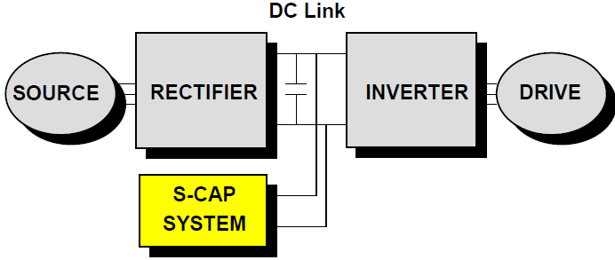
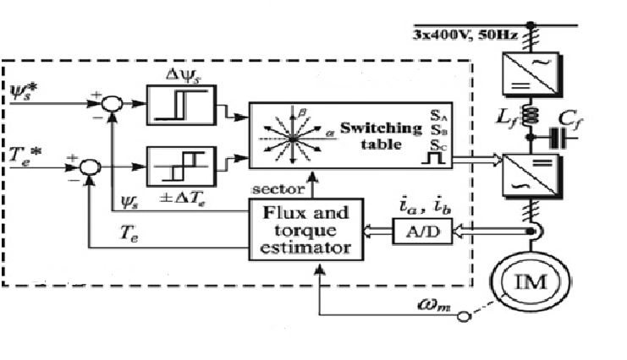
Fig No. 01
1.1DIFFERETN RIDE THROUGH ALTERNATIVES THEIR COMPARISON
In its basic version DTC consists of a three-level Hysteresis comparator for torque control and a two-level Hysteresis comparator for flux control. The main problem in Classical DTC ASD applications is a high value of the torque Ripple, which can be minimised by reducing the calculation Time for the switching states or by using switching table Modification. In this paper, a modified DTC scheme is used, in which a 2b plane is divided into 12 sectors (Denoted as ‘C12DTC’), instead of six, Fig. 02. One of the DTC favourable solutions for the constant switching. By adding capacitors to the DC- link, additional energy needed for full-power ride-through during voltage sag can be provided to the motor. It is a simple and rugged approach, which can provide limited ride-through for minor disturbances. However, its cost is relatively high and a large cabinet space is required. The load inertia may be utilized to provide ride- through capability to ASD’s. The inverter control software can be modified such that when a power disturbance causes the DC- link voltage to fall below a specified value, the inverter will adjust to operate at a frequency slightly below the motor frequency, causing the motor to act like a generator. The drive will absorb a small amount of energy from the rotating load to maintain the DC link at a specified level and maintains the specified DC- link for few seconds during a dip that does not exceed 20%. Here, no additional cost is included only small software modification is required but provides ride-through only for A boost converter can be used between the rectifier and the DC- link capacitors to maintain the DC- link voltage during voltage sag. During voltage sag, the boost converter will sense a drop in the DC-link voltage and begin to regulate the DC- link to the minimum voltage required by the inverter. Boost converter provides ride-through with lower cost, up to 50% sag but fails during outages. Replacing the diode rectifier with an active PWM rectifier regulates the DC- link which offers immunity to voltage sags and transients and low input current harmonics. The range of ride through provided by this approach is limited only by the current rating of the rectifier. Active rectifier with lower cost provides ride-through up to 50% sag but fails during outages. Ultracapacitors are new generation energy storage devices, which are true capacitors in the sense that energy is stored via charge separation at the electrode-electrolyte interface, and they can withstand a large number of charge/discharge cycles without degradation. The major advantages of Ultracapacitors include higher capacitance density, higher charge-discharge cycles, reliable, long life, and maintenance-free operation, environmentally safe, wide range of operating temperature, high power density and good energy density, so they are a good alternative. Ultracapacitors fill the gap between standard batteries and traditional Capacitors for high-power, short-duration energy storage.

1.2 Classification of different types of voltage sag/dips and impact on ASD’s
A balanced three-phase voltage dip will result in a type A. Since the voltage dip is balanced, the zero-sequence is zero, and a transformer will not affect the appearance of the voltage dip. This holds both for the phase-ground voltage and phase-to-phase- voltage. A phase-to ground-fault will result in a type B. If there is a transformer that removes the zero sequence between the fault location and the load, the voltage dip will be to-phase-fault results in a type C. The voltage dips of type E, F and G are due to a two-phase-to-ground fault. An overview of the different types of voltage dips due to a two phase- to-ground faults. A voltage dip is usually caused by an un-symmetrical fault.
1.3 Table 1 Motor data (per phase) and ASD parameters.
Rated power Pn/speed nn 1500W/2860 rpm
Number of pole pairs Pp 1
Stator phase voltage Us 230 V
Stator resistance rs 5.45 V
Stator leakage inductance Lls 11.8 mH
Rotor resistance rr 3.18 V
Rotor leakage inductance Llr 11.8 mH
Mutual inductance M 441.3 mH
Total inertia Jm 0.0035 kgm2
Dc-link capacitance (Cf) 2× 330 mF (in series)
Dc-link inductance (Lf) 2× 1.5 mH
Maximum constant output rms current 4.1 A
Dc-link under-voltage protection 420 Vdc
Switching frequency 5 kHz.

Mat lab Simulation
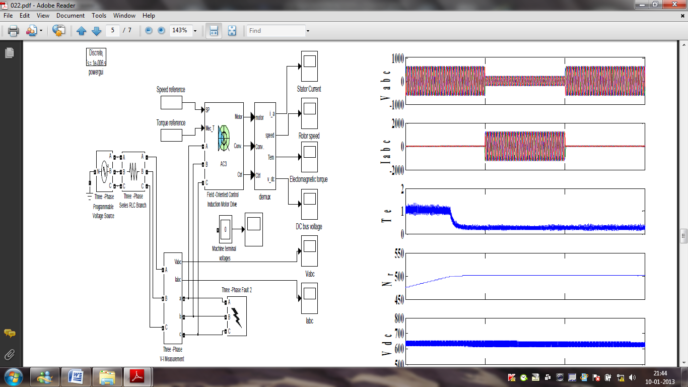
Fig. 3 MATLAB simulation of ASD’s with Ultra capacitor at DC- link (a). System Simulation

Mat lab simulation using ultra capacitor
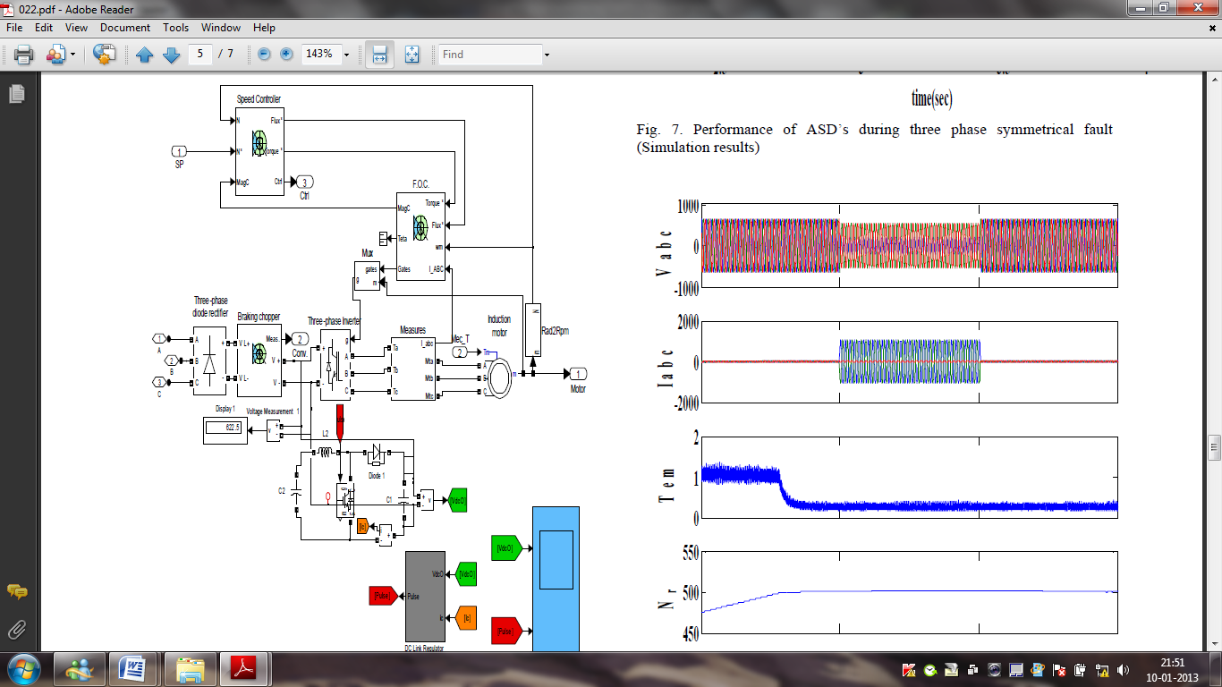

Fig. 3 MATLAB simulation of ASD’s with Ultra capacitor at DC- link
(a). System Simulation.

RESULTS
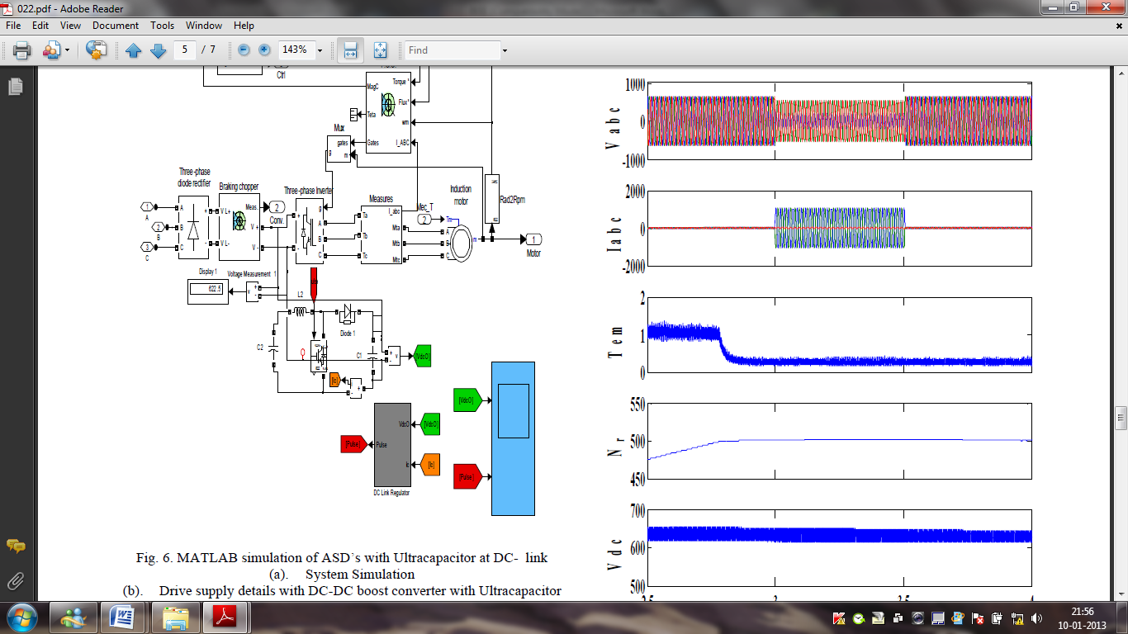

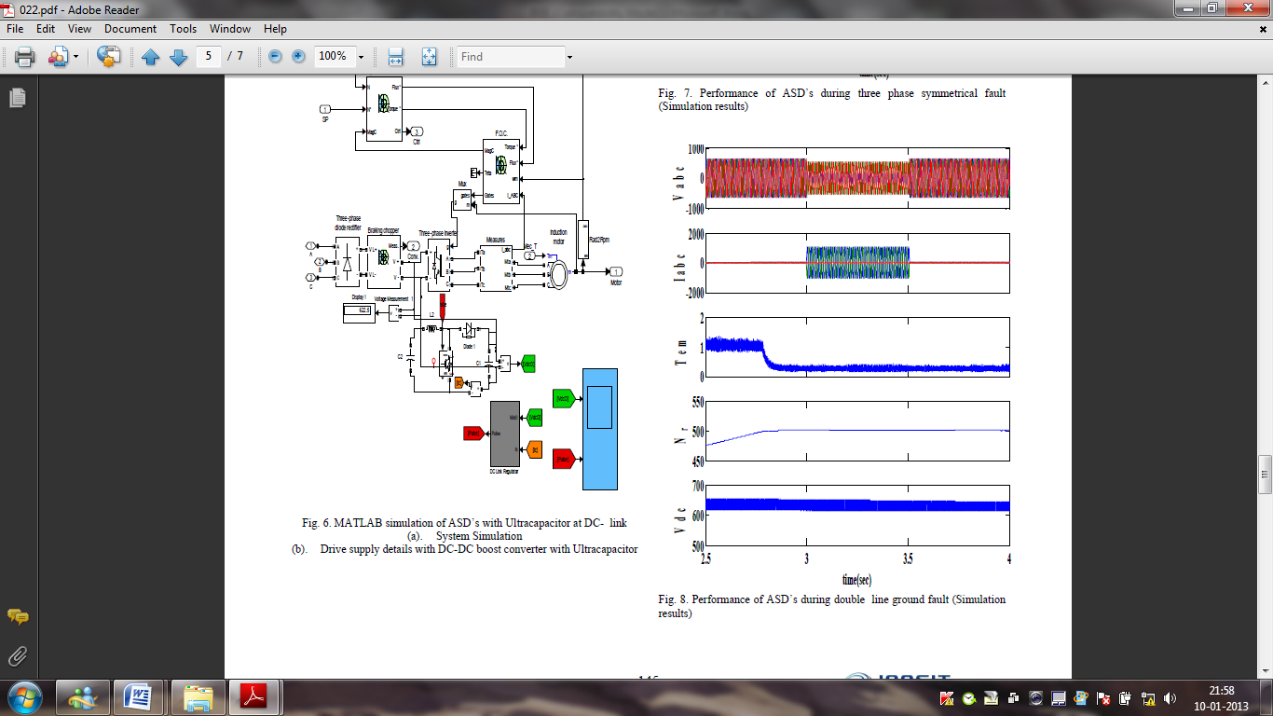

CONCLUSION
Modern ASDs can have different behaviour under voltage Sag, in terms of momentary tripping or partial performance Degradation. This paper, based on analytical analysis, Predicts IM drives’ response in case of SLGFs caused voltage sags with respect to different control schemes. High-performance drives (with DTC algorithm), owing to inner current/torque control loops, are less sensitive to voltage sag occurrence, particularly drives with traditional DTC technique with hysteresis comparators. The paper also suggests design criteria of inner control loops to reduce system sensitivity to voltage sags. It has been derived, and experimentally proved, that the higher inner closed-loop bandwidth provides better rejection of unwanted torque ripple caused by voltage sags. Shows the performance of the proposed scheme based on MATLAB simulation and designed experimental setup respectively. The parameters line current, phase current, line voltage ,phase voltage, speed ,torque and dc voltage, show the three- phase source voltages, line currents, electromagnetic torque, rotor speed, voltage & current in R, Y B phases and DC-link voltage respectively.

REFERENCES
[1] H.G. Sarmiento and E. Estrada, “A voltage dip study in an industry with adjustable speed drives, ” IEEE Industry Applications Magazine., Vol. 2, pp. 16-19, January/February 1996.
[2]International Electro technical Commission: ‘Electromagnetic Compatibility (EMC), Part 4: Testing and Measurement Techniques,Section 30: Power Quality Measurement Techniques’. IEC Standard 61000-4-30, 2003.
[3] Takahashi, I., Ohmori, Y.: ‘High-performance direct torque control of an induction motor’, IEEE Trans. Ind. Appl., 1989, 25, (2), pp. 257–264.
[4]Takahashi, I., Ohmori, Y.: ‘High-performance direct torque control of an induction motor’, IEEE Trans. Ind. Appl., 1989, 25, (2), pp. 257–264.
[5] Lai, Y.S., Chen, J.H.: ‘A new approach to direct torque control of Induction motor drives for constant inverter switching frequency and torque ripple reduction’, IEEE Trans. Energy Convers., 2001, 16, (3), pp. 220–227.
[6]Zhou, K., Wang, D.: ‘Relationship between space-vector modulations and three phase carrier-based PWM: a comprehensive analysis’, IEEE Trans. Ind. Electron. 2002, 49, pp. 186–196.
[7] Blaabjerg, F., Kazmierkowski, M., Zelecehowski, M., Swierczynski, D.,Kolomyjski, W.: ‘Design and comparison direct torque control techniques for induction motors’. Proc. European Conf. on Power Electronics and Applications, Dresden, Germany, January 2005, pp. 253–261.

