**Application Of Integrated Switched-Mode Rectifier For Automotive Alternator**

Trupti Nitnaware, Nitin Suryawanshi, Ravi Ranjan Kumar

K.D.K. College of Engg. Nagpur, India 440 009

Email:- ravikrranjan88@gmail.com

**Abstract- This paper proposes the technique for design of high-power Lundell alternators with integrated switched-mode rectifier (SMR). A new methodology of multi-section stator winding and interleaved rectifier arrangement is introduced that enables high power levels to be achieved and which greatly reduces the output filter capacitor requirements. The new modulation scheme may be implemented with simple control hardware, and without the use of expensive current or position sensors. The proposed technology is validated in the design and experimental evaluation of alternator has been done.**

***Keywords- Claw pole, SMR (Switch Mode Rectifier).***

1. INTRODUCTION

There is an interest indeveloping electrical systems at a higher voltage (42 V) tobetter accommodate more electrical power in automobilesand to achieve economies available through tightersuppression of overvoltage transients. These challenges havemotivated a variety of research into automotive alternatordesign in recent years[1].The alternators are designed to operate optimally at idle speed, thus maximizing output power delivery at the speed providing the least generated power. At higher speeds, the power capabilities of the alternator machine are under-utilized. Recent work has demonstrated that introduction of a switched-mode rectifier (SMR) and appropriate control into the alternator can overcome this limitation. In this approach, the bottom diodes of the rectifier bridge are replaced by controlled switches [e.g., power metal-oxide semiconductor field-effect transistors (MOSFETs)]. This SMR allows matching of the effective voltage seen by the alternator to that required for maximum power at anyspeed [2]. The electrical power requirements in automobiles have been rising rapidly for many years and are expected to continue to rise. This trend is driven by the replacement of engine-driven loads with electrically-powered versions, and by the introduction of a wide range of new functionality in vehicles. The continuous increase in power requirements is pushing the limits of conventional automotive power generation and control technology, and is motivating the development of

both higher-power and higher-voltage electrical systems and components [3]. When modified, auto alternators can provide variable direct current at 0 to 120 volts for battery charging, hot charging, light arc welding, or for running AC-DC appliances and lights. Another simple modification provides AC power to run some transformer-operated appliances [4]. The push to introduce dual-voltage (42V/14V) automotive electrical systems necessitates power generation solutions capable of supplying power to multiple outputs. A number of approaches for implementing dual-voltage electrical systems have been proposed, but most suffer from severe cost or performance limitations. This paper explores the design of alternators incorporating dual-output switched-mode rectifiers [5].

1. LUNDELL ALTERNATOR

Conventional three-phase Lundell alternators employ a diode bridge to rectify the generated ac voltages, and regulate the output voltage via field control. By exchanging the diodes in the bottom half of the rectifier bridge for active devices such as power MOSFETs, a semi-bridge switched-mode rectifier (SMR) is obtained. The switched-mode rectifier provides additional means of controlling the alternator [1].

The bottom MOSFETs of the SMR can only be effectively modulated while they carry positive current; during other periods, their corresponding back-diodes conduct. Any viable scheme must keep the alternator within allowed thermal limits.

For the modulation scheme to be practical given automotive cost constraints, it should not require expensive sensors or controls [2]. The Lundell, or Claw–Pole, alternator is a wound-field synchronous machine in which the rotor comprises a pair of stamped pole pieces (“claw poles”) secured around a cylindrical field winding. The field winding is driven from the stator via a pair of slip rings. The stator is wound in a three-phase configuration and a full-bridge diode rectifier is traditionally used at the machine output. Alternator system output voltage (or current) is controlled by regulating the field current. A relatively long field time constant and a high armature synchronous reactance are characteristic of this type of alternator, and tend to dominate its electrical performance [3].

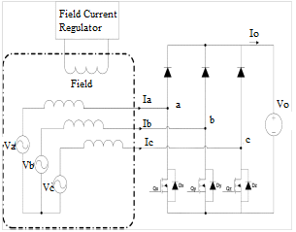

Fig.1 Electrical model of a Lundell alternator connected to an SMR[2]

1. AN INTERLEAVED MULISECTION WINDING

While the use of switched-mode rectification offers major opportunities, it also poses some practical challenges. One issue to be addressed is the pulsating ripple current at the output of the switched-mode. Unlike a diode rectifier, the output current of the SMR pulsates at the switching frequency, yielding an RMS ripple current into the rectifier output capacitor that is on the order of. where Io is the average alternator output current. Low equivalent-series-resistance (ESR) capacitors with high ripple current rating are, therefore, required to absorb this ripple Stator Winding current and contribute to EMI filtering .

Here we demonstrate a design strategy that addresses both of the above challenges. Instead of the design of Fig. 1, we employ and illustrated in Fig. 2. In this approach, the system is interleaved machine and rectifier configuration, as constructed from a number Nc of small rectifier cells connected in parallel, with each cell fed from a separate isolated three phase stator winding.

1. MULTISECTIONAL WINDING

The described here is alternator of VOL-GATE (12V, 60-A rating).The stator of the machine has 36 slots, into which the original three phase winding was wave wound. Each phase of the original machine comprised two parallel 16- SWG wires wound for a total of 72 series turn yielding six turns (12 wires) per slot, with some slots containing an additional two wires for terminating the winding. The stator was rewound for proposed interleaved SMR system at 42-V output. Rewinding of the machine focused on realizing the multiple three-phase sets for an interleaved system (see fig. 2). A four cell system was implemented having four separate sets of three- phase windings. Because our design incorporates a boost rectifier, the same number of turns (in each phase set) as the original 14-V alternator was used for 42-V output .the machine was rewound with each phase conductor comprising one strand of 22 SWG wire, yielding a copper packing factor close to that of the original machine[1].

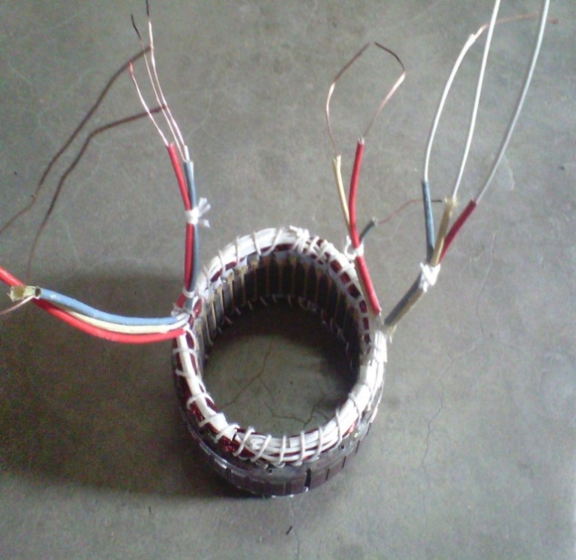

Fig. 2 A view of (Stator) Alternator with 12 o/p terminals

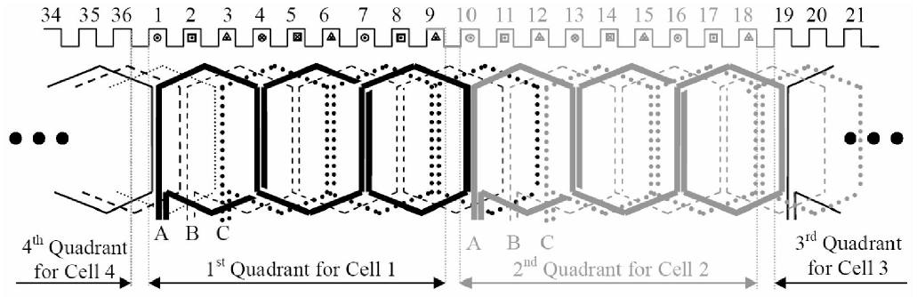

Fig. 3 Stator winding configuration for the 4-SMR-cell alternator system[1]

1. DESIGNING OF ALTERNATOR

The synchronous speed of alternator is given by,

 …………..Eq.[5.1]

The Pole pitch is the distance between two adjacent poles. Pole pitch is given by,

Pole pitch= …………..Eq.[5.2]

Pair of pole =  …………..Eq.[5.3] For any conventional alternator the output is given by, KVA Rating

Q =  …………..Eq.[5.4]

Where , Output Coefficient

() =

…………..Eq.[5.5] Specific magnetic and electric loading are given by,

Specific Magnetic Loading

() = …………..Eq.[5.6]

Specific Electrical Loading

(ac) =  …………..Eq.[5.7]

Stator Bore (D) =  …………..Eq.[5.8] Pole Pitch is givn by

Pole Pitch ( Ʈ) = …………..Eq.[5.9]

Total number of conductors

(Z) = S × …………..Eq.[5.10]

Stator Slot Pitch (  ) =  ……..Eq.[5.11]

Turns per phase can be calculated from EMF equation,

() = ………..Eq.[5.12]

Total number of armature conductor

(Z)= 6 ×  …………..Eq.[5.13]

Conductor per slot () = ………..Eq.[5.14]

Gross iron length

() …………..Eq.[5.15]

Net iron length () =0.9(Length of core – Width of duct) …………..Eq.[5.16]

Width of teeth at the gap surface

()= …………..Eq.[5.17]

Width of slots .……..Eq.[5.18]

Length of mean turn

() = 2L + 3Ʈ …………..Eq.[5.19]

Depth of core ()=  ………..Eq.[5.20]

Outer diameter of stator lamination …………..Eq.[5.21]

Table:5.1 Parameters and ratings of stator

|  |  |  |
| --- | --- | --- |
| Parameters | Symbols | Ratings |
| Full load KVA | Q | 480VA |
| Line voltage | V | 29.69V |
| Phase voltage | Vph | 17.14V |
| Frequency | F | 50Hz |
| Speed | N | 500rpm |
| Number of poles | P | 12 |
| Number of slots | S | 36 |
| Connection |  | Star |
| Winding |  | Double layer |

Table:5.2 Parameter for one section

|  |  |  |
| --- | --- | --- |
| Line voltage | V | 7.42V |
| Phase voltage | Vph | 4.28V |
| Number of slots | S | 9 |
| Number of poles | P | 3 |

1. SWITCHED-MODE RECTIFIER CONTROL

The Control of the alternator encompasses a number of tasks. Foremost is the regulation of the output voltage across variations in load. This is achieved through control of both the alternator field current and the switching pattern of the rectifier. Control of the field and switched-mode rectifier should also be performed in a manner that meets other goals, such as maintaining high efficiency and controlling output ripple. Additionally, there is a need to handle fault conditions.

Multiple possibilities exist for controlling the output voltage and current of the interleaved alternator configuration of Fig. 5. In each case, one selects a combination of field current and duty ratio that provides sufficient power to regulate the output. One straight forward possibility operate the interleaved system exactly as a single-cell design, is to but with the gating waveforms of the cells interleaved appropriately. With this strategy, the switching ripple current into the output capacitor is reduced by an amount that depends on the number of cells and the duty ratio, and the fundamental switching ; ripple frequency is increased by a factor Nc.Another control possibility arises from the fact that the switching ripple currents delivered by the interleaved cells cancel completely for certain duty ratios yielding an output waveform that is ideally free of switching ripple. For example, as illustrated in Fig. 9, in a two-cell system operating at a 5000 duty ratio (d =0.5), the pulsating currents from the individual cells add to provide a continuous (small-ripple) output current waveform.

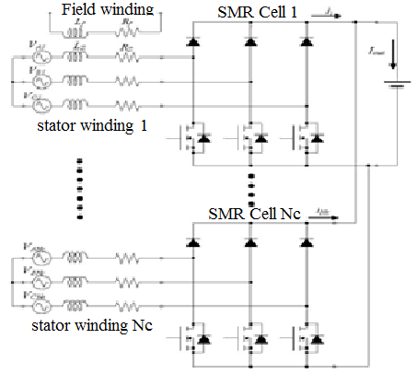

Fig.4 Schematic of multi-winding machine and interleaved switched-mode rectifier[1].

Thus, a two-cell system can ideally be operated at d = 0 (corresponding to diode rectification) or d 0.5 with minimal switching ripple. Likewise, in a four-cell system (Nc = 4), the cell switching ripple currents cancel completely for duty ratios d of 0, 0.25, 0.5, and 0.75. By accepting operation at only these specific duty cycles, significant reductions in capacitor rating and filtering requirements can be achieved at the expense of design complexity.

The alternator design demonstrated here takes advantage of this "perfect cancellation" interleaving strategy. Because we constrain the control to only discrete duty ratios, the load matching condition indicated in (4) and illustrated in Fig. 4 is not achieved precisely across speed. However, in our four cell design there is sufficient flexibility with four available duty ratios (d = 0, 0.25, 0.5 and 0.75) to make a reasonable approximation to load-matched performance at heavy loads.

The question arises of how to maintain output regulation across alternator speed and load. The strategy adopted in our prototype system is to select an appropriate duty ratio based on alternator speed (with a small amount of hysteresis in the transition points), and to regulate the output power within that speed range via field control.

Alternator field current is adjusted between 0 and a maximum value (nominally 3.6 A) by pulse-width modulation. As the field is wound for a 14 V output but is driven from 42 V in our design, the field duty ratio is limited to a maximum value of 28%. Field duty ratio is adjusted based on output voltage error mainly via proportional control, with a voltage deviation of +/-2.68 V causing a field duty ratio swing between 0 to max.

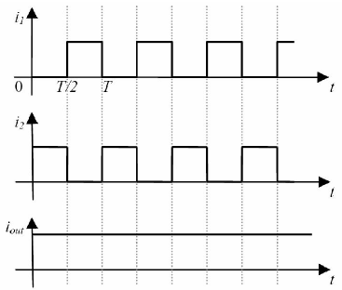

Fig .5 Example of ripple cancellation with interleaving for two interleaved cells.

1. POWER AND EFFICIENCY OF ALTERNATOR

With the new SMR technique, substantial increases in alternator output power can be achieved, particularly at speeds above idle. The curves of Fig. below indicate that the alternator power capability increases almost linearly with speed between idle and cruising speed. This contrasts with the case of a conventional diode-rectified alternator in which the available output power is relatively flat over much of the speed range. For some automotive loads the improved power capability with speed is ideal. [3].

Since the proposed system achieves both lower losses and increased power output, the efficiency of the overall system is improved tremendously.

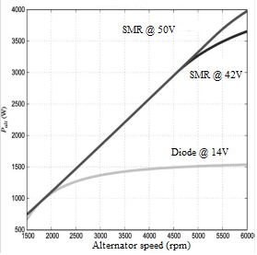 Fig.6 Analytical prediction of alternator output power versus speed at full field current for different operating conditions[3].

The experimentally-measured mechanical input to electrical output efficiency at full-field is plotted in Fig. 5 for the alternator system using conventional diode rectification at 14 V and SMR load-matching at 50 V. With the conventional diode rectified system, the efficiency starts at around 61% at idle speed of around 1800 rpm and declines to about 45% near the cruising speed of 6000 rpm.

With the switched-mode rectified system, the efficiency also starts near 61% at idle speed but *increases* to about 71% at cruising speed. This represents a dramatic improvement in the efficiency of the alternator. The improved efficiency provided by the new SMR load-matching is valuable from a fuel economy and environmental point of view and will become even more so as the average electrical loads in vehicles continue to increase [3].

Another control possibility arises from the fact that the switching ripple currents delivered by the interleaved cells cancel completely for certain duty ratios, yielding an output waveform that is ideally free of switching ripple. For example, as illustrated in Fig. 10, in a two-cell system operating at a 5000 duty ratio (d =0.5), the pulsating currents from the individual cells add to provide a continuous (small-ripple) output current waveform. Thus, a two-cell system can ideally be operated at d=0(corresponding to diode rectification) or d 0.5 with minimal switching ripple.

Likewise, in a four-cell system (Nc = 4), the cell switching ripple currents cancel completely for duty ratios d of 0, 0.25, 0.5, and 0.75. By accepting operation at only these specific duty cycles, significant reductions in capacitor rating and filtering requirements can be achieved at the expense of design complexity.

1. CONCLUSION

This paper presents techniques for the design of high-power Lundell alternators with integrated switched-mode rectifiers.

A multi-section stator winding and interleaved rectifier arrangement is introduced that enables high power levels to be achieved using small semiconductor devices, and which greatly reduces the output filter capacitor requirements. We also demonstrate control methods suited to this interleaved system. The proposed technology is validated in the design and experimental evaluation of a alternator has been done. The prototype alternator achieves approximately a factor of 2.1 increase in power and 1.6 increase in power density as compared to a conventional diode-rectified alternator, along with a substantial improvement in load dump performance.

REFERENCES

[1] S.C. Tang, D.M. Otten, T.A. Keim, and D.J. Perreault,“Design and Evaluation of a 42 V Automotive Alternator with Integrated Switched-Mode Rectifier”, IEEE Trans. On Energy Conversion, Vol, 25, no 4, December 2010.

[2] Juan Rivas*, David Perreault , Thomas Keim ,“*Performance Improvement of Alternators With Switched-Mode Rectifiers”, IEEE Trans. Energy Conversion, vol. l9,no.3,pp.561-568,May.2004.

[3] David J. Perreault, Vahe Caliskan, “Automotive Power Generation and Control”, IEEE Trans. Power Electron, vol.19, no.3 , pp. 618-630, Sep 2004.

[4] C. P. Mudannayake and M. F. Rahman, “Load dumped transient behaviour of a 42v prototype integrated starter alternator”, IEEE Power Electron. Spec. conf. Aachen. Germany, 2004. Pp 389-394.

[5]Gimba hasssan,David J. perreault, Thomos A. keim, “Design of Dual-output Alternator with switched-Mode rectification”, IEEE Trans. Power Electron, vol.20. no.1,pp. 164-172 Jan.2005.

[6]David J. Perreault, Vahe Caliskan, “A New Design for Automotive Alternators”, Massachusetts Institute of Technology, 2006-C084.

[7] A. K. Sawhney “ A Course in Electrical Machine Design”, Dhanpat Rai & Sons publication, Delhi, Jun. 1997.

[8] M D Singh, K. B. Khanchandani-“Power Electronics”,Tata McGraw-Hill publishing company Ltd New Delhi, Dec. 1998.

[9] B. L. Thereja, A.K Thereja, “A Textbook of Electrical Technology” Vol.2, S. CHAND & Sons ,publishing company Ltd. New Delhi, Mar. 2005.

[10]Website:- [www.alternator.com](http://www.alternator.com)