Enhancing Battery Life by using supercapacitor in parallel with battery

Lakshmikant M. Bopche
Student Of Electrical Engineering Department
G.H.Raisoni College of Engineering
Nagpur, Maharashtra
luckybopche.780@gmail.Com
Sandhya Pardhikar
Student of Electrical Engineering department
Government College of Engineering
Chandrapur, Maharashtra
Sandypardhikar@gmail.Com

Abstract- This paper deals with a system in which DC motor is started by using parallel combination of supercapacitor and battery, for enhancing the battery-life. Supercapacitor delivers energy during ride through periods, which typically are during starting or during overloads. While delivering the energy, their current demands heavily increase. For the cases of heavy drainage of energy, for a longer time, the reduction in terminal voltage of supercapacitor reduces the power fed by the supercapacitor. Then another capacitor is added in parallel with previous capacitor, supercapacitor bank of element can lead to higher effective current while enhance the power fed to the load during this overload period. MATLAB simulation has been done to analysis such systems. Energy calculations have also been done. The proposed system is realized experimentally on small D.C. motor.
Keyword:- supercapacitor, battery, dc motor
- Introduction :-
Ultracapacitors, are energy storage devices that store energy without chemical reaction. They offer many advantages over existing advanced battery technologies from the perspectives of power capability, life, charge/discharge efficiency, easy estimation of the state of charge, and low-temperature performance. Despite this important advance in energy storage, they are far from being compared with electrochemical batteries. Even lead-acid batteries can store at least ten times more energy than ultracapacitors. However, they present better performance in specific power than any battery and can be charged and discharged thousands of times without performance deterioration. These characteristics can be used in combination with normal electrochemical batteries to improve the transient performance of an electric vehicle, and to increase the useful life of the batteries.
If Ultra capacitor is source of energy, due to large time constants are involved and Energy transactions become slower as a result [1] Though this configuration limits the available power transfer paths, it can be simpler, lighter, and more cost effective, especially for light DC-drive vehicles. It is also more intuitive, making it an ideal educational demonstration of the technology. We built and tested an experimental vehicle, based on a go-kart with a separately-excited DC motor, to evaluate this configuration. The vehicle achieves effective kinetic energy recovery of higher than 30%, with selectable improvements in power, speed, and/or range. [2] A low cost effective solution has been suggested by Chen and Lai [3], for designing a charger wherein switch-over takes place from constant current charging to constant voltage charging, by the microcontroller unit.

2. Proposed Scheme

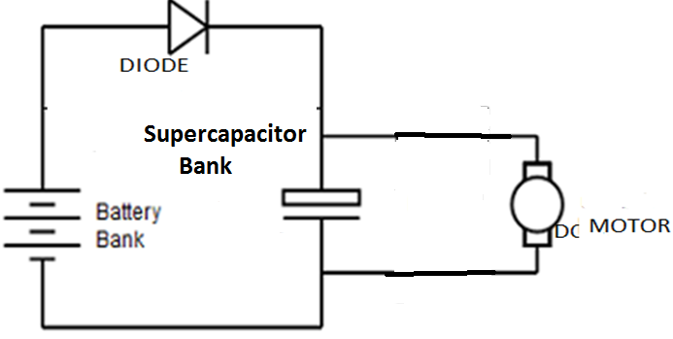 Fig (1): supercapacitor connected in parallel with battery and motor load
This proposed scheme in which DC motor is started by using parallel combination of supercapacitor and battery, supercapacitor delivers energy during ride through periods, which typically are during starting or during overloads. While delivering the energy, their current demands heavily increase. For the cases of heavy drainage of energy, for a longer time, the reduction in terminal voltage of supercapacitor reduces the power fed by the supercapacitor. Then another capacitor is added in parallel with previous capacitor, supercapacitor bank of element can lead to higher effective current while enhance the power fed to the load during this overload period.
The comparison is to be done in three proposed scheme:
i) Battery with motor load without supercapacitor
ii) Supercapacitor parallel with battery and dc motor load
iii) Switching of supercapacitor

3. Characteristics of supercapacitor
In propose scheme, comparison is dealt with battery with motor load without supercapacitor, supercapacitor parallel with battery and dc motor load, Recombination of supercapacitor. Discharging of Super Capacitor is studied in above two cases. In case of charged capacitors of 15V 3.33F are connected with dc motor load and time required for complete discharge and time required for voltage discharge up to battery peak voltage is measured , as shown in Fig 1.
In case of reconfiguration, two fully charged capacitors of 15V, 3.33F are connected with dc motor load initially first capacitor will be the voltage discharge to battery voltage. Now the time required for complete discharge and time require for voltage discharge up to battery voltage is measured, as shown in Fig 2(a) & 2(b).These two different readings of time in both the cases are compared.

3.1 Battery with motor load without supercapacitor
In case without supercapacitor battery of rating 15V are connected to motor load. The variation of voltage across load is observed.
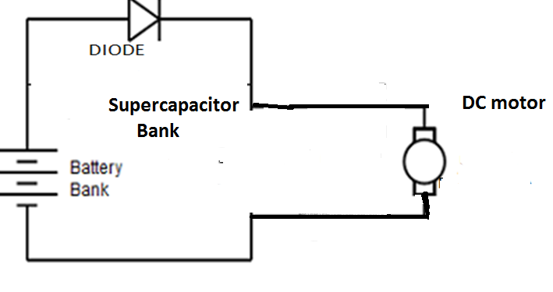
Fig (2) a: Battery with motor load without supercapacitor

3.2 Supercapacitor parallel with battery and dc motor load
Fig(2)b:Supercapacitor parallel with battery and dc motor load

The common parallel configurations of battery and ultracapacitor banks are shown in Fig 2b The parallel capacitance handles short-duration, high-current events, smoothing the demand on the battery. These configurations often require a capacitor bank with a voltage comparable to that of the battery bank. In some cases, the capacitor voltage operates in a range between the battery voltage and some peak
charge voltage, supplying current to the traction motor or other load when its voltage is higher than that of the battery. A low-current charging circuit may allow energy transfer between the battery and ultracapacitor.

3.3 Switching of supercapacitor
Ultra capacitors are considered as fully charged and connected in parallel with load, up to the chosen voltage cutoff to battery charging peak voltage. Now first Super capacitor will start discharging through motor load. When load voltage is becomes less than battery peak voltage, second capacitors are connected in series, then load voltage boosts up to 100% in the operation and then start, reducing exponentially. When the load-voltage reduces to battery peak voltage, first capacitor action should be stopped. Those two actions are graphically shown in Fig 2. In complete process, voltage is once boosted up to 100% by reconnection. It lies within battery voltage and 100% through the process. Thus by reconfiguration of the circuit, we extract the stored energy from UC in less time. This is substantiated by simulation.

4. Simulation studies and comparisons

  - Battery with motor load without supercapacitor
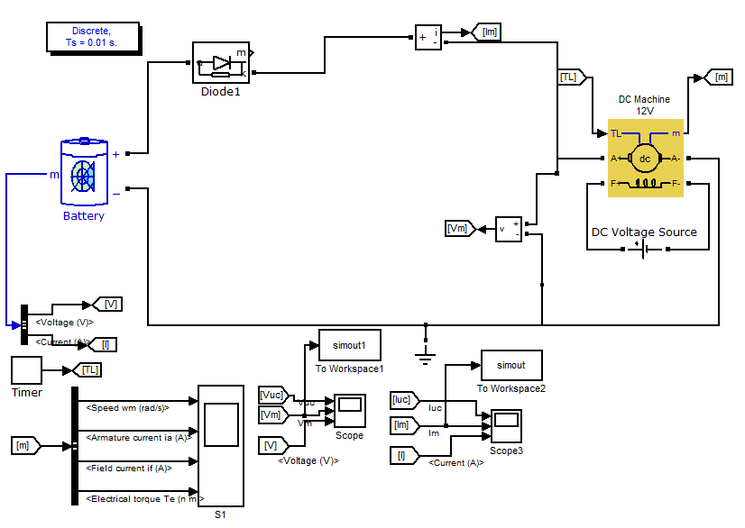
Fig (3) a: Simulation of Battery connected to motor load

In this simulation battery directly connected to motor load without supercapacitor. The waveform of motor load current and voltage shown in fig 3a

Fig 3(b): Response of Motor load current discharge
Fig 3(c): Response of motor voltage discharge

  - Supercapacitor parallel with battery and dc motor load

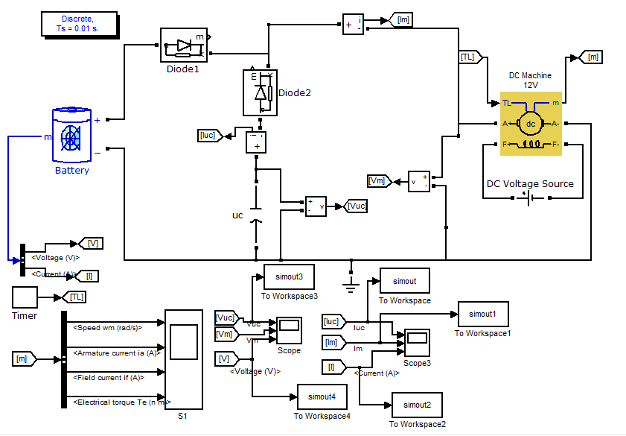 Fig 4(a): Supercapacitor parallel with battery and dc motor load.

In this simulation parallel combination of supercapacitor and battery with motor load. Initially required high starting current, current provided by supercapacitor, then disconnected, remaining energy delivered by battery. The waveform of supercapacitor current, voltage, battery voltage, current, motor voltage, current shown in fig 4a

Fig 4(b): Response of supercapacitor current discharge
Fig 4(c): Response of motor load current discharge

Fig 4(d): Response of battery current discharge

Fig 4(e): Response of supercapacitor voltage discharge

Fig 4(f): Response of motor load voltage discharge

Fig 4(g): Response of battery voltage discharge
Fig 4(h) Power shearing supercapacitor with battery

4.3) Switching of supercapacitor bank
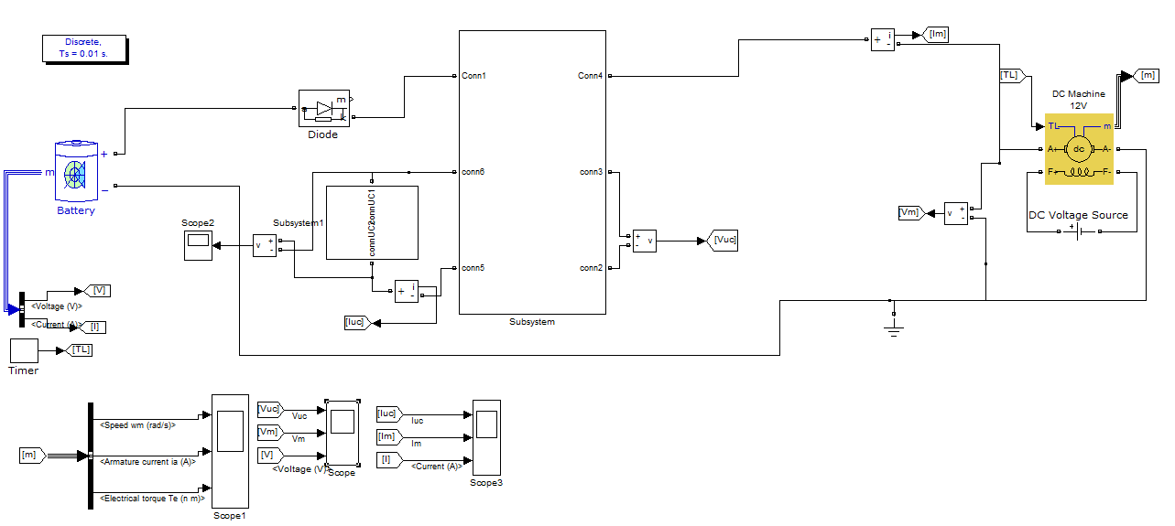
Fig 5(a): Simulation of recombination of supercapacitor bank

In this simulation supercapacitor bank is connected in parallel with battery and motor load. Initially first supercapacitor will discharge up to the battery peak voltage, disconnected first, after second supercapacitor boost up the voltage, then discharge up to battery peak voltage, battery in the operation. The waveform of supercapacitor bank voltage current, motor load current, voltage and battery current, as shown in fig
Fig 5(b): Response of supercapacitor bank voltage discharge
Fig 5(c): Response of battery voltage discharge

Fig 5(d): Response of motor current discharge

Fig 5(e): Response of battery current discharge
Fig 5(f): Response of motor current discharge

Fig 5(g): power shearing supercapacitor and battery
DC MOTOR SPECIFICATION
MOTOR TYPE | WOUND
ARMATURE RESISTANCE (R_{a}) | 2 ohm
ARMATURE INDUCTANCE (L_{a}) | 0.2 H
FIELD RESISTANCE(R_{f}) | 24 ohm
FIELD INDUCTANCE(L_{f}) | 12 H
MUTUAL INDUCTANCE(L_{af}) | 0.6 H
TOTAL INERTIA | 1 Kgm²
Table :1

- Conclusion
Co-working of supercapacitor and battery increases battery life. As an application of an innovative concept patented in 2012 by GHR labs, this effect is enhanced by inserting an additional charged supercapacitor during ride-through conditions.

- References
[1] Shane Colton “A Simple Series Battery/Ultracapacitor Drive System For Light Vehicles And Educational Demonstration” In Edgerton Center Summer Engineering Workshop Massachusetts Institute Of Technology, Cambridge, Massachusetts, United States Of America,March-2009.
[2] P.R.Sawarkar, Dr.S.G.Tarnekar, Dr.S.B.Bodkhe ”Improvement In Energy Transactions In Ultra Capacitor Banks By Series/Parallel Re-combination” ”—an Indian patent filed by GHRLABS, in 2012.
[3] Cheng-Chou Li,“A Stand Alone Super Capacitor Charging System Using A Feed Forward Boost Converter,” Proceedings of 2011 International Conference on System Science and Engineering, Macau, China, 8-10 June 2011 ICSSE 2011 p.p. 65-69.

[4] Zhifeng Bail, Yaojiie Sun, ' Yandan Lin, “Research On Ultracapacitor-Battery Hybrid Power System” In Institute For Electric Light Sources, Fudan University Engineering Research Center Of Advanced Lighting Technology Of Ministry Of Education, Departments Of Materials Science, Fudan University Shanghai, China,2011.
[5] Sheng Chen, Chih - Chen Chen*, Chen-Chain Hwu, Shao-Hua Chen, Han-Pang Huang” Super-Capacitor Applications On Series Lithium Batteries For Robot Power Management” 7th Asia-Pacific International Conference on Lightning, November 1-4, 2011, Chengdu, China,2011.
[6] Shiping Zhang, Rengui Lu, Jinwei Sun”Buck-boost Equalizer for Super-capacitor Modules” Publication Year: 2010 , Page(S): 1 – 5
[7] S.S.Deswal,, “Ride-Through Topology for Adjustable Speed Drives (ASD’s) During Power System Faults”, has been published in International Journal of Computer Science, Informatics and Electrical Engineering (JCSIEE), vol.2, issue 1, 2008.
[8] Juan W. Dixon & Micah E. Ortlizar ” Ultracapacitor + DC-DC Converters in Regenerative Braking System” in IEEE AESS System Catholic University of Chile, Maguzinr, August 2002.

