[1]

**Maximum Demand Controller For Management of Residential Loads During Peak Demand Periods**

Transformer less PV Inverter Topology

SHIVANI.S.DESHPANDE AMRUT.R.NINAWE MINAL.P.TATTE

K.D.K.C.E. Nagpur, Maharashtra.

amrutninawe1992@gmail.com shivanideshpande0706@gmail.com

***Abstract***-Industrial revolution in India since last 25 years has resulted in paradigm shift of residential population from rural to urban. Thus urbanization and industrialization have resulted in unprecedented increase in electricity demand. A direct consequence of this increased demand is the immense pressure that is build up on national electricity grid due to excessive load. This effect is more pronounced especially during peak demand periods. It becomes mandatory to reduce this pressure on grid in order to have reliable and continuous supply. One solution to this problem would be the construction of additional power generating facilities, but this solution is not economic as the installation is very costly as well as more power generating facilities will be threat to the environment. This solution thus has to be eliminated. A more feasible solution to this problem would be an instrument like maximum demand controller which can monitor the heavy load demand during peak hours. This paper proposes a controller which is easy in construction and various tests carried out on it resulted in many advantages like reduced electricity bill on recurring basis, improved load factor, and economy to the industrial user. The users of M.D controller can recover its cost through resulted savings in recurring electricity bill.

Keywords— Microcontroller, Voltage controllers Driver, Sensors.

1. INTRODUCTION

Every electrical system needs power for its working. Power is rated as per the amount of energy required to accomplish the work. Electrical power is measured in kilowatts per hour (kWh). Higher power consumption by an industry leads to huge bills along with penalties too. In order to avoid penalties, one solution would be increasing the power supplying facilities according to the maximum registered peak, but on contrary this will force the consumers to pay for such increased consumption of power. Another more feasible solution to this problem would be a maximum demand controller which will reduce the high peak demands by shedding the load. This controller will disconnect the non-critical load such as air conditioning, compressors, lighting and fans to reduce the consumption of power and

the critical load can be thus kept on. Thus it also provides load prioritization. Maximum demand refers to the maximum amount of electrical energy that is being consumed at a given time. It is measured in kilowatts per hours, which is a measurement of total electricity used for a period of time. The purpose of controlling the demand is, not to exceed the preset maximum demand limit. One way to do this is to shed non-critical loads. There are possible loads to be disconnected such as lights, compressors, air conditioners, pumps, fans and extractors, packaging machinery, shredders and others. Generally, all those machines do not give a significant effect to the main production process or are not essential. The general purpose of maximum demand meter is to monitor and control the maximum power demand which also reduces the monthly electricity bill. By using this meter, the users do not have to worry about their electricity bill as it will be much less as compared to previous bill before installing the meter. As a result consumer savings will increase. Maximum power demand meter can benefit every user especially factories. This new technology based meter can benefit the society at large. The proposed controller is easy in construction and various tests carried out on it resulted in many advantages like reduced electricity bill on recurring basis, improved load factor, and economy to the industrial user. The users of M.D controller can recover its cost through resulted savings in recurring electricity bill.

1. OBJECTIVE
2. To monitor the maximum power demand in industrial installation.
3. To control the power usage in industrial field.
4. To regulate and reduce electricity monthly bill.
   1. PROJECT STATEMENT

In industrial field, efforts should be made to achieve overall economy so that per unit cost of production is as low as possible. The problem of determining the cost of production of electrical energy is highly complex. Nowadays there is one equipment that can solve this problem which is the maximum demand meter. This meter is specifically design to monitor and also control the maximum power demand. The greater the

maximum demand, the greater is it sizes and cost. This type of meter can make sure that our monthly bill will not over limit thus also can fixed and maintain the monthly cost.

Controlling maximum demand can lower the bill thus saving the customer money. If the maximum power demand reading almost exceeds more than it is fixed by the company, the maximum demand meter will automatically control the power usage by load shedding. Load shedding can be accomplished by turning off non critical loads such as lamps and fans.

1. SCOPE OF PROJECT

Produce a meter that has function of monitoring and also controlling the maximum power demand in a device. The meter that we produce must easy to use and reliable. This project needs both hardware and software.

1. BLOCK DIAGRAM AND CIRCUIT DIAGRAM

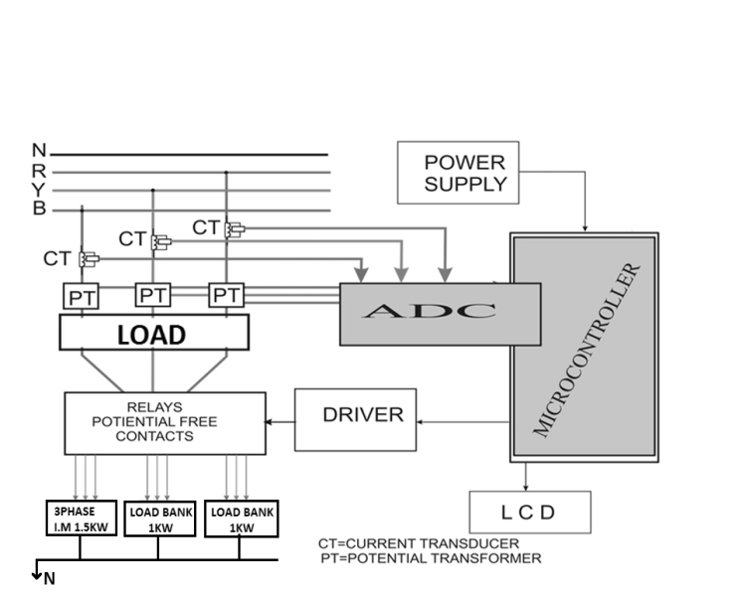

*Fig. 1.Block diagram of maximum demand controller*

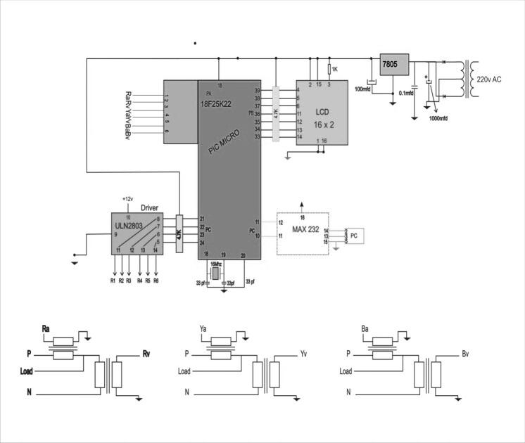

*Fig. 2. Circuit diagram of maximum demand controller*

Fig *3*.*HB WithUnipolar Switching*

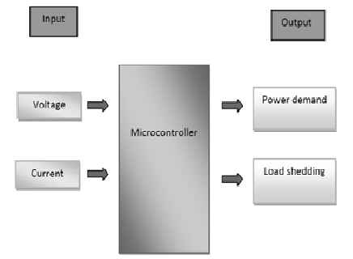

*Fig. 3.Block diagram of maximum demand controller*

Current and voltage are supply by company utilities as an input. The value of voltage supply is 240V from TNB. The current sensor is detecting the current from utilities and converts the current into the voltage. The voltage that converts from current sensor is 5V. The voltage from utilities will step down by transformer to 5V. The voltage from sensor and 5V will flow to the microcontroller because microcontroller only can read for 5V. The microcontroller will be program to monitor and display the power demand and shed the load.

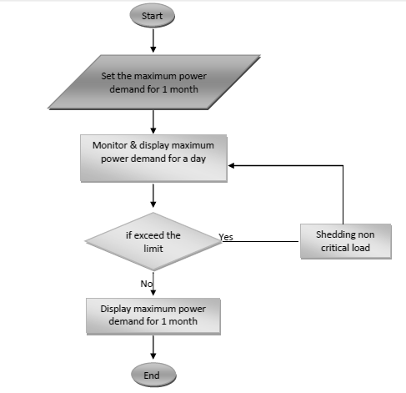

*Fig.3. Flow chart*

1. COMPONENT SPECIFICATION

**1. MICROCONTROLLER**

The AT89S52 is a low-power, high-performance CMOS 8-bit microcontroller with 8Kbytes of in-system programmable Flash memory. The device is manufactured usingAtmel’s high-density nonvolatile memory technology and is compatible with the industry-standard 80C51 instruction set and pin out. The on-chip Flash allows the programmemory to be reprogrammed in-system or by a conventional nonvolatile memory programmer. By combining a versatile 8-bit CPU with in-system programmable Flash ona monolithic chip, the Atmel AT89S52 is a powerful microcontroller which provides a

highly-flexible and cost-effective solution to many embedded control applications. The AT89S52 provides the following standard features: 8K bytes of flash, 256 bytes

of RAM, 32 I/O lines, Watchdog timer, two data pointers, three 16-bit timer/counters, asix-vector two-level interrupt architecture, a full duplex serial port, on-chip oscillator, and clock circuitry. In addition, the AT89S52 is designed with static logic for operation down to zero frequency and supports two software selectable power saving modes. The Idle Mode stops the CPU while allowing the RAM, timer/counters, serial port, and interrupt system to continue functioning. The Power-down mode saves the RAM contents but freezes the oscillator, disabling all other chip functions until the next interrupt or hardware reset.

**2. DRIVER**

The ULN2801A-ULN2805Aeach contains eight Darlington transistors with common emitters and integral suppression diodes for inductive loads. Each Darlington features a peak load current rating of 600mA (500mA continuous) and can withstand at least50V in the off state. Outputs may be paralleled for higher current capability. Five versions are available to simplify interfacing to standard logic families: the ULN2801Ais designed for general purpose applications with a current limit resistor; theULN2802Ahas a 10.5kW input resistor and zener for 14-25VPMOS; theULN2803Ahas a 2.7kW input resistor for 5V TTL and CMOS; the ULN2804A has a 10.5kW input resistor for 6-15V CMOS and the ULN2805A is designed to sink a minimum of 350mA for standard and Schottky TTL where higher output current is required. All types are supplied in a 18-lead plastic DIP with a copper lead from and feature the convenient input opposite- output pin out to simplify board layout.

**3. VOLTAGE REGULATOR**

The L7800 series of three-terminal positive regulator is available in TO-220, ISOWATT220 and TO-3 packages and with several fixed output voltages making it useful in a wide range of applications. These regulators can provide local on-card regulation, eliminating the distribution problems associated with single point regulation. Each type employs internal current limiting, thermal shut-down and safe area protection, making it essentially indestructible. If adequate heat sinking is provided, theycan deliver over 1A output current. Although designed primarily as fixed voltage regulators, these devices can be used with external components to obtain adjustable voltages and currents.

1. APPLICATIONS AND ADVANTAGES

The MD Meter will find its applications in wide areas like:

1. Process Control Industries

2. Main Incomers in Substations

3. Hospitals

4. Hotels

5. Corporate Offices

6. Educational Institutes

7. Small Single phase MD Controllers and be used for domestic purposes.

**ADVANTAGES:** - The use of MD Meter will provide many advantages; some of them are listed below:

1. Better Utilization of available Power
2. Avoids penalty
3. Improved Load Factor
4. Auto scaling from kVA to MVA
5. Predictive control method adopted to optimize demand control
6. Field programmable CT & PT ratios
7. Demand profile generation for setting realistic demand targets
8. Records peak demands with date & time
9. Time of the day (TOD) facility
10. Integration time selectable : 15/30 minutes (optional)
11. Communication interface to PC (optional)
12. Multi Control outputs for better control
13. The device has no or negligible running costs
14. It is economical to install
15. CONCLUSION

The main purpose of maximum demand meter is to monitor and control the maximum power demand and also to reduce the monthly electricity bill. Use of this meter will ensure customer from worry of hiked bill. Maximum power demand meter can benefit every user especially the factories or bulk user of electricity. The information about meter and knowledge about how to use it will certainly benefit lot to the society**.**

1. FUTURE SCOPE

* The maximum demand Controller can be interfaced with the computer and the maximum demand can be monitored through the SCADA system itself.
* The MD Controller can be made more accurate and transparent by using GSM technology

1. REFERENCES
2. “A Load Shedding Controller For Management Of Residential Loads During Peak Demand Periods” –IEEE AFRICON 2004.
3. “SMS based Load Shedding Period Control” System-International Journal of Computer Applications (0975 – 8887)Volume 29– No.7, September 2011
4. “Automated Load Shedding Period Control” System-Dwijen Rudrapal et al. / International Journal on Computer Science and Engineering (IJCSE).
5. Electric schedule E-20 Sheet 1-SERVICE TO customers with demands of 1000 kilowatts or more energy sufficient technology in electrical system.
6. “SMES for Protection of Distributed Critical Loads” M. V. Aware and D. Sutanto*, Senior Member, IEEEs*
7. Mehta, V.K. Principles of Power System. New Delhi: S.Chand & Company Ltd. 2005.

1.