4G TECHNOLOGY

WIRELESS COMMUNICATION

Akshay Vanjara

VI Semester Electronics & Telecommunication

S. R. P. C. E., Nagpur

9930929722.

ABSTRACT:

4G stands for the fourth generation of cellular wireless standards. It is a successor to 3G and 2G families of standards. Speed requirements for 4G service set the peak download speed at 100 Mbit/s for high mobility commun ication. The IEEE 802.16m or Wireless MAN-Advanced evolution of 802.16e is under development. The Mobile WiMAX (IEEE 802.16e-2005) mobile wireless broadband access (MWBA) standard (also known as WiBro in South Korea) is sometimes branded 4G, and offers peak data rates of 128 Mbit/s downlink and 56 Mbit/s uplink over 20 MHz wide channels. A 4G system is expected to provide a comprehensive and secure all-IP based mobile broadband solution to smartphones, laptop computer wireless modems and other mobile devices. Facilities such as ultra-broadband Internet access, IP telephony, gaming services, and streamed multimedia may be provided to users. New generations have appeared about every ten years since the first move from 1981 analog (1G) to digital (2G) transmission in 1992. This was followed, in 2001, by 3G multi-media support, spread spectrum transmission and at least 200 kbit/s, in 2011 expected to be followed by 4G, which refers to networks, mobile ultra-broadband (gigabit speed) access and multi-carrier transmission.

INTRODUCTION:

4G an acronym for fourth-generation wireless, is a technology that will transform wireless communications in a completely new way. It is also known as “beyond 3G," since it provides a comprehensive and secure IP (Internet Protocol) solution. Users will enjoy high quality streamin gvideo and"anytime,anywhere" voice and data at a much higher speed than previous generations. The “anytime, anywhere” solution of 4G technology is also referred to as “MAGIC,” which is an abbreviation for mobile multimedia; anytime/anywhere; global mobility support; integrated wireless solution; and customized personal services. The fourth-generation wireless technology will provide a wide variety of new services including HD video (high definition video), and high quality voice and high-data-rate wireless channels. 4G technology will not only be used for cellular telephone systems, but will also include several types of wireless broadband access communication systems

HISTORY:

The “G” in 3G and 4G basically stand for “generation” and indicate a major advancement in wireless technology that leads to a new generation in such technology. 3G and 4G are both telecommunications technologies used in wireless phone services and other devices, and these designations indicate advances in technology. Before 4G it was

* 1G is seen as early cellular technology that used analog signals, large batteries, and had numerous limitations to how phones could transmit and receive signals.
* 2G technologies marked the upgrade to digital signals that could transmit greater amounts of data which also includes short message services (SMS) or texting.
* 3G technology greatly improved the amount of data that could be transmitted through the networks used by wireless phones, allowing to exchange data such as pictures, videos, text messages using mobile phones.
* As technology increases with 4G, it enables high speed data transmission compared to 3G and also a large amount of data can be exchanged using phones on this network. The bandwidth utilization of phones improves greatly.

Data transmission diagram:

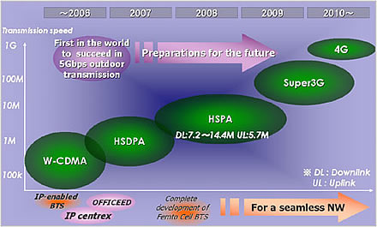

.

CHARACTERISTICS:

* 4G allows users to multi-task and talk on the phone while browsing the Internet and streaming videos.

* 4G offers the data transmission speed of 1gbps.
* It is based entirely on Internet protocol (IP).
* A 4G phone can handle the number of voice or other types of communications at one time .

* 4G phones have the ability to switch to 3G when out of range of 4G hubs, no disruption of service for users.
* A 4G phone can access the Internet and wireless data services at peak [gigabit](http://www.wisegeek.com/what-a-gigabit.htm), or mobile ultra-broadband, speeds.
* 4G communication makes it possible for employees to participate in a video conference using a cell phone
* 4G technology include Orthogonal Frequency Division [Multiplexing](http://www.wisegeek.com/what-is-multiplexing.htm) ([OFDM](http://www.wisegeek.com/what-is-ofdm.htm)), by which more signals are broadcasted over different frequencies by splitting radio signals.

4G PHONES:

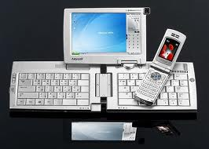

* P9000 is the 1st 4G phone introduced by samsung.

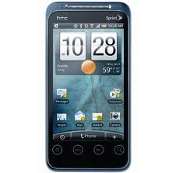

* Upcoming 4G sprint phone launched in 2011.

WORKING DIAGRAM OF 4G NETWORK:

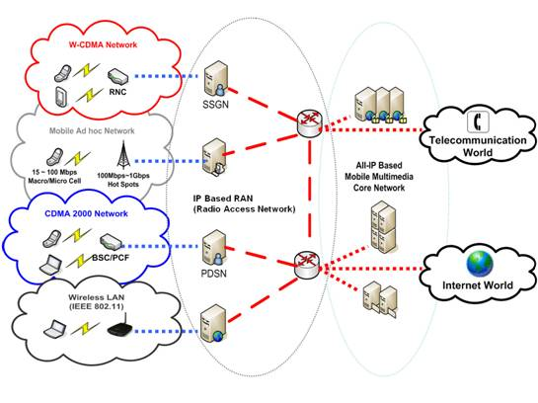

4G technology include Orthogonal Frequency Division Multiplexing (OFDM), which is designed to carry more data by splitting radio signals that are broadcast over different frequencies and are immune to interference. Mobile Worldwide Interoperability for Microwave Access (WiMAX) uses OFDMA and can support transmission speeds as high as 12 Mbps. Fourth-Generation universal mobile telecommunications system, often abbreviated 4G UMTS, is a wireless telecommunications data transfer standard. UMTS, referred to wideband code division multiple access (WCDMA), uses Internet protocol (IP) technology to connect wireless users with the Internet. First developed in the 1990s, UMTS is a reliable network that is frequently used to transmit data and voice. Mobile phones, laptop computers and other devices can connect to the Internet and make voice calls over a UMTS system. 4G UMTS calls for significant speed increases over the UMTS standard, which has been used since 2001. In 4G UMTS, data must download at a rate of 100 megabytes per second in mobile devices and at 1 gigabyte per second for electronics connected to a local wireless access hub. 4G UMTS require the simultaneous transfer of voice and data, which was a requirement first established during the switch from second generation to third protocol. 4G UMTS can transfer information using the same infrastructure. For emergency first-responders, 4G communication can stream video back to headquarters while their phones give a fix on their Global Positioning System (GPS) location. Workers can take photos and send them directly to [laser](http://www.wisegeek.com/what-is-a-laser.htm) printers. Users can perform Internet functions and enter or [upload](http://www.wisegeek.com/what-is-an-upload.htm) data while still using the phone itself.

ADVANTAGES

## Pure Data Network

The current 3G mobile network handle both voice and data separately. One of the most significant changes to the 4G network is that is a data network, transferring [Internet](http://www.ehow.com/internet/) Protocol (IP) data packets. A completely data based network will allow for more bandwidth which means more data can be passed through the network.

## Speed

The ITU set the standard for 4G networks to have a peak data download speed of 100 Megabits per second (Mbps) in mobile applications such as mobile phones and roaming network devices and 1 Gigabit per second (Gbps) in local, fixed locations.  
As of November 2010, no network technology can claim that it meets these standards though all the networks currently marketed as 4G do surpass current 3G speeds which tops out at 1 Mbps.

## Range

Current 3G network technology range is approximately 10 miles under optimum conditions. 4G candidate WiMAX currently has a range of up to 31 miles under optimum conditions.

## Hand Off

Though current 3G networks do have the ability to transfer data, when a user leaves a 3G coverage area for another, the data transfer may be halted or stopped due compatibility issues. The improved 4G network standards will eliminate this, allowing for smooth hand off from one coverage area to another without interruption to any ongoing data transfers. This will result in smooth streaming data for the user.

DISADVATAGES:

There might be a disadvantage for some who wish to use 4G Internet as part of their everyday lives. It isn't yet available just anywhere. Just as 3G technology started in major cities and to creep out into the suburbs and countryside slowly, 4G technology is currently found mainly in highly populated areas. If you're interested in this technology and want to use it for traveling, you might find that you can't take it as many places as you would like, as of yet. You'll simply run out of signal before you get where you're going.

APPLICATIONS:

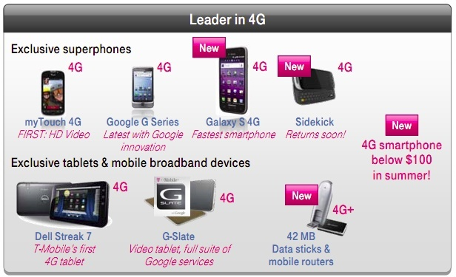

* A 4G system is expected to provide a comprehensive and secure all-IP based mobile broadband solution to
  + Smartphones,
  + Laptop computer wireless modems and
  + Other mobile devices.

It provides facilities such as

* + ultra-broadband Internet access,
  + IP telephony, and gaming services.

CONCLUSION

A major issue in 4G systems is to make the high bit rates available in a larger portion of the cell, especially to users in an exposed position in between several base stations. In current research, this issue is addressed by macro-diversity techniques, also known as group cooperative relay, and also by beam-division multiple access. Also the research is going for the advancement of 4G and also for development of 5G.

REFERENCES:

1 .www.wimaxforum.com

2 .www.alvarion.com

3. www.abisearch.com