**COLOUR IMAGE HISTOGRAM EQUALIZATION METHOD USING GRAY SCALE HISTOGRAM**

**Leena Mankani1, Amol Nakhate 2, Utkarsh Joshi 3, Vaibhav Yadav 4**

*B.E. ETRX (VIII SEM)*

*K.D.K. College of Engg, Nagpur*

*E-mail: leena.mankani21@gmail.com, amolnakhate69@gmail.com, ujoshi767@gmail.com,*

*vaibhavya1@rediffmail.com*

*Mob. no.:8793376429, 9049330333, 9423102328, 9096709923*

**Mrs. J.S.Gawai**

*Asst. Professor (Project Guide)*

*ETRX Department*

*KDK College of Engg, Nagpur*

***ABSTRACT*** *- The majority of colour histogram equalization methods do not yield uniform histogram in gray scale. After converting a colour histogram equalized image into gray scale, the contrast of the converted image is worse than that of a 1-D gray scale histogram equalized image. We propose a novel 3-D colour histogram equalization method that produces uniform distribution in gray scale histogram by defining a new cumulative probability density function in 3-D colour space. Test results with natural and synthetic images are presented to compare and analyze various colour histogram equalization algorithms based upon 3-D colour histograms. We also present theoretical analysis for non-ideal performance of existing methods.*

**1*.* INTRODUCTION**

The usage of digital images has rapidly increased with growing public consumption of entertainment and communication appliances, such as digital TV’s, digital cameras, scanners, mobile phone cameras, and personal media players. The expectation of a higher image quality prompts researchers to develop cutting-edge techniques for image enhancement. Histogram equalization has been one of the most widely used techniques due to its effectiveness and simplicity in contrast enhancement. Therefore, histogram equalization has become embedded in most consumer digital cameras. Histogram equalization modifies the pixel values in such a way that the intensity histogram of the resulting image becomes uniform. The output image then makes use of all the possible brightness values, thus, resulting in enhanced contrast [1]*.

**2. OVERVIEW**

First, we will briefly describe our study on the gray scale histogram equalization method, which is the basis for histogram equalization. Second, we present the comparison between the histogram equalization algorithms based upon the colour histogram.

**2.1 Gray Scale Histogram Equalization**

Each bin of a histogram in a gray scale image represents the number of pixels having the same gray value in the image. The histogram equalization method enhances the contrast of an image by mapping the pixel values in such a way that the histogram of the resulting image becomes uniform [1]. Because this algorithm mandates the use of all gray levels uniformly, it is quite effective in enhancing the contrast of overexposed or underexposed images.

This method is widely employed in many consumer digital cameras and mobile phone cameras due to its simplicity and efficacy. We first describe the histogram equalization of a gray scale image. Let the original input image be Iin the histogram equalized image Iout. The pdfs of them are denoted as Pin, and Pout and the corresponding cdfs are Cin, and Cout, respectively. We denote the intensity of the original input image as ni and the modified intensity of the resulting output image as no. Since the output pdf should be uniform, i.e., Pout=1/L, where L is the number of intensity levels. The ideal output cdf is

Cout(no) =

For no = 0...L-1. …equn (2.1)

Since Cin(ni) = Cout(n0) after the histogram equalization, we can obtain the output intensity using equn (2.1).

**2.2 Previous Methods Based Upon Colour Histogram Equalization**

A histogram equalization method applied to a colour image is more complicated than that of a gray image because the histogram requires three components of a colour space such R, G, and B.

Trahanias and Venetsanopoulos [2] defined the cdf in RGB colour space as

Cin(ri,gi,bi) = prob{(0 ≤ r ≤ ri), (0 ≤ g ≤ gi), (0 ≤ b ≤ bi)}

=

Where,

0 ≤ ri, gi, bi≤ L-1 …equn (2.2)

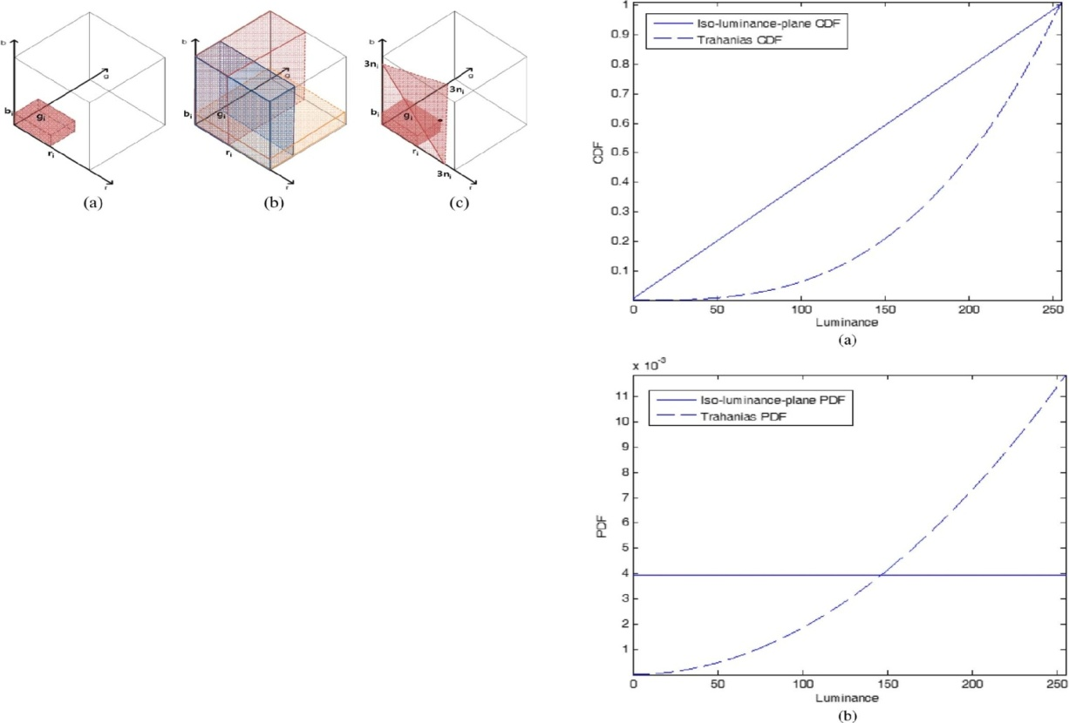

Fig.2.1 Support region of input cdf (Cin) of each method. (a) Trahanias method Cin(ri,gi,bi) = prob{(0 ≤ r ≤ ri), (0 ≤ g ≤ gi), (0 ≤ b ≤ bi)} = (b) Multiplication of three marginal cdfs in the Menotti method Cin(ri,gi,bi) = CinR(ri)*CinG(gi)*CinB(bi) (c) Proposed iso-luminance-plane method Cin(ri,gi,bi) = prob{r+g+b ≤ 3ni} = .

The desired output cdf value is given as

Cout(ro,go,bo) =

=

= …equn (2.3)

The output pdf is defined to be uniform in the colour space, which means pout(r, g, b) =1/L3 for 0 ≤ r, g, b ≤ L. The output colour (ro, go, bo) is the nearest value satisfying Cout(ro, go, bo) = Cin(ri, gi, bi) and the shift of each colour component is the same, i.e., r0-ri, g0-gi, b0-bi. This shifting method is a way of reserving the hue [3]. Since we must limit the range of resulting colour to [0 L-1], the resulting colour may not match the assigned intensity for some pixels whose gamut fall outside of the realizable range. If we apply this histogram equalization to a natural image which has a high correlation between colour components, the distribution of bright pixels increases. To investigate the reason for this higher distribution on bright intensity levels, we analyze a simplified case where R, G, and B components are the same, i.e., r = g = b = n. Note that the correlation between the colours of this test image is equal to one. The resulting cdf for this image is proportional to (n+1)3, i.e., Coutα(n+1)3 from equn (2.3). To simplify the analysis, we assume that the intensity is continuous. This is because the pdf of the output image, pout, is the differentiation of the cdf w.r.t. n, which is

pout(n) = $\frac{d}{dn}$ (CoutRGB) α (n+1)2  …equn (2.4)

The resulting pdf after equalization, pout, is proportional to (n+1)2. As shown in Fig. 2.2(b), resulting pdf after equalization has higher distribution at bright levels. Thus, the image becomes brighter after the histogram equalization.

Menotti proposed to adopt an input cdf that multiplies each marginal cdf of three channels, i.e.,

Cin(ri, gi, bi) ≡ CinR(ri) × CinG(gi) × CinB(bi) …equn (2.5)

Fig.2.1(b) shows the support region for the three marginal cdfs. We analyze the output pdf utilizing the same gray image used in the previous case. If the 1-D marginal cdf is Cout1(n), then the 3-D output cdf become Cout(n)=(Cout1(n))3. Since the output pdf is uniform in colour space, we have: Cout(r, g, b) ≡ (Cout1(n))3α (n+1)3 . Therefore, Cout(r, g, b) = (Cout1(n))3α (n+1)3 , or Cout1(n)α(n+1). Consequently, the pdf is uniform i.e., pout(n) = (Cout1(n) = 1/L. This method shows satisfactory results for most natural images which have high correlations between colour components. However, Menotti’s method also results in an over enhanced image when the correlation between colours is not high. To overcome this limitation, we propose a new cdf, which results in a uniform pdf in the intensity domain regardless of the correlation of R, G, and B components in an image.

**2.3 Generalization of Gray Scale Image Enhancement to Colour Images**

Naik and Murthy[5] proposed a scheme to generalize any gray scale image processing to colour images. First of all, the scheme produces an intensity image. It then applies a gray scale image enhancement algorithm to obtain a new intensity image, which is an enhanced version of the original. The intensity is defined as ni = (ri+gi+bi)/3, and the enhanced level is denoted similarly as no = (ro+go+bo)/3. The algorithm updates colour components using scaling and shifting to match the change in intensity, i.e., (ro, go, bo) = (αri+β, αgi+ β, αbi+β).

The scaling and shifting of colour is known to preserve the hue. If the intensity ratio α = no/ni is less than one, then the output is (αRi, αGi, αBi), and if α > 1, it applies a similar rule to the complementary colour components to avoid a gamut problem where the resulting colour falls outside of the range of realizable RGB space. This generic framework can be applied to colour histogram equalization: we apply gray scale histogram equalization in the intensity domain and obtain a new colour from the modified intensity values by applying the scaling and shifting. The gray scale histogram of this method is uniform. Therefore, the result of this algorithm is equivalent to our proposed method.

**3.** **PROPOSED CONCEPT**

We observed that the R, G, and B box summation cdf does not generate a uniform pdf in the intensity domain. We will now propose a new histogram equalization method to obtain the uniform distribution in the intensity domain. Fig.4.1 depicts the block diagram of the proposed method.

We define the new cdf as

Cin(ri,gi,bi) = prob{r + g + b ≤ 3ni}

=

…equn (4.1)

where ni = (ri + gi + bi)/3 is the input intensity. The summation volume is bounded by a plane whose intensity is ni as shown in Fig.2.1(c). Note that the input cdf is a function of the intensity. Since we can define the luminance as (ri + gi + bi)/3, the

plane can be regarded as a constant luminance plane. The term “iso-luminance plane” comes from this property. Since the ideal output pdf is uniform over all values of, the output cdf is

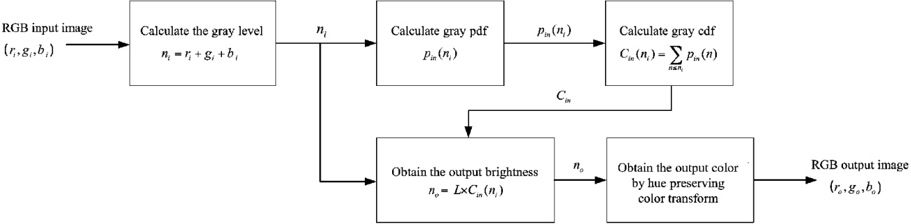

Fig.3.1 Block diagram of the proposed histogram equalization method. Cdf of gray level is calculated and the output gray level is obtained from the cdf. Equalized colour components are obtained by applying a hue preserving colour transform to the enhanced luminance.

Cout(no) = no/L …equn (4.2)

This iso-luminance definition of cdf results in a histogram equalization identical to the gray scale histogram equalization.

Since Cout(no) = Cin(ri,gi,bi),

We obtain no = L.Cin(ri,gi,bi).

Since we have the luminance component of the equalized image, each colour component can be obtained without gamut problem by scaling or shifting as shown in the previous section. Shifting was adopted in [2] [3], while scaling and shifting were applied in [5].Since the two methods did not show much difference, we chose to follow the method in [5].

Now we will estimate the computational complexity and memory requirement of the proposed method. The input image cdf is a function of the intensity, i.e. ri + gi + bi, therefore, it needs array with length 3L. First, we obtain the intensity pdf by counting pixels that correspond to the same intensity.

Calculation of pdf requires increment operation for each pixel. Second, input cdf is calculated by summing up pdfs from 0 to L-1, i.e.

Cin(n) = Cin(n-1) + pin(n)

For n > 0, with Cin(0)=pin(0).

Thirdly, once we calculate the equalized luminance from equn (4.2), we can obtain the colour components from the scaling and shifting as in [5]. These two operations need several multiplications and additions per pixel. We observe that the computational complexity is proportional to the number of pixels.

**4. SIMULATION**

We present a comparison of the performance of colour histogram equalization methods based upon the histogram in RGB colour space. We analyzed the theoretical basis for the brightening or over equalization effect of the Trahanias algorithm by presenting intensity cdf and pdf. The Menotti method shows satisfactory results for most natural images. However, we determine that the performance of the Menotti algorithm depends upon the correlation of colour components. Evaluation results with natural and synthetic images would be shown to confirm our theoretical analysis. We introduced the iso-luminance-plane cdf and demonstrated that the proposed method results in uniform pdf in gray level. We present a comparative analysis of the image enhanced by different methods.

**5. ADVANTAGES**

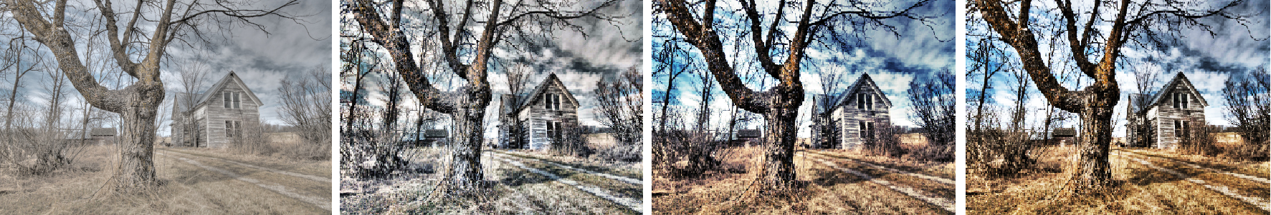

Fig. 3.2 Results of the histogram equalization (a) Input image. (b) Result of the proposed iso-luminance- plane method. (c) Result of Trahanias’s method. (d) Result of Menotti’s method.

Table no.3.2 Analysis of results

|  |  |  |  |
| --- | --- | --- | --- |
| **Methods** | **Error** | **Average Brightness** | **Time required** |
| Iso-luminance Plane method | 0.00181 | 127.18 | 1.72 sec |
| Menotti | 0.00084 | 134.39 | 12.35sec |
| Trahanias | 0.00161 | 127.55 | 12.51sec |

Histogram based techniques is one of the important digital image processing techniques which can be used for image enhancement. One of

the advantages of histogram based techniques is simplicity of implementation of the algorithm. Also it should be mentioned that histogram based techniques is much less expensive comparing to the other methods. Histogram based techniques for image enhancement is mostly based on equalizing the histogram of the image and increasing the dynamic range corresponding to the image.

**5.1 Requires Less Memory**

Unlike other contrast enhancement methods using colour image processing this method reduces the memory consumption. In this method we convert the [0 255] levels of colour image to [0 8] shades of black, white and gray, reducing the memory consumption.

**5.2 Produces Reliable Results Because Of Its Simplicity and Effectiveness**

Histogram equalization has been one of the most widely used techniques due to its effectiveness and simplicity in contrast enhancement. In general, a histogram is the estimation of the probability distribution of a particular type of data. An image histogram is a type of histogram which offers a graphical representation of the total distribution of the gray values in a digital image. By viewing the image’s histogram, we can analyze the frequency of appearance of the different gray levels contained in the image.

**5.3 Fairly Straight Forward Technique and an Inevitable Operator**

A histogram is a very useful tool to study the distribution of the components of an image but it also allows the contrast and the range of colours for over-exposed or under-exposed images to be corrected. Moreover, its modification does not deteriorate the information contained in the image but makes it more or less visible. Being very simple and reliable to use, this method is highly straight forward technique and a highly reliable method for the modification of the contrast of the image.

**5.4 Automatic and Reproducible**

This method is automatic i.e. it doesn’t require any manual operations to be performed. Hence assures greater efficiency. This method produces the same operation every time it is used with the same efficiency. This is a highly reliable method for contrast enhancement.

**6. APPLICATIONS**

Histogram equalization has been one of the most widely used techniques due to its effectiveness and simplicity in contrast enhancement. This technique can be embedded in consumer digital cameras and mobile phone cameras. This method can produce effective and reliable results, hence can also be used in satellite imaging. As this paper compares the image enhanced by different methods, it has wide range applications. This paper can be used any and everywhere an image enhancement is required.

**6.1 Consumer Digital Cameras and Mobile Phone Cameras**

The advantage of using this method is that it produces highly reliable results and because of the simplicity of operation. It is fairly straight forward technique and an inevitable operator and the biggest advantage of using this method is it reduces the memory consumption. And moreover the biggest advantage of this method is it requires less memory as converting the colour image to gray scale reduces the processing levels from 0 to 255 colour shades to 8 shades of black, gray and white. Hence, it can be used in Consumer digital cameras and Mobile phone cameras.

**6.2 Imaging**

This method can be used wherever there is the requirement of contrast enhancement of an image. In satellite imaging, underwater imaging, compartmental analysis of MRI scans, CT lung studies thresholding, normalization, normalization of MRI images, presentation of high dynamic images (IR, CT) as the images are taken from a greater length, there arises a necessity of contrast enhancement for proper viewing greater details.

This paper can be utilized for all the images, bright or dark. These images can be efficiently modified. The biggest application it has is it can be used in operations where proper light distribution cannot be possible like in case of underwater imaging, imaging useful for secret service application for viewing the greater details.

**7. CONCLUSION AND FUTURE SCOPE**

**7.1 Conclusion**

This report presents a new method for contrast enhancement in images for better perception. Histogram equalization has been one of the most widely used techniques due to its effectiveness and simplicity in contrast enhancement. This paper can be further developed to be used for satellite imaging, as in satellite imaging the images are taken from a greater length; there arises a necessity of contrast enhancement for proper viewing greater details.

**7.1 Future Scope**

A histogram is a very useful tool to study the distribution of the components of an image but it also allows the contrast and the range of colours for over-exposed or under-exposed images to be corrected.

Histogram equalization is a straightforward image-processing technique used to achieve better quality images in black and white colour scales in medical applications such as digital X-rays, MRIs, and CT scans. All these images require high definition and contrast of colours to determine the pathology that is being observed and reach a diagnosis.

This paper can also be developed for enhancing various images like in case of underwater imaging, compartmental analysis of MRI scans, CT lung studies thresholding, normalization, normalization of MRI images, presentation of high dynamic images (IR, CT) and various other applications wherever the contrast enhancement of the image is required.

**REFERENCES**

[1] R. C. Gonzalez and R. E. Woods, Digital Image Processing, 3rd ed. Upper Saddle River, NJ: Prentice- Hall, 2009.

[2] P. E. Trahanias and A. N.Venetsanopoulos, “Colour image enhancement through 3-D Histogram Equalization,” in Proc. 15th IAPR Int. Conf. Pattern Recognit., Aug.–Sep. 1992, vol. 1, pp. 545–548.

[3] D. Menotti, L. Najman, A. de Araújo, and J. Facon, “A fast hue-preserving histogram equalization method for colour image enhancement using a Bayesian framework,” in Proc. 14th Int. Workshop Syst., Signal Image Process. (IWSSIP), Jun. 2007, pp. 414–417.

[4] A. K. Forrest, “Colour histogram equalization of multichannel images,” in Proc. IEEE Vis. Image Signal Process., Dec. 2005, vol. 152, no. 6, pp. 677–686.

[5] S. Naik and C. Murthy, “Hue-preserving colour image enhancement without gamut problem”, *IEEE Trans. Image Process.*, vol. 12, no. 12, pp. 1591–1598, Dec. 2003.