**VLSI TECHNOLOGY**

Manjusha Bhoyar1 Pranoti Joshi2 Vaibhav Yadav3

[bhoyar.manjusha@rediffmail.com](mailto:bhoyar.manjusha@rediffmail.com) [pranotijoshi20@gmail.com](mailto:pranotijoshi20@gmail.com) vaibhavya1@gmail.com

B.E. Sem VIII (ETRX)

K.D.K.C.E. NAGPUR

**INTRODUCTION :-**

**I**ntegrated circuits were made possible by experimental discoveries which showed that semiconductor devices could perform the functions of vacuum tubes and by mid-20th-century technology advancement in semiconductor device fabrication. The integration of large numbers of tiny transistors into a small chip was an enormous improvement over the manual assembly of circuits using electronic components. The integrated circuits mass production capability, reliability, and building-block approach to circuit design ensured the rapid adoption of standardized ICs in place of designs using discrete transistors.

[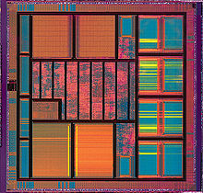](/wiki/File:Diopsis.jpg)

*Integrated circuit of Atmel Diopsis 740 System on Chip showing memory blocks, logic and input/output pads around the periphery*

*[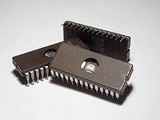](/wiki/File:Microchips.jpg)*

*Microchips (EPROM memory) with a transparent window, showing the integrated circuit inside*

There are two main advantages of ICs over discrete circuits: cost and performance. Cost is low because the chips, with all their components, are printed as a unit by photolithography rather than being constructed one transistor at a time. Furthermore, much less material is used to construct a packaged IC die than a discrete circuit. Performance is high since the components switch quickly and consume little power (compared to their discrete counterparts) because the components are small and positioned close together. As of 2006, chip areas range from a few square millimeters to around 350 mm2, with up to 1 million transistors per mm2.

**INVENTIONS :-**

Early developments of the integrated circuit go back to 1949, when the German engineer Werner Jacobi (Siemens AG) filed a patent for an integrated-circuit-like semiconductor amplifying device showing five transistors on a common substrate arranged in a 2-stage amplifier arrangement. Jacobi discloses small and cheap hearing aids as typical industrial applications of his patent. A commercial use of his patent has not been reported.

The idea of the integrated circuit was conceived by a radar scientist working for the Royal Radar Establishment of the British Ministry of Defence, Geoffrey W.A. Dummer (1909–2002), who published it at the Symposium on Progress in Quality Electronic Components in Washington, D.C. on May 7, 1952. He gave many symposia publicly to propagate his ideas. Dummer unsuccessfully attempted to build such a circuit in 1956.

A precursor idea to the IC was to create small ceramic squares (wafers), each one containing a single miniaturized component. Components could then be integrated and wired into a bidimensional or tridimensional compact grid. This idea, which looked very promising in 1957, was proposed to the US Army by Jack Kilby, and led to the short-lived Micromodule Program (similar to 1951's Project Tinkertoy). However, as the project was gaining momentum, Kilby came up with a new, revolutionary design: the **IC.**

[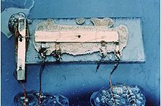](/wiki/File:Kilby_solid_circuit.jpg)

*Jack Kilby's original integrated circuit*

Robert Noyce credited Kurt Lehovec of Sprague Electric for the principle of p-n junction isolation caused by the action of a biased p-n junction (the diode) as a key concept behind the IC.

Jack Kilby recorded his initial ideas concerning the integrated circuit in July 1958 and successfully demonstrated the first working integrated circuit on September 12, 1958. In his patent application of February 6, 1959, Kilby described his new device as “a body of semiconductor material ... wherein all the components of the electronic circuit are completely integrated.” Kilby won the 2000 Nobel Prize in Physics for his part of the invention of the integrated circuit.

Robert Noyce also came up with his own idea of an integrated circuit half a year later than Kilby. Noyce's chip solved many practical problems that Kilby's had not. Noyce's chip, made at Fairchild Semiconductor, was made of silicon, whereas Kilby's chip was made of germanium.

**GENERATION :-**

In the early days of integrated circuits, only a few transistors could be placed on a 1960s, introduced devices which contained hundreds of transistors on each chip, called *"Medium-Scale Integration"* (MSI).

They were attractive economically because while they cost little more to produce than SSI devices, they allowed more complex systems to be produced using smaller circuit boards, less assembly work (because of fewer separate components), and a number of other advantages.

Further development, driven by the same economic factors, led to "*Large-Scale Integration"* (LSI) in the mid 1970s, with tens of thousands of transistors per chip.

Integrated circuits such as 1K-bit RAMs, calculator chips, and the first microprocessors, that began to be manufactured in moderate quantities in the early 1970s, had under 4000 transistors. True LSI circuits, approaching 10000 transistors, began to be produced around 1974, for computer main memories and second-generation microprocessors.chip, as the scale used was large because of the contemporary technology. As the degree of integration was small, the design was done easily. Later on, millions, and today billions, of transistors could be placed on one chip, and to make a good design became a task to be planned thoroughly. This gave rise to new design methods.

**SSI, MSI and LSI**

The first integrated circuits contained only a few transistors. Called "*Small-Scale Integration"* (SSI), digital circuits containing transistors numbering in the tens provided a few logic gates for

example, while early linear ICs such as the Plessey SL201 or the Philips TAA320 had as few as two transistors. The term Large Scale Integration was first used by IBM scientist Rolf Landauer when describing the theoretical concept, from there came the terms for SSI, MSI, VLSI, and ULSI.

SSI circuits were crucial to early aerospace projects, and vice-versa. The Minuteman missile program and various other Navy programs accounted for the total $4 million integrated circuit market in 1962, and by 1968, U.S. Government space and defense. The average price per integrated circuit dropped from $50.00 in 1962 to $2.33 in 1968. A typical application being FM inter-carrier sound processing in television receivers.

The next step in the development of integrated circuits, taken in the late

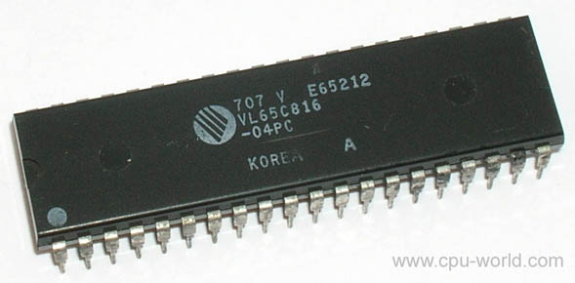

*40 PIN VLSI CHIP*

**CHALLENGES :-**

As microprocessors become more complex due to technology scaling, microprocessor designers have encountered several challenges which force them to think beyond the design plane, and look ahead to post-silicon:

**\* Power usage/Heat dissipation** – As threshold voltages have ceased to scale with advancing process technology, dynamic power dissipation has not scaled proportionally. Maintaining logic complexity when scaling the design down only means that the power dissipation per area will go up. This has given rise to techniques such as dynamic voltage and frequency scaling (DVFS) to minimize overall power.

**\* Process-variation** –

As photolithography techniques tend closer to the fundamental laws of optics, achieving high accuracy in doping concentrations and etched wires is becoming more difficult and prone to errors due to variation. Designers now must simulate across multiple fabrication process corners before a chip is certified ready for production.

**\* Timing/design closure** – As clock frequencies tend to scale up, designers are finding it more difficult to distribute and maintain low clock skew between these high frequency clocks across the entire chip. This has led to a rising interest in multicore and multiprocessor architectures, since an overall speedup can

be obtained by lowering the clock frequency and distributing processing.

**\* First-pass success** – As die sizes shrink (due to scaling), and wafer sizes go up (to lower manufacturing costs), the number of dies per wafer increases, and the complexity of making suitable photomasks goes up rapidly. A mask set for a modern technology can cost several million dollars. This non-recurring expense deters the old iterative philosophy involving several "spin-cycles" to find errors in silicon, and encourages first-pass silicon success. Several design philosophies have

been developed to aid this new design flow, including design for manufacturing (DFM), design for test (DFT), and Design for X.

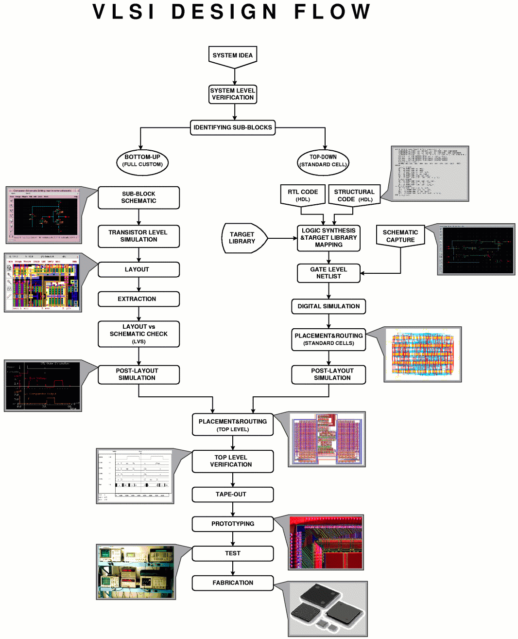

**APPLICATION**  **:-**

1. VLSI is an implementation technology for electronic circuitry - analogue or digital

2.It is concerned with forming a pattern of interconnected switches and gates on the surface of a crystal of semiconductor

3. Microprocessors

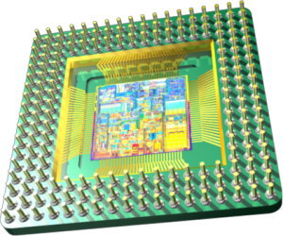

4. Microcontrollers

[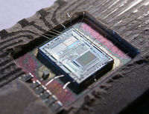](/wiki/File:153056995_5ef8b01016_o.jpg)

5. Personal computers

6. Memory - DRAM / SRAM

7. Special Purpose Processors - ASICS (CD players, DSP applications)

8. Optical Switches

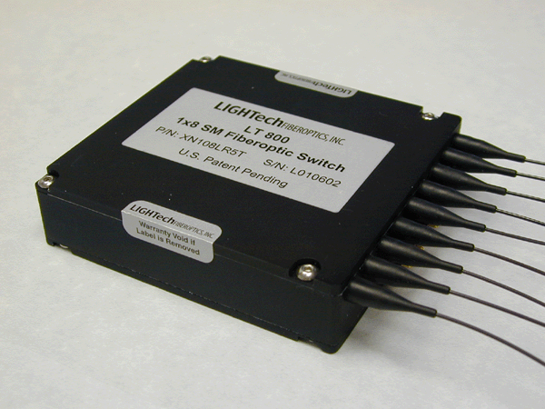

9. Has made highly sophisticated control systems mass-producable and therefore cheap

**ADVANTAGES :-**

1. Lower package count.
2. Low board space.
3. Fewer board level connection.
4. Higher performance.
5. Reliability and lower cost due to the lower chip count.

**DISADVANTAGES :-**

1. Long design .
2. Long fabrication time.
3. Higher risk project.
4. Spiking problem.
5. Leakage of power.

**CONCLUSION :-**

In this presentation we discused about the VLSI , its history and researches. In current research projects, integrated circuits are also developed for sensoric applications in medical implants or other bioelectronic devices.

ICs have consistently migrated to smaller feature sizes over the years, allowing more circuitry to be packed on each chip. This increased capacity per unit area can be used to decrease cost and/or increase functionality. In general, as the feature size shrinks, almost everything improves the cost per unit and the switching power consumption go down, and the speed goes up. Which concludes that, advancement in IC’s will be seen in future application.

**REFERENCES :-**

[www.google.co.in](http://www.google.co.in)

[www.ultavista.com](http://www.ultavista.com)

[www.wikipedia.org](http://www.wikipedia.org)

Magzin-electronics for you