**“MODERNIZATION OF INDIAN AGRICULTURAL SYSTEM”**

**Name of Students** :-

1. Anup B. Tayde (iamanuptayde@gmail.com)
2. Ankush A. Tagalpallewar (ankushtagal@gmail.com)
3. Ishwar B. Kathane ([ikathane22@gmail.com](mailto:ikathane22@gmail.com))
4. Kamlesh K. Raut ([akamlesh3@gmail.com](mailto:akamlesh3@gmail.com))
5. Giridhar M. Zade (girish50@live.com)

**College** :-

Smt. Radhikatai Pandav College of Engineering, Nagpur.

**1.ABSTRACT**

The fundamental aim of this project is to develop an automated system to design a wireless weather monitoring system which enables to monitor the weather parameter in an agriculture and to monitor the water pump and display the parameters on the PC’s screen. The system contains two parts. One is transmitter part and another one is receiver part & both can be of any number in large scale. The transmitter part consists of weather sensors, water pump temperature sensor, rain gauge, microcontroller and Zigbee & the receiver part consist of a PC interfaced with Zigbee through PC serial port and to that of farmer’s cell. In this project we deal with monitoring the weather related parameters through wireless Zigbee modules. When the water pump’s temperature gets exceeded to its threshold then the water pump will automatically gets switched off and a message will be transmitted to the Research and monitor centre. Here we monitor temperature and humidity with the help of respective sensors. The data from the sensors are collected by the micro controller and transmitted to the receiver section through wireless medium. All the parameters are viewed by the PC using program in the receiver side.

KEYWORDS

Zigbee, Temperature Sensor, Moisture Sensor, Water Level Sensor, Rain Gauge, 89c51 microcontroller, Max 232, Research & Monitor Centre.

**2.INTRODUCTION**

The increasing demand of the food supplies requires a rapid improvement in food production technology. In our country where agriculture plays an important part in shaping up the economy and the climatic conditions are isotropic, but still we are not able to make full use of agricultural resources. One of the main reasons is the lack of rains and scarcity of land reservoir water. Extraction of water at regular intervals from earth is reducing the water level, as a result of which the zones of un-irrigated land are gradually increasing. Also, the unplanned use of water inadvertently results in wastage of water. Detection of the temperature conditions will help us to avoid damages. This will majorly helps in reducing the percentage of farmers to get suicide.

**3.WORKING METHODOLOGY**

In an Modernization of Agricultural System using AT89c51, the most significant advantage is that water is supplied only when the moisture in soil goes below a pre-set threshold value. This saves us a lot of water. In recent times, the farmers have been using irrigation technique through the manual control in which the farmers irrigate the land at regular intervals by turning the water-pump on/off when required. This process sometimes consumes more water and sometimes the water supply to the land is delayed due to which the crops dry out. Water deficiency deteriorates plants growth before visible wilting occurs. In addition to this slowed growth rate, lighter weight fruit follows water deficiency. This problem can be perfectly rectified if we use our system in which the irrigation will take place only when there will be intense requirement of water, as suggested by the moisture in the soil. A Research &Monitor centre is a facility with instruments and equipment to make observations of [atmospheric](http://en.wikipedia.org/wiki/Earth's_atmosphere) conditions in order to provide information to make [weather forecasts](http://en.wikipedia.org/wiki/Weather_forecasting) and to study the [weather](http://en.wikipedia.org/wiki/Weather) and [climate](http://en.wikipedia.org/wiki/Climate). The measurements taken include [temperature](http://en.wikipedia.org/wiki/Temperature), [humidity](http://en.wikipedia.org/wiki/Humidity), and [precipitation](http://en.wikipedia.org/wiki/Precipitation_(meteorology)) amounts. Manual observations are taken at least once daily, while automated observations are taken at least once an hour.

Here we are using Moisture sensor to continuously monitor the soil moisture, water level sensor for measuring the level of water present in the well, two temperature sensors for monitoring the surrounding temperature and temperature of the water pump, rain gauge for measuring the rain water percentage. Also when after load shedding the system will automatically gets ON and the message of this will be send to the farmer.

**BLOCK DIAGRAM**

**33**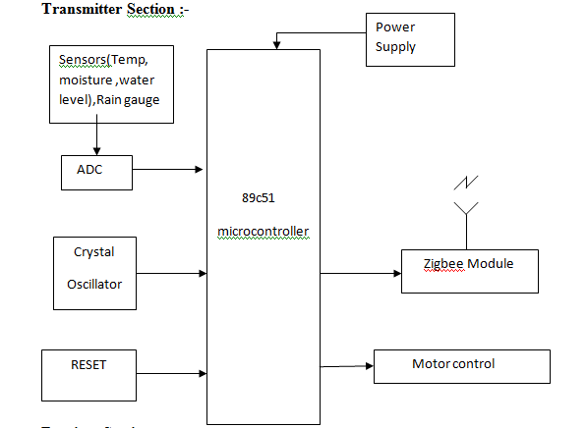

**3.2 Receiver Section :-**

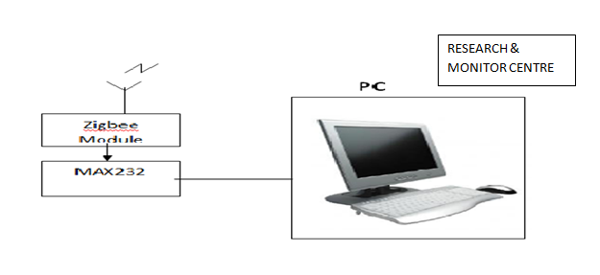

**4.STRUCTURE OF HARDWARE**

* 1. **AT 89c51 :**

The AT89C51 is a low-power, high-performance CMOS 8-bit microcomputer with 4Kbytes of Flash programmable and erasable read only memory (PEROM). The device is manufactured using Atmel’s high-density nonvolatile memory technology and iscompatible with the industry-standard MCS-51 instruction set and pinout. The on-chipFlash allows the program memory to be reprogrammed in-system or by a conventionalnonvolatile memory programmer. By combining a versatile 8-bit CPU with Flash

on a monolithic chip, the Atmel AT89C51 is a powerful microcomputer which providesa highly-flexible and cost-effective solution to many embedded control applications.

The AT89C51 provides the following standard features: 4Kbytes of Flash, 128 bytes of RAM, 32 I/O lines, two 16-bit timer/counters, a five vector two-level interrupt architecture,a full duplex serial port, on-chip oscillator and clock circuitry.In addition, the AT89C51 is designed with static logicfor operation down to zero frequency and supports twosoftware selectable power saving modes. The Idle Mode

stops the CPU while allowing the RAM, timer/counters,serial port and interrupt system to continue functioning. ThePower-down Mode saves the RAM contents but freezesthe oscillator disabling all other chip functions until the nexthardware reset.

**Features**

Compatible with MCS-51™ Products, 4K Bytes of In-System Reprogrammable Flash Memory,Endurance: 1,000 Write/Erase Cycles, Fully Static Operation: 0 Hz to 24 MHz,

Three-level Program Memory Lock, 128 x 8-bit Internal RAM,

32 Programmable I/O Lines, Two 16-bit Timer/Counters,

Six Interrupt Sources, Programmable Serial Channel,

Low-power Idle and Power-down Mode.

We are using the microcontroller AT89c51 because firstly we are only using this microcontroller for measuring the water level of well, weather parameters, temperature of the water pump and controlling the water pump automatically. These all parameters will be transmitted to the Research and Monitor centre. Transmitting only data and controlling the water pump automatically none other than this is our requirement. Other thing is that we are using such type of technology so that the farmer can bear it economically. So for such type of work there is no need of using LPC 2141/42/44/46/48 (ARM7TDMI), MSP430 etc. That’s why we used this microcontroller.

**4.2 Zigbee :**

* ZigBee is a low-cost, low-power, [wireless mesh network](http://en.wikipedia.org/wiki/Wireless_mesh_network) standard. The low cost allows the technology to be widely deployed in wireless control and monitoring applications. Low power-usage allows longer life with smaller batteries. Mesh networking provides high reliability and more extensive range. ZigBee chip vendors typically sell integrated radios and microcontrollers with between 60 KB and 256 KB flash memory.
* ZigBee operates in the industrial, scientific and medical ([ISM](http://en.wikipedia.org/wiki/ISM_band)) radio bands; 868 MHz in Europe, 915 MHz in the USA and Australia and 2.4 GHz in most jurisdictions worldwide. Data transmission rates vary from 20 to 250 kilobits/second.
* The ZigBee network layer natively supports both [star](http://en.wikipedia.org/wiki/Star_network) and [tree](http://en.wikipedia.org/wiki/Tree_network) typical networks, and generic mesh networks. Every network must have one coordinator device, tasked with its creation, the control of its parameters and basic maintenance. Within star networks, the coordinator must be the central node. Both trees and meshes allows the use of ZigBee [routers](http://en.wikipedia.org/wiki/Routing) to extend communication at the network level.
* ZigBee builds upon the [physical layer](http://en.wikipedia.org/wiki/Physical_layer) and [medium access control](http://en.wikipedia.org/wiki/Medium_access_control) defined in [IEEE standard 802.15.4](http://en.wikipedia.org/wiki/IEEE_802.15.4) (2003 version) for low-rate [WPANs](http://en.wikipedia.org/wiki/Personal_area_network#Wireless). The specification goes on to complete the standard by adding four main components: network layer, application layer, ZigBee device objects (ZDOs) and manufacturer-defined application objects which allow for customization and favor total integration.
* Besides adding two high-level network layers to the underlying structure, the most significant improvement is the introduction of ZDOs. These are responsible for a number of tasks, which include keeping of device roles, management of requests to join a network, device discovery and security.
* ZigBee is not intended to support [powerline networking](http://en.wikipedia.org/wiki/Power_line_communication) but to interface with it at least for [smart metering](http://en.wikipedia.org/wiki/Smart_meter) and [smart appliance](http://en.wikipedia.org/wiki/Smart_appliance) purposes.
* Because ZigBee nodes can go from sleep to active mode in 30 ms or less, the latency can be low and devices can be responsive, particularly compared to Bluetooth wake-up delays, which are typically around three seconds. Because ZigBee nodes can sleep most of the time, average power consumption can be low, resulting in long battery life.

**Featuresand Advantages :**

ZigBee technology has some important features that make itour best option to implement an ad hoc, on-demand, low-costand low-power location monitoring system. Consider this—if you need battery powered mobile nodes to implement anefficient location monitoring system, what happens if you have

to change batteries every day? ZigBee’s low-cost, low-powercapabilities help solve this issue and more.

ZigBee technology’s cost-effective features:

Operating in 2.4 GHz unlicensed band or one of the sub-GHz, regional bands, Standards-based solution, Specifically designed to support sensing, monitoring andcontrol applications, Low complexity (low memory footprint), Low power (battery operated devices), Mesh networking (a feature not found in most wirelessnetworking standards), Self healing, Self forming, Multihop routing protocol (AODV routing protocol)

**4.3Sensors :**

1. **Temperature Sensor :**

Temperature sensor is used here in two parts, first for the measuring

Surroundingtemperature and second for water pump.

1. **Soil Moisture Sensor & Water Level Sensor :**

Soil Moisture sensor is used for determining the contents of moisture present in the soil.Water level sensor is used for determining the level of water present in the well.

1. **Rain Gauge:** Rain Gauge is also one kind of sensor which is used for determining the falling percentage of rain water in the field.

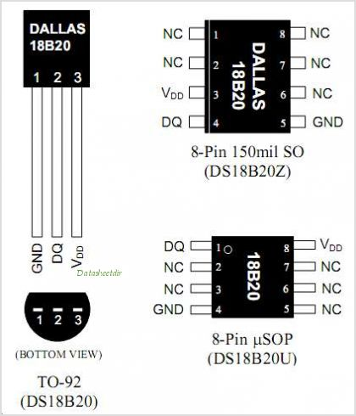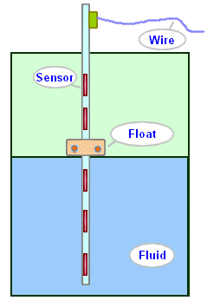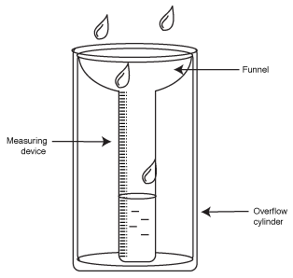

**Fig- Temperature Sensor Fig- Soil Moisture & Water Fig- Rain Gauge**

**Level Sensor**

* 1. **MAX 232 :**

MAX232 is compatible with RS-232 standard, and consistsof dual transceiver. Each receiver converts TIA/EIA-232-Elevels into 5V TTL/CMOS levels. Each driver converts TTL/

COMS levels into TIA/EIA-232-E levels. The MAX232 ischaracterized for operation from -40°C to +85°C for allpackages.MAX232 is purposed for application in high-performance information

processing systems and control devices of wideMAX232 is compatible with RS-232 standard, and consistsof dual transceiver. Each receiver converts TIA/EIA-232-Elevels into 5V TTL/CMOS levels. Each driver converts TTL/COMS levels into TIA/EIA-232-E levels. The MAX232 is

characterized for operation from -40°C to +85°C for allpackages.MAX232 is purposed for application in high-performance informationprocessing systems.

**Features :**

a. Operate from Single +5V Power Supply (+5V and +12V—MAX231/MAX239)

b. Low-Power Receive Mode in Shutdown(MAX223/MAX242)

c. Operates with low supply current of 8mA typically.

d. On the receiver side, the PC wants +12volt supply so it is given through it.

**5.CONCLUSION**

This research focuses on developing devices and tools to manage, display and alert the weather/disaster

warnings using the advantages of a wireless sensor network system. The system can workover far distances. The system uses 89c51 microcontroller and Zigbee Wireless module base on the

Zigbee/IEEE 802.15.4 standard. The developed system is very flexible and accurate. The developed systemhas core competency including

1) Display parameters of

2) Alert when water level goes low with its predefined values

3) keep weather information statisti

This project finds application in domestic agriculturalfield. In civilian domain, this can be used to ensure faithfulirrigation of farm field, since we have the option of findingout moisture level of soil in a particular area.

**6.REFERENCES**

1. ATCommands Interface Guide atVersion: 004, 05 April 2002
2. P. Kinney, "ZigBee Technology: Wireless Control that Simply Works", Secretary of

ZigBee BoDChair of ZigBee Building Automation Profile WG. 2 October 2003, Communications Design Conference

1. A. Baggio, “Wireless sensor network in precision agriculture ”,workshop on Real world wireless sensor networks (REALWSN’05), June 20-21,2005,Stokholm Sweden.
2. A. Wood, G. Virone, T. Doan, Q. Cao, L. Selavo, Y. Wu, L. Fang, Z. He, S. Lin, J.Stankovic, "Wireless Sensor Networks for Assisted-Living and Residential Monitoring", 200*6* Department of Computer Science University of Virginia
3. David E. Simon, An Embedded Software Primer, fifth edition, 2007.
4. ShizhuangLin; JingyuLiu; YanjunFang; Wuhan Univ., Wuhan" ZigBee Based Wireless SensorNetworks and Its Applications in Industrial”IEEE International Conference on Automation and Logistics, 200718-21Aug.2007page(s):1979-1983Location:Jinan
5. Computer and Automation Engineering(ICCAE), 286-288,2010

The 2nd International Conference on 26-28 Feb.2010

1. P. Kinney, "ZigBee Technology: Wireless Control that Simply Works", Secretary of ZigBee BoDChair of ZigBeeBuilding Automation Profile WG. 2 October 2003, Communications Design Conference Digi, "XBee ZNet 2.5/XBee PRO Znet 2.5 OEM Product Manual", 201*0*
2. Zhou Yiming, Yang Xianglong, Guo Xishan, Zhou Mingang, Wang Liren ,” A Design of Greenhouse Monitoring & Control System Based on ZigBee Wireless Sensor Network”,IEEE journa1-4244-1312- 5/07 2007 [4] R Vishnubhotla, PS Rao, A Ladha, S Kadiyala, A Narmada, B Ronanki, S Illapakurthi,”ZigBee Based Multi-Level Parking Vacancy Monitoring System” 978-1-4244-6875-10/2010 IEEE pg 2563-2566
3. Zigbee Alliance, "ZigBee Technology", March 2011

A. Wood, G. Virone, T. Doan, Q. Cao, L. Selavo, Y. Wu, L. Fang, Z. He, S. Lin, J. Stankovic, "Wireless Sensor Networks for Assisted-Living and Residential Monitoring", 200*6* Department of Computer Science University of Virginia Available from: <http://citeseerx.ist.psu.edu/viewdoc/download?doi=10.1.1.122.3161&rep=rep1&type=pdf>

11. F. L. LEWIS, " Wireless Sensor Networks", Associate Director for Research , The University of Texas atArlington Arduino, http://www.arduino.cc/ , March 2011