Intelligent Signal Processing at the Sensor Network Edge

Author-

R. D. Yelane
M.Tech (Communication), Second Semester,
Suresh Deshmukh College Of Engg. Selukate, Wardha
E-mail: riteshyccen@gmail.com

Abstract

Sensors are being used everywhere with new applications such as monitoring office rooms for building automation, increasing uptime in an industrial factory and monitoring the border for homeland security. Ideally, these new applications have potential to flood an area with an array of sensors. In order to do this an order of magnitude in cost reduction must be obtained while improving accuracy, robustness and future proofing the sensor network for changes in configuration.
While many technology standards are being introduced to address these challenges such as Wireless Sensor Networks using Zigbee for the RF protocol (based upon IEEE 802.15.4) and Sensor Plug and Play for a standard sensor interface (IEEE 1451.x), the goals of future sensor networks cannot be fully realized without going to a distributed processing network topology. This will require placing intelligent signal processing near or at the sensor before sending data across the communications link. In this paper industrial machine monitoring is used as an application example to illustrate why intelligent signal processing is needed at the edge and proposes a solution to the problem.
Traditional Sensor Deployments

The traditional approach for deploying sensors in factories is pictured in Figure 1. The control equipment is typically centralized and located in another area of the factory sometimes up to several hundred feet away. The signal output from the sensors is analog and as it travels along the wires in the factory it picks up interference. Different machines in a factory require their own specific sensor types resulting in sensor interface circuitry designed just for that sensor configuration on that machine. The entire system is either built to order before being shipped to the factory or customized by installation technicians.
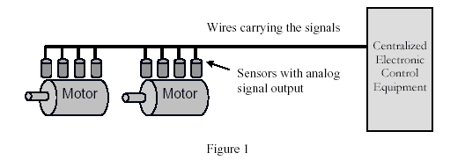

Industrial Machine Monitoring using Sensors

The modern industrial facility is making great strides to not just improve quality and efficiency but also to maintain the highest possible uptime without unscheduled outages. The ability to monitor the health of every machine in an integrated circuit (IC) fabrication plant would be very useful if it predicted a problem before it happened thus avoiding an unscheduled outage. In an IC fabrication plant there may be 6,000 motors to monitor with each motor requiring from a minimum of 2 up to 10 sensors to measure vibration, temperature, voltage and current depending upon the motor (how large and how critical it is in the process). Traditionally, each sensor would require a wire to be run back to a centralized computer station, but the cost to install the wiring is $100’s per linear foot. Since the data to be monitored is different for every motor type, a separate electronic circuit must be designed to interpret the signal from that sensor. Finally, the installation process must be quick as it can only be done during a scheduled shutdown of the factory which is brief and infrequent. The typical cost of deployment for machine monitoring ranges from $100s to over $1000 per sensor. For a factory like an IC fabrication plant this makes widespread machine monitoring network too expensive using traditional methods.

Improving the Sensor Network
The most expensive part of a sensor network with a lot of sensor points is the cost of installing the wire or cabling. This is why there is a lot of excitement behind the potential for Wireless Sensor Networks (WSN). WSN eliminates the wiring costs, allows a large number of sensors to be installed and self configure upon power up, and allows for future changes in the network configuration.
These advantages are directly beneficial to the application of monitoring machines in a factory. Monitoring a blower fan motor mounted in an air duct for an IC fabrication plant might be very important, but at a cost of $300 per sensor end point it is not practical. However, as the cost approaches $50 per sensor end point, it becomes interesting. At even lower costs it becomes compelling. Next, the cost to install the network must be as low as possible which is directly related to the installation time. It should also configure itself for network connections, traffic loads, etc. And finally, it should allow remote adjustments by an operator at any time. A properly designed WSN is capable of addressing these challenges.
However, several key issues remain unsolved. First, a sensor network should be able to recognize what type of sensors are being deployed and configure the sensor interface circuitry accordingly. This should be re-configurable for future proofing the network, and it must be done cost effectively. Second, as the number of sensors deployed on a network grows the amount of information collected and transmitted back to a centralized location can overload the ability of the RF link. A common RF link for WSN is Zigbee with a data rate up to 250Kbps. As an example, if you are using an accelerometer to watch for a 1 KHz frequency occurrence, you could use a 16 bit Analog to Digital converter with a 5 KHz sample rate. This results in a data rate of 10K bytes per second, or 80 K bits per second. If you have 3 accelerometers for the same function, then a total of 240 K bits per second is the data rate and nearly all of the bandwidth of the Zigbee RF link (250Kbps) is used up on just 3 sensors.
This network model of collecting data and sending it back to a centralized control unit for signal interpretation will not work. Signal processing must be moved closer to the sensor or even embedded within the sensor itself.

Sensor Interface Circuits
Signal processing is currently done with a combination of many components – both analog and digital. For a motor monitoring application the functional circuit blocks for processing the
signals from the sensors are shown in Figure 2.
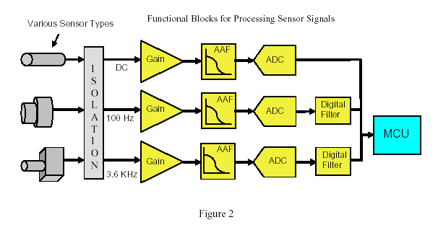
The signal output of most sensors is analog and can vary in voltage, current level and frequency range depending on the type of sensor and the purpose of the measurement (bearing failure, shaft out of round, foundation footing loose, etc). The first step is typically electrical isolation of the signal for protection reasons and shifting the voltage to a level compatible with the electronic circuit inside. The signal from the sensor is then amplified and the amount of gain required varies by sensor type. Next the signal must be converted to digital via an Analog to Digital Converter (ADC). To prevent errors in the conversion process, a lowpass Anti-Aliasing Filter (AAF) constructed using resistors, capacitors and amplifiers must be employed prior to the ADC. Sometimes, there is an additional filter such as a highpass or bandpass before the ADC while the signal is still in analog format. Whether it is just the lowpass AAF or additional filtering, the design of the filter is designed specifically for the signal of interest coming out of the sensor. The operating frequency of the ADC is also selected specifically for the signal frequency coming from the sensor. Another solution that is becoming more common is to perform additional filtering after the ADC using a Digital Signal Processor (DSP). This requires more components (DSP, RAM and PLD), but is more accurate than filtering done to the analog signal before the ADC. After all these steps, the signal is ready for a microcontroller to determine if an adverse condition has been reached and for deciding what action to take.
For example, in a motor monitoring application, you may want to watch for a specific frequency that would indicate a particular type of failure. If you were interested in a frequency of 3600 Hz for motor bearing vibration analysis, you would want a very sharp bandpass filter to pass only this frequency on to a processor or microcontroller. To obtain a precise bandpass filter at 3600 Hz a DSP can be programmed by writing filtering software code that runs a mathematical algorithm using filter coefficients. The more precise the filter, the less data that must be processed by the microcontroller, which lowers the processing power requirements and cost of the microcontroller.

Signal Processing at the Edge
If the number of machines and sensors deployed is very large (as in motor monitoring in an IC fab plant), the network communication link will be a bottleneck that may not be able to handle the data rates. Even if it can handle the data rate (such as a high speed wired network), the processing power needed at a centralized control for vibration analysis is large, plus the data can be corrupted by noise picked up along the wires running through the factory.
To avoid this, signal processing must be placed as close as possible to the sensor. A block
diagram of the necessary functional blocks is shown in Figure 3.
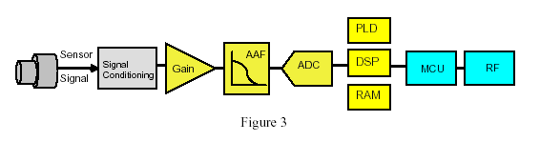

A key objective of Wireless Sensor Network (WSN) installations is keeping the physical size of the sensor end point modules as small as possible. A solution containing all the components in Figure 3 takes up too much board space, is too costly, consumes too much power. Using a DSP along with required supporting components (RAM, PLD) for the filtering function at the edge of the network falls short in other ways besides cost and board space. DSPs are generic processors meant to support a broad range of applications. Performing a high resolution filter is a rote mathematical function which requires a large amount of computational power (measured in MIPS). The MIPS rating of a DSP directly affects the cost and power consumption of the device.
A DSP runs on software that is programmable and can be rewritten and re-loaded, thus changing the filtering function. However, the AAF filter and the ADC are fixed in their specifications. The AAF is constructed from resistors, capacitors and amplifiers. The ADC frequency is typically determined by the crystal frequency and cannot be reprogrammed in circuit. This makes it impossible to implement the IEEE 1451.4 Sensor Plug and Play standard. IEEE 1451.4 requires that a sensor contain a digital “data sheet” (called TEDS – Transducer Electronic Data Sheet stored in EPROM) which is read by a controller or processor. The system is then required to configure the sensor interface circuitry for the amplification, lowpass AAF frequency, analog to digital conversion sampling frequency, and specific filter frequency and function. IEEE 1451.4 also tells the system how to calibrate for the sensor output readings.

A Fresh Approach
A better solution would be to develop a new integrated circuit that is designed for processing sensor signals. Specifications for such a part would include:
1. Software configurable voltage ranges and gain settings for the inputs.
2. A software configurable Anti Aliasing Filter scheme that could handle a wide range of
signals from DC up to several hundred KHz.
3. A software configurable Analog to Digital Converter that can also handle a wide range of
inputs from DC to several hundred KHz. The ADC accuracy should be in the 12 to 16 bit
range to satisfy most industrial applications.
4. Digital filtering that can be programmed to handle any type of filter – Lowpass,
bandpass, etc., with several stages for a wide range of frequency settings and for various
amounts of attenuation. Many applications require several stages of filtering.
5. Low cost, small circuit board footprint (for all the required circuitry) and low power.
This is the direction of the Quickfilter Technologies integrated circuit line. The first IC
being developed is the QF4A512 Programmable Signal Converter (PSC) and is depicted in
Figure 4 below. This product can be configured for a wide variety of sensor types and
applications. The Quickfilter IC handles 4 sensor signals simultaneously, with
programmable gain on each channel. Each channel can accept a signal that ranges from DC
up to 1.0 MHz. This requires a novel new design approach which implements an AAF that
can accommodate a broad range of frequencies without producing anti-aliasing errors after
the digital conversion. The ADC is programmable to cover a wide range of frequency
inputs.
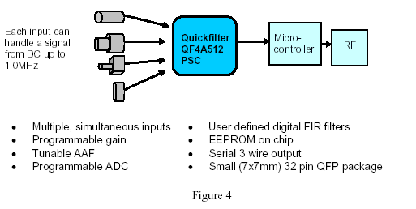

After post conversion digital processing, there is a section of digital filtering that is
programmable by the user. Each signal path has a dedicated 512 tap digital FIR filter capable of providing high levels of filtering functionality including the implementation of “brick wall” filters. The complete signal conditioning configuration and filter function design is accomplished by a design engineer in minutes using the Quickfilter software design tool.
The software tool configures the complete signal path on the Quickfilter IC, for all 4 channels, and then stores the information along with the filter coefficients in EEPROM on the chip. The Quickfilter IC can also be programmed in the circuit board at any time, allowing for changes throughout the design process, at the time of shipment, or after deployment in the field. The Quickfilter IC sends the filtered signals to the MCU which is able to detect signals which reach a predetermined amplitude value. By sending a very precise filtered data output to the MCU, the processing power (MIPS) requirement of the MCU is significantly reduced. When the MCU detects a condition requiring action, it can send a signal through the network (RF or wired) notifying a plant operator or it may be programmed to take action locally such as shutting down a motor. Such a signal requires only a fraction of the bandwidth required to send the complete unprocessed data stream.

Enabling Different Sensor Network Topologies
Having a single, programmable IC capable of handling a variety of multiple sensor inputs allows a network to truly monitor for problems. There is not a constant stream of data coming back to a central control station, nor does the network have to resort to polling each sensor once per day to save bandwidth. An IC fabrication plant that has 6,000 motors with 5 sensors each would require 21 sensors be polled and sending back data every minute. WSN utilizing Zigbee would run into a bandwidth bottleneck. Some machine monitoring installations are designed with a control unit that is close to a motor or group of motors, yet prefer to handle the sensor signal processing inside the control unit. This may be due to very harsh environment conditions at the motor which could harm sensitive electronic equipment. In this scenario the Quickfilter IC offers advantages for implementing the sensor interface circuitry. ( Figure 4) First, in-circuit programmability allows a manufacturer to reduce the number of different board configurations designed, built and held in inventory. The Quickfilter IC can be programmed in the circuit board at the last minute before shipping to an end customer. This last minute personalization reduces costs and allows for a faster response to customer orders. The Quickfilter IC can be used in several network topologies.
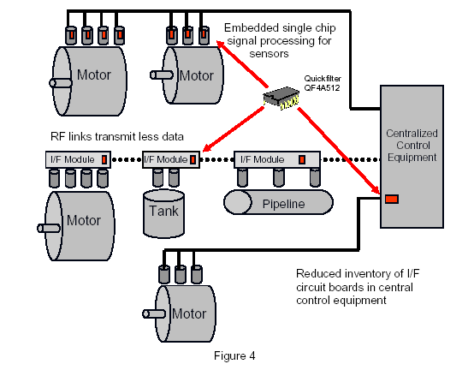

Another network topology places intelligent signal processing in close proximity to a motor where there is an interface module that handles a group of sensor signals. The Quickfilter IC is ideal for this since it can handle 4 signals at once, ranging from DC to 1 MHz. Manufactures like this hybrid distributed processing approach since it still achieves the goal of pushing intelligent signal processing to the edge while spreading the cost of sensor conditioning across 4 sensors. In addition, the Quickfilter IC can be programmed in the field by a technician performing the installation or making a change in the configuration. The Quickfilter IC can be programmed remotely enabling IEEE 1451.4 Sensor Plug and Play to be realized. A final location for the Quickfilter IC is embedded in the sensor itself. Here a single channel version would be required. By having a standard programmable IC, sensor manufacturers can use it across a wider portion of their product line. With extra user EEPROM space in the QF4A512 PSC, each sensor can be programmed for the TEDS (Transducer Electronic Data Sheet) standard per IEEE 1451.4, or other uses such as calibration information storage.

Summary
There is a need for pushing as much intelligence to the edge of sensor networks as is practical within the always constant constraints of power, space and cost. The Quickfilter Programmable Signal Converter IC allows for a wide variety of sensor types and applications, while very precisely sending out only the signal of interest to the microcontroller.

References:
- “Online Condition Monitoring of Motors Using Electrical Signature Analysis” by Aditya Korde
- “Rolling Bearing Vibration Detection” by Mike Sondalini – Equipment Longevity
- “Condition Monitoring in the 21st Century” by Sandy Dunn – Assetivity Pty Ltd.

