Building Automation using PLC and SCADA
Rasika Wadalkar¹ ,Ruchira shirbhate^{2,} Vijay V. Chakole³
¹ Eight sem. Final year
² Eight sem. Final year
³ Asst. Professor, KDKCE, Nagpur

email: 1-rasi12492@gmail.com,ruchee.

Abstract: Automation is the use of control systems and information technologies to reduce the need of human work in the production of goods and services. In the scope of industrialization, automation is the step beyond mechanization. Whereas mechanization provide human operators with machinery to assist them with the muscular requirement of well. Automation plays an increasingly important role in the world economy and in daily experience. Building automation is comparatively less expensive since it tends to require less power, less human effort than that of conventional building.
In building automation, we are using technology of PLC and SCADA. PLC is programmable logic controller used for the automation of various facilities including lighting system, security system and water system while SCADA is software used to give the pictorial representation of our project.

Keywords: PLC and SCADA..

1.Introduction
Early control system consists of huge control boards system of 100 to 2000 of electromechanical relays. An Engineer would design the system logic; electricians would receive the schematic outline of logic then implement the logic with relays. The schematic most commonly called “Ladder Schematic”.
The ladder displayed all the switches, sensors, motors, valves, relays etc. in the system.
Problem: long commissioning time, dependency on mechanical, reliance, any system logic design change required the power to the control board to be isolated stopping production.
General motor was among the first to recognize a need to replace the system “wired control board”.
Hydramatic division of GM specified the design criteria for the programmable control in 1968. Goal-eliminate the high cost associated with inflexible, relay control system.
In 1969 Gould Modicon developed the first PLC. Strength- Programmed with Ladder Logic. PLC’s have evolved from simple on or off control to being able to communicate with other control system, provide production reports, schedule production, diagnose machine and process faults.

What is Automation?
Automation is basically the delegation of human control function to technical equipment for:-

- Increasing Productivity

- Increasing Quality

- Reducing Cost

- Increasing Safety in working conditions

- Automation is the use of control systems and information technologies reducing human efforts in the production of goods and services.

In industrialization, automation is a step beyond mechanization. PLC
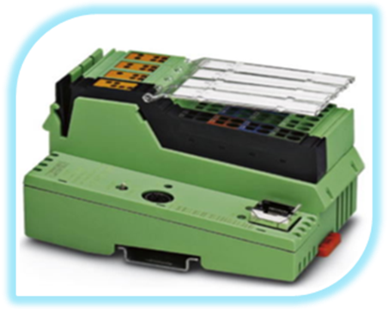
A programmable logic controller is a digital controller used for automation of electromechanical processes. It can be programmed logically as per the requirement.

- PLCs can be interfaced to modules like DC I/O, AC I/O, Relay, Transistor, Analog voltage input/output, Digital I/O, RS232 comm., RS485, more recently ETHERNET, Wi-Fi. Etc.

- PLC has many I/O ports i.e. up to 1 lack but in microcontroller we have limited number of I/O ports.

- PLC has very high working temperature range up to which it can work efficiently. PLC can work up to 65 C. On the other hand, microcontrollers may get damaged at very high temperature.

- As there is no PCB layout we don’t have to change connections every time.

- TIMERS, counters and temperature controllers are inbuilt in PLC. No need of interfacing is there but in case of microcontrollers one has to interface all such devices external

3. Working

In this Building Automation System, there is a Power Supply Unit (PSU) to generate a 24V for operating the PLC. PLC is the programmable logic controller; it is used to control input- output synchronization. In this system, we are applying the input in the form of sensors and switches.
In our project, we are including the automation of main door entry, lighting system, water tank system and security system.Automation in main door entry means when the vehicle is near to the main door, the sensor will detect the vehicle and door will be opened and when the vehicle entered, door will be closed.
Automation in lighting system means in the evening darkness sensor will sense and according to that light will be ON. At mid-night, out of this some lights will OFF Or ON and in the morning at a fixed time all lights will be OFF. But in any case the person who wants to light ON, then there will be a manual switch for this.Same think apply in the water system. The sensors which are connected in the water tank will detect the level of water and according to that tank filled up to particular level.
In security system, we are applying fire security system. In which if any emergency condition arises in the building the problem will be solved quickly as compared to manual system.

4. ADVANTAGES OF SYSTEM

- Efficient
As there is a less manual work and all the process controlled by Programmable Logic Controller, so the system is high efficient.

- Save Time
In this system, controller gives output quickly. So spending of time to do work reduces.

- Save Power
The system is work on less power and gives required output.

- Environmental friendly
The Building Automation System is environmental friendly. There is no pollution when system proceeds.

- The system reduces human efforts.
5. Conclusions :
Now ,we will reach to final is that the quality of living must be modified as same as our country will developed day by day.The modified form of living is start by our home i.e BUILDING AUTOMATION were we find out everything is going to automatic due to which our time is saving,
Time for doing any work required is very less.There have many application of these project
Like Shopping malls, Apartments, Offices etc.Hotels and Resorts.In manufacturing industries.eg. Pharmaceutical Industry.

References
- “Automation made Easy”
-By Peter G. Martin and Gregory Hale

- “PLC and Industrial Automation”.
-By Madhuchhandra Mitra and Smarjit Sen Gupta

- Wonder ware company- Intouch (software)

