Industrial Disaster Robot with SMS Feedback
Sachin Jambhulkar*1, Pratiksha Chokhandre#2, Sukhada Deshpande#3, Nikita Chandekar#4
*, # Department of Electronics Engineering, Rajeev Gandhi College Of Engineering & Research, Nagpur, India
¹sach.jambhulkar@gmail.com
²pratikshac11@gmail.com
³sukhadadeshpande.2011@gmail.com
⁴nikita.chandekar.nc@gmail.com

Abstract - The need for a device that can detect and extinguish a fire on its own is long past due. Many house fires originate when someone is either sleeping or not home. With the invention of such a device, people and property can be saved at a much higher rate with relatively minimal damage caused by the fire. Our task as electronics engineers was to design and build a prototype system that could autonomously detect and extinguish a fire. Also aims at minimizing air pollution. In this Project we design a Microcontroller based controlled Robot. It is the Robot that can move through a model structure, find and then extinguish it with help of a Blower. This is meant to simulate the real world operation of a Robot performing a fire extinguishing function in an oilfield and the SMS is provided for sending the information.

Keywords— Visual Basics, Detector Device, GSM – Global System for Mobile Communication.

I. INTRODUCTION
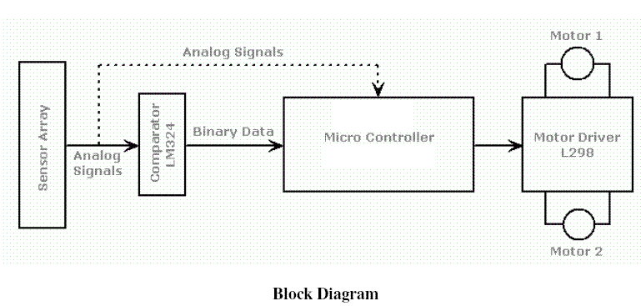
Emergency management is a continuous process by which all individuals, groups, and communities manage hazards in an effort to avoid or reorganize the impact of disasters resulting from the hazards. The main attributes of a disaster include unpredictability, unfamiliarity, speed, urgency, uncertainty, threat etc. Accidents in Chemical industry can occur due to human errors, leaks, failure of vessels/equipments or pipelines, lack of safety measure etc. In addition, natural hazards pose an additional risk for industrial accidents.
Project consists of industrial accident management system having the detection system and controlling and generating the message for the police ambulance and fire bridge system etc. The robot has ability to detect any flame that exists as the source of fire. It controls the fire and gas and if it has crossed threshold value then transmits the message to the central system.
Hence the robot is expected to work as a fire extinguisher and gas leakage controller. The system will get the temperature from the IC (DS1820) and it will control the speed according the values stored by the user. The System is fully controlled by the microcontroller AT89c52. To send the SMS we have to connect a mobile phone or GSM/GPRS modem to a computer. Then use the computer and AT
commands to instruct the mobile phone or GSM/GPRS modem to send SMS messages.
Robotics is a fascinating subject- more so, if you have to fabricate a robot yourself. The field of robotics encompasses a number of engineering disciplines such as electronics (including electrical), structural, pneumatics and mechanical.
The structural part involves use of frames, beams, linkages, axles, etc. the mechanical parts/ accessories comprise various types of gears (spurs, crowns, bevels, worms and differential gear systems), pulleys and belts, drive systems(differentials, castors, wheels and steering) etc. The pneumatics plays a vital role in generating specific pushing and pulling movements such as those simulating arms or leg movement. Pneumatic grippers are also used with advantage in robotics because of their simplicity and cost effectiveness. The electrical items include DC and Stepper motors, actuators, electrical grips, clutches and their control. The electronic parts involves remote control, sensors (touch sensors, light sensor, collision sensor, etc), there interface circuitry and a microcontroller for overall control functions.
- WORKING
Fig. 1: Path following Block
It is clear that the drive train of this robot is differential type, meaning the two rear wheels are responsible of moving the robot forward and backward, but are also used to turn the robot in any required direction depending the difference of speed between the right and left wheel. To keep your design as simple as possible, we have coupled a 100rpm geared 6v DC motor to the left front wheel and another identical motor to the right front wheel. Both these front motors are mounted side by side by facing in opposite direction. Wheel rims (5cm diameter) along with rubber wheels are directly coupled to each of the motor shaft.
During forward (or reverse) movement of the vehicle, the two wheel shafts, as viewed from the motor ends, would move in opposite directions (one clockwise and the other anticlockwise). For reversing the direction, you simply have to reverse the DC supply polarity of the two motors driving the respective wheels

III. TRANSMITTER CIRCUIT
Specification Differences: The primary specification difference between the two parts is the temperature conversion time: DS1820 = 500ms (max) and DS18S20 = 750ms (max). Software Compatibility: The DS18S20 is software compatible with the DS1820 in most applications.
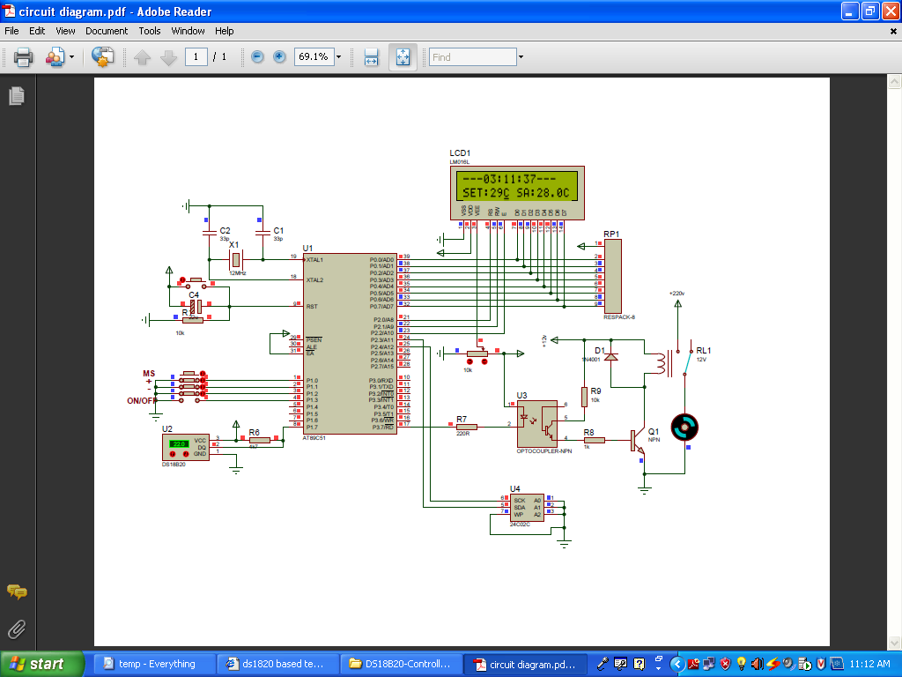

Fig.2. Transmitter Circuit
Hardware Compatibility: The DS18S20 is available in TO-92 (DS18S20) and 8-pin SOIC (DS18S20Z) packages. The DS18S20 (TO-92 package) replaces the DS1820 (PR35 package) since both packages are 3-pin packages with the same lead pitch. There is no replacement package for the DS1820S (16-pin SSOP); however, the DS18S20Z (8-pin SOIC) provides a smaller surface mount package option. Th1, the 50K thermistor, is a standard type. Available from Tandy/Radio-Shack experimented with different models from 22K to 100K and all worked fine after replacing the trimmer pot. The one used in the above circuit diagram was a 50K model. The resistance increases as the surrounding temperature decreases. Tolerance for my application (cooling a large power supply cool rib) is 10%. Another name for this thing is 'NTC'. NTC stands for "Negative Temperature Coefficient" which means when the surrounding temperature decreases the resistance of this thermistor will increase. encapsulated type (the best)critical at all. It acts only as a switch for the relay so almost any type will work, as long as it can provide the current needed to activate the relay's coil.

- RECEIVER CIRCUIT
The complete RF receiver decoder circuit employing HT12D is shown. Assuming that identical address is selected on the encoder and decoder, when any of the switches on the transmitter is depressed, the corresponding data pin of the demodulator will go low. The data output of HT12D are fed to Parallel port in computer to generate appropriate logic output in conformity.
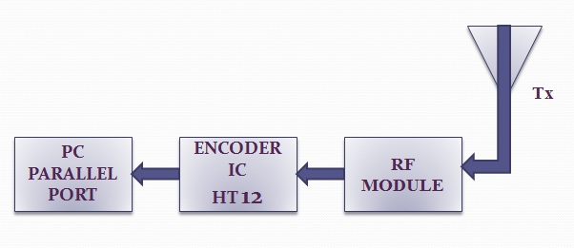
Fig. 3 Receiver Circuit

In general, there are two ways to send SMS messages from a computer / PC to a mobile phone:
- Connect a mobile phone or GSM/GPRS modem to a computer / PC. Then use the computer / PC and AT commands to instruct the mobile phone or GSM/GPRS modem to send SMS messages.
- Connect the computer / PC to the SMS center (SMSC) or SMS gateway of a wireless carrier or SMS service provider. Then send SMS messages using a protocol / interface supported by the SMSC or SMS gateway.
If you do not want to develop SMS software or applications but just want to use your computer / PC to send text messages.

Sending SMS Messages from a Computer Using a Mobile Phone or GSM/GPRS Modem
The SMS specification has defined a way for a computer to send SMS messages through a mobile phone or GSM/GPRS modem. A GSM/GPRS modem is a wireless modem that works with GSM/GPRS wireless networks. A wireless modem is similar to a dial-up modem. The main difference is that a wireless modem transmits data through a wireless network whereas a dial-up modem transmits data through a copper telephone line. More information about GSM/GPRS modems will be provided in the section "Introduction to GSM / GPRS Wireless Modems". Most mobile phones can be used as a wireless modem. However, some mobile phones have certain limitations comparing to GSM/GPRS modems. This will be discussed in the section "Which is Better: Mobile Phone or GSM / GPRS Modem" later.
To send SMS messages, first place a valid SIM card from a wireless carrier into a mobile phone or GSM/GPRS modem, which is then connected to a computer. There are several ways to connect a mobile phone or GSM/GPRS modem to a computer. For example, they can be connected through a serial cable, a USB cable, a Bluetooth link or an infrared link. The actual way to use depends on the capability of the mobile phone or GSM/GPRS modem. For example, if a mobile phone does not support Bluetooth, it cannot connect to the computer through a Bluetooth link.
After connecting a mobile phone or GSM/GPRS modem to a computer, you can control the mobile phone or GSM/GPRS modem by sending instructions to it. The instructions used for controlling the mobile phone or GSM/GPRS modem are called AT commands. (AT commands are also used to control dial-up modems for wired telephone system.) Dial-up modems, mobile phones and GSM/GPRS modems support a common set of standard AT commands. In addition to this common set of standard AT commands, mobile phones and GSM/GPRS modems support an extended set of AT commands. One use of the extended AT commands is to control the sending and receiving of SMS messages.
The following table lists the AT commands that are related to the writing and sending of SMS messages:
Table 1: AT Commands
AT command | Meaning
+CMGS | Send message
+CMSS | Send message from storage
+CMGW | Write message to memory
+CMGD | Delete message
+CMGC | Send command
+CMMS | More messages to send

One way to send AT commands to a mobile phone or GSM/GPRS modem is to use a terminal program. A terminal program's function is like this: It sends the characters you typed to the mobile phone or GSM/GPRS modem. It then displays the response it receives from the mobile phone or GSM/GPRS modem on the screen. The terminal program on Microsoft Windows is called HyperTerminal. More details about the use of Microsoft HyperTerminal can be found in the "How to Use Microsoft HyperTerminal to Send AT Commands to a Mobile Phone or GSM/GPRS Modem" section of this SMS tutorial.
REFERENCES
[1] Dearie S. ,Fisher K. , Rajala B. ,Wasson S. , “Design and construction of
fully autonomous fire fighting robot“, Electrical Insulation Conference &
Electrical Manufacturing, Coil Winding Conference, pp 303-310,2001.
[2] Su, K. L “Automatic Fire Detection System Using Adaptive Fusion” IEEE
International Conference on Systems, Man & Cybernetics, Vol 2, pg 966-
971, 8-11 October 2006.
[3] Chin T.L, Guo H., Su K.L, Shaiu S.V, “Develop a Multiple Interface
Based Fire Fighting Robot ” Mechatronics, ICM2007, 4th IEEE
International Conference, Pg 1-6,8-10 May 2007.
[4] The 8 Bit Microcontroller and Embedded System - By Mohamad Ali
Mazidi
[5] Electronics: Fundamentals and Application- By D. Chattopadhyay

