**ADVANCED ATM SECURITY SYSTEM USING GSM**

**Shefali Hanwatkar Pooja Damle Dhanashree Awadhani**

**Department of Electronics Department of Electronics Department of Electronics**

**R.G.C.E.R R.G.C.E.R R.G.C.E.R**

**Nagpur,India Nagpur,India Nagpur,India**

[**hanwatkars@yahoo.com**](mailto:hanwatkars@yahoo.com)[**pooja18damle@gmail.com**](mailto:pooja18damle@gmail.com)[**dhanashree.a4@gmail.com**](mailto:dhanashree.a4@gmail.com)

**Yutika Sarpatwar**

**Department of Electronics**

**R.G.C.E.R**

**Nagpur,India**

**yutikasarpatwar@gmail.com**

**Abstract—** ***The main objective of this project is to develop an embedded system, which is used for ATM security application. In this system bankers will receive a confirmation message using a GSM module. After receiving the message, the customer should enter the code using the keyboard. After entering it checks whether it is a valid one or not and allows the customer further access.***

***ATM security system using GSM Modules is one of the hot topics in embedded systems industry. For providing Security at ATMs GSM Modules are controlled by using 8051 based Microcontroller.***

*Keywords*

ATM, security, GSM module

# **INTRODUCTION**

An automated teller machine or automatic teller machine (ATM) is a computerized telecommunications device that enables the clients to perform financial transaction without the need for a cashier, human clerk.

The first ATM was put into use in 1959 in the Kingsdale Shopping Center in Ohio. On most modern ATMs, the customer is identified by inserting a plastic ATM card with a magnetic strip or a plastic smart card with a chip that contains a unique card number and some security information such as an expiration date or CVVC (CVV). Authentication is provided by the customer entering a Personal Identification Number (PIN).

Now a days, the self service banking system has got extensive popularization with a characteristics offering high quality 24 hours service for customers. Using the ATM which provides customers with the convenient bank note trading is very common. However the financial crime case rises repeatedly in recent years a lot of criminal tamper with the ATM terminal and steal users credit card and password with illegal means.

For secure operations and adequate safety precautions of cash withdrawal operation in ATM from hackers or thieves a system is designed. It introduces about a new design problem that there is “Immediate and mandatory message should displayed on mobile number of ATM card holder’s about amount of withdrawn of money from their account. It provides enhanced security for the ATM card holder about their cash withdrawn and gives a double security”.

1. **LITERATURE REVIEW**

Madu and Madu (2002) pointed out that the concern of customers about security and privacy, while using this service, is a major cause of their dissatisfaction. Ihejiahi (2009) expressed concern about the lack of cooperation among banks in the fight to stem the incidence of ATM frauds now plaguing the industry. He expressed that the silence among banks on ATM frauds makes it difficult for banks to share vital information that will help curb the menace. Obiano (2009) blamed the menace of ATM frauds on indiscriminate issue of ATM card without regard to the customer’s literacy level. According to him one of the frequent causes of fraud is when customers are careless with their cards and PIN numbers as well as their response to unsolicited e-mail and text messages to provide their card details. Omankhanleu (2009) opined that the current upsurge and nefarious activities of Automated Teller Machine (ATM) fraudster is threatening electronic payment system in the nation’s banking sector with users threatening massive dumping of the cards if the unwholesome act is not checked. Adeloye (2008) identified security as well as power outage as major challenges facing the ATM users in Nigeria. Brunner et al. (2004) in their study concluded that the location of ATM is a high determinant to fraud or crime carried out at ATM point. From this research over 75% of the respondents affirm that the location of ATM in secluded place contribute to the fraud perpetuated at ATM point. ATM within the banking premises is more secure than ATMs outside the bank premises. Also, it is obvious that the location of ATM in attractive place does not make it prone for fraud. Diebold (2002) in his view states that the major form of ATM fraud is PIN theft which is carried out by various means; skimming, shoulder surfing, camera, key pad recorder etc. This study elucidates that the common type of fraud perpetuated is PIN theft which is mostly as a result of congestion at ATM points. Other forms of fraud that were enumerated by respondents were; force withdrawal, card theft, and skimming and congestion method fraud at ATM. Cynthia (2000) states that the 24 hours access to the ATM machine is a double edge sword, it has both advantage and disadvantage.

1. **METHODOLOGY**

ATM system using GSM modules is one of the hot topics in embedded systems industry. In this system bankers will first receive a confirmation message using a GSM module. After receiving the confirmation message the card holder should enter the code using the keyboard. For providing security at ATMs, GSM modules are controlled by using 8051 based microcontroller. The financial crime cases rise repeatedly year by year, a lot of criminals tamper with the ATM terminal and steal users credit card and password with illegal means. By implementing this project, these crimes can be minimized.

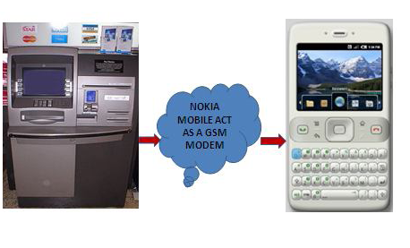

***Fig.1. ATM Mobility communication***

* 1. ***Hardware Design***

Our project mainly consists of GSM module,8051 CONTROLLER, MAX232, PC as SERVER Database, BARCODE Reader for ATM Card, Power Supply, L293D Motor Driver IC,12V DC Motor,5V or 12V Buzzer (If Required),PC Monitor as Display Unit KEYPAD for Typing 4 Digit PIN Number is used from PC Keyboard.

The major building blocks are-

* *8051 Microcontroller*:The microcontroller has got all the peripheral facilities on a single chip so development of a system with a micro controller reduces PCB size and cost of the design. It is the heart of project and controls the entire system.
* *GSM Module*:The SMS specification has defined a way for a computer or microcontroller to send SMS messages through a GSM modem. It is used for sending message to user mobile.
* *Laser Barcode Reader*:Laser scanners uses laser beam as the light source and typically employ either a reciprocating mirror or a rotating prism to scan the laser beam back and forth across the bar code. It is use to scan the ATM card.
* *MAX232 IC*: The MAX232 is a dual driver/receiver that includes a capacitive voltage generator to supply TIA/EIA-232-F voltage levels from a single 5-V supply. It is used for serial communication.

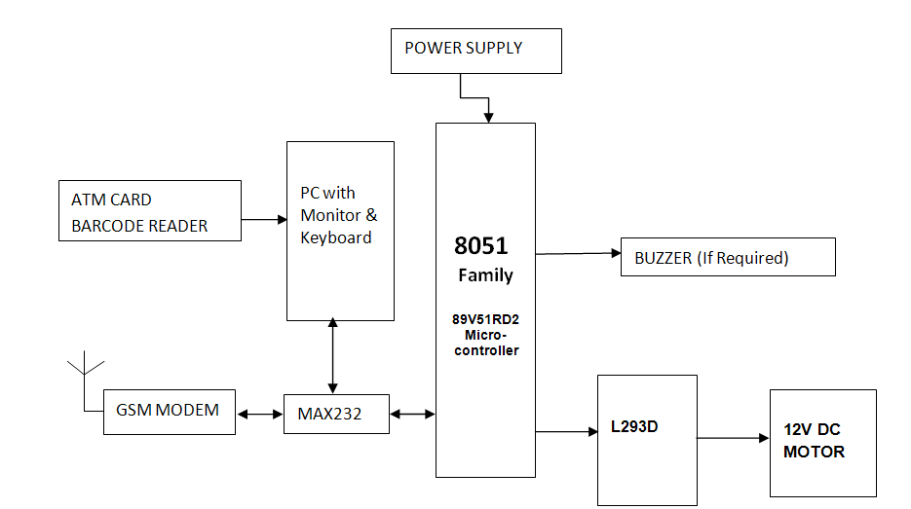

***Fig.2. Block diagram of system***

* 1. ***Software Design***

The design of software includes the implementation of algorithm. This process consists of understanding of the present situation and automating the security management system. The project requires following softwares-

* *Embedded”RIDE ASM” Language:*It is a assembly language.It is used for writing program for microcontroller which controls the entire system.
* *Flash Magic*: Flash Magic is an application developed by Embedded Systems Academy to allow you to easily access the features of a microcontroller device. With this program you can erase individual blocks or the entire Flash memory of the microcontroller. It is used to dump program on microcontroller.
* *VB(Visual Basic)* :It used for writing the program for Database which is stored in PC.

As soon as yes message will be received the green LED will glow and the gate which will be driven by the motor will be opened when the card holder withdraws the money indicating valid and successful transaction of money.When No message will be received the red LED will glow and the gate which is driven by the motor will be closed with no withdrawal of money.

1. **CONCLUSION**

The design of ATM security system based on GSM technology took advantages of the stability and reliability. This project ensures authenticated security and hence can be implemented on the large scale for reducing invalid money withdrawal. Usage of GSM technology allows worldwide transaction of money. The whole system is built on the technology of embedded system which makes the system more safe, reliable and easy to use.

1. **FUTURE SCOPE**

The following are included in future scope of similar study

* May be suitably integrated for the blind.
* Adopting for international banking system.
* Voice SMS feature may be incorporated.
* Amount of withdraw limit can be changed.

**REFERENCES**

1. E Saatci, V Tavsanogh, “ Fingerprint image enhancement using CNN gabor- Cpe filter[C]”. Proceedings of the 7th *IEEE* International Workshop on Cellular Neural Networks and their Applications 2002: 377-382.
2. Smits G FJordaan E M, “ Improved SVM Regression using Mixtures of Kernels [A]”. Proceedings of the 2002 International Joint Conference on Neural Networks[C]. Hawaii: *IEEE.* 2002. 2785-2.
3. J. C. Francis et al., "Evolutionary Mobility & Service Support in DECT Access Networks," To appear in October 1997 special issue of *IEEE* JSAC on Personal Communications - Services, Architecture and Performance.
4. Aditya Abhyankar, Stephanie Schucker “Towards integrating level-3 Features with perspiration pattern for robust fingerprint recognition,” in Proceedings of 2010 *IEEE* 17th International Conference on Image Processing, September 26- 29 2010 Hong Kong.
5. YunYang Sch. of Electr. & Inf. Eng., Shaanxi Univ. of Sci.&Technol.,Xi'an,China Jia Mi .2010“ATM terminal design based on finger print recogSnition” IEEE conference on Volume: 1, No:3.
6. Vaishnavi, R.A.Inf. Techno., Kalasalingam Univ., Virudhunagar, India Rajalakshmi , R. 2012 “Shape to maintain the ATM system stability” IEEE conference on Volume: 10.
7. Rashid, R.A. Dept. of Telecomm. & Opt., Univ. Techno. Malaysia, Skudai Mahalin, N.H. ; Sarijari, M.A. ; Abdul Aziz, A.A. 2008 “Security system using biometric technology: Design and implementation of Voice Recognition System (VRS)” IEEE conference on Volume: 8.