**ADVANCE EMBEDDED SYSTEM DESIGN FOR VEHICLE ACCIDENT DETECTION AND ITS LOCATION FINDING**

Electronics &Telecommunication Engineering

Submitted by

Ku. Shital D. Sonone.

Dr.Bhausaheb Nanduker Collage of Engineering and Technology ,Yavatmal.

**INDEX**

1) ABSTRCT

2) INTRODUCTION

3) BLOCKDIAGRAM

4) DISCRIPTION

5) FLOWCHART

6) ADVANTAGES

7) APPLICATION

8) CONCLUSION

9) REFARENCE

**ABSTRCT:**

Most people are stressed out and overstrained after accidents even if no one is hurt. Consequently, they may face some difficulty in reporting the accident to the police and civil defense, or they may provide them with inaccurate information about the location of the accident. Moreover, even if they were able to provide the necessary information it may take them some time to deliver it to a human counterpart and hence it will take the police and civil defense more time to reach the accident location in the appropriate time to rescue people. This system is designed to inform about an accident by GSM modem and finding the location of that incident by GPS tracker. which is occurred to a vehicle to the family members of the travelling persons. This uses a temperature transducer (sensor) , smoke transducer & vibration transducer which can detect an abrupt changes in temperature, vibration & smoke resp., when an accident is occurred. The uniqueness of this system is not only alerting the neighbours by its siren, but also it sends an caution SMS to four mobile numbers along with latitude and longitude. This system proposes the use of location based services that can be used easily to report and locate an accident more quickly and precisely.

**INTRODUCTION**

In the world, security in travel is primary concern for everyone. The main purpose of this system is used for the protection of human life. This system is designed to inform about an accident by GSM modem and finding the location by GPS tracker. That is occurred to a vehicle to the family members of the travelling persons. And then send SMS to family member of travelling person and giving the exact location of that situation to the family member, police & ambulance by GPS tracker & information of that situation send to MCU through signal. A GSM modem is interfaced to the MCU and reads the data from GPS tracker and the GSM modem sends an SMS to the predefined mobile number and informs about this accident and location i.e. Latitude and longitude. The numbers can be changed at any time by the user using a 3X4 key pad. Whenever an accident is done and any kind of smoke and fire is detected then sends the SMS to firebridged also. This system is, not only alerting the neighbours by its siren, but also it sends an caution SMS to four mobile numbers along with latitude and longitude.

**BLOCKDIAGRAM:**

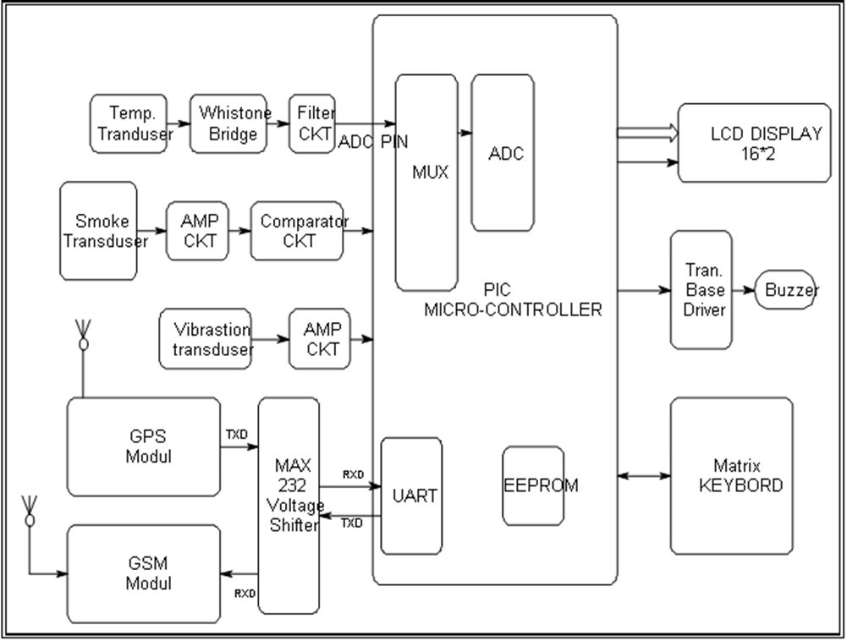

**DESCRIPTION:**

**EEPROM**

EEPROM is a special type of PROM that can be erased by exposing it to an electrical charge. Like other types of PROM, EEPROM retains its contents even when the power is turned off. Also like other types of ROM, EEPROM is not as fast as RAM.

EEPROM is similar to *flash memory* (sometimes called *flash EEPROM*). The principal difference is that EEPROM requires data to be written or erased one byte at a time whereas flash memoryallows data to be written or erased in blocks. This makes flash memory faster

**EEPROM**  stands for **E**lectrically**E**rasable **P**rogrammable **R**ead-**O**nly **M**emory and is a type of non-volatile memory used in computers and other electronic devices to store small amounts of data that must be saved when power is removed, e.g., calibration tables or device configuration.

When larger amounts of static data are to be stored (such as in USB flash drives) a specific type of EEPROM such as flash memory is more economical than traditional EEPROM devices. EEPROMs are realized as arrays of floating-gate transistors.

EEPROM is user-modifiable read-only memory (ROM) that can be erased and reprogrammed (written to) repeatedly through the application of higher than normal electrical voltage generated externally or internally in the case of modern EEPROMs. Unlike EPROM chips, EEPROMs do not need to be removed from the computer to be modified. However, an EEPROM chip has to be erased and reprogrammed in its entirety, not selectively. It also has a limited life - that is, the number of times it can be reprogrammed is limited to tens or hundreds of thousands of times. In an EEPROM that is frequently reprogrammed while the computer is in use, the life of the EEPROM can be an important design consideration.

# **Analog-to-digital converter**

An **analog-to-digital converter** a device that converts a continuous quantity to a discrete digital number. The reverse operation is performed by a digital-to-analog converter (**DAC**).

Typically, an ADC is an electronic device that converts an input analog voltage (or current) to a digital number proportional to the magnitude of the voltage or current. However, some non-electronic or only partially electronic devices, such as rotary encoders, can also be considered ADCs.

The digital output may use different coding schemes. Typically the digital output will be a two's complement binary number that is proportional to the input, but there are other possibilities. An encoder, for example, might output aGray code.

An ADC might be used to make an isolated measurement. ADCs are also used to quantize time-varying signals by turning them into a sequence of digital samples. The result is quantized in both time and value.

**Smoke or fire detector**

The detector comprises a light source and a photosensitive cell located in a container which allows entry of smoke but is impervious to exterior light. Any smoke entering the container affects the cell by reflecting the light from the source onto the cell or by obscuring to a varying extent the light from the source. The light source is a liquid-state or solid-state component and preferably a semiconductor component.

A vibration transducer is a device that takes vibrations from the environment and transforms them into a form of energy that can be either used or deciphered for a variety of different purposes.

## ***Transducer***

A transducer refers to any device that converts input energy of a certain type into a different form of energy. This is usually so the energy can be used for some practical purpose.

***Calibration***

Vibration transducers can either read vibrations at one specific frequency or can be calibrated to read and recognize a range of different frequencies.

**A universal asynchronous receiver/transmitter**

is a type of "asynchronous receiver/transmitter", a piece of computer hardware that translates data between parallel and serial forms. UARTs are commonly used in conjunction with other communication standards such as EIA RS-232.

A UART is usually an individual (or part of an) integrated circuit used for serial communications over a computer or peripheral device serial port. UARTs are now commonly included in microcontrollers. A dual UART, or **DUART**, combines two UARTs into a single chip. Many modern ICs now come with a UART that can also communicate synchronously; these devices are called **USARTs** (universal synchronous/asynchronous receiver/transmitter).

The advanced embedded system design for car accident detection and its location finding is used by GSM modem and GPS track. This system describes a design of effective alarm system that can monitor an automotive / vehicle / car condition in travelling. This system is designed for preventing the human life. It gives an information about an accident to the family of travelling person through SMS.

This system uses a vibration transducer (sensor), temperature transducer, and smoke transducer which can detect the abrupt changes when an accident is occurred. The vibration transducer detects an abrupt vibration when an accident is occurred. Vibration transducers can either read vibrations at one specific frequency or can be calibrated to read and recognize a range of different frequencies. This sends a signal to micro controller. When a fire or any smoke is detected in a car, SMS will send to the family member of travlling person, police, ambulance &Firebridged and when accident is occurred and no fire is detected in a car then SMS will not send to the firebridged.

The system is built around the PIC ("Programmable Interface Controller”) micro controller from Microchip. It includes inbuilt flash memory, 10 bit ADC, EEPROM of 256 byte, UART.

An ADC is an electronic device that converts an analog to digital no. to the magnitude of the voltage or current. GPS is a Global position system, it is used for detecting the exact location of place whenever an accident is occurred.

A GSM (Global System for Mobile Communication) modem is interfaced to the MCU. The GSM modem sends an SMS to the predefined mobile number and informs about this accident. This micro controller provides all the functionality of the SMS alert system. It also takes care of filtering of the signals at the inputs. Only after an input has remained unchanged for 30 milliseconds, is this new signal level passed on for processing by the micro controller program. This system gives an alerting siren an also giving an alerting SMS to Four mobile number. This numbers can be changed at any time by the user using a 3X4 key pad. These numbers are stored in EEPROM. This system uses regulated 5V, 750mA power supply. 7805 three terminal voltage regulator is used for voltage regulation. Bridge type full wave rectifier is used to rectify the ac output of secondary of 230/12V step down transformer.

**GSM**

This GSM modem is a highly flexible plug and play GSM 850 900 / GSM 1800 / GSM 1900 modem for direct and easy integration  RS232, voltage range for the power supply and  audio interface make this device perfect solution for system  integrators and single user. It also comes with licence free integrated Python. Python is a powerful easy to learn programming language. Such a Python driven terminal is 5 times better and faster and 5 times cheaper than standard PLC/RTU with communication interface and external GSM / GPRS modem.

Voice, Data/Fax, SMS, DTMF, GPRS, integrated TCP/IP stack  and other features like the GSM / GPRS modules  on this home page.

## **GSM modem characteristics**

* Quad GSM GPRS modem ( GSM 850 /900/1800 / 1900 )
* Designed for GPRS, data, fax, SMS and voice applications
* Fully compliant with ETSI GSM Phase 2+ specifications (Normal MS)
* License free Python interpreter with free of charge programming tools

## **GSM modem Interfaces**

* RS232 through D-TYPE 9 pin connector, RJ11 for I2C, SPI and GPIO
* Power supply through Molex 4 pin connector
* SMA antenna connector
* Toggle spring SIM holder
* Red LED Power on, Green LED status of GSM / GPRS module

## **GSM modem general characteristics**

* Input voltage: 5V-30V
* Current: 8mA in idle mode, 150mA in communication GSM 900 @ 12V, 110mA in GSM 1800 @ 12V
* Temperature range: Operating -30 to +85 degree Celsius; Storage -30 to +85 degree Celsius
* Overall dimensions: 80mm x 62mm x 31mm
* Weight: 200g

## **Python**

Python is an object-oriented, strictly, dynamically typed, lexically scoped programming language. Its object model is quite flexible (single-dispatch, metaclasses, everything is an object), and somewhat similar to that of Smalltalk. Python has some functional programming features: first-class functions, map(), reduce(), list comprehension’s, and lexical closures. Python is a very "freeform" language with very few ways of invariant construction.

**FLOWCHART:**

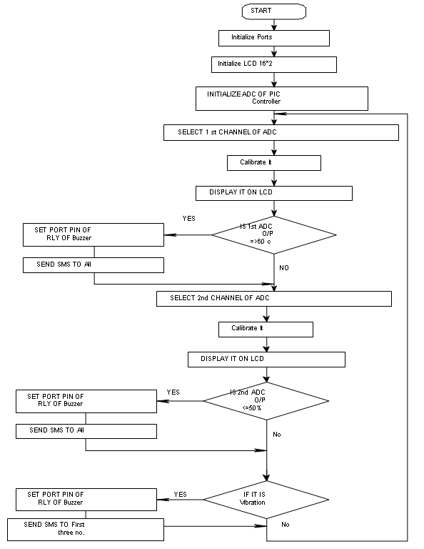

**Advantages:**

1) It gives the exact location of vehicle.

2) Fire detection in vehicles.

3) Sophisticated security.

4) Monitors all hazards and threats.

5) Alert message to mobile phone for remote information.

6) Mobile number can be changed at any time.

**Applications:**

1) It is used to protect human life.

2) Military and civilian applications.

3) Finding accident locations.

**Conclusion:**

Thus from this project, we can conclude that we can able to protect the human life by

reaching the accident place in proper time .

**REFERENCE:**

1. http://doi.ieeecomputersociety.org/10.1109/ISMS.2010.15
2. http://ieeexplore.ieee.org/xpls/abs_all.jsp?arnumber=4220656
3. www.ieee-aess.org/.../77-vehicle-positioning-and-navigation-system-using-gps-and-gsm
4. www.wineyardtechnologies.com/tools/assets/WK412.pdf
5. A . K .SHAWNEY