A Digit-Serial Multiplier for Finite Field GF(2^{m})

Vaishali Boldan
M.Tech V.L.S.I.( IV Sem)
PCE , Nagpur
Maharashtra, India
vpakare@gmail.com

Abstract— A finite field GF(2^{m}) has been widely used in various applications such as error correcting code, switching theory, and cryptography. In this paper, an efficient digit-serial systolic architecture is proposed for multiplication in Finite field GF(2^{m}) using the standard basis representation from the least significant bit first multiplication algorithm, we obtain a new dependence graph and design an efficient digit-serial systolic multiplier. If input data come in continuously, the proposed array can produce multiplication result at a rate of one every [m/L] clock cycles, where L is the selected digit size. Analysis shows that the computational delay time of proposed architecture is significantly less than the previously proposed digit-serial multiplier. In addition, the computational delay time of the proposed architecture is significantly less than previously proposed digit serial systolic multiplier. As a result, multiplier proposed has flexibility with respect to the choice of irreducible polynomial, digit size & pipeline stages. The new architecture has the feature of regularity, modularity and unidirectional data flow. Again we add a look up table approach to further increase speed of digit serial systolic multiplier. The proposed decoder design is simulated on ModelsimSE6.3f and implemented using VHDL code.
Keywords- VHDL, GF, Digit serial architecture, systolic array, Finite field multiplication

Introduction
In recent years, finite field GF (2^{m})has been widely used in various applications such as error-correcting code, switching theory, and cryptography [1], [2]. Important operations in GF (2^{m}) are addition, multiplication, exponentiation, and division. Since addition in GF (2^{m}) is bit independent XOR operation, it can be implemented in fast and inexpensive ways. The other operations are much more complex and expensive. This paper focuses on the hardware

implementation of a fast and low-complexity digit-serial multiplier over GF (2^{m}) , since computing exponentiation and division can be performed by repeated multiplications. Many approaches and architectures have been proposed to perform multiplication in GF (2^{m}) [3]–[17]. In those implementations, many architectures applied systolic array concept [6]–[9], [12], [17]. In general, a nonsystolic architecture has global signals. Therefore, if m becomes large, propagation delay also increases. A systolic architecture, however, does not suffer from the problem. This is because the systolic architecture consists of replicated basic cells and each basic cell is connected with its neighboring cells through pipelining, i.e., there are no global signals. Consequently, the systolic architecture is a better choice than the nonsystolic architecture for a high-speed VLSI implementation [9], [17].
The most commonly used basis representations are dual, normal, and standard basis. Multipliers using the dual [14], [15] and normal basis [16] representations require a basis conversion, in which complexity heavily depends on the irreducible polynomial G(x) . In contrast, multipliers that use the standard basis do not require a basis conversion; they are therefore more efficient from the point of view of irreducible polynomial selection and hardware optimization [3]. The array type multiplication algorithms, when the standard basis is used, are classified as least significant bit (LSB) first and most significant bit (MSB) first schemes [4]. The LSBfirst scheme processes the least significant bit of the multiplier operand first, while the MSB-first scheme processes its most significant bit first. For GF (2^{m}) multiplication, the multiplier implemented using the LSB-first scheme has lower critical path delay compared to the multiplier based on the MSB-first scheme [11]. Additionally, these multipliers for GF (2^{m}) can be further classified into four types: bit-serial, bit-parallel, hybrid, and digit-serial architecture. The bit-serial architecture, which processes one bit of input data per clock cycle, is area-efficient and suitable for low-speed applications. The bit-parallel architecture, which processes one whole word of input data per clock cycle, is ideal for high-speed applications when pipelined at the bit-level. These architectures are typical examples of the area–speed tradeoff paradigm. But these architectures may not be suitable for applications that require moderate sample rates. In other words, the bit-serial architecture may be too slow and the bit-parallel architecture with bit-level pipelining may be faster than necessary and require too much area. To avoid the extreme tradeoffs required by the bit-serial and bit-parallel architectures, hybrid [10] and digit-serial [11]–[13] architectures have recently been proposed. The hybrid architecture represents the field GF (2^{m}) as GF ((2^{n}) ^{k}) , where m= n . k. It uses bit parallel arithmetic in the subfield and serial processing for the extension field arithmetic. Thus, the hybrid multiplier processes input data at a rate of n-bits per clock cycle and yields output results at a rate of one every k clock cycles. In the digit-serial architecture, data words with length m are first partitioned into digits of few bits each, and then processed and transmitted on a digit-by-digit basis. Suppose that word size is m -bits, digit size is L -bits, and N= [m/L] ; then the digit-serial system processes input data at a rate of L-bits per clock cycle and yields output results at a rate of one every clock N cycles.
In this paper, we propose a new digit-serial architecture for multiplication in GF(2^{m}) using the standard basis representation. Two major characteristics of the proposed architecture are: 1) it does not restrict the choice of irreducible polynomial and digit size and 2) it can be easily pipelined at the bit level. In addition, it leads to a considerable reduction of computational delay time with nearly the same hardware requirement, compared to the previously proposed digit-serial systolic multiplier [12]. If input data come in continuously, the proposed array can produce multiplication results at a rate of one every N clock cycles after an initial delay of 3N clock cycles. Finally, since the proposed architecture has the features of regularity, modularity, and unidirectional data flow, it is well suited to VLSI implementation.

LSB-FIRST MULTIPLICATION ALGORITHM IN GF(2^{m})
In this section, we briefly review the LSB-first multiplication algorithm [4] and derive a dependence graph (DG). Let A(x)and B(x) be two elements in GF(2^{m}) , G(x) be the irreducible polynomial used to generate the field GF(2^{m})$\text{GF}(2^{m})≃\text{GF}(2)[x]/G(x),$ and P(x), and be the result of the multiplication A(x)B(x) mod G(x). Then we can write $P(x)=A(x)B(x)\text{mod}G(x)\text{.}\text{.}\text{.}\text{.}\text{.}\text{.}\text{.}\text{.}\text{.}\text{.}\text{.}\text{.}\text{.}\text{.}\text{.}\text{.}\text{.}\text{.}\text{.}\text{.}\text{.}\text{.}\text{.}\text{.}\text{.}\text{.}\text{.}\text{.}\text{.}\text{.}(1)$
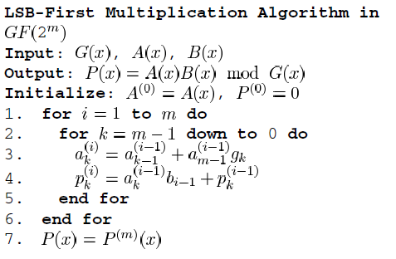
Based on the LSB-first multiplication algorithm, the DG can be derived as shown in Fig. 1.
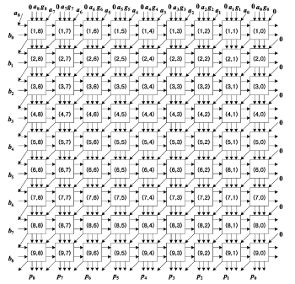
Fig 1: Dependance Graph for multiplicationin GF(2⁹)

Generally, a DG consists of m × m basic cells for multiplication in GF(2^{m}) . In particular, we assumed m=9 in the DG of Fig. 1. The architecture of the basic cell in Fig. 1 is depicted in Fig. 2, where i,j , refers to row and column index of the DG in Fig. 1, respectively.
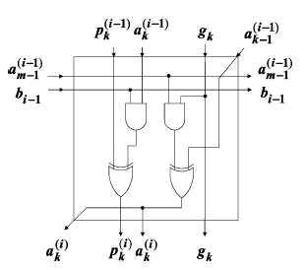
Fig 2: Circuit of (i,k)th cell in fig 1.
The cells in the i^{th} row of the array compute the coefficients of A^{(i)} (x) and P ^{(i)} (x). The multiplication result emerges from the bottom row and is equal to P ^{(i)} (x).

DIGIT-SERIAL MULTIPLIER
Let L be the digit size, N= m/L be an integer, and A_{is} ,B_{is} ,G_{is} , and P_{is} (0≤ i ≤N-1) be the digits of the coefficients of A(x) ,B(x) , G(x) , and P(x) , respectively. Each digit consists of L bits such as the digit Ai = ( a_{iL+L-1}, a_{iL+L-2},…..,a_{iL+1},a_{iL}) ; the digits Bi, Gi , and Pi are defined similarly.

A. Modification of DG and Basic Cell
As the first step for construction of a new multiplier array, we combine L×L basic cells in Fig. 1 into a new basic cell. Fig. 3 shows the modified DG, where L=3 and N=m/L=3. Fig. 4 represents the modified circuit of corresponding basic
cell. As described in Fig. 3, the modified DG consists of N×N basic cells. In the modified DG, the digits and enter the
(1,i )^{th} basic cell, the enters the (i+l , N-l)th basic cell, and the digit Pi emerges from the (N,i) th basic cell, where 0≤ i ≤N-1.

Although the modified DG in Fig. 3 has high regularity, it is impossible to obtain a one-dimensional signal flow graph (SFG) array. This is because the data flow is bidirectional in the horizontal direction. As a result, the DG in Fig. 3 cannot be projected along the east direction [18].

Fig 3. Modified Dependance graph of Fig. 1 with L=3. In other words, the (i,k)th basic cell has to obtain the (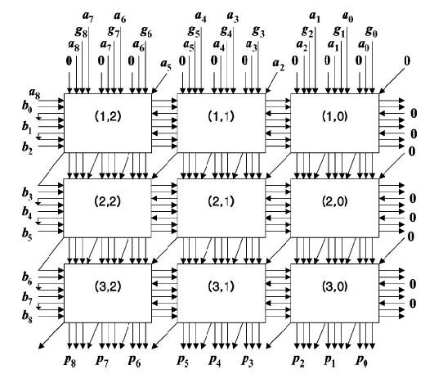L-1) temporary results a_{iL-1},kL-1,a_{iL-2},kL-1,……………., and a_{iL-(L-1}),kL-1 and from the right neighboring ( i,k-1)th basic cell. For example, since L=3 in Fig. 4, the (i,k)th cell should get two temporary results aiL-1,kL-1 and aiL-2,kL-1from the (i,k-1)th cell.

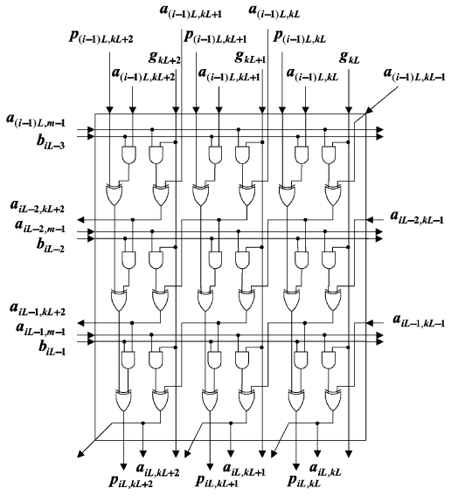
Fig 4. Circuit of (i,k)th cell in fig 3.
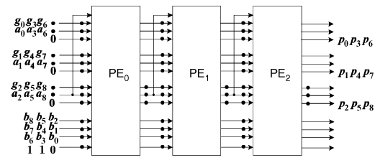
Fig 5. One-dimensional SFG array for multiplication inGF(2 ) with L = 3.
By applying the cut-set systolization techniques [18] to the SFG, we can obtain the digit-serial systolic multiplier
as shown in Fig. 5. If the input data come in continuously, this array produces multiplication results at a rate of one every N cycles from the right-hand side of the array in serial form with the most significant digit first.

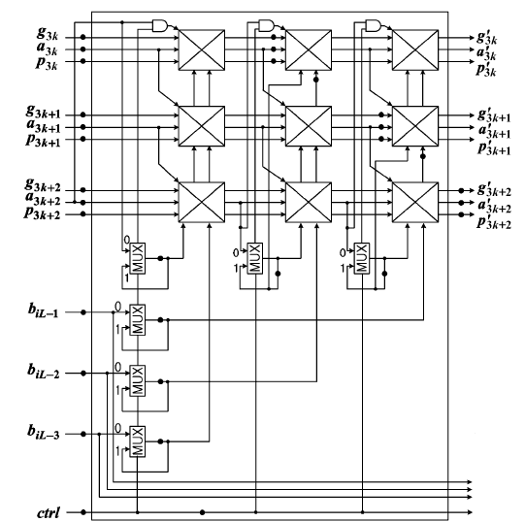

Fig. 6. Structure of each PE in Fig. 5.
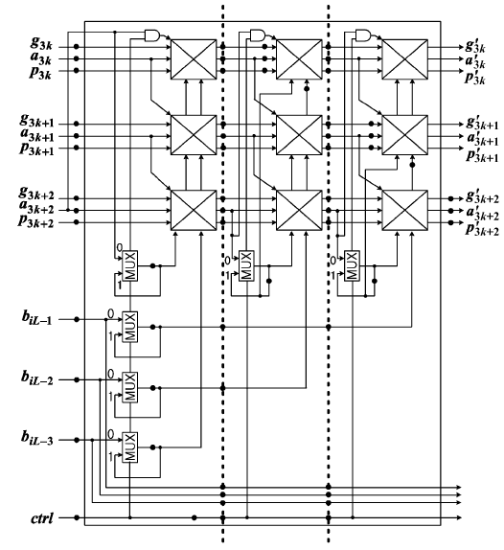
Fig .7. Bit-level pipelined structure of each PE in Fig. 5 with S = 2.
When the digit size becomes large, the maximum propagation delay will increase accordingly. In this case, a high clock
rate can be maintained by further pipelining each basic cell. By applying the retiming procedure [18], each PE in Fig.6 can be easily pipelined at the bit level. The bit-level pipelined structure of each PE is described in Fig.7. As shown in Fig. 7, extra 1-bit latches are added to the data bus located between basic cells.

Until now, we have assumed that m/L is an integer, where L is the selected digit size. Actually, the digit-serial systolic multiplier GF(2^{m}) for , depicted in Fig.5, can also perform multiplication in case m/L is not an integer.

SIMULATION RESULTS
The proposed multiplier was modeled in VHDL and simulated usimg ModelSimSE 6.3F to verify its functionality. The
Fig 8 shows the Simulation Result of Basic Unit of (i,k)th cell and Fig 9 shows Simulation Result of A Digit Serial Multiplier Using GF(2⁸).
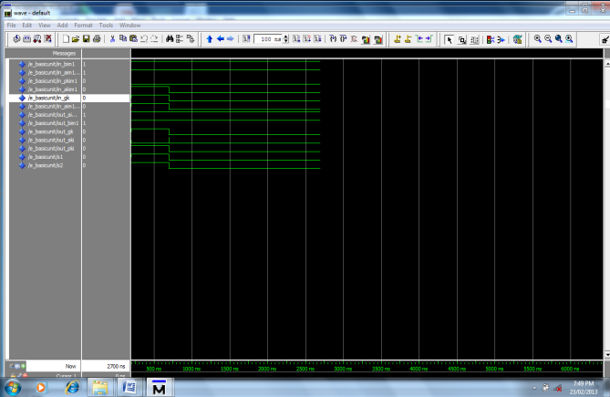
Fig 8: Simulation Result of Basic Unit of (i,k)th cell
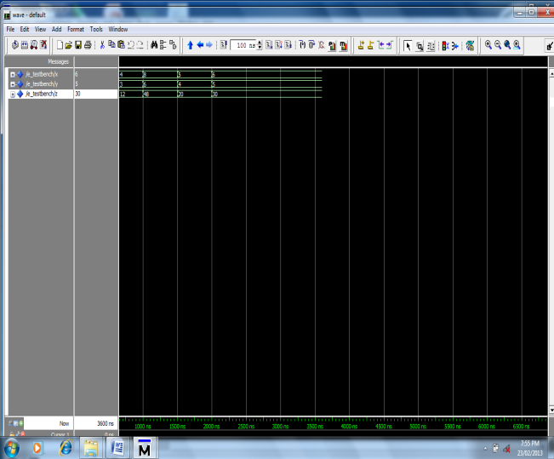
Fig 9: Simulation Result of A Digit Serial Multiplier Using GF(2⁸)
- CONCLUSION
In this paper, we proposed an efficient digit-serial systolic multiplier for GF(2^{m}). Two major characteristics of the proposed architecture are: 1) it does not restrict the choice of irreducible polynomial and digit size and 2) it can be easily pipelined at the bit level . Again we add a look up table approach to further increase speed of digit serial systolic multiplier. The proposed decoder design is simulated on ModelsimSE6.3f and implemented using VHDL code. Furthermore, since the multiplier has the features of regularity, modularity, and unidirectional data flow, it is well suited to VLSI implementation requiring moderate sample rates and where area is critical.

References
[1] R. E. Blahut, Theory and Practice of Error Control Codes. Reading, MA: Addison-Wesley, 1983.
[2] Applied Cryptography. New York: Wiley, 1996.
[3] T. Zhang and K. K. Parhi, “Systematic design approach of Mastrovito multipliers over GF(2^{m} ),” in Proc. 2000 IEEE Workshop on Signal Processing Systems (SiPS): Design and Implementation, Lafayette, LA, Oct. 2000, pp. 507–516.
[4] S. K. Jain, L. Song, and K. K. Parhi, “Efficient semi-systolic architectures for finite field arithmetic,” IEEE Trans. Very Large Scale (VLSI) Syst., vol. 6, no. 1, pp. 101–113, Mar. 1998.
[5] G. Orlando and C. Paar, “A super-serial Galois fields multiplier for FPGA’s and its application to public-key algorithms,” in Proc. 7th Annu. IEEE Symp. Field Programmable Computing Machines (FCCM‘99), Napa Valley, CA, Apr. 1999, pp. 232–239.
[6] C. S. Yeh, I. S. Reed, and T. K. Trung, “Systolic multipliers for finite fields GF(2^{m} ),” IEEE Trans. Comput., vol. C-33, no. 3, pp. 357–360, Mar. 1984.
[7] C.-L.Wang and J.-L. Lin, “Systolic array implementation of multipliers for finite field GF(2^{m} ),” IEEE Trans. Circuits Syst., vol. 38, no. 7, pp. 796–800, Jul. 1991.
[8] M. A. Hasan and V. K. Bhargava, “Bit-serial systolic divider and multiplier for finite fields GF(2^{m} ),” IEEE Trans. Comput., vol. 41, no. 8, pp. 972–980, Aug. 1992.
[9] W. C. Tsai and S. J.Wang, “Two systolic architectures for multiplication in GF(2^{m} ),” Proc. Inst. Elect. Eng. Comput. Digit. Tech., vol. 147, no. 6, pp. 375–382, Nov. 2000.
[10] C. Paar, P. Fleischmann, and P. Soria-Rodriguez, “Fast arithmetic for public-key algorithms in Galois fields with composite exponents,” IEEE Trans. Comput., vol. 48, no. 10, pp. 1025–1034, Oct. 1999.
[11] L. Song and K. K. Parhi, “Low energy digit-serial/parallel finite field multipliers,” J. VLSI Signal Process., vol. 19, no. 2, pp. 149–166, Jun. 1998.
[12] J.-H. Guo and C. L.Wang, “Digit-serial systolic multiplier for finite field GF(2^{m} ),” Proc. Inst. Elect. Eng. Comput. Digit. Tech., vol. 145, no. 2, pp. 143–148, Mar. 1998.
[13] M. C. Mekhallalati, A. S. Ashur, and M. K. Ibrahim, “Novel radix finite field multiplier for GF(2^{m} ),” J. VLSI Signal Process., vol. 15, no. 3, pp. 233–245, Mar. 1998.
[14] M. Morji, M. Kasahara, and D. L. Whiting, “Efficient bit-serial multiplication and the discrete-time Wiener-Hopf equation over finite field,” IEEE Trans. Inf. Theory, vol. 35, no. 6, pp. 1177–1183, Nov. 1989.
[15] S. T. J. Fenn, M. Benaissa, and D. Taylor, “GF(2^{m} ) multiplication and division over the dual basis,” IEEE Trans. Comput., vol. 45, no. 3, pp.319–327, Mar. 1996.
[16] A. Pincin, “A new algorithm for multiplication in finite fields,” IEEE Trans. Comput., vol. 38, no. 7, pp. 1045–1049, Jul. 1989.
[17] M. Kovac´ and N. Ranganathan, “SIGMA: a VLSI systolic array implementation of a Galois field GF(2^{m} ) based multiplication and division algorithm,” IEEE Trans. Very Large Scale (VSLI) Syst., vol. 1, no. 1, pp. 22–30, Mar. 1993.
[18] S. Y. Kung, VLSI Array Processors. Englewood Cliffs, NJ: Prentice- Hall, 1988.
[19] N. Weste and K. Eshraghian, Principles of CMOS VLSI Design: A System Perspective, 2nd ed. Reading, MA: Addison-Wesley, 1993.

