Prototype Greenhouse Environment
Monitoring System

Varun Satokar , Shreyas Deshpande , Rajendra Pandey, Tanmay Agrawal
Electronics Department,Ramdeobaba College of Engineering and Management, Nagpur.
varun.satokar@gmail.com,9764554155

Abstract – The objective of this project is to design a simple, easy to install, micro controller-based circuit to monitor and record the values of temperature, humidity, soil moisture, CO₂ concentration and sunlight of the natural environment in order to accurately shape the growth of greenhouse crops.

- INTRODUCTION
We live in a world where everything can be controlled and operated automatically, but there are still a few important sectors in our country where automation has not been adopted or not been put to a full-fledged use, perhaps because of several reasons one such reason is cost. One such field is that of agriculture. Agriculture has been one of the primary occupations of man since early civilizations and even today manual interventions in farming are inevitable. Greenhouses form an important part of the agriculture and horticulture sectors in our country as they can be used to grow plants under controlled climatic conditions for optimum produce. Automating a greenhouse envisages monitoring and controlling of the climatic parameters which directly or indirectly govern the plant growth and hence their produce. Automation is process control of industrial machinery and processes, thereby replacing human operators.The proposed system for automation of greenhouse is an embedded system which will closely monitor and control the microclimatic parameters of a greenhouse on a regular basis round the clock for cultivation of crops or specific plant species which could maximize their production over the whole crop growth season and to eliminate the difficulties involved in the system by reducing human intervention to the best possible extent. The system comprises of sensors, analog to digital converter, microcontroller and actuators. When any of the above mentioned climatic parameters cross a safety threshold which has to be maintained to protect the crops, the sensors sense the change and the microcontroller reads this from the data at its input ports after being converted to a digital form by the adc. The microcontroller then performs the needed actions by employing relays until the strayed-out parameter has been brought back to its optimum level. Since a microcontroller is used as the heart of the system, it makes the set-up low-cost and effective nevertheless. As
the system also employs an LCD display for continuously alerting the user about the condition inside the greenhouse, the entire set-up becomes user friendly. Thus, this system eliminates the drawbacks of the existing set-ups mentioned in the previous section and is designed as an easy to maintain, flexible and low cost solution.

- LIST OF COMPONENTS
- Sensors:-
- Temperature sensor (LM35)
- Humidity sensor (SYHS220)
- Light sensor (LDR)
- Soil Moisture sensor
- Co₂ Sensor(TGS 4161)
- Microcontroller(msp430g2231)
- Liquid Crystal Display (Hitachi’s HD44780)

- BLOCK DIAGRAM
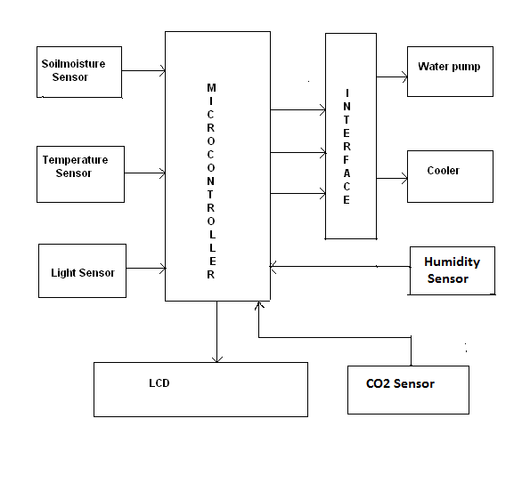

- STEPS FOLLOWED IN DESIGNING THE SYSTEM
- Identify measurable variables important to production. It is very important to correctly identify the parameters that are going to be measured by the controller’s data acquisition interface, and how they are to be measured.
- Select proper devices which will be accurate, compatible, cheap (since it is aimed at poor farmers) and easily available.
- Hardware must always follow the selection of software, with the hardware required being supported by the software selected. In addition to functional capabilities, the selection of the control hardware should include factors such as reliability, support, previous experiences with the equipment (successes and failures), and cost.

V.DESCRIPTION OF COMPONENTS
- Temperature sensor (LM35):- The LM35 is precision integrated-circuit temperature sensor whose output voltage is linearly proportional to the Celsius temperature. It does not require any external calibration or trimming to provide accuracy at room temperature over a full −55 to +150°C temperature range.

- Humidity sensor (SYHS220):- This sensor module converts relative humidity (30-90%RH) to voltage and can be used in weather monitoring application. It has an operating range of 0 to 60°C.With accuracy of ± 5% RH (at 25°C, 60%RH)
- Light sensor (LDR):- A light dependent resistor (LDR) is a resistor whose resistance decreases with increasing incident light intensity; in other words, it exhibits photoconductivity. It has wide spectral response with operating temperature range of 25°C to 75°C.
- Co₂ Moisture sensor (TGS 4161):- It is a solid electrolyte CO2 sensor which offers miniaturization and low power consumption. A range of 350~10,000ppm of carbon dioxide can be detected by TGS4161, making it ideal for air control applications. The sensor displays good long term stability and shows excellent durability against the effects of high humidity.
- Soil Moisture sensor: - For soil moisture measurement, we can use homemade soil moisture sensor. It is cheap soil and consists of two probes (metal rods) held apart at a fixed distance by some insulating material.

- Microcontroller (MSP430G2231):- The MSP430 family of ultra-low-power 16-bit RISC mixed-signal processors from Texas Instruments (TI) provides the ultimate solution for battery-powered measurement applications. Using leadership in both mixed-signal and digital technologies, TI has created the MSP430 which enables system designers to simultaneously interface to analog signals, sensors and digital components while maintaining unmatched low power
- Liquid Crystal Display (Hitachi’s HD44780):- A liquid crystal display (LCD) is a thin, flat display device made up of any number of color or monochrome pixels arrayed in front of a light source or reflector. Each pixel consists of a column of liquid crystal molecules suspended between two transparent electrodes, and two polarizing filters, the axes of polarity of which are perpendicular to each other.

VI.DESCRIPTION OF SOFTWARE (CCS)
Code Composer Studio™ (CCStudio) is an integrated development environment (IDE) for Texas Instruments’ (TI) embedded processor families. CCStudio comprises a suite of tools used to develop and debug embedded applications. It includes compilers for each of TI's device families, source code editor, project build environment, debugger, profiler, simulators, real-time operating system and many other features. The intuitive IDE provides a single user interface taking you through each step of the application development flow. Familiar tools and interfaces allow users to get started faster than ever before and add functionality to their application thanks to sophisticated productivity tools

VII.CONCLUSION
In this research, we establish a greenhouse environment control system which is similar to greenhouse control system developed in INDIA. But our design is more efficient which can adjust greenhouse environment in anywhere. And this function will let user grasp the information as soon as possible. The result shows the proposed system is effective and feasible. This system saves human resources, power and water consumption a lot.

VIII.REFERENCES:-
Greenhouse Environment System Based on
Remote Control -Chen. Chiung Hsing, Chen. Guan Yu, and Chen. Jwu Jenq
International Conference on Chemical, Ecology and Environmental Sciences (ICCEES'2011) Pattaya Dec. 2011

