**MICROSOFT TECHNOLOGY**

**By: Ashwini Pimpalkar**

**Department of Computer Engineering,**

**DBNCOET, Yeotmal**

**ABSTRACT:**

Gone are the days when it took a large number of clicks and button presses for you to complete a miniscule task. Never again will we have to read through series of messages to get a simple job done. Microsoft, the same giants from Redmond that brought us the enduring Windows OS, essential software suits such as MS Office and Visual Studio and devices like the Zune, Xbox and Kinect , comes another astounding union of hardware and software brilliance that only Microsoft could provide. Microsoft has presented a new device called the ‘Microsoft Surface’ and guess what it is? A coffee table, that should amaze the world, right? The device is a coffee table with a multi-input touch screen. It should solve one of the major pain points; cables everywhere and different drivers that make communication between devices difficult. Operation of the device is completely done by use of touch screen, so bye, bye mouse! Microsoft Surface is a multi-touch product from Microsoft which is developed as a software and hardware combination technology that allows a user, or multiple users, to manipulate digital content by the use of gesture recognition.

**INTRODUCTION**

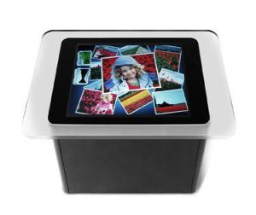

## Surface is essentially a Windows Vista PC tucked inside a black table base, topped with a 30-inch touchscreen in a clear acrylic frame. Five cameras that can sense nearby objects are mounted beneath the screen. Users can interact with the machine by touching or dragging their fingertips and objects such as paintbrushes across the screen, or by setting real-world items tagged with special barcode labels on top of it.

## Surface can simultaneously recognize dozens and dozens of movements such as touch, gestures and actual unique objects that have identification tags similar to bar codes. Surface will ship to partners with a portfolio of basic applications, including photos, music, virtual concierge and games, that can be customized to provide their customers with unique experiences.

## The Origins of Microsoft Surface

## What is so special about Microsoft Surface? One can touch a color in the one-screen palette and draw an image on the screen. Touch blue and draw the sky, Touch green and draw grass. Microsoft Surface can understand all this. It also recognizes various objects. The system can be designed to set up a plate on the surface and the system throws up a menu! And many more possibilities await us as we progress.

**OVERVIEW**

Surface is essentially a Windows Vista PC tucked inside a table, topped with a 30-inch reflective surface in a clear acrylic frame. A projector underneath the surface projects an image onto its underside, while five cameras in the machine's housing record reflections of infrared light from human fingertips. The camera can also recognize objects placed on the surface if those objects have specially-designed "tags" applied to them. Users can interact with the machine by touching or dragging their fingertips and objects such as paintbrushes across the screen, or by placing and moving tagged objects.

Surface has been optimized to respond to 52 touches at a time. During a demonstration with a reporter, Mark Bolger, the Surface Computing group's marketing director, "dipped" his finger in an on-screen paint palette, then dragged it across the screen to draw a smiley face. Then he used all 10 fingers at once to give the face a full head of hair.

In addition to recognizing finger movements, Microsoft Surface can also identify physical objects. Microsoft says that when a diner sets down a wine glass, for example, the table can automatically offer additional wine choices tailored to the dinner being eaten.

Prices will reportedly be $5,000 to $10,000 per unit. However Microsoft

said it expects prices to drop enough to make consumer versions feasible in 3 to 5 years.

Partner companies plan to use the Surface in their hotels, restaurants, and retail stores. The Surface is to be used to choose meals at restaurants, plan vacations and spots to visit from the hotel room. Starwood Hotels plan to allow users to drop a credit card on the table to pay for music, books, and other amenities offered at the resort. In T-Mobile stores, the plans for the Surface include dropping two different phones on the table and having the customer is able to view and compare prices, features, and plans.

The machines, which Microsoft debuted May 30, 2007 at a technology conference in Carlsbad, California, were set to arrive in November 2007 in T-Mobile USA stores and properties owned by Starwood Hotels & Resorts Worldwide Inc. and Harrah's Entertainment Inc. But with delays in developing custom applications for each of the partners, it will take until spring 2008 before the machines start showing up at these locations.

## Origins of Microsoft Surface

## While computers have become part of life today, many researchers continue to bring out new technologies and new products to make our life simpler. Microsoft Surface, one such product with unbelievable features. Before we go into the origins of Microsoft Surface, let us see how the technology evolved.

## Keyboards were used even in the earliest computers. Then came Mouse. And touch pad replaced mouse in laptops. We saw tablet PCs, touch screens and then finally Microsoft Surface.

## The first “touch sensor" was developed in 1971 by Dr. Sam Hurst, an instructor at University of Kentucky. This sensor was patented by The University of Kentucky Research Foundation and the sensor was called ‘Elograph’. This was not a transparent touch screen. Dr. Sam Hurst founded his company ‘Elographics’ and developed a transparent touch screen in 1974 and five wire resistive technology in 1977, which is the most popular touch screen technology. This technology was patented by Elographics. This enabled the concept of touch screen computers, which became part of Automatic Teller Machines (ATMs) of many banks, where the user need not use a key board or mouse, but simply touch various options to draw cash or transact. While this is not linked to the origins of Microsoft Surface, touch screen technology certainly would have generated some interest in researchers to offer much more than following a menu on screen.New technology, ‘Multi-touch’ based on human-computer interaction technique was introduced in 1982. University of Toronto did pioneering work in bringing out multi-touch tablets and Bell Labs created multi-touch screens. All these recognize multiple

## simultaneous touch points and the corresponding software ware designed to interpret simultaneous touches. This technology can be linked directly to the origins of Microsoft Surface, which is becoming a reality now.

**HISTORY**

The technology behind Surface is called Multi-touch. It has at least a 25-year history, beginning in 1982, with pioneering work being done at the University of Toronto (multi-touch tablets) and Bell Labs (multi-touch screens).

The product idea for Surface was initially conceptualized in 2001 by Steven Bathiche of Microsoft Hardware and Andy Wilson of Microsoft Research. In October 2001, a virtual team was formed with Bathiche and Wilson as key members, to bring the idea to the next stage of development.

In 2003, the team presented the idea to the Microsoft Chairman Bill Gates, in a group review. Later, the virtual team was expanded and a prototype nicknamed T1 was produced within a month. The prototype was based on an IKEA table with a hole cut in the top and a sheet of architect vellum used as a diffuser. The team also developed some applications, including pinball, a photo browser and a video puzzle. Over the next year, Microsoft built more than 85 early prototypes for Surface. The final hardware design was completed in 2005.

A similar concept was used in the 2002 science fiction movie Minority Report and in the 2005 science fiction movie The Island, by Sean Bean's character "Merrick". As noted in the DVD commentary, the director Michael

Bay stated the concept of the device came from consultation with Microsoft during the making of the movie. One of the film's technology consultant's associates from MIT later joined Microsoft to work on the Surface project.

Surface was unveiled by Microsoft CEO Steve Ballmer on May 30, 2007 at The Wall Street Journal's 'D: All Things Digital' conference in Carlsbad, California.

Surface Computing is part of Microsoft's Productivity and Extended Consumer Experiences Group, which is within the Entertainment & Devices division. The first few companies to deploy Surface will include Harrah's Entertainment, Starwood Hotels & Resorts Worldwide, T-Mobile and a distributor, International Game Technology

**Microsoft Surface Architecture**

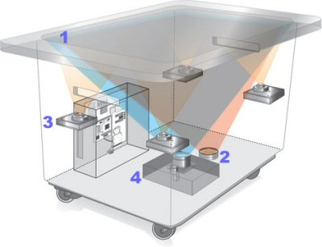

**1)Screen –**  
• There is a diffuser which turns the Surface’s acrylic tabletop into a large horizontal “multitouch” screen, which is capable of processing multiple inputs from multiple users. The Surface is so far advanced than we could imagine that it can recognize objects by their shapes or by reading coded “domino” tags when placed on the table.

**2)Infrared –**  
• Surface’s “machine vision” operates in the near-infrared spectrum, using an 850-nanometer-wavelength LED light source aimed at the screen. When objects touch the tabletop, the light reflects back and is picked up by multiple infrared cameras with a net resolution of 1280 x 960.

**3)CPU –**  
• Surface uses many of the same components found in everyday desktop computers — a Core 2 Duo processor, 2GB of RAM and a 256MB graphics card. Wireless

communication with devices on the surface is handled using WiFi and Bluetooth antennas (future versions may incorporate RFID or Near Field Communications). The underlying operating system is a modified version of Microsoft Vista.

**4)Projector -**  
• Microsoft’s Surface uses the same DLP light engine found in many rear-projection HDTV’s. The footprint of the visible light screen, at 1024 x 768 pixels, is actually smaller than the invisible overlapping infrared projection to allow for better recognition at the edges of the screen.

**FEATURES**

Microsoft notes four main components being important in *Surface's* interface: direct interaction, multi-touch contact, a multi-user experience, and object recognition.

Direct interaction refers to the user's ability to simply reach out and touch the interface of an application in order to interact with it, without the need for a mouse or keyboard. Multi-touch contact refers to the ability to have multiple contact points with an interface, unlike with a mouse, where there is only one cursor. Multi-user is a benefit of multi-touch—several people can orient themselves on different sides of the surface to interact with an application simultaneously. Object recognition refers to the device's ability to recognize the presence and orientation of tagged objects placed on top of it.

The computer's "vision" is created by a near-infrared, 850-nanometer-wavelength LED light source aimed at the surface. When an object touches the tabletop, the light is reflected to multiple infrared cameras with a net resolution of 1024 x 768, allowing it to sense, and react to items touching the tabletop.

Surface will ship with basic applications, including photos, music, virtual concierge, and games, that can be customized for the customers.

A unique feature that comes preinstalled with Surface is the pond effect "Attract" application. Simply, it is a "picture" of water with leaves and rocks within it (a lot like a screen saver used in Windows XP or Vista). By touching the screen, users can create ripples in the water, much like a real stream. Additionally, the pressure of touch alters the size of the ripple created, and objects placed into the water create a barrier that ripples bounce off, just as they would in real life.

**The Magic of Microsoft Surface**

The magic of Microsoft Surface has already captured the imagination of many.

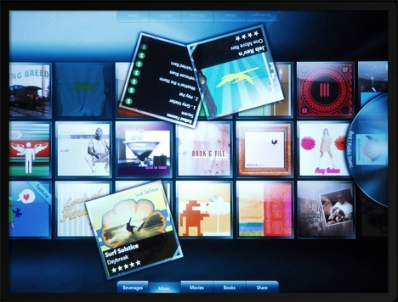

It is very early to see Microsoft Surface in action or to own one. However, some companies have taken initiative to bring the magic of Microsoft Surface to their customers.

There are plenty of opportunities for hotel and restaurants to leverage the features of Microsoft Surface. They can do away with their regular tables and use Microsoft Surface as the table. The Interior architects may develop custom built seating arrangement around Microsoft surface, so that many people can sit around the table with Microsoft Surface and experience the magic of Microsoft Surface, by ordering items from menu individually.

Soon the Photo studios may offer services using Microsoft Surface. The clients may click the photos on their digital cameras, go to the studio for getting the photos printed. They may place the digital camera on the Microsoft surface and the photos are uploaded to the Microsoft Surface automatically. You may preview them, delete unwanted photos, select a theme/background for Photo, select the size of the print and select the print option. And you may get your prints as required in jiffy. That will be the magic of Microsoft Surface.

New applications are being developed for use with Microsoft Surface. Bill payment through credit cards will be very user friendly and secure. Imagine four of you go to a restaurant and have to pay the bill. If you want to split the bill into three credit cards, you may feel delicate. Generally, it is billed to one credit card and then others pay cash to the person whose card is used for transaction. With Microsoft Surface, your bill payments will be easy. Just lay your credit cards on the Microsoft Surface and drag the items from the bill to the credit card. You may distribute different items to different credit cards and pay the bills as you want. With this magic of Microsoft Surface, you can pay bills safely and securely. There will be many more such applications bringing the magic of Microsoft Surface at many places in near future.

**The Possibilities of Microsoft Surface**

The possibilities of Microsoft Surface are many. It depends on the creativity of the solution developers and the willingness of the businesses to change their infrastructure to accommodate Microsoft Surface.

Restaurants may have custom built furniture to sit around the Microsoft Surface, which wotks as a table as well as a computer. The menus pop up based on specific cutlery, so that one can select the items to be ordered. Send emails or browse the net Play games till the items are served. These are just a few of the Possibilities of Microsoft Surface.

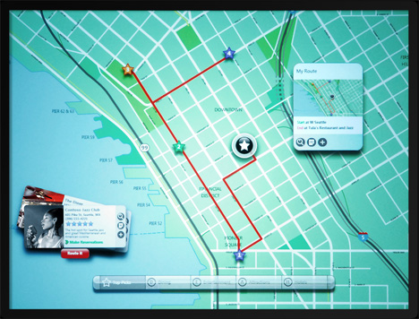

You go to a mobile stores and want to check the models you like and compare few models. Just pick them off the rack and place them on the Microsoft Surface. You can see the features as well as the comparisons. You then select one model and check out the accessories for that mobile phone. Drag them to the order menu. Check the ringtones. Drag them to the Mobile phone, so that they are automatically

loaded on to the mobile phone. Check the items selected and the bill. Add items or delete items simply by dragging in or out of the menu with your hands. Once you are ready, confirm the bill. You also may be able to pay the bill by simply placing the credit card on the Microsoft Surface and drag the bill to the creditcard. And there goes your payment safely and securely and you need not give the credit card to anyone for swiping. Such are the possibilities that make your shopping memorable.

The Possibilities of Microsoft Surface are many. They depend on your imagination. Once the applications are built around Microsoft Surface and are made available for public use, the acceptance of Microsoft Surface is expected to be high. The Possibilities of Microsoft Surface like products are many and the consumers are likely get benefited in longer term.

**Applications**

1. Surface technology can be use in schools & colleges.
2. Hospitals.
3. Hotels & pubs.
4. Shopping malls.
5. Mobile stores.

**ADVANTAGES**

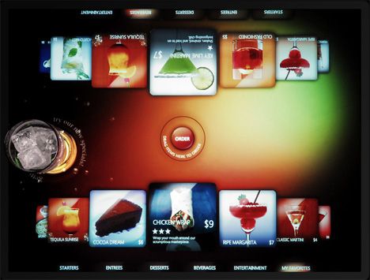

* Surface brings forth a world of graphical goodness of its own.
* Moving about the environment with simple taps and gestures comes as naturally to us as it can.
* User interaction is fluid yet nicely handled by its diversified system.
* A plethora of built-in applications and graphics enable the panel to provide an awe-inspiring experience to

the user.

* The simplicity which the Surface provides makes it applicable in almost every field of human activity.

**DISADVANTAGES**

* The Surface panel’s size and construction make it as space consuming as it is useful.
* With great performance comes great power requirements and that’s exactly what this beast demands.
* All this performance comes with a cost, quite a big one at that.
* Considering the tied down nature of under-development technologies and the secrecy surrounding it, getting your hands on one of these devices can be tricky.

**CONCLUSION**

With more sophisticated technological breakthroughs from Microsoft and Co. heading our way, it’s only a matter of time before Surface panels are spread out all over our surroundings. As developers plough through with their efforts to make our dreams into reality and bring the fruits of their labour into our daily life it’s just a short while towards a day when everyone have a Surface panel in their pockets guiding them on their way. We’ve only seen a brief glimpse of the Surface, quite literally, and its only leaves us craving for more goodness heading our way. The future of Surface lies just beyond our imagination.

**REFERENCES**

* Google.com
* Wikipedia.com
* Microsoft.com
* Aboutmicrosoftsurface.com
* Yahoo.com