**MOBILE & WIRELESS TECHONOLOGY**

Miss. Aachal Mandape Miss. Pravika zade Miss Priyanka Belsare

3rd year (ETRX) 3rd year (ETRX) 3rd year(ETRX)

**B.C.Y.R.C Umrer College Of Engineering Umrer**

**Abstract**

Wireless technology is becoming an ever-growing part of human life with new services and products being released every month. Wireless communications brings huge benefits to the user or users and is therefore becoming a mustfor industry. The report looks into the possibility of installing mobile devices (PDA’s) integrated with a wireless network into a hospital.Hospitals are information intensive and need the speed and easiness of wireless communications.Issues raised through this report include the types of wireless networking technologies available, the effects of electro-magnetic radiation on hospital equipment and peoples’ health, the use and benefits of personal digital assistants (PDA’s), security covering aspects such as encryption, authentication, data protection act and the Health Insurance Portability and Accountability Act (HIPAA) and finally, system design, an area that illustrates how a system might function based on examples of systems currently being tested.

**Introduction**

Wireless networking is slowly pushing out wired networking as the cost of devices fall and due to the ease of use that wireless networking brings, a lot of businesses and industries are turning to wireless networks. Wireless is the ideal solution for a user that wants the ability and freedom to roam without having a fixed cable determining the distance that that user can go before having to stop due to a cable. Wireless networks can provide users with access to information anywhere in their workplace. Installing a wireless network can be fast and easy and can eliminate the need to pull cable through walls and ceilings. Wireless allows the network to go where wire cannot go or doesn't currently exist.This project looks into the up and coming integration of mobile devices (personal digital assistants) and wireless networks into the workplace, predominantly healthcare. Analysis of hospital environments and health risks associated with wireless devices will be addressed along with the current wireless technologies and security issues surrounding the use and storage of patient data.

* **Wireless Technologies**: This section looked at the types of wireless standards available today along with the benefits of using a wireless network over a wired equivalent. Also in this section I recommended IEEE802.11b as the main standard for use in wireless networking. This was based on the information found and the work carried out.
* **EMI**: From the research conducted earlier, the issues concerning wireless communication links within hospitals seems to be a bit misunderstood. It can be seen that the low /ultra low power data links in the UK such as which the IEEE802.11 wireless family use, represent no biological hazard to inhabitants of buildings on which such equipment is located where as cellular technologies transmitting at much higher power levels could and may pose a health threat. With the subject of hospital equipment and acknowledgment to the Medical Devices Agency publication DB9702 entitled "Electromagnetic Compatibility of Medical Devices with Mobile Communications": “No significant levels of interference were detected from cordless handsets, local area networks or cellular base stations.”
* The most important point for people to note is that the health and safety issues concerned with mobile data communications is about Cellular radios and not about low and ultra low power data transfer wireless systems such as the standards being proposed for use in wireless networking of schools, libraries and businesses.
* **Use of Personal Digital Assistants (PDA’s)**: This part of the report discussed the uses of personal digital assistants (PDA’s) and the benefits they bring to the user. This part also looked at the history and the advent of PDA’s into the workplace. PDA’s bring the user a whole load of applications and benefits as well as providing better point of care for the patient as information can be accessed anywhere at anytime without having to wait for or locate a computer.
* **Security Issues**: Security forms a big area of this report but from the analysis taken, it can be said that there are no immediate security risks in operating such a wireless system in a hospital environment. With regards to data transmission, the encryption protocols used are being replaced with much stronger ones. User identification and authentication is encapsulated into every piece of operating system software and is set-up in every wireless network with users the same as in a wired network with users. Just like a wired network, users have access rights, which permit a level of access to certain data depending if one has the credentials. With stronger encryption and greater security, the Health Insurance Portability and Accountability Act should not be of a concern although it should always be taken into account.
* **System Design**: In this section I looked at the current systems in use and in design in this country and worldwide. Research found several companies who manufacture these systems along with application design companies and case studies of systems that have been tested or have been used to improve day to day working. Of all the systems found, Footman Walker-Symphony, Ward-In-Hand and the Royal Hampshire County Hospital projects were looked at and documented. These three projects demonstrate that the integration of wireless applications into a healthcare environment can be achieved with enormous benefits to staff and quality of care for the patient. From the information gathered in each of the above areas, the dream of a wireless, mobile hospital ward can become reality. The benefits of such a system are clear and the health risks addressed accordingly. Equipping caregivers with mobile point-of-care solutions can produce a more patient-focused approach to healthcare. There are several areas that can greatly benefit from mobile computing technology, including bedside computing and home healthcare. Soon everyday tasks will be performed on some sort of electronic device and the result or instruction sent via wireless communication, through the Internet and to some process from which it will return. Accessing information anywhere at anytime and without the risks associated with high power communication techniques such as cellular networks will revolutionise the way hospitals are run and the methods in the way data is managed.

|  |  |  |  |  |  |  |  |  |
| --- | --- | --- | --- | --- | --- | --- | --- | --- |
| |  |  | | --- | --- | | **Wireless Based Technologies** The 3 Generations of wireless Technology (IMT2000  and 3G Body) | | | http://m-ti.com/images/arrow.gif | 1st generation analog voice and data      - AMPS (Advanced Mobile Phone Services) | | http://m-ti.com/images/arrow.gif | 2nd Generation digital voice and data      - CDMA (Code Division Multiple Access)      - CDPD (Cellular Digital Packet Data)      - TDMA (Time Division Multiple Access)      - GSM (Global System for Mobile Communications)      - PDC (Personal Digital Cellular)      - GPRS (General Packet Radio Services) | | http://m-ti.com/images/arrow.gif | 3rd Generation digital voice, data and Broadband services      - W-CDMA (Wideband Code Division Multiple Access)      - CDMA2000 (ITU Standard IS-195      - UMTS (Universal Mobile Telephone Standard)      - Wireless Voice over IP      - Wireless streaming vide | |
| |  |  | | --- | --- | | **An Overview of the Wireless Technologies available** | | | http://m-ti.com/images/arrow.gif | Common Wireless Based Technologies | | http://m-ti.com/images/arrow.gif | Why go Wireless? | | http://m-ti.com/images/arrow.gif | Bounded vers. Unbounded Transmission sytems | | http://m-ti.com/images/arrow.gif | Advantages of Free Space (Wireless) Communications | | http://m-ti.com/images/arrow.gif | Addressing Frequency and health concerns | | http://m-ti.com/images/arrow.gif | Understanding the Frequency Spectrum and Frequency  Classifications      - Addressing regulatory issues      - Licensed vers. unlicensed spectrum | | http://m-ti.com/images/arrow.gif | Types of Radio Transmission in Free Space | | http://m-ti.com/images/arrow.gif | Factors to consider in Free Space Communications | | http://m-ti.com/images/arrow.gif | Frequency effects on transmission      - Troposcatter radio      - Microwave radio | | http://m-ti.com/images/arrow.gif | Advantages and Disadvantages of Microwave Transmissions | |
| |  |  | | --- | --- | | **Local Area Wireless Technologies** | | | http://m-ti.com/images/arrow.gif | The IEEE 802.1x Security Standard | | http://m-ti.com/images/arrow.gif | Wired Equivalent Privacy or WEP | | http://m-ti.com/images/arrow.gif | Infra-red | | http://m-ti.com/images/arrow.gif | Free Space Optics | | http://m-ti.com/images/arrow.gif | Multi-spectrum Fixed Wireless Solutions | | http://m-ti.com/images/arrow.gif | IEEE 802.16 Standard      - GEOs LEOs and MEOs      - Frequency Bands assigned to Satellite Communication      - Very Small Aperature Terminals (VSATs) | | http://m-ti.com/images/arrow.gif | IEEE 802.11x Wireless LAN standards      - IEEE 802.11 thru 802.11g | | http://m-ti.com/images/arrow.gif | Common Wireless LAN layouts      - Ad-Hoc or Peer to Peer mode      - Infrastructure mode or Basic Service Set (BSS)      - BSS integrated into a wired LAN      - Mesh or ESS (Extended Service Set) mode | |
| |  |  | | --- | --- | | **Infrastucture or Wide Area Wireless Technologies** | | | http://m-ti.com/images/arrow.gif | Wireless MAN/WAN | | http://m-ti.com/images/arrow.gif | Concepts of the wireless telephone      - calling examples      - major components      - Concepts of AMPS, FDMA, TDMA, ETDMA, CDMA and GSM technologies      - Enhanced 911         - using GPS         - using Cell Triangulation      - Multi mode Satellite phone      - The Iridium Satellite phone | | http://m-ti.com/images/arrow.gif | Cellullar and Personal Communications Systems | |
| |  |  | | --- | --- | | **Technologies available to support Data over Cellular** | | | http://m-ti.com/images/arrow.gif | 1xRTT (Radio Transmission Technology) | | http://m-ti.com/images/arrow.gif | CDPD (Cellular Digital Packet Data | | http://m-ti.com/images/arrow.gif | GPRS (General Packet Radio Services) | | http://m-ti.com/images/arrow.gif | iDEN (Integrated Digital Enhanced Network) | |
| |  |  | | --- | --- | | **Other Popular Technologies available for the local area.** | | | http://m-ti.com/images/arrow.gif | Bluetooth | | http://m-ti.com/images/arrow.gif | IrDA Infrared Data Association | | http://m-ti.com/images/arrow.gif | UWR (Ultra Wideband Radio) | |
| |  |  | | --- | --- | | **The Wireless WEB and PDAs** | | | http://m-ti.com/images/arrow.gif | WAP (Wireless Application Protocol) and WAP Services | | http://m-ti.com/images/arrow.gif | Short Messanging Services | | http://m-ti.com/images/arrow.gif | WEP Wired Equivalent Privacy | | http://m-ti.com/images/arrow.gif | Popular PDAs | | http://m-ti.com/images/arrow.gif | Blackberry units and Blackberry network | | http://m-ti.com/images/arrow.gif | Wide area service providers      - Modient      - Cingular | | http://m-ti.com/images/arrow.gif | Security for PDAs | |
| |  |  | | --- | --- | | **Solutions offered by Wireless Technologies** | | | http://m-ti.com/images/arrow.gif | Wireless solutions for business and industry including.      - Department stores, and warehouse.      - Trucking and movement of goods     Car rental billing and tracking | | http://m-ti.com/images/arrow.gif | Wireless solutions for schools.      - In the classroom      - Remote schools      - Mobile access for students and student services | | http://m-ti.com/images/arrow.gif | Wireless solutions for people on the go.      - Real Estate Agents      - Stock Brokers      - Doctors      - Service personnel      - Airplane Pilots | | http://m-ti.com/images/arrow.gif | Wireless solutions for the home and SOHO.      - Personal Area Networks for the home      - Personal and home security | | http://m-ti.com/images/arrow.gif | Wireless solutions for police and emergency vehicles.      - Reducing respond time      - Increasing efficiency      - Health care services      - E911 services | |

**Mobile Radio Functions**

This diagram shows a block diagram of a mobile radio transceiver. In this diagram, sound is converted to an electrical signal by a microphone. The audio signal is processed (filtered and adjusted) and is sent to a modulator. The modulator creates a modulated RF signal using the audio signal. The modulated signal is supplied to an RF amplifier that increases the level of the RF signal and supplies it to the antenna for radio transmission. This mobile radio simultaneously receives another RF signal on a different frequency to allow the listening of the other person while talking. The received RF signal is then boosted by the receiver to a level acceptable for the demodulator assembly. The demodulator extracts the audio signal and the audio signal is amplified so it can create sound from the speaker.

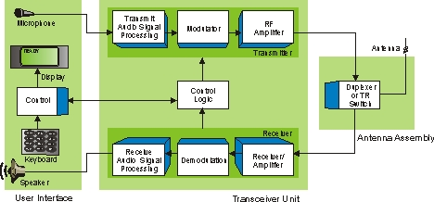

**Bluetooth System**

This diagram shows Bluetooth devices that have created temporary connections. In this diagram, the personal digital assistant (PDA) device is synchronizing (deleting, changing, and adding) addresses with a laptop computer. The laptop computer is also connected to the Internet through a Bluetooth enabled access node. A mobile phone is also synchronizing its phone book listing with the laptop computer. However, because it is out of direct range of communicating with the laptop, it communicates through the access node. The mobile phone is also communicating with a wireless headset.

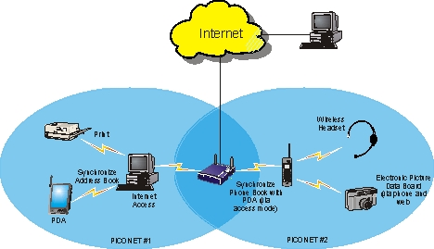

**Mobile Telephone System**

This figure shows a mobile telephone system. The wireless network connects mobile radios to each other or the public switched telephone network (PSTN) by using radio towers (base stations) that are connected to a mobile switching center (MSC). The mobile switching center can transfer calls to the PSTN.

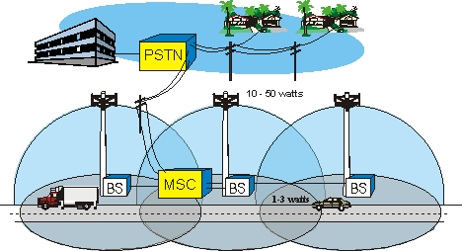

1. **Wi-Fi At Home**

Home Wi-Fi clients come in many shapes and sizes, from stationary PCs to digital cameras. The trend today and into the future will be to enable wireless into every devices where mobility is prudent.

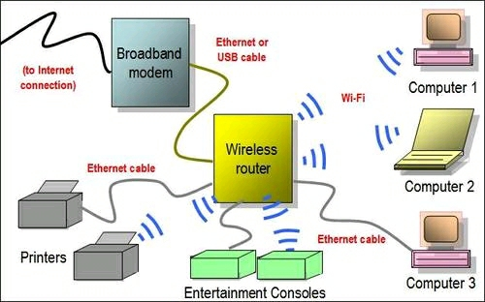

Wireless Home Network Diagram Featuring Wi-Fi Router

Wi-Fi devices are often used in home or consumer-type environments in the following manner:

* Termination of a broad band connection into a single router which services both wired and wireless clients, where cable connection can not be hooked up.
* Ad-hoc mode for client to client connections ,
* Built into non-computer devices to enable simple wireless connectivity to other devices or the Internet.

1. **Wi-Fi in Business**

In Business and Industry  current Technology of  Wi-Fi  is  moving toward ‘thin’ Access Points, with all of the intelligence housed in a centralized network appliance; relegating individual Access Points to be simply ‘dumb’ radios   utilizing true mesh topologies.

**3.Wi-Fi in gaming**

Some gaming consoles and hand helds make use of Wi-Fi technology to enhance the gaming experience   in local multiplayer as well as connecting to wireless networks for online game play or with separate adapter.

**Technical information**

**Wi-Fi: How it Works**

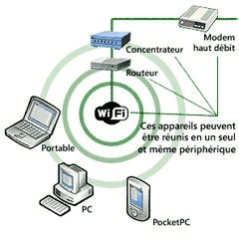

**Working of WiFi**

A typical Wi-Fi setup contains one or more Access Points (APs) and one or more clients. An AP broadcasts its SSID (Service Set Identifier, “Network name”) via packets that are called beacons, which are usually broadcast every 100 ms. The beacons are transmitted at 1 Mbit/s, and are of relatively might use signal strength to decide which of the two APs to make a connection to. The Wi-Fi standard leaves connection criteria and roaming totally open to the client. Since Wi-Fi transmits in the air, it has the same properties as a non-switched wired Ethernet network, and therefore collisions can occur  , which can not be   detected, and instead uses a packet exchange (RTS/CTS used for Collision Avoidance or CA) to try to avoid collisions.

**Channels:** Wi-Fi uses the spectrum near 2.4 GHz, which is standardized, although the exact frequency allocations vary slightly in different parts of the world, as does maximum permitted power, except for 802.11a,which operates at 5 GHz.. However, channel numbers are standardized by frequency throughout the world, so authorized frequencies can be identified by channel numbers. The maximum number of available channels for Wi-Fi enabled devices are:

* 13 for Europe
* 11 for North America. Only channels 1, 6, and 11 are recommended for 802.11b/g to minimize interference from adjacent channels.
* 14 for Japan.

**Standard Devices**

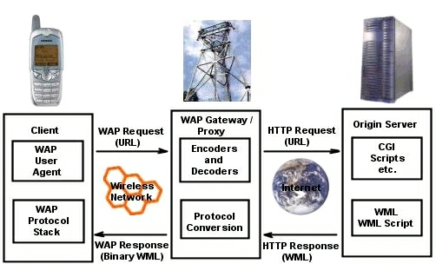

**Wireless Access Point (WAP)**

A wireless access point connects a group of wireless devices to an adjacent wired LAN. An access point is similar to an ethernet  hub, relaying data between connected wireless devices in addition to a (usually) single connected wired device, most often an ethernet hub or switch, allowing wireless devices to communicate with other wired devices.

**Advantages**

**Wireless m-Learning as Performance Support**

Wireless m-learning performance support systems (PSS) are similar to traditional PSS. m-Learning solutions integrate mobile devices with the work to help the user perform a task by providing information, guidance, and learning experiences when and where they are needed. Advantages of this use include the following:

• Puts training and performance support where the actual work takes place. Look for situations in which it would be helpful to have a performance support tool available as the job is being done. It might be the case of a repair person who has an iPAQ (hand-held computer) with documentation, job aids, and diagrams available to refer to as he or she does the repair.

• Allows new skills or knowledge to be immediately applied. Consider the use of these devices in a retail environment in which there are dozens of new products to learn to sell each month. Rather than taking sales associates away from the sales floor for new product training, think about putting product training on mobile devices. This would allow sales associates to learn about the products as the products become available for sale, instead of training associates weeks in advance. The device could also be used to look things up, such as product comparisons, warranty information, and other information vital to answering customer questions. Why ask sales associates to memorize information when they can reference it with accuracy?

• Enables training when it is needed. Wireless and mobile learning can empower “teachable moments,” that is, times when those with a stake in a particular issue are attentive, willing, and receptive to learning. Using mobile devices, learners can access job aids, reference materials, or instruction when needed.

• Allows use of rich media when appropriate. Some of the wireless and mobile devices support rich media such as video, photographs, images, audio, and animation. If these media make instruction, reference material, or job aids more

the customer’s database and they need to learn more about the advanced options for securing data. Using a PDA with instant messaging and awareness (the ability to tell if someone is accessible via e-mail, instant messaging, or phone), learners can access expertise. The awareness option enables the learner to see which of the experts is available right now to dialog via e-mail, instant message, or phone. In this case the service engineers can call the expert and ask questions that will create knowledge and result in learning.

**Disadvantages**

**A Fragmented Learning Experience** A study done at Stanford University’s Language lab (Qingyang, 2003) provides some insights into the fragmented experience of learning with mobile device. The lab staff chose foreign language study as the content area, hypothesizing that mobile devices could provide opportunities for review, listening, and speaking practice in a safe, authentic, personalized, and on-demand environment. The prototypes developed let users practice new words, take a quiz, access word and phrase translations, work with a live coach, and save vocabulary to a notebook—all in an integrated voice/data environment. The study warned that “Learning requires concentration and reflection. However, being on-the-go (riding a train, sitting in a cafe, walking down the street) is fraught with distractions. Students are in situations that place unpredictable but important demands on their attention. This leaves the mobile learner with a highly distracted, highly fragmented experience. The learning application must be designed with this in mind.”

**Small Screens and Difficulty Accessing Information from the Web**

Mobile and wireless devices have significant disadvantages relative to screen size and ability to access information designed for traditional PC-based Web viewing. If the mobile devices are accessing information from websites, Jacob Neilsen (2003b) advises

Currently, the best we can hope for are websites that are basically scaled-down and redesigned to eliminate graphics and multi-column layouts. At worst, websites offer no mobile version, so you get crunched images and skinny columns that are almost impossible to read. Clearly, traditional websites are intended for a big-screen user experience. Putting them on a small screen is like the dog that sings: the miracle is that it does so at all. While a technical feat, usability is never going to be good. To cater to mobile devices, websites and services should offer much shorter articles, dramatically simplified navigation, and highly selective features, retaining only what’s needed in a mobile setting.

**High Costs**

One of the biggest disadvantages and drawbacks for using a mobile wireless e-learning solution is cost. Recommending m-learning or wireless learning means investing in devices for each learner, paying for wireless service, budgeting for maintenance repair and upgrades, and support from an IT group to answer users’ questions and resolve technical problems. It takes a compelling business case to implement this kind of technology for learning.

**Challenges to the Security of the Device and Its Data**

Security is a challenge in the office environment with desktop PCs, and that challenge is magnified with mobile devices. Because of their size and portability, they are easy to lose, subject to damage, and more likely to be stolen than desktop systems. There are also serious considerations regarding data security. In a Computer World article, Muir (2003) estimates that “probably fewer than 10 percent of mobile devices used by major organizations have serious protection for stored data. This vulnerability persists despite the annual Computer Security Institute/FBI studies that document substantial financial losses associated with theft and exposure of confidential data and despite federal regulations governing the security of private data collected by financial and health care organizations

**Applications**

Although wireless technology was initially introduced into the corporate setting, the technology has been adapted for use in homes. The major form of wireless technology being introduced into the domestic setting is [WIFI Networking](http://wiki.media-culture.org.au/index.php/Domestic_Wireless_Technology_-_WIFI_Networking). This allows two or more devices in the same geographical area to be connected together and communicate with each other(Ring, 2003). Therefore, an internet connection and printers can be shared without metres of cables running throughout the house.

Another application of this technology is [Home Automation](http://wiki.media-culture.org.au/index.php/Domestic_Wireless_Technology_-_Home_Automation). An increasing number of new homes are being designed as â€˜smart homesâ€™. As expected, fully automating a house can be an expensive exercise (Smart Homes, 2004). However, there is substantial evidence to suggest that, in the long run, home automation is energy efficient. Home automation utilises the technology in many different ways, from wireless detector lights to integrating and controlling a homeâ€™s heat, ventilation and air-conditioning

**Conclusion**

The development of m-commerce and the wireless World Wide Web is the evolution of several different technologies to make the Internet more accessible and commerce easier for the consumer. While the Internet is already a valuable form of business, which has already changed the way the world is doing business, the format in which we will view it is changing. There are many new opportunities that have only just begun to be explored. This will become a large opportunity for those who capitalize upon this technology. The growth trends are impressive, and the public interest and large companies are behind this technology.

We are currently in a wireless version of the chicken-and-the-egg scenario. Finding a stable, high-bandwidth wireless option is critical if wireless technology is to become a fundamental part of our day-to-day lives. However, the carriers need to know if the technology will be accepted before investing billions in new infrastructure. Acceptance will be determined by how the technology can be applied to the users' day-to-day activities. New networks of wireless networks are springing up around the country, as users find a need for wireless applications that are not currently supported by the existing wireless companies

**References**

<http://www.designshare.com/Research/Wired/wired1.htm>

<http://www.education-world.com/a_tech/tech143.shtml>

<http://www.csulb.edu/~murdock/histofcs.html>