**OBJECT COLLECTING ROBOT**

**Anujkumar Burewar1*, Vijay Chakole2 ,Alok mishra3**

1Students , Electronics Department , K.D.K. College of Engineering , Nagpur

2Asst. Prof. Electronics Engineering , K.D.K College of Engineering , Nagpur

*Correspondingauthoremail:anujburewar@gmail.com

Abstract:

Multi-robotic systems are of better advantages than that of single-robotic system in certain workforce tasks such as building surveillance, transportation of large objects or search and rescue job after large-scale disasters. In order to enlarge its advantages and finish one mission more efficiently This paper describes a robot to collect object in a driving range and is called as Robotic object Collector (R.O.C). The main goal of this project is to design and build a prototype of a tennis ball collector which will be useful indoors and outdoors. The prototype is able to walk freely on the floor avoiding obstacles. The prototype is able to locate oject and pick them up. The purpose of this prototype is to avoid any object found on its way and pick up oject by detecting and then collecting them, R.O.C will reduce the time and effort required in collecting the oject from around the agriculture fields,tennis court etc.

Keywords: Robotic object collector (R.O.C).

.

**1. Introduction**

Robots have always been an object of fascination in our society. They have been portrayed as humble servants of man as well as evil creations that rise to overthrow their masters. All robots share one thing in common at the root of their design and purpose – they can perform tasks in place of humans. Life is filled with many repetitive tasks, and if robots are able to perform those tasks, they can help to ease an overarching burden. With that said, robots are optimal replacements for humans in a multitude of scenarios. As simple as it may seem, the primary action in many repetitive tasks is picking up objects and moving them to other locations. Be it picking up garbage from the floor, moving parts along an assembly line or removing fallen debris, robots that can pick up and move objects will always be useful. Tennis players develop their skills by repetition, in order to achieve that goal they practice with several balls one after the other.

**2. History of robot**

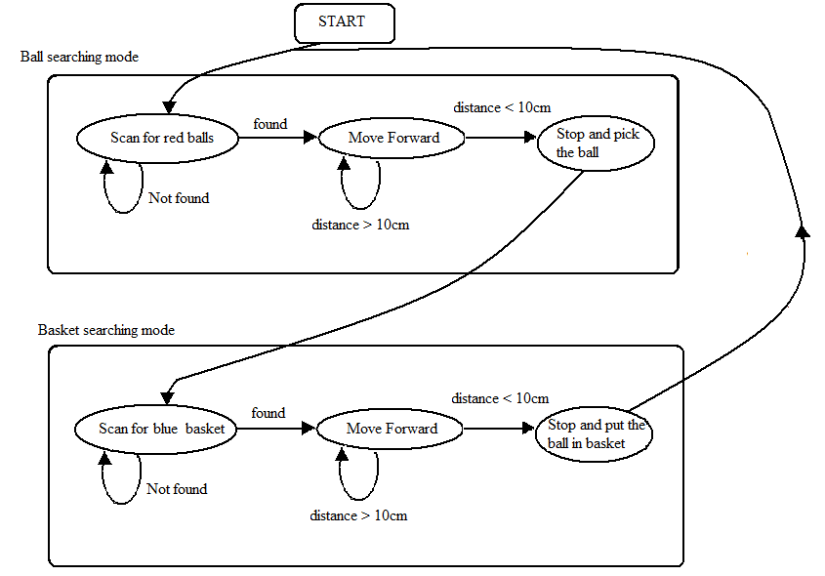This history of robotics is intertwined with the histories of technology, science and the basic principle of progress. Technology used in computing, electricity, even pneumatics and hydraulics can all be considered a part of the history of robotics. The timeline presented is therefore far from complete. Robotics currently represents one of mankind’s greatest accomplishments and is the single greatest attempt of mankind to produce an artificial, sentient being. It is only in recent years that manufacturers are making robotics increasingly available and attainable to the general public the General Robotics Corp[\1]. The RB5X was a programmable robot equipped with infrared sensors, remote audio/video transmission, bump sensors, and a voice synthesizer. It had software that could enable it to learn about its environment. Aqua robot, a walking robot for undersea use, was created at the Robotics Laboratory at the Ministry of Transport in Japan. Developed by Kato Corporation, the WL12RIII was the first biped walking robot which was able to walk on a terrain stabilized by trunk motion. It could walk up and down stairs and could take a single step every 0.64 seconds. IRobot Corporation was founded by Rodney Brooks, Colin Angle and Helen Greiner and produced domestic and military robots**.**

**3.Block Diagram**

**4. Working**

This project is aimed at programming the firebird to act as a tennis ball collector robot. This project consists of two parts: one is the C code to be burnt into the firebird and the other is the Mat lab code which runs on a PC attached with a zigbee module. When the firebird is switched on, the robot rotates in steps of 3 degrees and scans for the ball (red colored) in the field using a camera attached on it. The camera takes snapshots and sends it to the Mat lab code running on a PC. The Mat lab code processes the images and if a ball (centroid of the ball) is detected in a small band centered around the central axis of the image, the robot stops rotating and goes towards it and picks it up. Else it will continue rotation and scan the area. If a ball is detected, the robot goes towards it and while going towards it, it calculates the distance with the obstacle in the front. Since the ball was in the central band of the image, only the ball will be in front of the robot. When the distance between the ball and the robot is less than 10 cm it stops and the two servo motors drop the gripper down and the servo motor attached to the arm activates and opens up the arm of the gripper to collect the ball. Then after collecting the ball, the robot scans for a blue colored basket and if detected, goes towards it and drops the ball into it. After dropping the ball, it continues to scan for more balls. The Mat lab code sends a signal when a ball is detected using the zigbee module attached to the PC. The Mat lab code contains the code for detecting the red objects first. Whenever a red colored continuous area is detected, the program constructs a bounding box around it and calculates the centroid of this bounding box. This technique is followed since on calculating centriod of the continuous area directly, it may result in many centroids if the lighting is not good. A figure similar to the one shown below will be created on following this inefficient approach.

**5. Innovations**

* One of the major features of this project is that this works in an open arena.
* Another feature is that robot can collect ball even if it is far away from the robot. There is no restriction on the area of the arena provided the camera can detect the ball.

**6. Challenges**

* One of the biggest challenges in the project was the communication between the robot and the Mat lab code using zigbee. The communication is slow compared to the wired communication.
* Distinguishing between the basket and ball: Since the ball and the basket were of different colour, the mat lab code needs to identify two different colours. So the code needs to be designed such that there is no much delay in image processing.

**7. APLLICATION/FUTURE SCOPE**

* It can be used as agro bot.
* Can be used in tennis courts.
* Can be used in industries.
* Can be used as spy.

**References**

[1] Heiner Gillmeister, “Tennis: A Cultural History,” Leicester University Press, London, England, 1998.

[2] Johnathon Schultz, Peter Clain, Jesse Miner, “Wall-E Robot,” Final Report, Cornell University, Ithaca, New York, 2010.

[3] Ryan Collier, Mohammed Adham, Perry Haldenby, Kevin Smith, “Autonomous Tennis Ball Collector,” Design Report, University of Waterloo, Ontario, Canada, 2009.

[4] Kevin Dluzen, Jonathan Hall, Diyang Qiu, “PV Autonomous Golf Ball Retriever, University of Illinois at Urbana – Champaign, 2012.

[5] Rodrigo Andres Barbosa, Karina Chang,Luxon Laborieux , Juan Zuluaga, “Self-Piloted Tennis Ball Collector,” Final Report, Florida International University, Miami, Florida, 2008

[6] RobotShop Distribution Inc., 2008

www.robotshop.ca [www.robotshop.us](http://www.robotshop.us)