**Induced Transmission System for Bicycle**

1 Abhimanyu P. Kali,2 AniketN.Kharwade,3Mangesh S.Kamble,4Chetan A.Wankhede

Students of Final Year, Bachelor of Engineering

Department of Mechanical Engineering

Umrer College of Engineering, Umrer Dist. Nagpur

abhi.kali161@gmail.com, aniket.kharwade@gmail.com

Mo.9579117838

**Abstract:**

Bicycles continue to constitute a major means of transport by poor people in rural and urban areas. Given the uneven nature of roads, the rider on a cycle becomes very uncomfortable. People had an old cycle, which required lot of effort to ride. The energy absorbed by the shock absorber was wasted. Using the energy wasted in shock absorbers for propelling the rear wheel so as to supplement the pedal function. When cycle bumps on an uneven road or undulating terrain, the force induced by the bump and rider's weight is stored in a spring attached below the seat. In the first prototype, there was a problem with reverse pedaling. It was overcome by designing a new model. Our cycle would not slow down after bumps as conventional bicycles do. It would accelerate after every bump because of its ability to convert vertical movement due to bumps into horizontal propulsion. **Keywords**: Ball Bearing, Sprocket, Spring Stresses, Rack and pinion mechanism.

Introduction

Bicycles continue to constitute a major means of transport by poor people in rural and urban areas. Given the uneven nature of roads, the rider on a cycle becomes very uncomfortable. People had an old cycle, which required lot of effort to ride. The energy absorbed by the shock absorber was wasted. Using the energy wasted in shock absorbers for propelling the rear wheel so as to supplement the pedal function. When cycle bumps on an uneven road or undulating terrain, the force induced by the bump and rider's weight is stored in a spring attached below theseat. In the first prototype, there was a problem with reverse pedaling. It was overcome by designing a new model.

Bicycles continue to constitute a major means of transport by poor people in rural and urban areas. Given the uneven nature of roads, the rider on a cycle becomes very uncomfortable.. When cycle bumps on an uneven road or undulating terrain, the force induced by the bump and rider's weight is stored in a springs attached under the pedal.. It would accelerate after every bump because of its ability to convert vertical movement due to bumps into horizontal propulsion. This could indeed become a commercial success within the country and even worldwide.

This project is totally mechanical linkages based project. In this mechanism there is rack & pinion arrangement with freewheel ,with the help of chain to convert pressure energy of human body into mechanical work to run the bicycle.

Components

**Rack And Pinion**:Made Of Steel, Carbon Steel, Alloy Steel, Hardened And Tempered Steels, Case Carburised, Case Hardened Steels, Cast Iron, Bronze,Aluminum, HylamOr As SpecifiedStandard And Custom Made As Per Specifications, Drawing Or Sample

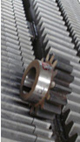

**Gear Rack Capacity**

|  |  |  |
| --- | --- | --- |
| Particular | Metric | Imperial |
| Max. (full depth) | 20 mod | 1DP |
| Max. Face Width | 250 mod | 10'' |
| Max. Overall Width | 500 mm | 20'' |
| Max. Height | 300 mm | 12'' |
| Max. Length | 2500 mm |  |
| Tooth Pressure Angle | 14 1/2˚, 20˚, 25˚ |  |
| ISO, AGMA and DIN | Full Depth and stub Spur or Helical to 45˚ PA |  |

**Bearings**

A ball bearing is a type of rolling-element bearing that uses balls to maintain theseparation between the bearing races .The purpose of a ball bearing is to reduce rotational friction and support radial and axialloads. It achieves this by using at least two races to contain the balls and transmit the

loads through the balls. In most applications, one race is stationary and the other is

attached to the rotating assembly (e.g., a hub or shaft). As one of the bearing races

rotates it causes the balls to rotate as well. Because the balls are rolling they have a

much lower coefficient of friction than if two flat surfaces were sliding against each

other.

**Shaft**

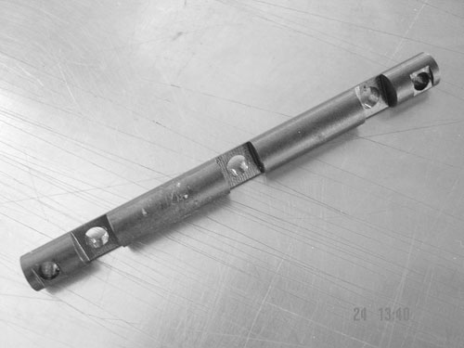

A shaft-driven bicycle is a bicycle that uses a drive shaft instead of a chain to transmitpower from the pedals to the wheel. Shaft drives were introduced over a century ago, butwere mostly supplanted by chain-driven bicycles due to the gear ranges possible withsprockets and derailleurs. Recently, due to advancements in internal gear technology, asmall number of modern shaft-driven bicycles have been introduced.Shaft-driven bikes have a large bevel gear where a conventional bike would have its

compressive, or torsional loads.chain ring . This meshes with another bevel gear mounted on the drive shaft. The use ofbevel gears allows the axis of the drive torque from the pedals to be turned through 90degrees. The drive shaft then has another bevel gear near the rear wheel hub whichmeshes with a bevel gear on the hub where the rear sprocket would be on a conventionalbike, and canceling out the first drive torquechange of axis.

**Spring**



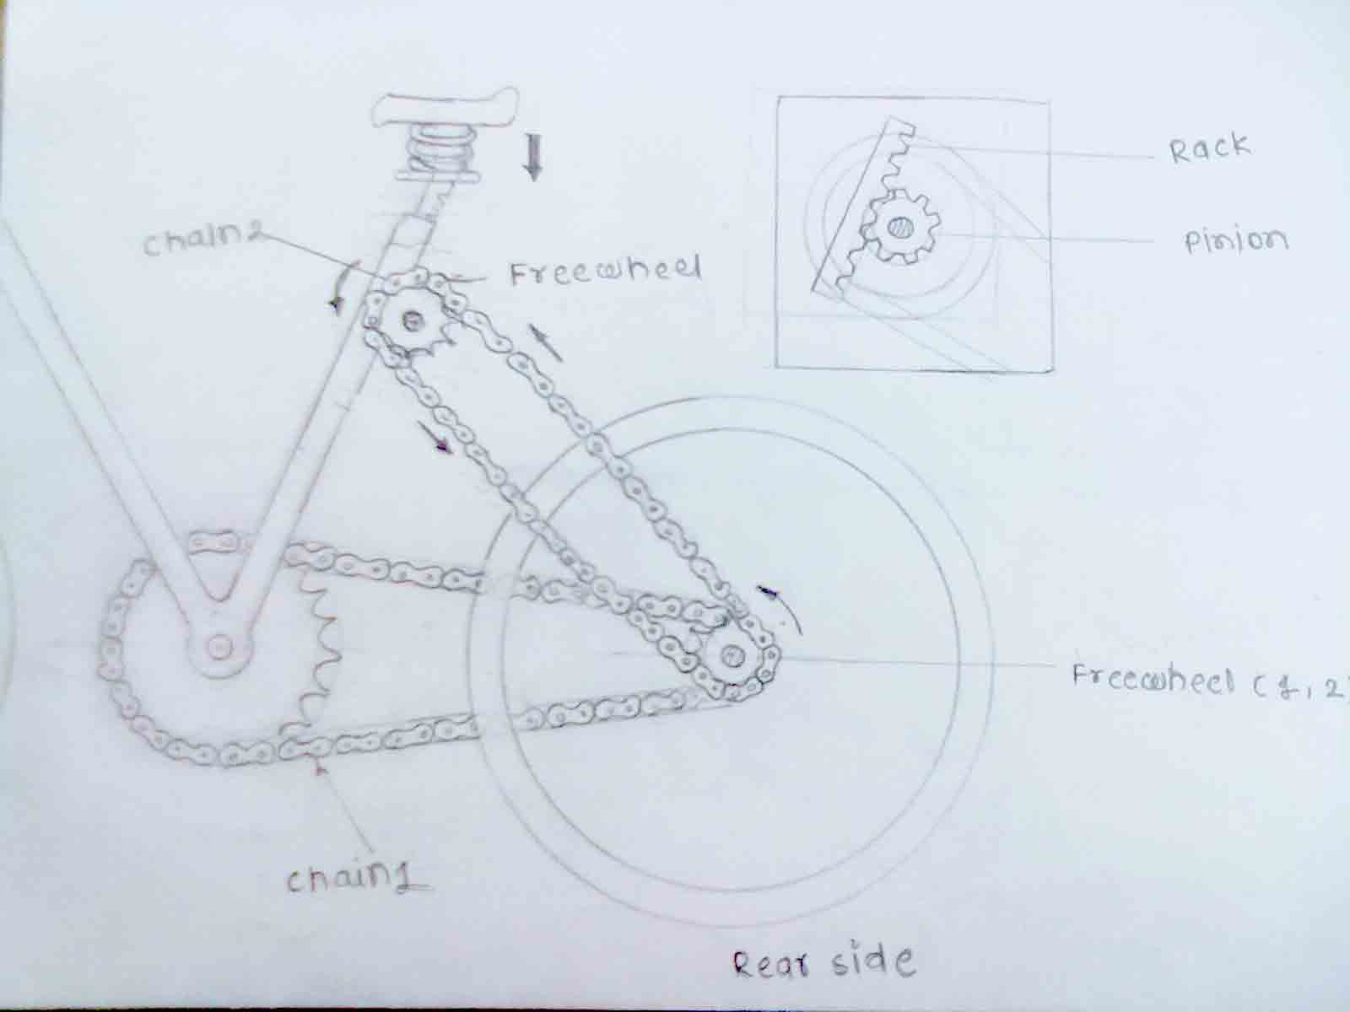A spring is a resilient member capable of providing large elastic deformation. A spring is basically defined as an elastic body whose function is to distort when loaded and to recover its original shape when the load is removed. Mechanical springs are used in machines and other applications mainly

• to exert force, • to provide flexibility • to store or absorb energy.

In general, springs may be classified as either wire springs, flat springs, or special-shaped springs, and there are variations within these divisions. Wire springs include helical springs of round or square wire that are cylindrical or conical in shape and are made to resist tensile,

**Sprocket**

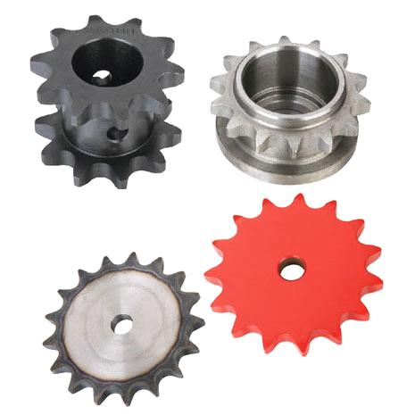

Roller Chain Sprockets, Spur Gears, Chain Couplings, V-Belt Sheaves, Bushings, Idler Sprockets, Synchronous drives, screw conveyors, drag conveyors, bucket elevators, industrial hand tools, and custom commercial forgings, we also offer miter gears, bevel gears, rack and rack gear, 20 degree pitch gears, 14.5 degree pitch gears, engineering class sprockets, plastic sprockets, sintered metal sprockets. Martin Sprocket and Gear is here to serve you with all your pulley and v-belt sheave needs. We offer made-to-order sheaves and sprockets as well as gears. Stainless steel bushings and bronze bushings are among the wide selection of bushings

**Arrangement of components**

In this mechanism , we apply body pressure on the compression spring with the help of seat and uneven road condition .when we apply pressure on the seat spring is compressed at the same time, due to compression rack moves on the pinion, sprocket and pinion are mounted on the same shaft with the help of bearing support . When the pinion rotates on the rack due to rotation power is transmitted to sprocket , with the help of chain this power is transmitted to free wheel. In this way mechanical work which is used to run the bicycle.After that we remove the load on seat freewheel rotates in reverse direction and spring come to its initial position. In this way transmission of pressure energy into mechanical work.

**MECHANISM FROM REAR SIDE OF BICYCLE**

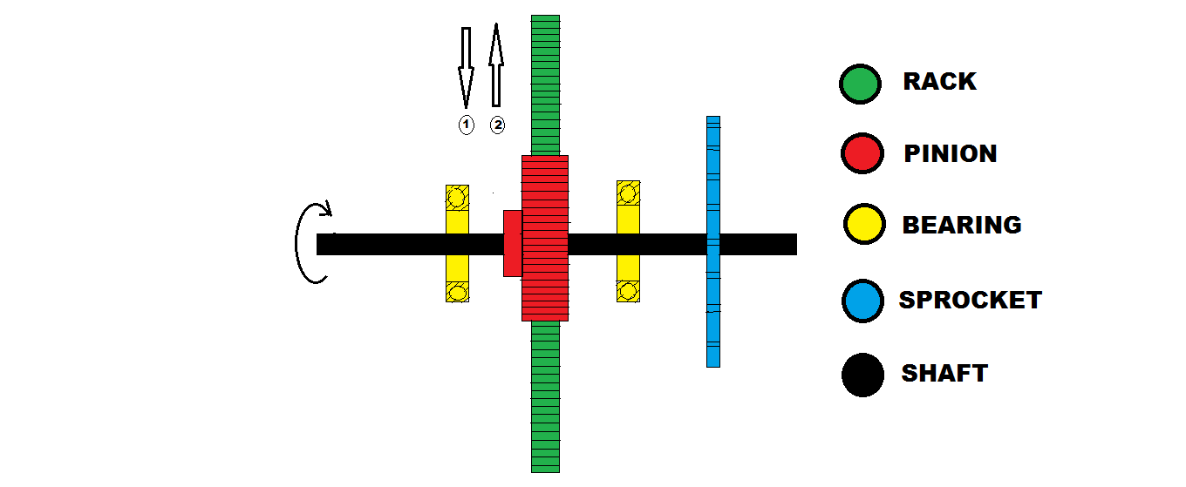

Conclusions

We concluded that by using this mechanism convert the pressure energy of body into mechanicalwork.Itreduce human efforts of paddling,Increase the efficiency of Bicycle

**References**

[1]a b c Brumbach, Michael E.; Clade,Jeffrey A. (2003), Industrial Maintenance ,

Cengage Learning, pp. 112–113, ISBN 978-0-7668-2695-3 .

[2]Sobel, Dava (1995). Longitude . London: Fourth Estate. p. 103.

ISBN 0-00-721446-4 . "A novel antifriction device that Harrison developed for H-3

survives to the present day – ...caged ball bearings."

[3] Speer, Albert (1970). Inside the Third Reich. New York and Toronto: Macmillan.

pp. 331–347.[4] Brunner, Gisbert (1999). Wristwatches – Armbanduhren – Montres-bracelets . Köln,

Germany: Könnemann. p. 454. ISBN 3-8290-0660-8 .

[5]Bicycle History, Chronology of the Growth of Bicycli

[6]R. S. Khurmi and J. K. Gupta “ Theory Of Machine” (2009) 1-35.

[7]R. S. Khurmi and J. K. Gupta “ Machine Design” (2005) 50-125.

[8]TATA Margo Hill “Power generation”<Mechanical power

generation theory Links mechanism> (1998) 312-358.

[9]R. P. Sunkari and L. C. Schmidt, "Structural synthesis of planar kinematic chains by adapting a Mckay-type algorithm," *Mechanism and Machine Theory* 41 (2006) 1021–1030