**FABRICATION OF AIR COOLER DIVERTER STRIP MFG. (conventional method)**

**Suraj Vishwakarma, Rajhans Manwatkar**

**Mechanical engineering department**

**KDK College of engineering, Nagpur**

**Surajvishwakarma619@gmail.com**

**ABSTRACT:**

The Air-Cooler diverter strip available have a typical aerodynamic profile and structure which is the most important operational requirement of the component. To manufacture the strips of this profile with economy precision and other details is a very tedious job to carry in an engineered way. Our seminar deals with the conventional method of strip manufacturing.

**INTRODUCTION:**

Air-Cooler diverter is the basic arrangement used in house-hold desert coolers to control the direction of flow of air. Depending on the type of particular design and employment, various manufacturing schemes are devised with varying degrees of merits and demerits. The project includes 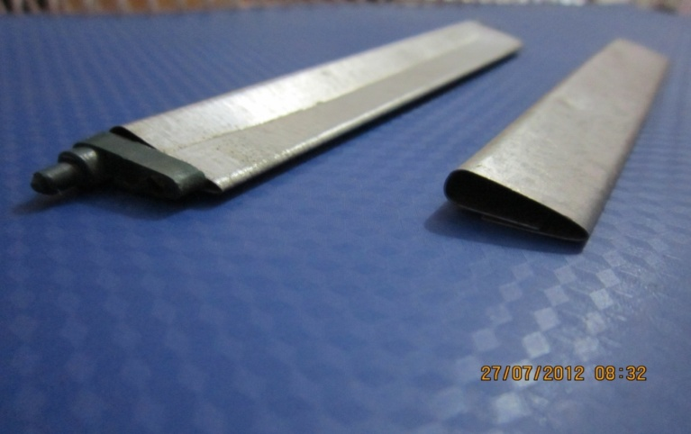the concept and overall assessment of one such manufacturing scheme employed.

The nature of the project has fabrication as its important aspect.

**AIM AND OBJECTIVES:**

* To make study and working of air diverters.
* Detail study of working principle of shearing, hand press.
* To study deformation of sheet

**PROCESS DETAILS**

* Cutting of sheet metal
* Bending of sheet metal
* Total bending of sheet metal

**REFERENCES**

* Manufacturing Science- Ghosh and Mallik
* Production Engineering- P.C. Sharma
* Various Cooler Industries