**A**

**PRESENTATION ON**

**HYBRID POWER SPRAYER**

***Submitted by***

**Ajinkya S. Ujjankar Prashant Girsawale Kaustubh Balpande**

VIII sem, final Year VIII sem, final Year VIII sem, final Year

B.C.Y.R.C’sU.C.O.E,UMRER B.C.Y.R.C’sU.C.O.E,UMRER B.C.Y.R.C’sU.C.O.E,UMRER

***Bachelor of Engineering***

**At**



***Guided by***

**Prof. D. R. Thawkar**

**Department of Mechanical Engineering**

UMRER COLLEGE OF ENGINEERING, UMRER

**2012-13**

**HYBRID POWER SPRAYER**

**Abstract:** “Energy - demand” is one the major thread for our country. Finding solutions, to meet the “Energy -demand” is the great challenge for Social Scientist, Engineers, Entrepreneurs and Industrialist of our Country. According to them, Applications of Non conventional energy is the only alternate solution for conventional energy demand. Now-a-days the Concept and Technology employing this Non-conventional energy becomes very popular for all kinds of development activities. One of the major area, which finds number applications are in Agriculture Sectors. Solar energy plays an important role in drying agriculture products and for irrigation purpose for pumping the well water in remote villages without electricity. This Technology on solar energy can be extended for spraying pesticides, Fungicides and Fertilizers etc., using Solar Sprayers. This paper deals how a ‘Power Sprayer’ which is already in use and works with fossil fuel can be converted into solar sprayers works without any fossil fuel.

**Key words:** Energy alternate device, Solar Sprayer, Agriculture Implements

1. **Introduction:**

The "Energy Demand" of our country is increasing day by day as consumption of energy increased. For the socio-economic development, continuous supply of sufficient energy is very important. It's a challenge to meet overcome the requirement of energy for Government, Industry and all the sectors. The application of "Non Conventional Energy" resources certainly helps to reduce the somewhat energy demand. Usage of non conventional energy resources is increasing. The increase in non conventional energy resources rises due awareness in people. Nowadays it find large number of areas to implement and development. Agriculture Sector also find number of applications of "Solar Energy". Solar Energy plays important role in the agriculture sector as crop production depends upon Climatic conditions. The solar energy can be utilize to spraying the Pesticides, Fungicides, Fertilizers and etc. by using the Hybrid Power Sprayer.

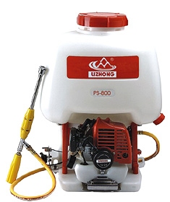

Figure 1: Conventional Power Sprayer

Fig. 1 shows the conventional power sprayer which is presently in use in the agriculture purposes. Sprayer having a two stroke petrol engine, a tank, and sprayer arrangement. This two stroke petrol engine requires petrol to run.

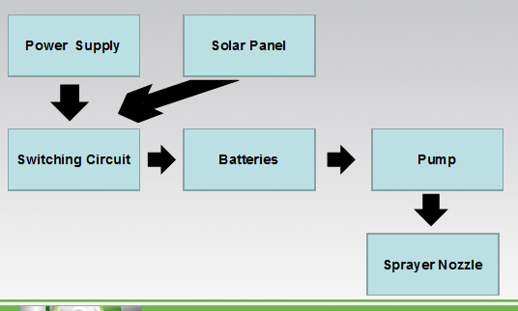

Figure 2. Schematic diagram of Hybrid Power Sprayer

Fig. 2 shows the schematic diagram of Hybrid Power Sprayer. It is consisting of solar panel, switching circuit, batteries, pump, sprayer nozzle. It uses the Solar power or electricity to charge the batteries which will used to run the sprayer. Instead of using conventional fuel we are utilizing the alternative fuel here.

1. **Literature Survey:**

**R. Joshua, V. Vasu and P. Vincent [1]**  developed a Solar sprayer and gives a comparison between solar sprayer and power sprayer. The data is used to make concept of the hybrid power sprayer model. The data will also help us throughout our research and development.

**H. P. Garg J. Prakash [2]** write a book on solar energy. The data used to understand the photovoltaic's technology and the overview of PV system. This data will be helpful in a designing.

**Solar Radiant Energy over India [3]** is a report/research carried out by Report by India Meteorological Department, Ministry of Earth Sciences. Funded by Ministry of New and Renewable Energy,2009. It gives the data about the Solar Energy in India and its overview.

**Rangan Banerjee [4]** is the Forbes Marshall Chair Professor in the Department of Energy Science and Engineering and currently the Dean of Research and Development at the Indian Institute of Technology Bombay. He gave seminar on “Solar Power in India :Technology and R&D” Presentation at Fifth Annual Conference on “Solar Power in India” - June 27, 2012. which gives the overview of recent scenario.

**Peter Meisen [5]** studied about the potential of India in renewable energy and summarized the report. The report is helpful for taking the data.

1. **Problem definition:**

In case of conventional power sprayer, the 2 stroke petrol engine is used. The petrol engine having various parts which required a periodic maintenance. The operating cost goes high as price of petrol rises day by day.

1. **Objective:**

* To analyze the data for conventional sprayer.
* To design a hybrid power sprayer.
* To analyze the data for hybrid power sprayer.

1. **Scope of Problem:**

The conventional power sprayer consist of 2 stroke engine. It requires periodic maintenance which increase its operating cost. We will replace the 2 stroke engine mechanism by Hybrid powered mechanism which will lowers operating cost.

**7. Proposed plan of work:**

1. Literature survey and introduction.
2. Study of each part of Hybrid Power Sprayer.
3. Fabrication of experimental set-up.
4. Conducting experiments by using Solar energy and Electricity.
5. Analysis of recorded data.
6. **Chapter Schemes:**

* Chapter 1. Introduction
* Chapter 2. Literature survey
* Chapter 3. Methodology
* Chapter 4. Experimental set-up
* Chapter 5. Data analysis
* Chapter 6. Work done / Publications
* Chapter 7. Conclusion
* References

**References:**

[1] R. Joshua, V. Vasu and P. Vincent “Solar Sprayer - An Agriculture Implement” International Journal of Sustainable Agriculture 2 (1): 16-19, 2010 ISSN 2079-2107

[2] H. P. Garg and J Prakash “Solar Energy - Fundamentals & Applications” First Revised edition ISBN 0-07-463631-6 pp370.

[3] “Solar Radiant Energy on India” Report by India Meteorological Department, Ministry of Earth Sciences. Funded by Ministry of New and Renewable Energy,2009.

[4] Rangan Banerjee “Solar Power in India :Technology and R&D” Presentation at Fifth Annual Conference on “Solar Power in India” - June 27, 2012

[5] Peter Meisen “Overview of Renewable Energy Potential of India” a report by Global Energy Network Institute (GENI) October 2006