**TECHNOLOGY OF GROUNDNUTSHELLERMACHINE AND FABRICATION**

Akshay Winchurkar Vikash Kumar Dhiraj kumar

8th semester 8th semester 8th semester

Department of Mechanical Engineering

K.D.K College of Engineering

**ABSTRACT**

An invention releated to an improvement of the existing jucier mixture system Automation in industries and domestic has been important role in the development of automatic machinery and equipments for the use in industrial plants and domestic application. The mechanical mechanisms for power transmission has many advantages.

As a part of literature review different total presentation have been collected from the journals. This paper have been found to the co-related to project topic. The system employ the pedal drive arrangement that are most suitable for human fitness and maintained the atmosphere free polluted.

**PAPER ON GROUNDNUT SHELLER MACHINE**

**INTRODUCTION**

* To facilitate the understanding of the present invention, the construction of the prior art pedal operated groundnut Sheller having the functions discuss below.
* The system been cost effective, has a wide applications which when implement can show good and effective result. It can be use deliberately in domestic applications, where the electricity is not available and where the load shading is continue in day time.
* Today electricity consumption rate is not economical so to over come this problem we shows our innovative ideas in our project
* Synchronization of various equipment involve in the system. Preparing a work on existing model and work on it is effectiveness.
* We would like to see this trend continue as commuting by bicycle saves a lot of money, improves your health, and is probably one of the quickest and most effective ways to reduce environmental pollution!

**working**

The final concept was chosen to be the roller-on-roller mechanism. Each of these methods was chosen after careful consideration for how well the concept would function; maintenance, ease of use, simplicity, and manufacturability were also taken into consideration. One of the rollers would be driven using a power source, however, it would be stationary and its mount would be bolted in that position on the frame. The other roller would not be driven; however, it would be able to move on the frame to variable distances from the other roller to allow for different sized seed crops to be passed through. The power source was determined to be a human pedaling a stationary bicycle (Figure 4) which has a chain that connects the bicycle’s gears to the shaft of a separate transmission that was geared to accept the belt that connects a gear already mounted on the driven roller. The rest of the design was then built around those key concepts. The two rollers used for the prototype were realized through a ―purchase solution‖ that were taken from a treadmill.

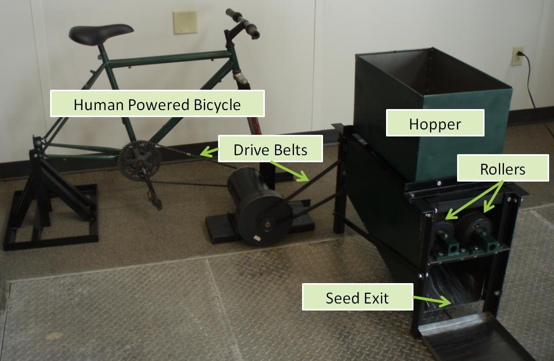

The rollers are especially unique because they not only had a true central shaft, but bearings were also pressed into the inner diameter of the rollers. This made a great deal of difference because it not only cut cost but also significantly reduced manufacturing time. By utilizing the pressed bearings, it eliminated the need for bulky pillow bearings and allowed for cheaper custom steel mounts to be made in-house to connect the rollers onto the frame. It was decided that some kind of texture would need to be put onto the rollers to ensure that the seeds would be pulled through. The rollers were sent to an outside source to be trued and to have a horizontal knurl texture be put onto them.

**Basic components**

• Roller chain drive and sprocket

• Hopper.

• Roller.

• collector.

• Fan.

• Bicycle frame.ne the scope and parameters of the problem.

**1.HOPPER**

Hopper is used to pour dry groundnuts in to a machine. the hopper should be properly design for proper pouration of groundnuts in to a machine.

**2.CHAIN DRIVE**

Chain drive is used to transmit power form one shaft to another by motion with the help of chain.

**3.CONTAINER IN MACHINES**

Container in Sheller machine is used for collection of seed which is separated form groundnut. It is made up by steel having moderate weight

**WHY WE USE DRY GROUNDNUT .**

1.We used dry groundnut because if moisture contain in groundnut is high it difficult to break in actual practice we see that if groundnut is dry it is easily to break than highly moisture contain groundnut. therefore while designing a Sheller machine we can also used this phemenon and considered this while designing. if we feed highly moisture contain groundnuts then they have possibility to physically damage of groundnut.

2. properties of groundnut which include the size, mass, bulkdensity , true density, sphericty, porosity , coefficient ofstatic fiction and angle of repose and resultant systemsleads to reduction in working efficiency .

3. This study was therefore carried out to determine thegeometric properties (length, width, thickness , geometricand arithmetic mean diameter, sphericity and surfacearea) , gravimetric properties (including unit mass, grain mass, true volume, true density , bulk density ,andporosity) and frictional properties (angle of repose andstatic coefficient of friction) of groundnut in order todevelop appropriate equipment that will reduce postharvest losses and thus enhance productivity .

**METHDOLOGY**

When we start to rotate the bicycle pedal by human effort the rotational motion of drive sprocket transfer towards the Sheller machine driven sprocket shaft ,during rotation of pedal Sheller drum also rotate and as feeding the ground nut start broken in parts ,the broken parts of ground nut travel out on path during traveling seeds separated from shell and shell thrown away by blower air flow.

**conclusion**

 The Peanut/Groundnut Sheller is a simple machine, requiring less than $10US of materials. It is hand operated and is capable of shelling 50 kilograms of raw, sun-dried nuts per hour.   
It is made of concrete, poured into two simple fibreglass molds, some primitive metal parts, one wrench and any piece of rock or wood that might serve as a hammer. It accepts a wide range of nut sizes without adjustment. If necessary, adjustment is easily done in seconds.In Mali, it is estimated that one machine will serve the needs of a village of 2000 people. The life expectancy of the machine is around 25 years.