**Load Operated Power Assisted Bicycle**

Ashayraj Nagdive, Keshao Daud, Mayur Jogi, Anurag Lale Prepared Under Guidance of Prof. A.H. Ingle Sir, SRPCE

*Abstract*—The conventional electric bicycles in the market today are very expensive. They are controlled using a discrete accelerator unit. Also when the bicycle is being run through battery power, the rider remains idle. The aim of our ‘POWER ASSISTED BICYCLE’ is to create an economically viable hybrid bicycle that utilizes both manpower and the electric power from the battery at the same time. The ratio of power to be obtained from the rider and the battery is controlled intelligently using a microcontroller assembly. This leads to optimum utilization of power and increases the overall efficiency of the bicycle. All this is done without any effort on part of the rider. He is not required to learn any new riding technique. Our ‘POWER ASSISTED BICYCLE’ is superior to the conventional mass marketed electric bicycles due to reasons like increase in battery backup as only partial power is obtained from the battery. It also promotes exercising as the rider is required to keep pedaling at all times during operation. The bicycle is comparatively cheaper as compared to its specialized imported counterparts and hence is economically more suitable for people of India.

# INTRODUCTION

The first electric bicycle is credited to Mr. Ogden Bolton Jr. in the year 1895. Modern electric bicycles are vastly different from that initial prototype but the underlying concept is the same. External power is supplied to the bicycle by means of a battery operated d.c. motor. This d.c. motor can be controlled using a switch or a handlebar mounted throttle unit.

In our ‘Power Assisted Bicycle’, the d.c. motor only supplies partial power, with the other part being supplied by the rider. The force applied by the rider is sensed using a pressure sensor mounted on the pedal of the bicycle. If the rider is found to be exerting a force beyond some predetermined threshold, then the motor is immediately switched on by the microcontroller, to ease the effort applied by the rider. Thus we can say that in our ‘Power Assisted Bicycle’ the motor is regulated by pedaling and not by some external throttle unit.

The electrical bicycles have many clear advantages over the traditional fuel based means of transportation. The most important advantage is the savings in fuel achievable. Traditional fossil fuels like petrol and diesel are in short supply on earth. They are non-renewable sources of energy and will take a long time to replete. Sooner or later the demand for fossil fuels is going to outstrip the supply, and to be better prepared for that time it is very essential to explore alternative fuel sources. Needless to say that since electric power is much cheaper than fossil fuel, e-bikes bring about savings in fuel and are economically feasible for developing countries like ours. Also since electric supply is available in almost every house around the world, there is no need to worry about recharging of the vehicle.

Electric bicycles also bring about many health benefits. Many people avoid cycling to avoid being exhausted. Power assisted bicycles reduce the amount of effort required from the rider as partial power is supplied by the battery powered motor. As such, electric bicycles are an excellent mean of exercising for those looking for light workout. These bikes are also great for going over moderate distances or hilly areas that are difficult to travel using conventional bicycles.

When compared to fuel based vehicles, the electric bicycles are clean and green. They have negligible contribution towards the emission of greenhouse gases. Most electric bicycles can be classified as zero-emissions vehicles, as they emit no combustion byproducts. The environmental effects of electricity generation and power distribution and of manufacturing and disposing of (limited life) high storage density batteries must be taken into account. Even with these issues considered, electric bicycles will have significantly lower environmental impact than conventional automobiles, and are generally seen as environmentally desirable in an urban environment. The small size of the battery pack on an electric bicycle, relative to the larger pack used in an electric car, makes e-bikes very good candidates for charging via solar power or other renewable energy resources.

Electric Bicycles also have low operating cost as compared to the fuel based vehicle. Other than the savings in fuel, e-bikes also have very low maintenance cost. They don’t have any big moving part or complex machinery. Brushless type d.c. motor has a very long life and requires no maintenance. Options are also available to use NiMH, NiCd and/or Li-ion batteries which offered lighter, denser capacity batteries. Also since in most countries, the e-bikes requires no license or registration and this brings about savings in third-party costs.

# Objective of Project

The aim of our ‘POWER ASSISTED BICYCLE’ is to create an economically viable hybrid bicycle that utilizes both manpower and the electric power from the battery at the same time. The ratio of power to be obtained from the rider and the battery is controlled intelligently using a microcontroller assembly. This leads to optimum utilization of power and increases the overall efficiency of the bicycle. The conventional electric bicycles in the market today are very expensive. They are controlled using a discrete accelerator unit. Also when the bicycle is being run through battery power, the rider remains idle All this is done without any effort on part of the rider. He is not required to learn any new riding technique. Our ‘POWER ASSISTED BICYCLE’ is superior to the conventional mass marketed electric bicycles due to reasons like increase in battery backup as only partial power is obtained from the battery. It also promotes exercising as the rider is required to keep pedaling at all times during operation. The bicycle is comparatively cheaper as compared to its specialized imported counterparts and hence is economically more suitable for people of India.

# Components

## The various components which are used in the project are listed below

## 1. Bi-Cycle

## 2. DC-Motor

## 3. Two 12V battery

## 4. Chain drive

## 5. Transmitter and Receiver

## 6. Load sensors

## Also, the electronic components which are used so as to get an intelligent output as desired are listed below

## 1. Microcontroller ATmega32-It is controlling element which sends the output to the driver ic according the programmed instruction saved in it, as stimulated by the input from the load sensor.

## 2. Driver IC-L293D- The driver IC L293D is used in the circuit to drive the motor, it amplifies the voltage from 5V to 12V supply dc voltage.

## 3. Voltage regulator IC-7805- The voltage regulator I.C is used for converting higher voltage to lower voltage, it converts the 12V magnitude of voltage to 5V magnitude.

## Electronic components play a vital role in gaining the motto of the project. The main aim of the project is to control the entire process of acceleration intelligently without any discrete accelerating unit, with aid of microcontroller, driver IC and voltage regulator IC as stated above. The entire working of these components is described further.

# Working

For our final year project we will be assembling a working prototype of a ‘Power assisted bicycle’. We will be purchasing a commercially available d.c. motor (12V, 360 rpm) and coupling it with a battery (7A, 12V). The controlling of the motor will be done via a microcontroller assembly consisting of Atmel Atmega32 (microcontroller), L293D (amplifying motor driver IC) and a KIA7805 IC (Voltage regulator IC). The ICs will be mounted on a PCB that we will be fabricating in the later stages of our project. All these components will be mounted on the frame of a conventional geared bicycle.

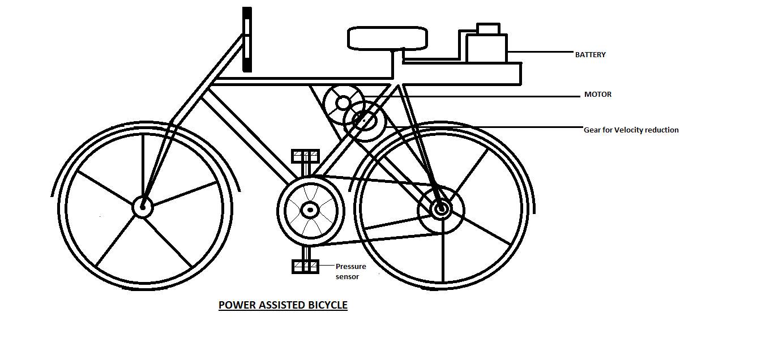

As shown in the figure, the battery pack will be mounted on the carrier space of the bicycle. This battery will be coupled with the d.c. motor which will be positioned as shown in the figure. A gearbox will be attached to the motor to obtain the required gear reduction ratio (70:1) and the power from the gearbox will be supplied to the rear wheel axis using a chain drive.

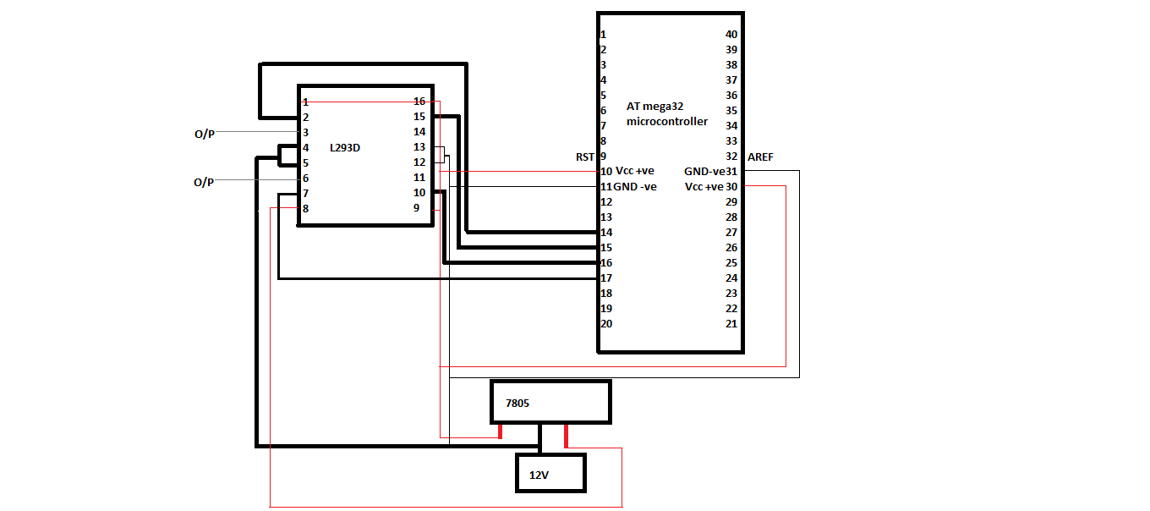

The motor will be regulated by the microcontroller assembly which will get its input from the pressure sensors mounted on the pedal of the bicycle. The inputs from pressure sensors will be be given to the Port A of the microcontroller. The microcontroller will determine the required power to be obtained from the motor and give its output to the L293D IC. This IC will amplify the output of the microcontroller and convey it to the motor, so that the required amount of power can be obtained.

# Advantages

* Economical.
* Easy To operate.
* Great physical exercise.
* Saving the environment.

# Scope

* With the recent hike in oil prices, replacing your car with a bike makes more sense, rather than splurging on gasoline. Aside from the fact riding the bike is healthy; it is also cost effective and environmental friendly.
* The battery can be recharged with aid of solar energy using solar panel thus full utilization of renewable source of energy.
* Regenerative braking system can be used to conserve the power wasted while applying brakes. This power can be used to recharge the battery.
* As electric bicycles market is growing with new innovations and add-ons, users have more choices in picking up over models, styles, power, and operating efficiencies.
* The electric bicycle has undergone continual adaptation and improvement since its inception. These innovations have continued with the advent of modern materials and computer-aided design, allowing for a proliferation of specialized bicycle types.

# references

www.freepatent.com – The official website

www.google.com

www.youtube.com

en.wikipedia.org

www.atmel.com

www.DatasheetCatalog.com