**ELECTRICALLY ASSISTED REGENERATIVE BICYCLE**

**DEPARTMENT OF MECHANICAL ENGINEERING**

**K.D.K. COLLEGE OF ENGINEERING, NAGPUR.**

**GUIDED BY : PROF. S.K. CHOUDHARI**

**Submitted By:**

**Ankit Nimje**

**Swapnil Lende**

**Sachin Gohokar**

**8th Sem,**

**Department Of Mechanical Engineering,**

**K.D.K.C.E.,**

**Nagpur.**

**Registration No:404**

**ELECTRICALLY ASSISTED REGENERATIVE BICYCLE**

**DEPARTMENT OF MECHANICAL ENGINEERING**

**K.D.K. COLLEGE OF ENGINEERING, NAGPUR.**

**Guided by : Prof. S.K. Choudhari**

**INTRODUCTION:**

An **electric bicycle**, also known as an **e-bike**, is a [bicycle](http://en.wikipedia.org/wiki/Bicycle) with an [electric motor](http://en.wikipedia.org/wiki/Electric_motor) used to power the vehicle. Electric bicycles use rechargeable batteries and can travel up to 15 to 20 mph (24 to 32 km/h). In some markets they are rapidly replacing traditional bikes and motorcycles.

Some of the less expensive electric bicycles used bulky lead acid batteries, whereas newer models generally used NiMH, NiCd and/or Li-ion batteries which offered lighter, denser capacity batteries. Performance varied; however, in general there was an increase in range and speed.

[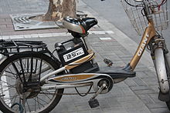](http://en.wikipedia.org/wiki/File:Electric_bike_shanghai.JPG)

The very best thing that assisted bikes offer is confidence: confidence that you can take off from the intersection quickly enough to be comfortable in traffic and confidence that you can head off on a day ride with friends or family and you’ll be able to keep up with ease. They are also chosen by riders who don’t want to get sweaty on the way to work or who ride over hilly terrain.

Most lithium ion batteries can be fully recharged about 500 times. A partial re-charge is a fraction of a full recharge. This equates to about 20,000km of riding. Replacement batteries are available for all the bikes on this test.

## ABOUT THE BLDC MOTOR:

The Brushless DC (BLDC) motor is the ideal choice for applications that require high reliability, high efficiency, and high power-to-volume ratio. Generally speaking, a BLDC motor is considered to be a high performance motor that is capable of providing large amounts of torque over a vast speed range. BLDC motors are a derivative of the most commonly used DC motor, the brushed DC motor, and they share the same torque and speed performance curve characteristics. The major difference between the two is the use of brushes. BLDC motors do not have brushes (hence the name "brushless DC") and must be electronically commutated.

A BLDC motor is highly reliable since it does not have any brushes to wear out and replace. When operated in rated conditions, the life expectancy is over 10,000 hours. For long term applications, this can be a tremendous benefit. Whenever a motor breaks down or needs to be replaced, your project, or part of it, must be shut down. This costs you time and money, perhaps a great deal depending on how long it takes to replace the worn part or parts and get the application started again. Although a BLDC motor may cost more than a brushless motor, it will often more than pay for itself in the amount of work time saved.

The drive unit uses a brushless DC motor "BLDC". This type of motor has tremendous advantages over a brushed DC motor including better reliability, more power, better efficiency, low maintenance, and all parts in a sealed enclosure. You can read a lot more about BLDC motors

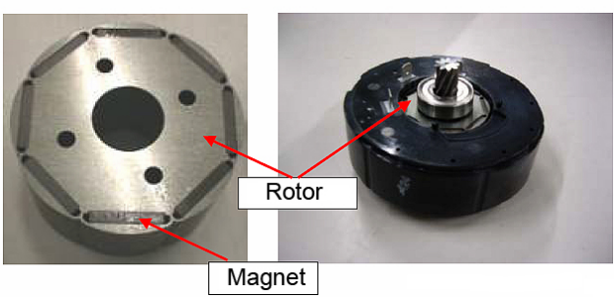

Some important features and advantages of the BLDC motor over a brushed DC motor are:

* No electrical contacts. Brushes need to be maintained regularly, and as they wear down they leave debris inside the motor that can contaminate the contacts, making the motor less efficient or inoperable. Eventually they need to be replaced. The brushless motor works without contacts, which makes it low-maintenance and better at transferring power to move you forward.
* The magnets move, the motor coils don't. Most other electric motors have it the other way around. This means that the rotor can be lighter which makes it more responsive and efficient. The other advantage is that the driver coils of the motor stand still. They don't need to be reinforced to spin at high speed without problems and they can be cooled by conduction rather than airflow.

Below is a picture of the motor coils from the Panasonic motor. On the left is an unfinished unit that shows the arrangement of wiring that turns power into motion. The rotor fits into the middle of this unit. On the right are photos of a completed unit and a cut-away model that shows its construction. Note that the finished unit is encased in resin, which helps cool it off, and makes it possible to extract more power from a smaller and lighter motor.

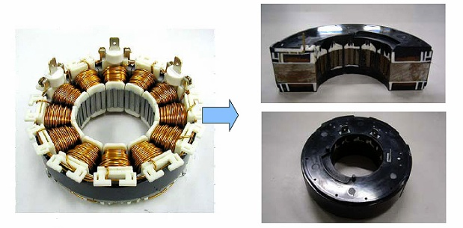

**DETAILED DESCRIPTION**:

|  |  |
| --- | --- |
| Voltage | 24V |
| Design | Brushless |
| Wattage | 201 - 300w |
|  |  |
| Function | Driving |
| Torque Value | 30 N.M |
| Shape | Round |
| Fork | Suitable for standard fork size |
| Weight | Light weight small size |