**“SOLAR OPERATED UV WATER PURIFIER”**

1.Ashish Bhagat 2.Bhushan Asamwar 3.Abhishek kumar Singh

Reg no.:-ME-158

Students of Final Year, Bachelor of Engineering

Department of Mechanical Engineering

Umrer College of Engineering, Umrer Dist. Nagpur

**ABSTRACT**

The lack of clean drinking water is a problem that plagues many areas of the world today.  Approximately 884 million people suffer each day from insufficient quantities of clean, drinkable water.  Most of the current technologies available to combat this problem are expensive and consume too much power to be effective in rural regions of the planet.  The solutions that do not consume an excess of power generally require expensive and time consuming filter maintenance.  The use of chemical processing mechanisms of purification is an affordable solution, but it has been known to be hazardous if used improperly.  With the idea of low cost and sustainability in mind, we plan to develop a water filtration system that will take advantage of natural energy in order to power a water purification system.  Water will enter the system, where it will flow through a sediment filter and then be processed by a UV purifier.  By using both standard sediment filtration and ultraviolet radiation purification techniques, our goal is to produce water with a total concentration of less than 0.01% Coliform bacteria. In order to save on energy and cut costs, water will enter the system manually and use gravity to pull it through the system, eliminating the need for a pump.  We plan to use photovoltaic technology to transform sun rays into electric potential that will be stored in a battery backup system.  This battery system will power the ultraviolet purification process of the system. When water comes in contact with UV lamp it gets disinfected by the removal of the bacteria from the raw water entering the system.

**Introduction:**

Water purification is the process of removing undesirable chemicals, biological contaminants, suspended solids and gases from contaminated water. The goal is to produce water fit for a specific purpose. Most water is purified for human consumption drinking water, but water purification may also be designed for a variety of other purposes, including meeting the requirements of medical, pharmacological, chemical and industrial applications. In general the methods used include physical processes such as [filtration](http://en.wikipedia.org/wiki/Filtration), [sedimentation](http://en.wikipedia.org/wiki/Sedimentation), and [distillation](http://en.wikipedia.org/wiki/Distillation), biological processes such as [slow sand filters](http://en.wikipedia.org/wiki/Slow_sand_filters) or [biologically active carbon](http://en.wikipedia.org/wiki/Activated_carbon), chemical processes such as [flocculation](http://en.wikipedia.org/wiki/Flocculation) and [chlorination](http://en.wikipedia.org/wiki/Chlorination) and the use of electromagnetic radiation such as [ultraviolet light](http://en.wikipedia.org/wiki/Ultraviolet_germicidal_irradiation).

The purification process of water may reduce the concentration of particulate matter including [suspended](http://en.wikipedia.org/wiki/Suspension_(chemistry)) [particles](http://en.wikipedia.org/wiki/Particle_(ecology)), [parasites](http://en.wikipedia.org/wiki/Parasite), [bacteria](http://en.wikipedia.org/wiki/Bacteria), [algae](http://en.wikipedia.org/wiki/Algae), [viruses](http://en.wikipedia.org/wiki/Virus), [fungi](http://en.wikipedia.org/wiki/Fungi); and a range of dissolved and particulate material derived from the surfaces that water may have made contact with after falling as [rain](http://en.wikipedia.org/wiki/Rain).

**What is ultraviolet?**

Ultraviolet light is [electromagnetic radiation](http://en.wikipedia.org/wiki/Electromagnetic_radiation) with wavelengths shorter than [visible light](http://en.wikipedia.org/wiki/Visible_light). UV can be separated into various ranges, with short range UV ([UVC](http://en.wikipedia.org/wiki/Ultraviolet)) considered “germicidal UV.” At certain wavelengths UV is mutagenic to bacteria, viruses and other micro-organisms. UV radiation of wavelength 2,537 [Angstroms](http://en.wikipedia.org/wiki/Angstroms) (254 nm) directly attacks DNA of micro-organisms. Microorganisms are killed as they come in contact with UV light within seconds.

In this project:-

UV radiation from ultraviolet water systems alone is not suitable for water with high levels of suspended solids, turbidity, color, or soluble organic matter. These materials can react with UV radiation, and reduce disinfection performance. Water turbidity makes it difficult for the Ultraviolet radiation to penetrate water. If your water supply has these characteristics, a  [Sediment Prefilled](http://www.freshwatersystems.com/c-732-sediment-prefilter-kits-for-uv-systems.aspx) (5 micron or less) should be installed before your UV water purification system to remove particulate matter prior to UV water disinfection.  
Ultraviolet radiation can be used as a pretreatment or polishing step to sterilize and disinfect water.  UV systems are typically used to pre-treat a water supply that is considered biologically unsafe (lake or sea water, well water, etc).  The UV disinfection process is a non-chemical method for destroying microorganisms by altering their genetic material, and rendering them unable to reproduce.

**Objective:**

Now a days, we are using conventional energy sources for purification of Drinking Water in household and treatment plant. We can use nonconventional energy sources to purify water. UV provides water purification without addition of harmful chemicals such as chlorine. It also avoids the potential of generating harmful chemical disinfection byproducts. UV does not change the taste, odor and color of water.

The objective to this project is to design a low-cost and easily manufactured water filtration system for use in households. This water filtration system will include a water filtering component, a lidded container to hold clean water and a valve for easy access of water. Manufacturing facility arrangement will also be examined and planned. The water filtration system is designed to provide safe drinking water for households of four to eight people. In order to achieve the low cost, use of simple technology and readily available materials are the prime consideration needed to insure production of the filters in the local area.

Existing water filters have been analyzed and compared to determine the best type on the basis of cost, material availability, and effectiveness. Filter dimensions are calculated base on amount of water consumption per household and flow rate of filter. Water samples are analyzed at a licensed laboratory to demonstrate the effectiveness of the filter design and a working prototype will be available by the end of the academic year.

**COMPARISON OF UV PURIFIER WITH OTHER PURIFICATION SYSTEM**

|  |  |  |
| --- | --- | --- |
| **PARAMETERS** | **SOLAR OPERATED WATER PURIFIER** | **OTHER PURIFICATION SYSTEMS** |
| Purification capacity | our system disinfects maximum raw water entering the system | Household RO units recovers only 5-15% of water entering the system. The reminder is discharged as the waste water from the system to the drainage. |
| Disinfection | UV radiation are able to kill the bacteria present in the water. | No other system are able to kill the bacteria present in the water. |
| Power source used | It uses non conventional source of energy which is freely available. | Other purifiers uses conventional source of energy. |
| Affection to characteristics of water | The taste and other characteristics remain as it is. | Characteristics of water like taste, smell, color may change |
| Cost of filtration | It is cheaper filtration process. | The other filtration system may be costlier than UV filtration system. |
| Maintenance | No need to change the UV lamp until it gets fused  (life of UV lamp is 2-3 years ) | Particle fiber filters and ceramic filters need to be cleaned regularly to avoid bacteria buildup. most disposable filters have a service cycle |
| Effects on mineral contents. | There is no affect on the minerals present in water by the UV disinfection process. | Due to its fine membrane construction, reverse osmosis not only removes harmful contaminants that may present in water, it also strips many of the good, healthy minerals from the water as well and finally we get the demineralised water. |

**Construction:**

Figure consists of following parts

1. Solar panel
2. Electronic circuit
3. Battery
4. UV assembly and UV light
5. DC motor
6. Sensors
7. Two water storage tanks

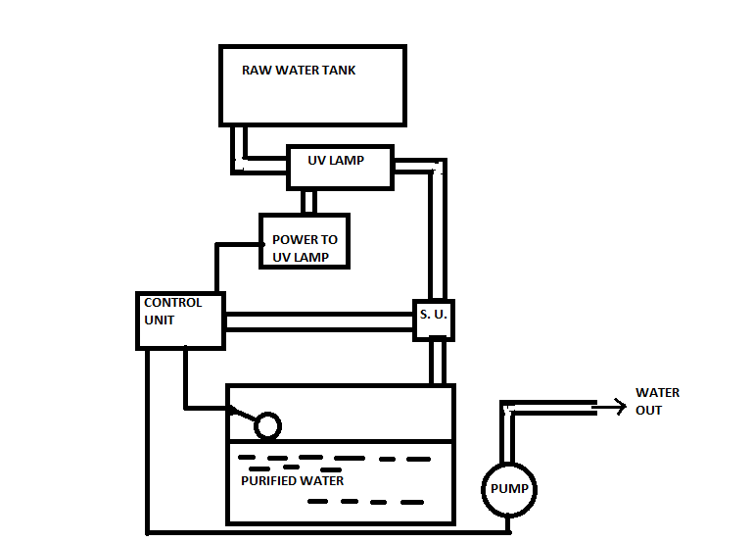

As figure shows the sketch of solar operated UV water purifier. It consist of the parts as listed above. Solar panel is attached with the battery by a set of cables this solar panel mounted on a frame. Rectifier circuit which is used to avoid the backflow of the current from the battery to the solar panel having one end is connected to the solar panel and another is connected to the battery. Power to glow the UV lamp is provided by the battery. Input water is passed through the pre-filter which removes the dirt, mud, and clay particles (physical contaminants)from the water. Then water is poured into the tank due to the gravity in the raw water tank. These water flow down into uv assembly which is having the two ports one is inlet and another is outlet for flowing the water and the UV lamp fitted at the center of the UV assembly. From the outlet purified water comes out and stores into the bottom storage tank. The bottom storage tank is fitted with the level sensor to maintain the level of the water in the storage tank. DC pump is provided to pump the purified water to the tap for drinking purpose. The metal sensor is provided at the tap as the metallic glass comes in the contact with the sensor the water tends to discharge from the tap.

**working :**

* Solar panel collects all the rays incident on the surface of the panel.
* These sunrays will excite photons which causes electrons to flow through circuit and produces charge.
* This charge will be stored in battery in the form of electrical energy.
* Water will starts flowing from the raw water tank to the UV assembly with help of the gravity,as the enters into these assembly the water flows around the UV lamp the UV radiations having a high intensity of around 200-400 nm incidents on the water as it flows through the periphery of the UV lamp for the disinfection purpose of the water.
* These disinfected water is stored in the bottom storage tank for providing the water when required.
* As the level of water in bottom storage tank goes below the level sensor the restricted flow of the water will started and UV lamp to switched on for the disinfection of the water.
* As the UV lamp glows, water around lamp comes in contact with radiation of 254nm which is of UV-C type and gets disinfected.
* As UV-C radiation is germicidal in nature it will disinfect water second.
* These water is stored in bottom storage tank can be utilized when the metallic container comes in the contact of the metal sensor fitted at the tap.
* The flow of disinfected water starts and water is available to drink.

**References:**

* + M. R. Shaeri and M. Yaghoubi “Numerical analysis of turbulent convection heat transfer from an array of perforated fins” International Journal of Heat and Fluid Flow 30 (2009) 218-228.
  + K. H. Dhanawade and H. S. Dhanawade “Enhancement of forced convection heat transfer from fin arrays with circular perforation” 978-1-4244-9082-0/10/©2010 IEEE.
  + E. A. M. Elshafei “Natural convection heat transfer from a heat sink with hollow/perforated circular pin fins” Thermal Issues in Emerging Technology, ThETA 3, 978-1-61284-266-0/10/©2010 IEEE.
  + Abdullah H. AlEssa, Ayman M. Maqableh and Shatha Ammourah “Enhancement of natural convection heat transfer from a fin by rectangular perforations with aspect ratio of two” International journal of Physical Sciences Vol. 4(10),pp.540-547, October, 2009.
  + Abdullah H. AlEssa, Ayman M. Maqableh and Shatha Ammourah “Enhancement of natural convection heat transfer from a fin by triangular perforations of bases parallel and toward its base” The Arabian Journal for Science and Engineering, Volume 34, Number 2B, pp.531-544, October, 2009.
  + ULTRAVIOLET RADIATION AND ITS GERMICIDAL EFFECT IN DRINKING WATER PURIFICATION, Journal of Phytology 2010*,* **K.M.Johnson**
  + JOURNAL OF TOXICOLOGY AND ENVIRONMENTAL HEALTH,

**P. Murgan**