Analysis & Design of Bridle Roll Shaft in JSW Ispat Steel Ltd

¹Ashish Marode, ²Ratnadip Somkuwar , ³Bhushan Agarkar
Students of Final Year, Bachelor of Engineering
Umrer College of Engineering, Umrer Dist. Nagpur
aeroashd@gmail.com, rdssomkuwar@gmail.com
Mo.9158524118

Abstract: In this study, the failure of bridle roll shaft has been selected as investigation topic. It essentially focuses on both stress and fatigue analyses. Ispat Industries Limited is leading manufacturing of Cold rolled, Galvanized steel. Bridle rolls are used in processing line at number of location in continuous galvanizing line (CGL-4). The problem identified here is the failure of drive end bridle roll shaft located at exit section in one of the galvanizing unit. Some of the rolls observed cracks near the step of 110-130mm near the welded portion on drive end shaft. The shaft failed due to the cyclic loading which cause for the fatigue failure. These results in the entire load acting over the bridle roll shaft causing pre-stressing of shaft because of the welding of shaft to external barrel of 1050mm. The analysis has been carried out for dynamic loading. Finite element analysis revealed that the stresses acting at fractured region are exceeding the yield stress values. A 3D modeling software PRO/E is used to prepare a CAD model of bridle roll shaft and evaluate the results in the form of stresses by applying the calculated loads in the finite element analysis software ANSYS 12.
Keywords: Bridle Roll, fatigue loading, cyclic loading, stresses, finite element analysis

1. Introduction

ISPAT Industries Limited was one of the first Indian companies to set up a Continuous Galvanizing Line for thin gauge sheets in 1985 at Kalmeshwar near Nagpur. The company pioneered in the manufacture of thin, medium and thick gauge cold rolled coils, galvanized steel, color coated sheets in the country. With two Galvanizing Lines, one galvalume line at its plant at Kalmeshwar, it manufactures coils and GP/GC sheets that meet the needs of the most demanding customers. Bridles function as tension amplifiers or line-speed pacers in metal strip process lines. The typical speed regulated bridle consists of several rolls each of which is driven by an individual power source. Bridle roll compose of body, face, neck and bearing supported shaft. Bridle roll compose of body, face, neck and rive & non-drive shaft. Failure occurs at neck of drive end shaft. The bridle roll has a double function. At normal running of line, it increases the strip tension to the required value for the purpose of proper winding at the recoiler unit. At the time of strip cutting at exit, it maintains upstream the correct value of strip line tension. Bridle roll has two rolls, both individually driven by A.C. motor with frequency control through gear box having ratio of 35.5:1. The problem identified in the operation condition of bridle roll in continuous galvanizing line is that the bridle roll shaft fails due to bending and torsional stress. Following are the observations on failed shaft. It should be noted that, the drive end shaft is an integral part of bridle roll provided at the exit section is driven by 55 KW motor. Bridle roll is made of two half shaft welded to external barrel of 1050mm diameter through number of circular plates. The bridle roll shaft usually fails during processing of higher gauge HR sheet of thickness above 2.5mm up to 3.15 mm. Failure initiates near the welded region at the step of 110-130 mm diameter. Failure initiates at the radii of shaft which progresses and shears the bridle roll shaft into two pieces.
Bridle Rolls
In Continuous process industry many types of roll are used for various applications; however process rolls used are classified in to two as working & conveying. Working rolls are used for changing the product being process .This included cold rolling mill, hot rolling mill rolls used for reduction of sheet thickness & shape. Printing press rolls used for transferring pattern to product. Corrugation rolls used for changing the profile of sheet. Conveying rolls are mainly having application of transferring product from one place to other. This type rolls are smaller diameter and are generally nondriven to large diameter used for transferring sheets, paper, and textile products in continuous process industry. A series of rolls that provide line tension and/or driving force to the metal strip as it moves through a continuous processing industry. Bridles function as tension amplifiers or line-speed pacers in metal strip process lines. The typical speed regulated bridle consists of several rolls each of roll individually driven by power source. One of the rolls in the bridle is speed regulated. .
Bridle roll compose of body, face, neck and bearing supported shaft. Bridle roll having larger diameter ranging from 900 to 1200 mm diameter .The outer barrel is welded to two half shaft through no of circular plates & ribs. The outer barrel of 1050 mm diameter is further coated with nitrite coating of hardness of 80-85 shore hardness, to have better grip of sheet with roll. Two half shaft made from 140 mm diameter MS rod, one is drive &other is non drive is steeped shaft. Drive shaft is having provision for fitting gear coupling is driven by motor of 55 KW. Complete bridle roll having two bearing support at 1750mm apart.

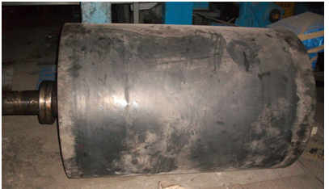
Fig. 1 Bridle Roll Shaft
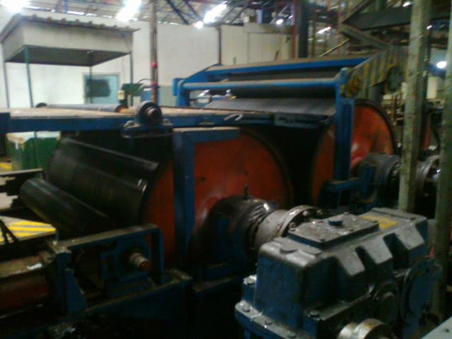
Fig. 2 Bridle Roll Setup
2. Force analysis of Bridle Roll Shaft
- Static analysis may be used to determine the forces and moments acting on a joint when no motion takes place or at one instant in time during a dynamic activity.
- A simplified technique is used such as a free body diagram and limits the analysis in one plane.
- Forces acting on bridle roll shaft :
Stress Raiser in shaft due to various parameters that are acting on bridle roll are as follows
1) Shear stresses due to torque transmission by motor of 55 KW
2) Bending stresses due to forces acting by
i) Weight of roll shell
ii) Weight of sheet
iii) Weight of shaft itself
iv) Strip tension on forward & backward direction for 225⁰ angle of lap
3) Stresses due to combined torsional and bending load

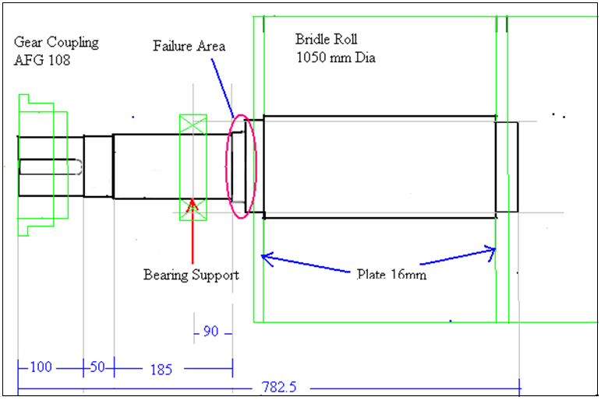
Fig.3 Bridle Roll unit drive end shaft geometry
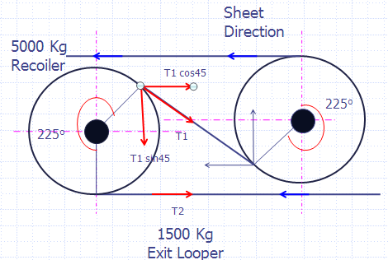
Fig.4 Forces acting on Bridle roll (side view)
The stress analysis for the bridle roll shaft is carried out for fatigue analysis in two ways i.e. by
1) Analytical Analysis and
2) Finite Element Analysis.
For the analysis the technical specifications in which the total length and other parameters are mentioned . For the static analysis the shaft is considered like a horizontal cantilever shaft fixed at its one end. The forces acting over the bridle roll has been designed and used for analysis of shaft. The strip tension on forward & backward is treated as belt tension.
W

T1

T2

3.Fatigue
.Most equipment and components such as shafts are subjected to fluctuating loads whose magnitude is well below the fracture load. Fatigue damage of components subjected to normally elastic stress fluctuations occurs at regions of stress (strain) raisers where the localized stress exceeds the yield stress of material. After a certain number of load fluctuations, the accumulated damage causes the initiation and subsequent propagation of a crack, or cracks, in the plastically damaged regions. This process can and in many cases does cause the fracture of components. So, the more severe the stress concentration, the shorter the time to initiate a fatigue crack. According to ASTM E 1150, fatigue is stated as “The process of progressive, localized, permanent structural change occurring in a material, subjected to conditions that produce fluctuating stresses and strains at some point or points and that may culminate in cracks or complete fracture after a sufficient number of fluctuations”. Fluctuations may occur both in stress and with time (frequency). Thus, going further from this statement, one can say that, when failure of a moving machine element occurs, it is usually due to so-called fatigue. Fatigue failure occurs because, at some point, repeated stress in a member exceeds the endurance strength (Se) of the material. In the case of fluctuating (alternating) loading, where the load is repeated a large number of times, failure occurs as a brittle fracture without any evidence of yielding.

3.1 Mechanism of Fatigue Failure

Fatigue cracks generally start at a notch that may have been introduced in the manufacturing or fabricating process, providing high stress concentration due to cyclic straining around stress concentration. In fact, there are three stages of fatigue failure, fatigue-crack- initiation, fatigue crack propagation and sudden fracture due to unstable crack growth. The first stage can be of short duration, the second stage involves most of the life the shaft and the third stage is instantaneous. The number of cycles required to initiate a fatigue crack is the fatigue-crack initiation life, Ni. The number of cycles required to propagate a fatigue crack to a critical size is called the fatigue-crack-propagation life, Np. The total fatigue life, Nt is the sum of the initiation and propagation lives, that is,
Nt = Ni + Np
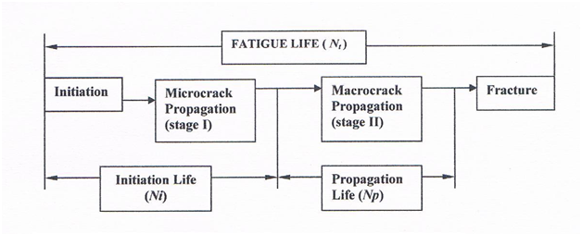
Fig.5 Total Fatigue Life
However, there is no simple or clear delineation of the boundary between fatigue crack initiation and propagation. Furthermore, a pre-existing notch (or crack) in a component can reduce or eliminate the fatigue-crack-initiation life and, thus, decrease the total fatigue life of the component. As stated above, the fatigue life of structural components is determined by the sum of the elapsed cycles required to initiate a fatigue crack and to propagate the crack from subcritical dimensions to the critical size. Consequently, the fatigue life of structural components may be considered to be composed of three continuous stages:
- fatigue crack initiation,
- fatigue-crack propagation and
- Fracture.
The fracture stage presents the terminal conditions in the life of structural component. The useful life of cyclically loaded structural components can be determined only when the three stages in the life of the component are evaluated individually and the cyclic behaviour in each stage is thoroughly understood

4. 3D modeling of bridle roll shaft

Pro/ENGINEER is a computer graphics system for modelling various mechanical designs and for performing related design and manufacturing operations.
The material properties of bridle roll shaft (IS 2062 Fe 410 WB) is inserted in software for the analysis are as follows.
Properties | Unit | Value
Density | Kg/m³ | 785
Young’s Modulus | MPa | 2E5
Poisson’s Ratio | - | 0.303

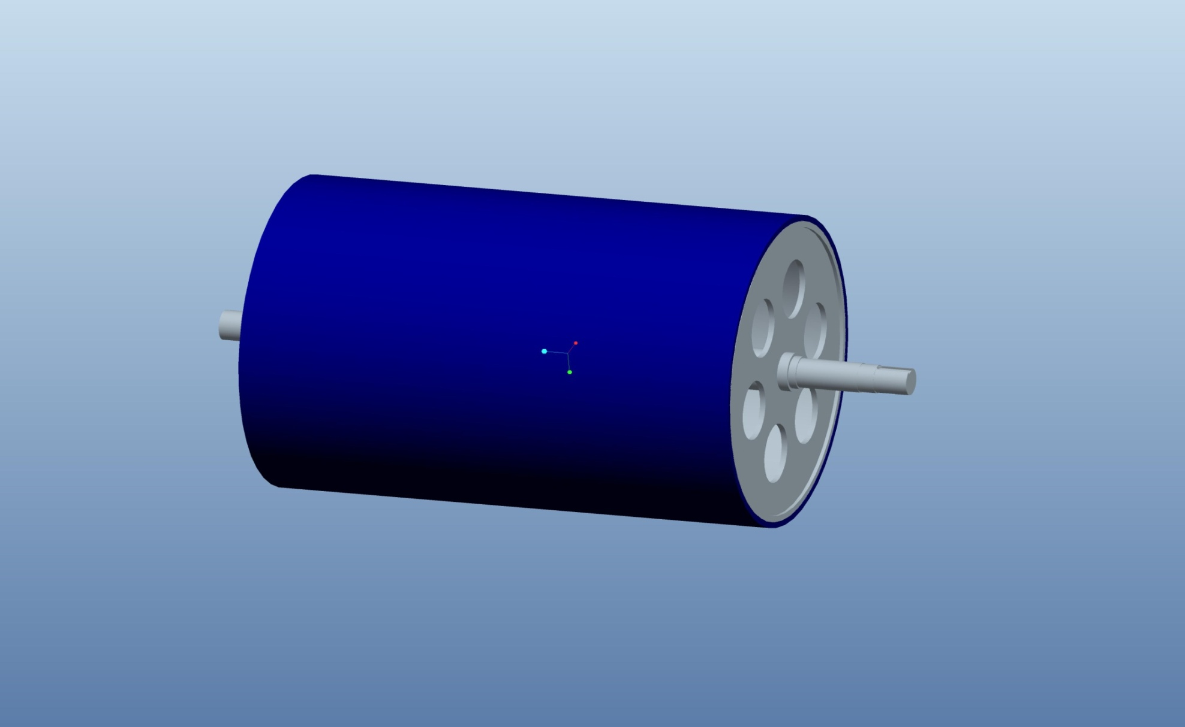
Fig.6 Pro/E Model

5. Finite Element Analysis (Ansys)

Using the technical specification of bridle roll shaft the FE analysis has been carried out in Ansys 12.0. A higher order 3-D, 10-node element having three degrees of freedom at each node: translations in the nodal x, y, and z directions SOLID187 were used. The analysis has been carried out for the above mentioned loading cases. At first the bridle roll shaft is analyzed by considering the moment calculated for static and dynamic load. The maximum shear stresses obtained which compare with the results calculated. But the shat is also pre-stressed by the pressure applied during press fit; therefore it is necessary to analyzed it to check the strength of shaft. The boundary condition and FE results in Ansys for moment and pressure at static and dynamic are as below. Structural Analysis of bridle roll shaft has been carried out using following steps:-

- Open ANSYS 12.0 Workbench.
- Select static structural analysis system.
- Insert the properties of material in engineering data.
- Import geometry of bridle roll assembly which in IGES file format.
- Meshing the model using the option generate mesh, set the relevance.
- Apply boundary conditions.
- Find the equivalent stress and maximum shear stresses for each mode by selecting solve option.
Mesh Model :
Number of nodes - 120289
Number of elements-44671
Type of element –Tetrahedral(Solid 187)
Behaviour of element – DOF-3

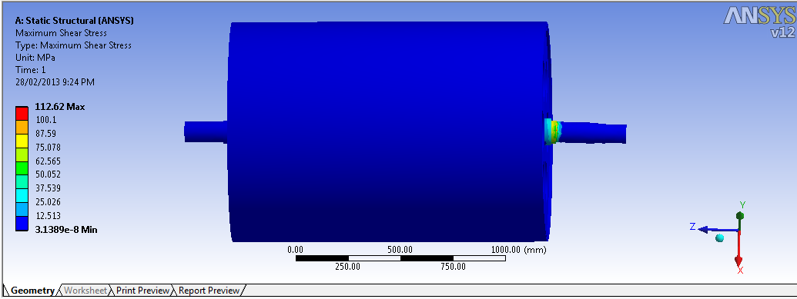
Fig. 7 Ansys Results
The FE analysis is also shows the region of high stresses at the step of 130 mm diameter near welded region from which the failure is known to happen frequently. Hence analysis proves that the shaft is heavily loaded and on some instances like while processing higher gauge material responsible for the extra tractive effort developed on the shaft. Further the actual loading condition would have the additional load or shocks due to improper tension, jerk, misalignment of bridle roll, traction variation at exit section etc. All these factor shall contribute to increase in the load and hence the stress

6. Conclusions
The analytical analysis for the static and fatigue analysis indicates the stresses increases during the variable loads. Stress analyses performed by both analytical and Ansys-12.0 software show that maximum stresses are generated at step of 130 mm diameter near heat affected zone (HAZ). This indicates that a fatigue crack-initiation near the HAZ. The component to be preventing Fatigue failure, Max Shear Stresses should be less than yield strength of material. In this case it is greater than the allowable yield strength of material. The dynamic loading for equivalent stress (von-mises) is safe and develops bending stress up to 208.08 N/mm² but maximum shear stress is 114.15 N/mm^{2,} which is exceeding the allowable stress of 110 N/mm². This result in fatigue failure of drive end shaft. The failure of the shaft is taking place near the area where the shaft is welded to external barrel through circular plate.

7.Reference:
[1]Osman Asi - Fatigue failure of a rear axle shaft of an automobile‖- Engineering Failure Analysis 13 (2006) 1293–1302
[2]M. Ristivojevic, R. Mitrovic, T. Lazovic ―Investigation of causes of fan shaft failure‖-Engineering Failure Analysis 17 (2010) 1188–1194
[3] R.W. Fuller a, J.Q. Ehrgott Jr. b, W.F. Heard b, S.D. Robert b, R.D. Stinson b,
[4] K. Solanki , M.F. Horstemeyer ―Failure analysis of AISI 304 stainless steel shaft‖ - Engineering Failure Analysis 15 (2008) 835–846
[5] M. J. Reid―Analysis Of the Causes of Recent Roll Shaft Failures in Natal Sugar Mills- Proceedings of the South African Sugar Technologists' Association - June 1988
[6] Saleh A. Al-Fozan, Anees U. Malik and Mohammad Al-Hajri ―Failure Analysis Of Sheared Shaft Of A Brine Recycle Pump- Troubleshooting Technical Report No. TSR 3804/05005 in August 2005
[7] E. Rusiński, J. Czmochowski, P. Moczko ― Failure reasons investigations of dumping conveyor breakdown‖- Volume 23 Issue 1 July 2007 Journal of Achievements in Materials and Manufacturing Engineering
[8] Deepan Marudachalam M.G, K.Kanthavel, R.Krishnaraj ― Optimization of shaft design under fatigue loading using Goodman method - International Journal of Scientific & Engineering Research Volume 2, Issue 8, August-2011 2 ISSN 2229-5518
[9] N.Sachs. ‘Failure analysis of mechanical components’,1993
[10] Machine Design by R S Khurmi , J K Gupta
[11] Machine Design by P Kannaiah
[12] Design Data Book & Design of Machine Elements by B D Shiwalkar
[13] DRG No. 03/CGL IV / 014, “Bridle roll Ǿ1050*1500 mm”, Ispat Industries ltd, Kalmeshwar.

