# PROJECT ON

“A MULTI-CHANNEL PARAMETER SCANNER USING MICROCONTROLLER AND PLC”

PRESENTED BY:-CHIRANJEEV KUMAR, MOB NO:9579693464

KULDEEP SINGH TANWAR, MOB NO:-8657104648

DILEEP KUMAR, MOB NO:-8055696473

GUIDED BY: - PROF. PUSHPRAJ NERKAR.

BHAUSAHEB MULIK COLLEGE OF ENGINEERING, BUTIBORI NAGPUR.

# Contents

Abstract …2

Introduction …3

Main Block Diagram …4

Power Supply Circuit …6

Scanning Circuit …8

Relay and Temperature, voltage and vibration Sensing Circuit …10

Components List …12

Component Details …13

PCB Designing …35

Soldering and Testing …37

Advantages and Disadvantages …38

Future Implementation …39

References …40

The project has the aim of scanning several motor sequentially, in order to achieve the temperature, voltage and vibration of all the motors. The main idea behind this sequential scanning is for getting knowledge about the temperature, voltage and vibration condition of all the motors, within fraction of time. In case there is any kind of irregular temperature, voltage and vibration rise in any motor then that motor can be rectified as according the fault. This project can be applied to any field as the parameter which is the key of sensing any kind of fault, is present in any field. As temperature, voltage and vibration is a very **flexible parameter**.

The Oscillator generates the pulse continuously so that the continuous monitoring of all the motor can be done sequentially. For the first pulse the first output of the display circuit will become active and the temperature, voltage and vibration of the first Motor will be displayed on the Display Circuit in this way for the second pulse the second output will become active and then the temperature, voltage and vibration of the second Motor will be Displayed in the Display Circuit and for the next pulse the next temperature, voltage and vibration will be displayed and hence the process will go on until the temperature, voltage and vibration of the last Motor is detected . After the last Motor the temperature, voltage and vibration of the first Motor will be displayed for the next pulse and hence the process will continue forming a closed loop of continuous Temperature, voltage and vibration Display

SYNOPSIS

MULTI- CHANNEL PARAMETER

SCANNER USING PLC

The subject of machine condition monitoring is charged with developing new

technologies to diagnose the machinery problems. Different methods of fault identification have been developed and used effectively to detect the machine faults at an early stage using different machine quantities, such as current, voltage, speed, efficiency, temperature, voltage and vibration and vibrations. One of the principal tools for diagnosing rotating machinery problems has been the vibration analysis. Through the use of different signal processing techniques, it is possible to obtain vital diagnostic information from vibration profile before the equipment catastrophically fails. A problem with diagnostic techniques is that they require constant human interpretation of the results. The logical progression of the condition monitoring technologies is the automation of the diagnostic process. The research has been underway for a long time to automate the diagnostic process. Recently, artificial intelligent tools, such as expert systems, neural network and fuzzy logic, have been widely used with the monitoring system to support the detection and diagnostic tasks.

**Condition monitoring** is the process of monitoring a parameter of condition in machinery, such that a significant change is indicative of a developing failure. It is a major component of predictive maintenance. The use of conditional monitoring allows maintenance to be scheduled, or other actions to be taken to avoid the consequences of failure, before the failure occurs. It is typically much more cost effective than allowing the machinery to fail. In work places many a times when there is fault in the motor the user never know about overloading of motors or unsafe operation or any visual indication or alarm which can lead to burning of motor winding. In industries there are many motors and to take care of each motor manually is a very cumbersome job.

**Main Block Diagram**

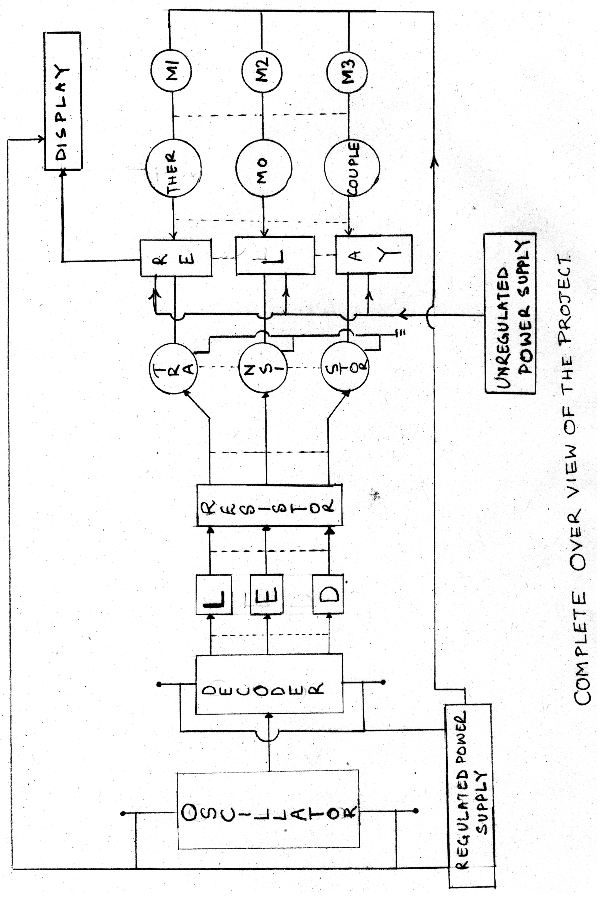

**Explanation**

The above figure is the complete overview of our project. There are four sov(electromagnetic valves)on water distribution line are fitted. This circuitry is mainly concerned with electromagnetic valve, Oscillator, Voltage Limiting Circuit, Isolator, Current Amplifier, Relay and the Display circuit.

The Oscillator generates the pulse continuously so that the continuous operation of all the sov s can be done sequentially. For the first pulse the first output of the de coded counter circuit will become active and the first electromagnetic valve will on .in this way for the second pulse the second output will become active and then the second electromagnetic valve will be on for the next pulse the next valve will be activated and hence the process will go on until the last valve is operates . After the last valve the next pulse and hence the process will continue forming a closed loop. Here we are going to use 555 IC for the generation of continuous pulse.

As we can see in the above mentioned diagram the output pulse of the oscillator is fed to the decoder counter. This decoder counter de codes the pulse and then fed it to the voltage limiter. This voltage limiter limits the voltage to the safer value of about +5V. This is because the increase in the limits will lead to the damage of the setup. Then the further output is fed to the current amplifier which helps in the amplification of the current. Actually for driving any device there is requirement of minimum amount of current, this can be achieved by using current amplifier in the circuit. Then this output is fed to the Relay. Then a particular relay gets activated and hence the particular valve will operated on the line.

The power supply to the entire circuit is provided by regulated power supply. The relay needs the unregulated supply where as the de coder needs regulated supply . The layout for the power supply circuitry is shown and explained in the further section of the report.

**Power Supply Circuit**

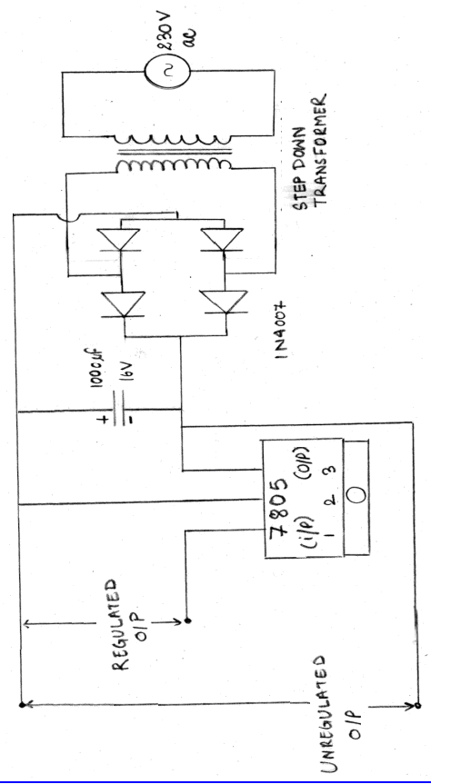

Explanation

In the above circuit is for generating the regulated power for the scanning Circuit. The circuit consists of Transformer, Regulated I.C, Filter, Diodes, and Bridge Rectifier circuit. In this circuit the secondary of the transformer is connected to the Bridge Rectifier. The transformer step downs the voltage and then is fed as an input to the bridge rectifier. The rectifier converts the A.C to D.C. The filter filters the D.C for getting pure D.C. of 8V. This regulated power is then used for driving the entire circuit.

**Control Circuit**

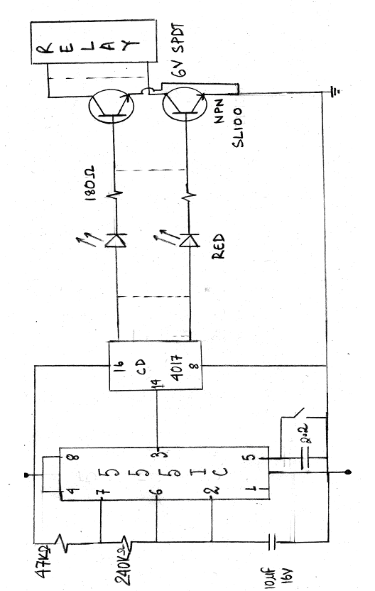

**Explanation**

In the above figure the circuit shows the connections of the decoder output with the Relay contact. The circuit shows how the Relay is connected to the Decoder through the Diode and the Light Emitting diode. The output of the Oscillator first goes to the Decoder and then the signal is further provided to the first Relay through the resistance, which is used to limit the current and the Diode, which will not allow the reverse flow of the current in case of the fault condition. Then the signal is further given to the Current Amplifier, which takes the value of current to a suitable level as per required by the Relay circuit to operate.

**Relay and Temperature, voltage and vibration Measuring Circuit**

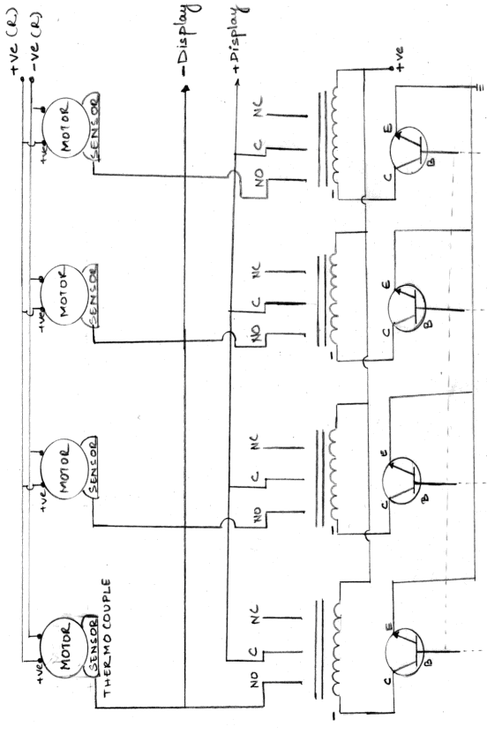

**Explanation**

The above figure shows how the Relay and Temperature, voltage and vibration circuit. This circuit has Thermocouple sensor, Relay contact and motor. This work together to measure the temperature, voltage and vibration of each motor and to displays it. When the Oscillator generates the first pulse the corresponding Sensor through the Relay becomes active and the Sensor senses the temperature, voltage and vibration of the first Motor and the temperature, voltage and vibration of the first Motor is displayed on the Display Circuit. The Relay consists of three terminals No, C, Nc. In normal condition the No is normally closed and C is always closed and the Nc is normally closed, but when the first pulse is generated by the Oscillator the first Relay becomes active and the terminals in the Relay circuit i.e. No and Nc are interchanged and the circuit enables the first Sensor to give the signal hence the temperature, voltage and vibration is displayed by the Display circuit.

## Component List

The following are the list of all components used in the project: -

1. PCB, copper clad ,single sided
2. Transformer of rating 230/12 V, 1.5A
3. Four Diodes of 1N4007 series with rating of 250V, 6A
4. IC 7805, the regulator IC of rating +5V, 1A
5. Capacitor of ratings
   * 1000 F, 16V
   * 10 F,16V
   * 33pico F
6. Resistors of 47K ohm, 240K ohm and 180 ohm
7. Transistor of SL100, NPN, 50V, 0.1A,0.5W,300MHz
8. Relay of 6V SPDT,100 ohm, coil resistance, 3A

## Component Details

1. **Electrical Components**

**Motor:** An electric motor is a machine which converts electric energy into mechanical energy. Its action is based on the principle that when a current carrying conductor is placed in a magnetic field it experiences a mechanical force whose direction is given by Fleming’s left hand rule and whose magnitude is given by force in Newton. In fact it seems to be one of the fundamental laws of nature that no energy conversion from one form to another is possible until there is some one to oppose the conversion. But for the presence of this operation there would simply no energy conversion in generators opposition is provided by magnetic drag. Whereas in motors back emf does the job . Moreover it is only the part of input energy that is used for overcoming this opposition that is converted into other form.

There are several types of electric motors available today. The following outline gives an overview of several popular ones. There are two main classes of motors: AC and DC. AC motors require an alternating current or voltage source (like the power coming out of the wall outlets in your house) to make them work. DC motors require a direct current or voltage source (like the voltage coming out of batteries) to make them work. Universal motors can work on either type of power. Not only is the construction of the motors different, but the means used to control the speed and torque created by each of these motors also varies, although the principles of power conversion are common to both. Motors are used just about everywhere.In your house, there is a motor in your furnace for the blower, for the intake air, in the sump well, dehumidifier, in the kitchen in the exhaust hood above the stove, microwave fan, refrigerator compressor and cooling fan, can opener, garbage disposer, dish washer pump, clocks, computer fans, ceiling fans, and many more items! In industry, motors are used to move, lift, rotate, accelerate, brake, lower and spin material in order to coat, paint, punch, plate, make or form steel, film, paper, tissue, aluminum, plastic and other raw materials.

They range in power ratings from less than 1/100 hp to over 100,000 hp.  The rotate as slowly as 0.001 rpm to over 100,000 rpm.  They range in physical size from as small as the head of a pin to the size of a locomotive engine.

**Types of Motors:** There are several types of motors used in industrial, commercial and residential applications

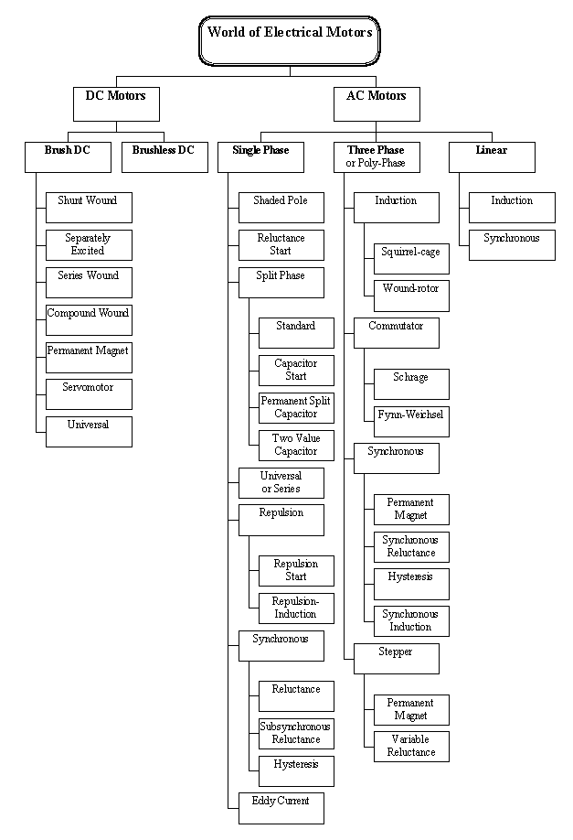

**D.C motor:** Constructional wise there is no basic difference between a dc generator and a dc motor. In fact the same dc machine is used interchangeably as a generator or as a motor. D.C motor are also like generator, shunt wound or series wound or compound wound.

When its field magnets are excited and its armature conductors are supplied with the current from the supply main, the experience a force tending to rotate the armature. Armature conductors under the N poles are assumed to carry downward and those under S poles to carry current upward by applying Fleming’s left hand rule, the direction of the force on each conductor can be found. It will be seen that each conductor experience a force F which tend to rotate the armature in anticlockwise direction. This force collectively produces a driving torque which set the armature rotating.

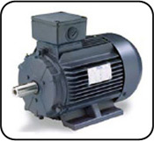

**Induction Motor :** As a general rule, conversion of electrical power into mechanical power takes place in the rotating part of an electrical motor. In D.C motors, the electric power is conducted directly to the armature through brushes and commutator. Hence in this sense, a dc motor can be called a conduction motor. However , in a.c motors, the rotor does not receive electrical power conduction but by induction in exactly the same way as the secondary of a two winding transformer receives its power from the primary. That is why such motors are known as induction motors. In fact, an induction motors can be treated as a rotating transformer i.e. one in which primary winding is stationary but the secondary is free tom rotate.

An induction motor consists of two main parts:

a) Stator

The stator of an induction motor is made up of number of stampings, which are slotted to receive the windings and is fed from a three phase supply. It is wound for a definite number of poles.Greater the number of poles lesser the speed and vice-versa.

1. Rotor
   * Squirrel cage rotor: Motors employing this type of rotor are known as squirrel-cage induction motor.
   * Phase-wound or wound rotor: Motors employing this type of rotor are variously known as ’phase-wound’ motors or ‘wound’ motors or as ‘slip-ring’ motors.

**Synchronous Motor:**The general principle of synchronous motor is electrically identical with an alternator or a.c generator. In fact, a given synchronous machine may be used, at least theoretically, as an alternator, when driven mechanically or as a motor, when driven electrically or as a motor, when driven electrically, just as in case of d,c. machine most of synchronous motors are rated between 150kw and 15Mw and run at speeds ranging form 150 to 1800 r.p.m. The working of a synchronous is in many ways, similar to the transmission of mechanical power by a shaft. It consist of two pulleys ie: driver and load transmitting the power from the driver to the load. This two pulleys are assumed to be a just as stator and rotor poles and the are interlocked with each other, hence they run at exactly same speed. When load is loaded it slightly falls behind owing to the twist in the shaft. The angle of twist being a measure of the torque transmitted. It is clear that unless load is so heavily loaded as to break the coupling, both pulleys must run at same speed.

The characteristic features of a synchronous motor are worth nothing:

It runs either at synchronous speed or not at all i.e. while running it maintains a constant speed. The only way to change its speed is to vary the supply frequency. It is capable of being operated under a wide range of power factors, both lagging and leading.

#### Resistor

A **resistor** is a two-terminal electrical or electronic component that resists an electric current by producing a voltage drop between its terminals in accordance with Ohm's law. The relationship between voltage, current, and resistance through a metal wire, and some other materials, is given by a simple equation called Ohm's Law:

V = IR

where V is the voltage (or potential difference) across the wire in volts*,* I is the current through the wire in amperes, and R, in ohms, is a constant called the resistance—in fact this is only a simplification of the original Ohm's law. Materials that obey this law over a certain voltage or current range are said to be ohmic over that range. An ideal resistor obeys the law across all frequencies and amplitudes of voltage or current.It is a passive circuit component or elements which offers to flow of the current .It is used in almost every circuit for various purpose like current limiting. Biasing of active components, voltage dropping, etc. Resistors are made of high resistive materials. Their values of power ratings are usually specified.

Resistor are classified broadly into three types as give below:

Resistor

Fixed Variable Non-linear

Examples:

Carbon Potentiometer L.D.R

Metal Rheostats Thermistor

**Color-Coding Scheme for Resistors**

All the carbon composition resistors are color coded to indicate resistance in ohms. The color-coding scheme is based on the use of color bands painted on the body of the resistor as numerical values. Each color band stands for a digit. Generally there are four bands, out of which the first three gives the value of the resistor and fourth color gives the tolerance. Reading left to right is the correct method to identify the value of the resistor.

The table drawn below gives the details about the values of the resistors.

**Color Coding Table**

|  |  |  |  |  |
| --- | --- | --- | --- | --- |
| **Color** | **1st Band** | **2nd Band** | **Multiplier** | **Tolerance** |
| Black | 0 | 0 | 100 | 1% |
| Brown | 1 | 1 | 101 | 2% |
| Red | 2 | 2 | 102 | -- |
| Orange | 3 | 3 | 103 | 1K |
| Yellow | 4 | 4 | 104 | 0.5% |
| Green | 5 | 5 | 105 | 0.25% |
| Blue | 6 | 6 | 106 | 0.1% |
| Violet | 7 | 7 | 107 | 0.05% |
| Grey | 8 | 8 | 108 | -- |
| White | 9 | 9 | 109 | -- |
| No color | -- | -- | -- | + /-20% |
| Silver | -- | -- | 10-2 | +/-10% |
| Gold | -- | -- | 10-1 | +/-5% |

Figure shows the color band of a resistor

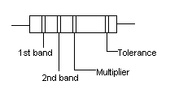

**Relay**

‘*Relay is a device by means of which an electric circuit can be controlled (opened or closed) by the change in the same circuit or other circuit*’.

Thus a relay is an **electrically operated switch**. Current flowing through the coil of the relay creates a magnetic field which attracts a lever and changes the switch contacts. The coil current can be on or off so relays have two switch positions and they are **double throw** (changeover) switches. Relays allow one circuit to switch a second circuit which can be completely separate from the first. For example a low voltage battery circuit can use a relay to switch a 230V AC mains circuit. There is no electrical connection inside the relay between the two circuits, the link is magnetic and mechanical. **The coil of a relay passes a relatively large current, typically 30mA for a 12V relay**, but it can be as much as 100mA for relays designed to operate from lower voltages. Most ICs (chips) cannot provide this current and a [transistor](http://www.kpsec.freeuk.com/trancirc.htm#chip) is usually used to amplify the small IC current to the larger value required for the relay coil. The maximum output current for the popular 555 timer IC is 200mA so these devices can supply relay coils directly without amplification. But as our circuit demands the usage of IC s like CD 4017 whose output is not sufficient for providing the required power for running the relay. This asks for the usage of transistors.

Relays are usuallly Single Pole Double Throw(SPDT) or Double Pole Double Throw(DPDT) but they can have many more sets of switch contacts, for example relays with 4 sets of changeover contacts are readily available.Relay coils produce brief high voltage 'spikes' when they are switched off and this can destroy transistors and ICs in the circuit. To prevent damage you must connect a protection diode across the relay coil. But as our circuit is not generating much spike so we had avoided the use of diode for protection.

**Type of Relays**

Generally the types of relays are fragmented on the bases of the field of application.

Based on technology:-

* Electromagnetic Relay
* Static Relay
* Microprocessor based protective Relay

Based on the function they are as follows:-

* Over Current Relays
* Under Voltage Relays
* Impedance Relays
* Directional Relays
* Under Frequency Relays

**Electromagnetic Relay**

An electro-mechanical relay, has one or more coils, movable element, contact system, etc. The operation of such relay depends on whether the operating torque/force is greater than the restraining torque/force.

Let relay operates, if the net force F in the give equation below is positive

F = Fo – Fr

F = Net Force

Fo = Operating Force

Fr = Restraining Force

Or if the value of net torque in the equation given below

T = To – Tr

T = Net Torque

To = Operating torque

Tr = Restraining torque

Relay operates when Operating force > Resrtaining force

The electromagnetic relay consists of a multi-turn coil, wound on an iron core, to form an electromagnet. When the coil is energized, by passing current through it, the core becomes temporarily magnetized. The magnetized core attracts the iron armature.   
The armature is pivoted which causes it to operate one or more sets of contacts. When the coil is de-energised the armature and contacts are released. The coil can be energized from a low power source such as a transistor while the contacts can switch high powers such as the mains supply. The relay can also be situated remotely from the control source.

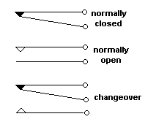

The relay's switch connections are usually labelled COM, NC and NO:

* **COM** = Common, always connect to this, it is the moving part of the switch.
* **NC** = Normally Closed, COM is connected to this when the relay coil is **off**.
* **NO** = Normally Open, COM is connected to this when the relay coil is **on**.

**Types of Electromagnetic Relays**

* Attracted Armature Type
* Induction Type

#### Protection diode

If the load is a **motor**, **relay** or **solenoid** (or any other device with a coil) a diode must be connected across the load to protect the transistor (and chip) from damage when the load is switched off. The diagram shows how this is connected 'backwards' so that it will normally NOT conduct. Conduction only occurs when the load is switched off, at this moment current tries to continue flowing through the coil and it is harmlessly diverted through the diode. Without the diode no current could flow and the coil would produce a damaging high voltage 'spike' in its attempt to keep the current flowing.



**Capacitor**

A **capacitor** is an electrical device that can store energy in the electric field between a pair of closely spaced conductors (called 'plates'). When voltage is applied to the capacitor, electric charges of equal magnitude, but opposite polarity, build up on each plate.Capacitors are used in electrical circuits as energy-storage devices. They can also be used to differentiate between high-frequency and low-frequency signals and this makes them useful in electronic filters.Capacitors are occasionally referred to as condensers. Electrons cannot easily pass directly across the dielectric from one plate of the capacitor to the other as the dielectric is carefully chosen so that it is a good insulator. When there is a current through a capacitor, electrons accumulate on one plate and electrons are removed from the other plate. This process is commonly called 'charging' the capacitor, even though the capacitor is at all times electrically neutral. In fact, the current through the capacitor results in the separation of electric charge, rather than the accumulation of electric charge. This separation of charge causes an electric field to develop between the plates of the capacitor giving rise to voltage across the plates. This voltage V is directly proportional to the amount of charge separated Q. Since the current I through the capacitor is the rate at which charge Q is forced through the capacitor (dQ/dt), this can be expressed mathematically as:

I = dQ/dt =C dV/dt

Where I is the current flowing in the conventional direction,measured in amperes, dV/dt is the time derivative of voltage,measured in volts per second and C is the capacitance in farads.There are various types of capacitors present in the market according to the constumers need. However we r using two types of capacitors.They are:

* Electrolytic Capacitor
* Paper Capacitor

**Codings for Capacitor**

There are three types of coding used for capacitor are as explained below:-

* Using Numerical:For three digits, consider first two digits as it is and take third

digit as a power of 10.Again multiply this by the factor 10-12.

* Using Characters: When a letter K comes in between two digits, it act as decimal point and for a letter ‘K’ multiply by factor 103 and again by 102.
* Directly printed: For some capacitors, the value of capacitor is directly printed in

the digit form that will take directly in F.

**b) Electronic Components**

**Transistors:** Theyare divided into two main categories: bipolar junction transistors (BJTs) and field effect transistors (FETs). Application of current in BJTs and voltage in FETs between the input and common terminals increases the conductivity between the common and output terminals, thereby controlling current flow between them.In analog circuits, transistors are used in amplifiers, (direct current amplifiers, audio amplifiers, radio frequency amplifiers), and linear regulated power supplies. Transistors are also used in digital circuits where they function as electronic switches. Digital circuits include logic gates, random access memory (RAM), microprocessors, and digital signal processors (DSPs).

Transistors are categorized by:

* Semiconductor material: germanium, silicon, gallium arsenide, silicon carbide
* Structure: BJT, JFET, IGFET (MOSFET), IGBT, "other types"
* Polarity: NPN, PNP, N-channel, P-channel

The **bipolar junction transistor** (BJT) was the first type of transistor to be mass-produced. Bipolar transistors are so named because they conduct by using both majority and minority carriers. The three terminals of the BJT are named emitter, base and collector. Two p-n junctions exist inside a BJT: the base*/*emitterjunction and base*/*collectorjunction. The BJT is commonly described as a current-operated device because the collector/emitter current is controlled by the current flowing between base and emitter terminals. Unlike the FET, the BJT is a low input-impedance device. Bipolar transistors can be made to conduct by light, since absorption of photons in the base region generates a photocurrent that acts as a base current; the collector current is approximately beta times the photocurrent. Devices designed for this purpose have a transparent window in the package and are called phototransistors.

Concentrating on two types of standard transistors, **NPN** and **PNP**, with different circuit symbols. The letters refer to the layers of semiconductor material used to make the transistor. Most transistors used today are NPN because this is the easiest type to make from silicon. This page is mostly about NPN transistors and if you are new to electronics it is best to start by learning how to use these first.The leads are labelled **base** (B), **collector** (C) and **emitter** (E).



### Functional model of an NPN transistor

* The base-emitter junction behaves like a diode.
* A base current IB flows only when the voltage VBE across the base-emitter junction is 0.7V or more.
* The small base current IB controls the large collector current Ic.
* Ic = hFE × IB   (unless the transistor is full on and saturated)   
  hFE is the current gain (strictly the DC current gain), a typical value for hFE is 100 (it has no units because it is a ratio)
* The collector-emitter resistance RCE is controlled by the base current IB:
  + IB = 0   RCE = infinity   transistor off
  + IB small   RCE reduced   transistor partly on
  + IB increased   RCE = 0   transistor full on ('saturated')

**Important Properties of NPN**

* A resistor is often needed in series with the base connection to limit the base current IB and prevent the transistor being damaged.
* Transistors have a maximum collector current Ic rating.
* The **current gain hFE can vary widely**, even for transistors of the same type!
* A transistor that is **full on** (with RCE = 0) is said to be '**saturated**'.
* When a transistor is saturated the collector-emitter voltage VCE is reduced to almost 0V.
* When a transistor is saturated the collector current Ic is determined by the supply voltage and the external resistance in the collector circuit, not by the transistor's current gain. As a result the ratio Ic/IB for a saturated transistor is less than the current gain hFE.
* The emitter current IE = Ic + IB, but Ic is much larger than IB, so roughly IE = Ic.
* **NPN transistor**, is used when the supply output is **high**. If one needs the opposite action PNP transistor is put to use.

**Regulated Power Supply**

The power supply is a basic requirement of any circuitry for it’s functioning. Our circuit comprises of semiconductors, sensors and relays which requires the use of regulated as well as unregulated supply. Unregulated d.c supply is needed for the activation of relay. On the other hand the latter is required for the functioning of the scanning circuit. As scanning circuit comprises of a series of semiconductors, which requires only 5V d.c supply for it’s functioning. The LM78XX series of three terminal regulators is available

with several fixed output voltages making them useful in a wide range of applications. One of these is local on card regulation, eliminating the distribution problems associated

with single point regulation. The voltages available allow these regulators to be used in logic systems, instrumentation, and other solid state electronic equipment. Al-though designed primarily as fixed voltage regulators these devices can be used with external components to obtain adjustable voltages and currents. The LM78XX series is available in an aluminum TO-3 pack-age which will allow over 1.0A load current if adequate heat sinking is provided. Current limiting is included to limit the peak output current to a safe value. Safe area protection for the output transistor is provided to limit internal power dissipation. If internal power dissipation becomes too high for the

heat sinking provided, the thermal shutdown circuit takes over preventing the IC from overheating. Considerable effort was expanded to make the LM78XX series of regulators easy to use and minimize the number of external components. It is not necessary to bypass the output, although this does improve transient response. Input by-passing

is needed only if the regulator is located far from the filter capacitor of the power supply.

For output voltage other than 5V, 12V and 15V the LM117 series provides an output voltage range from 1.2V to 57V.

Features

* Output current in excess of 1A
* Internal thermal overload protection
* No external components required
* Output transistor safe area protection
* Internal short circuit current limit
* Available in the aluminum TO-3 package

Voltage Range

LM7805C 5V

LM7812C 12V

LM7815C 15V

#### Diodes

In electronics, a **diode** is a component that restricts the direction of movement of charge carriers. Essentially, it allows an electric current to flow in one direction, but blocks it in the opposite direction. Thus, the diode can be thought of as an electronic version of a check valve. Circuits that require current flow in only one direction will typically include one or more diodes in the circuit design. Most modern diodes are based on semiconductor p-n junctions. In a p-n diode, conventional current can flow from the p-type side (the anode) to the n-type side (the cathode), but not in the opposite direction.

A semiconductor diode's current-voltage, or I*-*V*,* characteristic curve is ascribed to the behavior of the so-called depletionlayer or depletionzone which exists at the p-n junction between the differing semiconductors. When a p-n junction is first created, conduction band (mobile) electrons from the N-doped region diffuse into the P-doped region where there is a large population of holes (places for electrons in which no electron is present) with which the electrons "recombine". When a mobile electron recombines with a hole, the hole vanishes and the electron is no longer mobile. Thus, two charge carriers have vanished. The region around the p-n junction becomes depleted of charge carriers and thus behaves as an insulator.

However, the depletion width cannot grow without limit. For each electron-hole pair that recombines, a positively-charged dopant ion is left behind in the N-doped region, and a negatively charged dopant ion is left behind in the P-doped region. As recombination proceeds and more ions are created, an increasing electric field develops through the depletion zone which acts to slow and then finally stop recombination. At this point, there is a 'built-in' potential across the depletion zone.

If an external voltage is placed across the diode with the same polarity as the built-in potential, the depletion zone continues to act as an insulator preventing a significant electric current. This is the reversebias phenomenon. However, if the polarity of the external voltage opposes the built-in potential, recombination can once again proceed resulting in substantial electric current through the p-n junction. For silicon diodes, the built-in potential is approximately 0.6 V. Thus, if an external current is passed through the diode, about 0.6 V will be developed across the diode such that the P-doped region is positive with respect to the N-doped region and the diode is said to be 'turned on' as it has a forwardbias.

Types of semiconductor diodes are

* Zener diode
* Schottky diode
* Tunnel diode
* Light-emitting diode
* Photo diode

**Light Emitting Diode :**

LED's are special diodes that emit light when connected in a circuit. They are frequently used as "pilot" lights in electronic appliances to indicate whether the circuit is closed or not. A clear (or often colored) epoxy case enclosed the heart of an LED, the semi-conductor chip. The two wires extending below the LED epoxy enclosure, or the "bulb" indicate how the LED should be connected into a circuit. The negative side of an LED lead is indicated in two ways: 1) by the *flat side* of the bulb, and 2) by the shorter of the two wires extending from the LED. The negative lead should be connected to the negative terminal of a battery. LED's operate at relative low voltages between about 1 and 4 volts, and draw currents between about 10 and 40 milli-amperes. Voltages and currents substantially above these values can melt a LED chip.   
  
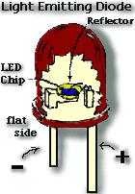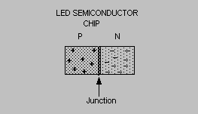

Fig(a) Fig(b)

The most important part of a light emitting diode(LED) is the semi-conductor chip located in the center of the bulb as shown at the right. The chip has two regions separated by a junction*.* The **p region** is dominated by positive electric charges, and the **n region** is dominated by negative electric charges. When sufficient voltage is applied to the chip across the leads of the LED, electrons can move easily in only one direction across the junction between the p and n regions. In the p region there are many more positive than negative charges. In the n region the electrons are more numerous than the positive electric charges. When a voltage is applied and the current starts to flow, electrons in the n region have sufficient energy to move across the junction into the p region. Once in the p region the electrons are immediately attracted to the positive charges due to the mutual Coulomb forces of attraction between opposite electric charges. When an electron moves sufficiently close to a positive charge in the pregion, the two charges "re-combine". Each time an electron recombines with a hole for each recombination of a negative and a positive charge, a quantum of electromagnetic energy is emitted in the form of a photon of light with a frequency characteristic of the semi-conductor material (usually a combination of the chemical elements gallium, arsenic and phosphorus).Only photons in a very narrow frequency range can be emitted by any material. LED's that emit different colors are made of different semi-conductor materials, and require different energies to light them.

**Oscillator (555timer)**

The **555** is an integrated circuit (chip) implementing a variety of timer and multivibrator applications. The 555 timer is one of the most popular and versatile integrated circuits ever produced. It includes 23 transistors, 2 diodes and 16 resistors on a silicon chip installed in an 8-pin mini dual-in-line package (DIP). The 556 is a 14-pin DIP that combines two 555s on a single chip.

The 555 has three operating modes:

* Monostable mode: in this mode, the 555 functions as a "one-shot". Applications include timers, missing pulse detection, bouncefree switches, touch switches, etc.
* Astable mode: the 555 can operate as an oscillator. Uses include LED and lamp flashers, pulse generation, logic clocks, tone generation, security alarms, Pulse Width Modulation (PWM) etc.
* Bistable mode: the 555 can operate as a flip-flop, if the DIS pin is not connected and no capacitor is used. Uses include bouncefree latched switches, etc.

**Pin Configuration**

Pin 1 (Ground)

The ground (or common) pin is the most-negative supply potential of the device, which is normally connected to circuit common when operated from positive supply voltages.  
  
Pin 2 (Trigger)

This pin is the input to the lower comparator and is used to set the latch, which in turn causes the output to go high. This is the beginning of the timing sequence in monostable operation. Triggering is accomplished by taking the pin from above to below a voltage level of 1/3 V+ (or, in general, one-half the voltage appearing at pin 5). The action of the trigger input is level-sensitive, allowing slow rate-of-change waveforms, as well as pulses, to be used as trigger sources.  
One precaution that should be observed with the trigger input signal is that it must not remain lower than 1/3 V+ for a period of time *longer* than the timing cycle. If this is allowed to happen, the timer will re trigger itself upon termination of the first output pulse. Thus, when the timer is driven in the mono stable mode with input pulses longer than the desired output pulse width, the input trigger should effectively be shortened by differentiation.  
The minimum-allowable pulse width for triggering is somewhat dependent upon pulse level, but in general if it is greater than the s (micro-Second), triggering will be reliable.  
A second precaution with respect to the trigger input concerns storage time in the lower comparator. This portion of the circuit can exhibit normal turn-off delays of several microseconds after triggering; that is, the latch can still have a trigger input for this period of time *after* the trigger pulse. In practice, this means the minimum monostable output pulse width should be in the order of 10uS to prevent possible double triggering due to this effect.  
The voltage range that can safely be applied to the trigger pin is between V+ and ground. A dc current, termed the *trigger* current, must also flow from this terminal into the external circuit. This current is typically 500nA (nano-amp) and will define the upper limit of resistance allowable from pin 2 to ground. For an astable configuration operating at V+ = 5 volts, this resistance is 3 Mega-ohm; it can be greater for higher V+ levels.  
  
Pin 3 (Output)

The output of the 555 comes from a high-current totem-pole stage made up of transistors Q20 - Q24. Transistors Q21 and Q22 provide drive for source-type loads, and their Darlington connection provides a high-state output voltage about 1.7 volts less than the V+ supply level used. Transistor Q24 provides current-sinking capability for low-state loads referred to V+ (such as typical TTL inputs). Transistor Q24 has a low saturation voltage, which allows it to interface directly, with good noise margin, when driving current-sinking logic. Exact output saturation levels vary markedly with supply voltage, however, for both high and low states. At a V+ of 5 volts, for instance, the low state Vce(sat) is typically 0.25 volts at 5 mA. Operating at 15 volts, however, it can sink 100mA if an output-low voltage level of 2 volts is allowable (power dissipation should be considered in such a case, of course). High-state level is typically 3.3 volts at V+ = 5 volts; 13.3 volts at V+ = 15 volts. Both the rise and fall times of the output waveform are quite fast, typical switching times being 100nS.  
The state of the output pin will always reflect the inverse of the logic state of the latch, and this fact may be seen by examining Fig. 3. Since the latch itself is not directly accessible, this relationship may be best explained in terms of latch-input trigger conditions. To trigger the output to a high condition, the trigger input is momentarily taken from a higher to a lower level. [see "Pin 2 - Trigger"]. This causes the latch to be set and the output to go high. Actuation of the lower comparator is the only manner in which the output can be placed in the high state. The output can be returned to a low state by causing the threshold to go from a lower to a higher level [see "Pin 6 - Threshold"], which resets the latch. The output can also be made to go low by taking the reset to a low state near ground [see "Pin 4 - Reset"].  
  
Pin 4 (Reset)

This pin is also used to reset the latch and return the ouput to a low state. The reset voltage threshold level is 0.7 volt, and a sink current of 0.1mA from this pin is required to reset the device. These levels are relatively independent of operating V+ level; thus the reset input is TTL compatible for any supply voltage.  
The reset input is an overriding function; that is, it will force the output to a low state regardless of the state of either of the other inputs. It may thus be used to terminate an output pulse prematurely, to gate oscillations from "on" to "off", etc. Delay time from reset to output is typically on the order of 0.5 uS, and the minumum reset pulse width is 0.5 uS. Neither of these figures is guaranteed, however, and *may vary* from one manufacturer to another. When not used, it is recommended that the reset input be tied to V+ to avoid any possibility of false resetting.  
  
Pin 5 (Control Voltage)

This pin allows direct access to the 2/3 V+ voltage-divider point, the reference level for the upper comparator. It also allows indirect access to the lower comparator, as there is a 2:1 divider (R8 - R9) from this point to the lower-comparator reference input, Q13. Use of this terminal is the option of the user, but it does allow extreme flexibility by permitting modification of the timing period, resetting of the comparator, etc.  
When the 555 timer is used in a voltage-controlled mode, its voltage-controlled operation ranges from about 1 volt less than V+ down to within 2 volts of ground (although this is not guaranteed). Voltages can be safely applied outside these limits, but they should be confined within the limits of V+ and ground for reliability.  
In the event the control-voltage pin is not used, it is recommended that it be bypassed with a capacitor of about 0.01uF (10nF) for immunity to noise, since it is a comparator input.  
  
Pin 6 (Threshold)

Pin 6 is one input to the upper comparator (the other being pin 5) and is used to reset the latch, which causes the output to go low.  
Resetting via this terminal is accomplished by taking the terminal from below to above a voltage level of 2/3 V+ (the normal voltage on pin 5). The action of the threshold pin is level sensitive, allowing slow rate-of-change waveforms.  
The voltage range that can safely be applied to the threshold pin is between V+ and ground. A dc current, termed the *threshold* current, must also flow into this terminal from the external circuit. This current is typically 100nA, and will define the upper limit of total resistance allowable from pin 6 to V+. For either timing configuration operating at V+ = 5 volts, this resistance is 16 Mega-ohm.  
  
Pin 7 (Discharge)

This pin is the open collector of an npn transistor (Q14), the emitter of which goes to ground. The conduction state of this transistor is identical in timing to that of the output stage. It is "on" (low resistance to ground) when the output is low and "off" (high resistance to ground) when the output is high.  
In both the monostable and astable time modes, this transistor switch is used to clamp the appropriate nodes of the timing network to ground. Saturation voltage is typically below 100mV (milli-Volt) for currents of 5 mA or less, and off-state leakage is about 20nA (these parameters are not specified by all manufacturers, however).  
Maximum collector current is internally limited by design, thereby removing restrictions on capacitor size due to peak pulse-current discharge. In certain applications, this open collector output can be used as an auxiliary output terminal, with current-sinking capability similar to the output (pin 3).  
  
Pin 8 (V +)

The V+ pin (also referred to as Vcc) is the positive supply voltage terminal of the 555 timer IC. Supply-voltage operating range for the 555 is +4.5 volts (minimum) to +16 volts (maximum), and it is specified for operation between +5 volts and + 15 volts. The device will operate essentially the same over this range of voltages without change in timing period. Actually, the most significant operational difference is the output drive capability, which increases for both current and voltage range as the supply voltage is increased. Sensitivity of time interval to supply voltage change is low, typically 0.1% per volt.  
  
**Astable Mode of Operation**

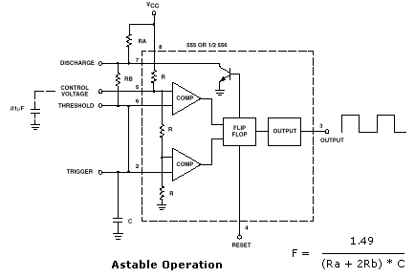

the figure shows 555 timer connected as an astable multivibrator. Initially, when the output is high, capacitor C starts charging towards VCC through Ra and Rb. However as soon as voltage across the capacitor equals 2/3 Vcc, comparator ! triggers the flip flop, and the output switches low. Now capacitor C starts discharging through Rb and transistor Q1. When the voltage across C equals 1/3 Vcc , comparator 2’s output triggers the flip flop, and the output goes high. Then the cycle repeats. The output voltage and capacitor voltage waveform are shown in figure. As shown in the figure, the capacitor is periodically charged and discharged between 2/3 Vcc to 1/3 Vcc ,respectively. The time during which the capacitor charges from 1/3 Vcc to 2/3 Vcc is equak to the time the output is high and is given by

tc =0.69(Ra+Rb)C

where Ra and Rb are in ohms and C is in farads. Similarly, the time during which the capacitor discharge from 2/3 Vcc to 1/3 Vcc is equal to the time the output is low and is given by

td = 0.69(Rb)C

where RB is in ohms and C is in farads. Thus the total time period of the output waveform is

T = tc +td =0.69(Ra+2Rb)C

This, in turn, gives the frequency of oscillation as

*fo* =1.45/(Ra + 2Rb)C

**Thermocouple:**

The thermocouple si one of the simplest and most commonly used methods of measuring process temperature, voltage and vibrations. The operation of a thermocouple is based upon Seebeck Effect. In 1821,seebeck discovered that when heat is applied to junction (hot junction)of two dissimilar metals, an emf is generated which can be measured at the other junction (cold junction ). The two dissimilar metals form an electric circuit, and a current flows as a result of the generated emf as shown in the figure.

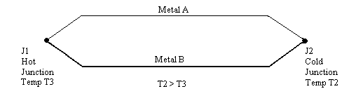

This current will continue to flow as long as T3 >T2. Metal B is described as -ve with respect to a metal A if current flows into it at the cold junction.

The emf produced is function of the difference in temperature, voltage and vibration of hot and cold junction and is given by :

E = a

Where,   difference between temperature, voltage and vibrations of hot and cold junctions.

Here in our project we are using J type of thermocouple for the measurement of temperature, voltage and vibration. We have used four thermocouples for measuring the temperature, voltage and vibration of four different motors.

**Construction of Thermocouple:**

A pair of two dissimilar metals that are in physical contact with each other form a thermocouple These metals may be twisted , screwed , peened, clamped or welded together. The most commonly used method for fabricating is to weld the metals together .

Thermocouple do not use bare conductors except in application where atmospheric conditions permit their use. These conditions obtained when temperature, voltage and vibrations to be measured are low and the atmosphere is non- corrosive. Industrial thermocouples employ protective sheathing surrounding the junction and a portion of the extension leads. The leads and the junction are internally insulted from the sheath ,using various potting compounds, ceramic beads or oxides. The type of insulation used depends upon the process being monitored. Thermocouples are normally not installed in pipelines vessels or other pieces of equipment directly. They are usually placed inside protective wells so that they may be easily removed or replaced without interruption or shut down pf the plant .Protecting walls are made of stainless steel and some other special alloy materials. They are normally 12.5mm to 25mm in diameter. The use of protective wells slows down the response time is primary consideration, bare or thin sheathed thermocouples are used .

**Percentage error of the J type thermocouple:**

The percentage error of the J type Thermocouple used is given by

% Error = (Actual temperature, voltage and vibration – Displayed temperature, voltage and vibration)/Actual temperature, voltage and vibration

Displayed Temperature (oC) Actual Temperature (oC)

a) **34** **35.6**

b) **35** **36.7**

c) **36** **37.9**

d) **37**  **38.4**

e) **38** **41.8**

Therefore,

% error = (35.6 -34)/35.6 = 4.49%

% error = (36.7 -35)/36.7 = 4.63%

% error = (37.9 -36)/37.9 = 5.01%

% error = (38.4 -37)/38.4 = 3.64%

% error = (41.8 –38)/41.8 = 9.09%

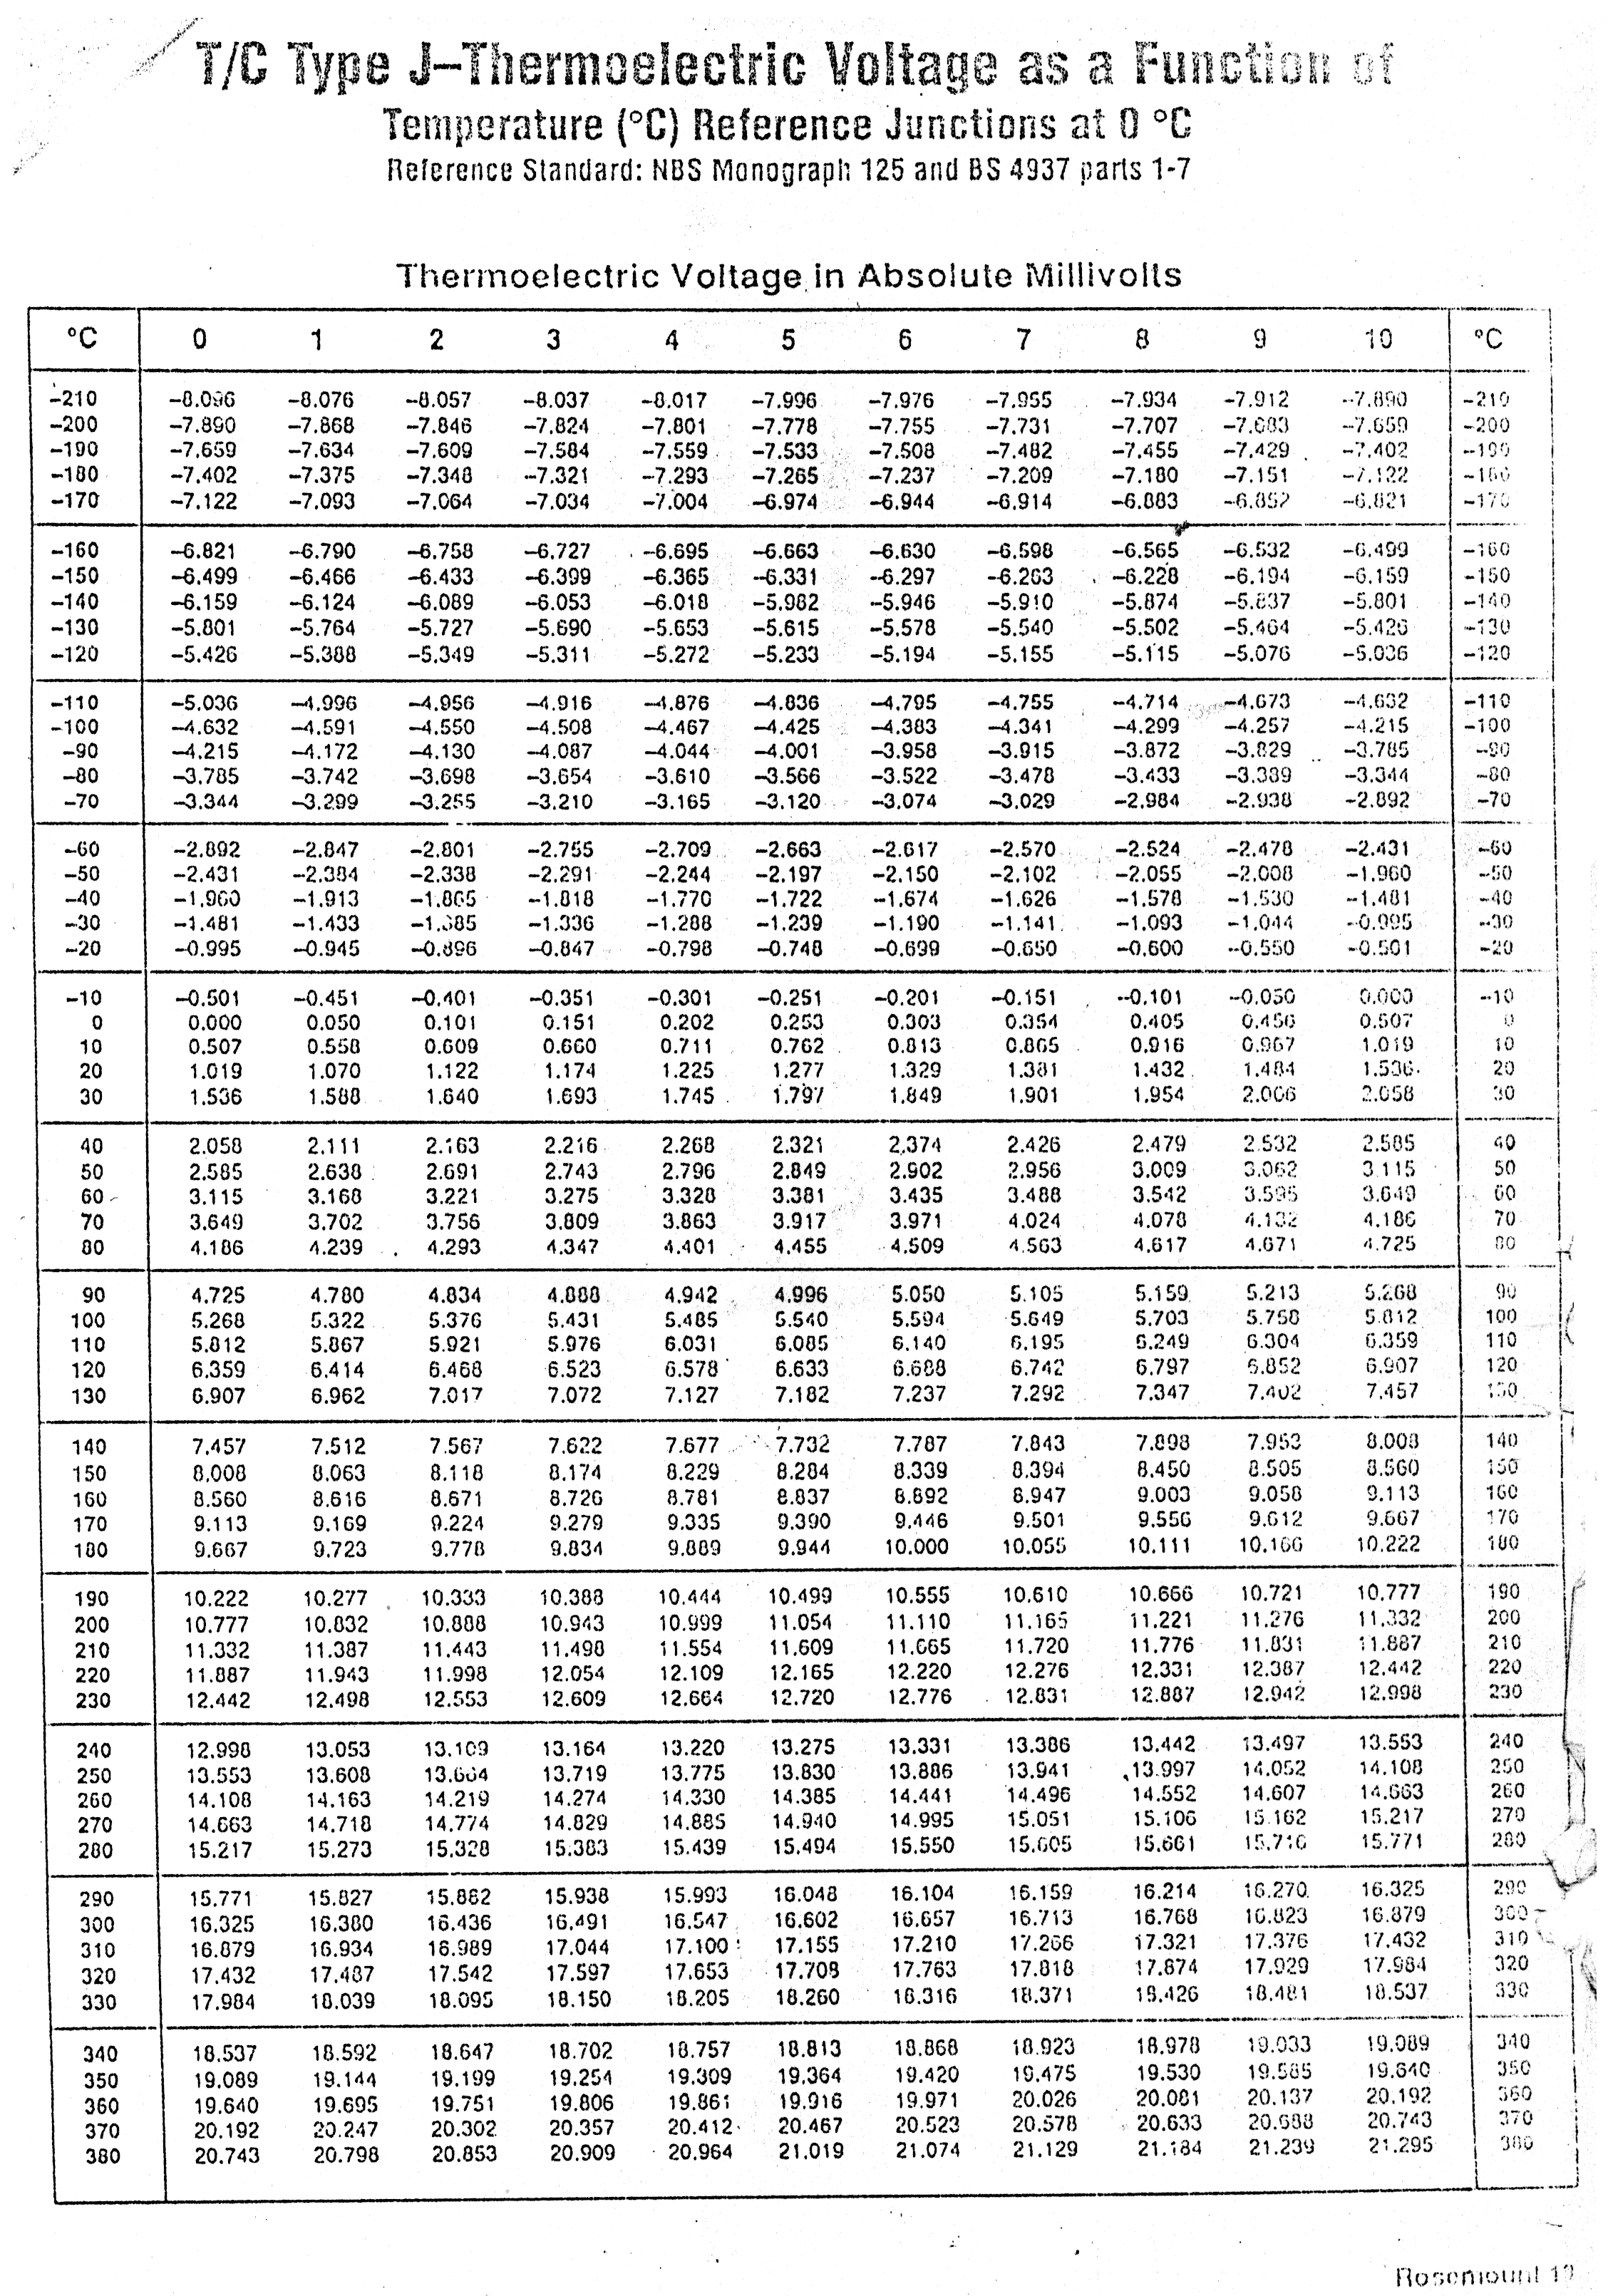

**P.C.B Designing and Soldering**

P.C.B. is an electronic mounted on a base material. It is of insulating material usually bakelite provided with holes, to accommodate various electronic components. PCB plays a vital role in the design and production of electronic equipment. Usually the P.C.B is a circuit made up of thin copper foil. Due to the thin copper foil P.C.B. needs a base support .The base is mounting device, which is used to fasten the complete package. Instead of copper sometimes the conducting material like aluminium, silver, Ni are used. The name printed circuits board a rises because the electronics circuit appears to be printed on the base material.As the P.C.B. is designed and fabricated, the circuit can be assembled easily by mounting and soldering the components in the holes provided by them.

**Types of P.C.B.’s:**

There are four types of PCB.

* Single sided
* Double sided
* Multi Layer
* Flexible

The few things needed for PCB designing are listed below:

* Enamel Paint: The normal black paint used on your door and windows. PCB Transfers can well be used instead
* A Set of thin Brushes: The type used for water and oil paintings and are available from most pen shops. These are not needed if transfer are used.
* Petrol or Spirit: Used for cleaning and removing paint.
* Ferric Chloride (FeCl3 ) **:** This brownish powdr is available from most chemists and chemical stores in packings of 500 grams each at a cost of about Rs30.
* Tools for cutting filling and drilling

**Steps involved in fabrication of PCB Designing**

The various steps involved in PCB design and fabrication are as follows:

1. Layout: The proto circuit is initially tested. A layout is then prepared which shows the location of the components on the PCB.This is the first step in PCB fabrication.
2. Artwork: The purpose of artwork preparation is to develop a layout for the finial circuit board .the place of various components and conductor thickness is defined in this step. The artwork is prepared on the component side of the PCB with the help of the circuit diagram.
3. Printing and Etching: Printing involves the transfer of artwork on to the copper clad. Photographic and screen-printing methods are used for mass fabrication of PCB. This method involves sticking etch tapes and pads on the copper clad as per the view of the artwork.This is followed by the process of etching i.e. removal of unwanted copper from the clad .The most common etchant used is a Ferric Chloride solution (Fecl3). The copper clad is dipped in this solution and taken out after an hour .The copper clad is then washed with clean water.

iv. Drilling: The last step is drilling of PCB after removing the etch resist tapes and

pads. Holes are drilled according to the thickness of the components lead

v. Mounting components and soldering: The components are mounted on the PCB as per the layout. The leads of the components are fixed in the holes drilled earlier are soldered and then extra length of the leads are cut.

**Soldering and Testing**

Soldering is the process of making firm electrical contacts between two terminals or between two wires. Soldering involves on-the-spot melting of soldering metal, which has low melting point. This molten solder spreads over the surface of the two metal parts to be joined and on cooling gives mechanically strong and electrically continuous joint. The soldering metal is a Tin-Lead alloy having 63% tin and 37% lead.

A perfect solder joint can be obtained by following this procedure. Clean the two surfaces to be soldered thoroughly. Remove all the dust particles, stains of grease or chemicals . Apply a small amount of flux on the surface to be soldered. Heat up the component/ surface to soldered slightly, and apply the soldering core directly onto the component and not to the tip of the soldering iron. Now melt the core with the tip of the soldering iron. The flux should remain liquid as long as the joint is being made. If not, apply a little more flux/solder and reheat the joint. Now, extra lengths of component leads may be cut off. The commercial grade soldering cores do not usually melt at temperature, voltage and vibrations below180 degree C.

**Methods of soldering:**

1. Manual soldering, using soldering iron and soldering wire.
2. Dip soldering.
3. Drag soldering.
4. Wave soldering.

**Testing :**

The testing of the circuit is done by using multi meter. Here we have use it for checking the continuity of the circuit.

**Future Implementations**

The concept of the project “Conditioning monitoring of multiple motors” can be used in many fields. Some of the fields where it can be implemented are mentioned below.

a) This project can be extended in a more sophisticated way. The interfacing of the project with personal computer will make it easier for the operator to take note of all the motor temperature, voltage and vibrations within a short interval of time. This interfacing requires the use of software programming. Hence this project is very useful for those industries which has number of motors spread over a vast region.

1. It can also be used in the medical field. The scanning concept of our project can be used for finding the various physical conditions of a coma patient.
2. It can be also used for knowing the temperature, voltage and vibration condition of all the equipment in

premises. As any abnormal rise in temperature, voltage and vibration means the equipment is surely faulty.

d) In bio medical field instead of using temperature, voltage and vibration sensor we can use the pressure sensor. Hence we can detect the pressure in various equipment installed in the laboratory.

**References**

1. Electrical Measurements And Instrumentations - A.K.Sawhney

1. www.scientificinstruments.com
2. www.wikipedia.com

4. Electronics Devices And Circuits-2

5. Electrical Technology Volume-2 - B.L.Theraja /A.K.Theraja

6. Electronic Projects Hand Book Volume 1 - Amrit Bir Tiwana

7. Op-Amps and Linear integrated Circuits, - Ramakant A.Gayakwad Third Edition