Design and Fabrication of Paddy Harvester

Ganesh M Junghare#

*Department of Mechanical Engineering K.D.K. College of Engineering*

#[ganeshjunghare26@gmail.com](mailto:ganeshjunghare26@gmail.com)

***Abstract*** - Paddy Cutter is a device operates on small DC Motor and use to harvest paddy, wheat, weeds, tall grass, etc. It is capable of harvesting about 0.7 to 1.2 acre per hour. It is portable and cheaper. It reduces labor cost. Operating cost is very low.

**Keywords**- Paddy Cutter, Portable Harvester, Non-conventional Harvester.

1. **INTRODUCTION**

Agriculture is the main occupation of Indian people. Particularly in Vidharbha Maharashtra region, rice is the main content in daily meal. So the people take crop of paddy. But the main problem in paddy crop is that it requires labour for harvesting or harvesting machineries. Now a days, harvesting facilities are not so cheaper or it is far from common man. Existing harvesting equipments are so costly and their wages are also so high. Common man cannot afford costly harvesting machineries also he cannot hire labour to harvest paddy in proper time. Due to this problem there is a need to find way to provide cheaper harvesting facilities to poor farmers.

We decided to fabricate such a machine or paddy harvester which can harvest paddy, cheaper, easy to operate, low operating cost device which operates on small DC Motor and use to harvest paddy, wheat, weeds, tall grass, etc. It should be capable of harvesting about 0.7 to 1.2 acre per hour. It should be portable and cheaper.

1. **EXISTING DESIGN**

Existing model consist of following components

1. Petrol Engine
2. Clutch
3. Shaft
4. Bearings
5. Bevel gears
6. Cutting blade
7. Other essential parts.

Petrol engine is used to power the cutter which is basically Honda ultra-lightweight GX25 Mini 4-Stroke engine. A clutch is attached to engine which is used to engage and disengage engine from rest of assembly. A composite shaft flex is used to transmit power from engine to blade. Bevel gears mounted in gear housing and sealed to protect from dust and moisture and a 24 cm composite blade to cut crops. 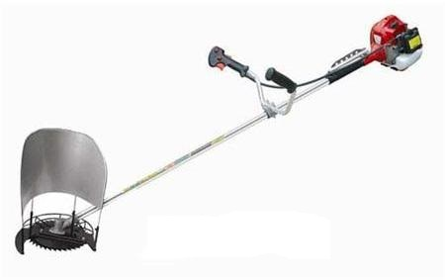

*Fig 1 Existing model of Paddy Cutter*

1. **DROBACKS IN EXISTING MODEL**

In existing model the whole assembly is operated with the help of petrol engine. Due to use of petrol engine there is always the operating cost of petrol. Also petrol is fossil fuel so the sources of fossil fuels are limited and they are going to exhaust soon in near future. Due to combustion of petrol harmful gasses like CO2, NOx, SOx, are released in the atmosphere due to which the atmosphere gets polluted.

Also this device has to work in rural areas where there will petrol may not be available to farmers. Also there is lot of components and linkages due to which there is lot of losses and actual power of engine will not transmitted to blades

1. **OUR PROPOSED MODEL**

After studying various research papers and journals we decide to modify existing design and eliminate some of the drawbacks of the cutter. As it is agricultural machinery so it has to give more performance at very low maintenance so parts and components should be as strong as possible. Also one has to equip this machine on ones arm so it should be as light as possible. The life of parts should be as long as possible. Periodic replacement of failed parts cannot be affordable to poor farmer. So we have to assume high factor of safety. At the same time we also have to consider about the cost.

Instead of using petrol engine we decided to use electric motor to run this cutter which will be powered by the high capacity and light weight battery and charge the battery with solar energy, due to which operating cost will be negligible. And this device will be affordable to poor farmers also it also solve the problem of pollution. Problem due to unavailability of petrol in interior parts also will be solved.

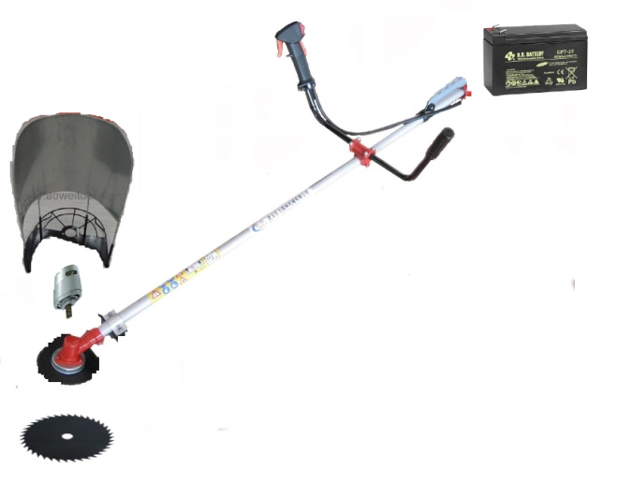

*Fig 2. General layout of our modified Design*

1. **GENERAL DESIGN**
2. **Design of windrowing system**

In order to windrowing the harvested plant an aluminum sheet with cylindrical shape was used that installed at the upper portion of the cutting blade. By using of this system, cut straws gathered and transported with width movement of operator hand until the ending of distinct cutting width, then voided and rowed. Height and panicle length of the tested varieties are showed in Table 6. radius of sheet choose equal the blade radius and its distance from blade surface computed 13 cm. schematic and dimensions of cutting head showed in Fig. 6. With considering 10 cm cutting height, 5 cm shaft length, 2mm blade thickness and 13 cm distance of rower from blade surface, heights of rower was 40 cm. it’s made from aluminum sheet and its schematic showed in Fig.6. Designed blade was made from carbon steel and installed on an existent machine (brush cutter model BG 430) with designed aluminum windrower



*Fig 3 Schematic and dimensions of cutting head (left), schematic of windrowing system (right)*

1. **DC Motor**

HCB71-020 is Compact size, High reliability DC Motor. It has high torque output at high rpm. And also maintenance free.



*Fig 4. HCB71-020 DC Motor*

1. **Battery**

EP7-12 (EP7-12FR) battery in this Absorbent Glass Mat technology for efficient gas recombination technology is used an it is Maintenance free(no water topping-up required) and No free acid(Non-spillable battery) it Can be used in any orientation(excluding used inverted). The battery is designed for heavy duty cyclic application. It has Low self-discharge rate, lower than 3% capacity loss per month



*Fig 5 EP7-12 (EP7-12FR) battery*

**References**

[1] Bainer R, Kepner RA, Berger EL (1978) Principles of farm machinery, 3 rd edn. Willey, New York.

[2] Nesar Mohammadi BANEH, Hosein NAVID, Mohammad Reza ALIZADEH, Hamid Reza GHASEM ZADEH, (2012) Design and Development of a Cutting Head for Portable Reaper Used in Rice Harvesting Operations

[3] Chakraverty A, Mujumdar AS, VijayaRaghavan GS,Ramaswamy HS (2003) Handbook of post-harvest technology cereals, Fruits, Vegetables, Tea and Spices. Marcel Dekker Inc, p 883.

[4] Chancellor WJ (1988) Cutting of biological materials. Handbook of Engineering in Agriculture, Vol 1. CRC prero INC, p 35.

[5] Ganesh CB, Gunner KH (2007) Low cost mechanical aid for rice harvesting. J Appl Sci. 7(23):315-318.