ABS (Anti-lock Breaking System)

By : Gaurav Bose (3rd yr. Mech.)

K.D.K College Of Engineering

**ABSTRACT:**

**Theory Behind“ABS”**

The Theory Behind ANTI-LOCK Brakes is simple. A Skidding wheel has Less Traction than a Non-skidding wheel. If you have been stuck on ice, you know that if your wheels are spinning you have no traction. This is because the contact patch is sliding relative to the ice by keeping the wheels from skidding while you slow down, ANTI-LOCK brakes benefit you in TWO ways:

1. You’ll stop faster and,
2. You’ll be able to steer while you stop.

**KEY WORDS: ABS- Anti-Lock Breaking System**

**INTRODUCTION:**

Anti-Lock Braking Systems (ABS)use electronic controls to maintain wheel rotation under hard breaking that would cause vehicle’s wheel lock up. Thus keeping the wheels rotating without lock-up increases vehicle stability.

**History:**

**ABS by TOYOTA:**

Toyota was one of the first to introduce ABS into Vehicles. According to them ABS Helped making vehicle stable when braking suddenly on slippery surface and provided more stable BRAKING FORCE and Facilitating Steering.

**Principle:**

When brakes are pressed on and off, the wheels DON’T lock so that you can steer your vehicle safely.

When the wheels LOCK, the ABS releases the wheel lock by repeatedly and quickly increasing and decreasing the braking force, ensuring the steering maneuverability and helping prevent accidents.

**Working:**

Sensors on each wheel constantly measures there rotational speed.The ABS MODULE samples this data constantly, comparing the rotational speed of each wheel.

If one or more wheel is rotating slower than the others and is in a condition of lock, the system takes action and instructs the BRAKE MASTER CYLINDER to move the brake force away from the locking wheel so regains traction again. As the wheel begins to turn again breaking force is momentarily reapplied. This process is repeated upto 20 times a second and causes the characteristic pausing feel through the brake peddle as a result the drivers intended brake force is applied either locking up and skidding, allowing the driver to maintain steering control while breaking in-return reducing the stopping distance.

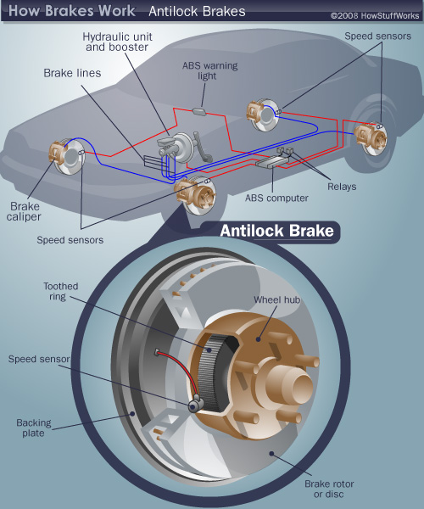

There are four main components to an ABS system:

* Speed sensors
* Pump
* Valves
* Controller

**Speed Sensors:**

The anti-lock braking system needs some way of knowing when a wheel is about to lock up. The speed sensors, which are located at each wheel, or in some cases in the differential provides this information.

**Hall Effect WSS(WHEEL SPEED SENSORS)** are the most commonly used sensors at present DATE.

**Valves:**

There is a valve in the brake line of each brake controlled by the ABS. On some systems, the valve has three positions:

* In position one, the valve is **open**; pressure from the MASTER CYLINDER is passed right through to the brake.
* In position two, the valve **blocks** the line, isolating that brake from the master cylinder. This prevents the pressure from rising further should the driver push the brake pedal harder.
* In position three, the valve **releases** some of the pressure from the brake.

**Pump:**

Since the valve is able to release pressure from the brakes, there has to be some way to put that pressure back. That is what the pump does; when a valve reduces the pressure in a line, the pump is there to get the pressure back up.

**Controller:**

The controller is a computer in the car. It watches the speed sensors and controls the valves.

**Improvised ABS {ABS at PRESENT}**

During Emergency Braking on slippery surface (like sand, wet surface etc.,) a driver may apply BRAKES with a braking force, which is greater than the tires capacity for GRIP. If this happens the wheel can lock up and causing the vehicle to skid. By preventing this lock up the vehicle stops sooner keeping the car under control.

**Applications of ABS:**

Used generally in aircrafts, that has been implemented in both the 4-Wheelers as well as 2-Wheelers.

ABS is also considered as the most safest way of stopping a moving vehicle.

ABS can be implemented in almost every transport vehicle.

**Pros and Cons:**

ABS is acronym of ANTI-LOCK BREAKING SYSTEM, it doesn’t expands to ANTI-SKID BREAKING SYSTEM!

The relative merits of ABS have been a subject of ongoing debate. Generally, this discussion weighs the cost of implementing an ABS system against the practical safety benefits, and the net effect on driver behavior.  
Many opponents of ABS cite the phenomenon of risk compensation, which theorizes that drivers of cars equipped with ABS tend to drive more aggressively due to the additional safety feature, thus negating any practical benefit. Others believe that a skilled driver is better able to control their vehicle in a dangerous situation, without the override of an automated system.  
Other tests, including those performed by the Highway Loss Data Institute, conclude that ABS is an effective way to prevent crashes, and promote overall road safety.

**ADVANTAGES:**

ABS brakes were designed to combat the problem of tire lock up and uncontrolled spins. Since brakes are most effective at slowing the car at a point just before wheel lock up, a system that provides for wheel braking while preventing wheel lock up is very desirable.Anti-lock brakes do just this by using a computer processor to monitor and control the application of the brakes. At braking, the processor monitors rpm and braking pressure on each of the vehicle's wheels. With this information, measured amounts of pressure are sent to each wheel in the form of hydraulic pulses of pressure to the calipers. These pulses achieve the desired braking pressure without allowing the wheels to lock up.

**CONCLUSION:**

You may have heard that it's possible to slow down quicker in a car without ABS. This has elements of truth, but in practical terms the benefits of ABS massively outweigh the slightly longer braking distances. For road use, ABS is an absolute must as it will allow you to steer out of the way of unexpected hazards.

ABS prevents the wheels from locking, and this allows you to steer and control your vehicle safely. Without ABS, as the driver applies the brakes the wheels lock. Despite applying steering lock, the car continues straight ahead due to the loss of steering and a collision results.

**REFERNCES:**

[www.howstuffworks.com/](http://www.howstuffworks.com/)

<http://www.sciencetis.com/topics/s/speed-sensor-hall-effect.htm>

<http://www.drivingfast.net/technology/abs.htm#.UUKzgtYrpIA>