A PROJECT REPORT ON
“DESIGN & FABRICATION OF PUSH TYPE SPRAYING MACHINE”

CONTENTS

1. Abstract

2. Introduction

3. Main parts of sprayers

4. Diagram

5. Working

6. Advantages

7. Applications

8. References

ABSTRACT
Spraying machine is the system in which the spraying of the fluid is done the help of pressurized gas or by pressurized discharge of the fluid through nozzle. The atomization of the fluid is obtained by the nozzle arrangement.
The spraying technology is developing day by day earlier the spraying is done by the can over which nozzle is attached. Now a day there are electrically operated spraying system.

INTRODUCTION:
The Push Type spraying machine is the manually operated spraying machine in which rotary motion of the wheel is used for the mechanism of spraying. It is the machine in which the fuel usage is absent as this is operated by the physical force. The machine arrangements of parts are as given below:

Basic Components:
- Wheel arrangements.
- Reciprocating pumps arrangements.
- Hose arrangement.
- Spraying nozzle arrangement.
- Spray flow regulator.
- Weeder arrangement.

The rotary motion is produced by the push given to the machine by the handler.
MAIN PARTS OF SPRAYERS
In order to operate a sprayer properly, to carry out repairs and to replace parts , one should known and understand the functions of the different components of sprayer. The important parts of sprayer are tank, pump, pressure gauge, filter, pressure chamber , hose cut off device , and nozzles.
1} TANK
The sprayer may have a built in tank or there may be a separate container for holding the spray fluid. The capacity of tank varies from less than 1 ltr to 2700 ltr. Bigger tanks can provide spray for larger areas before refilling is necessary. Even the best planned refilling procedure takes time. A simple calculation will show how many tanks filling will be necessary . Similarly the time for which one filling will last can be computed easily by dividing the capacity of the tank by the output of the sprayer. The operation will become tedious unless the tank provide for 15-20 min of spraying.
Tank with rounded corners and bottom facilitates cleaning. The filter hole should be large, so that a funnel is not required and hand can be introduced in to the tank easily for proper cleaning. The lid caps of all the opening in the tank should be leak proof. It should also be possible to clamp lid and caps in to position easily to prevent splashing and waste during the spraying operation. The tank should have a strainer in the filler hole. it should also be possible to drain and clean the container quikly.
2} PRESSURE GAUGE
It is sometimes provided on the discharge line as a quik means of whether other components of machine are functionally correctly and for guiding the operator in properly adjusting the pressure for each spraying job. The pressure gauge should be so located that it can be seen easily by the operator. Further it should be connected to the pipeline as near the nozzle as possible.
The pressure gauge is an important on a spraying machine. The continued pulsation of press-ure which occurs with the piston or diaphragm pumps, shortens the effective life of the pressure gauge.
3} FILTERS (STRAINER)
The liquid must be filtered we;; to keep out the dirt in order to protect the pump from abras -ion, to avoid interference with the function of valves and to prevent the blocking of nozzles. A strainer made of fine gauze should be fitted beneath the tank filler cap to filter the spray fluid as the tank is being filled. There may be several filters in the sprayer assembly. They are usually provided between the tank and pump unit, between the pump and spray boom or spray lance and within the spray lance. In some cases they are provided even on individual nozzle. Nozzles used for spraying concentrated fluids can easily get blocked by even the finest particles of dirt. Even in the case of partial blocked, the spray pattern is distorted, resulting in uneven coverage or in some areas being left unsprayed it is generally recommended that strainers with approximately 40 meshes/sq cm and should be between the tank and pump and the nozzles respectively.
4} PRESSURE CHAMBER
The pressure chamber is provided in spray operated with hydraulic pump. It prevents fluctuations in the pressure and , hence affect uniformly in spraying. However, in larger pumps pulsation in the discharge are overcome by incorporating into them two or more cylinders with separate pistons which work alternately.
5} HOSE
The hose is attached to the one end and the spray lance on the other, using hose couplings and clamps. It should be light , non absorbent , oil resistant , durable and flexible. Its bursting pressure should be over three times greater than the spraying pressure . hoses of synthetic rubber are heavier , less flexible and liable to crack at hose couplings. The other materials used for making hoses are natural rubber , cotton fabrics , plastic and nylon. The plastic and nylon hoses are more common these days because of being light ad cheap. Non – braided plastic hoses are also available.
6} NOZZLES
The nozzle of a sprayer is usually attached to a brass rod of varies design. The length of the rod varies from 35 to 90 cm according to the requirements. Normally, the spray lances is of simple constructions and can be easily detached. Usually, the lance has a 120 deg bend from a goose neck. Nozzles may be fixed to the spray lance by a screw thread mechanism.
7} CUT – OFF Device
Cut off valves are provided to shut off the flow of the liquid they are either spraying activated ( trigger control or operated by a knob).

DIAGRAM:

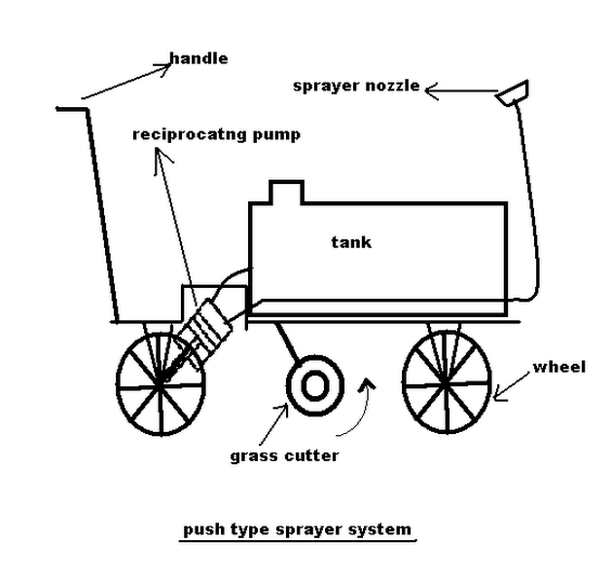

WORKING:
The push type spraying machine is the system in which the rotary motion of the wheel is converted into the reciprocating motion. The reciprocating motion which is produced is used to operate the reciprocating pump.
As the trolley move forward the wheel rotates & this rotation motion of wheel is converted into reciprocating motion which is based on the principle of four bar linkage/chain mechanism. In these this principle is used.
The mechanism used in this is slider crank mechanism. In this the forward stroke is used to force out/discharge out the fluid/gas & the return stroke is used for the suction of the fluid/gas.
The spraying is control by the hand lever of the spraying nozzle. The atomization of the liquid particles is control by the adjustment of the nozzle.
The forward motion of the trolley is also used for the weeds cutting. The arrangement is made to cut/trim/bend the weeds. When there is no Requirement of this operation at that time provision is made to disengaged the weeder.

ADVANTAGES:
- Eco-friendly.
- Fuel supply not required.
- Maintenance cost is less.
- Skill handler is not necessary.
- Multipurpose operation can be done.

APPLICATIONS:
- Machine can be used for spraying pesticides.
- It can be used at any place like in farm, garden, houses.
- It can be attached to any cycle/motorcycle.
- It can be used for stopping growth of weeds.

References:

http://www.wikipedia.com/sprayingmachine

http://www.googleimages.com/spraying machine

Guided by “Prof. A. H. INGLE”

Subimtted By:

1} Mr. Harshal Kshirsagar 2} Mr. Pawan Jangid

3} Mr. Sanket Shahir 4} Mr. Samir Bhise

