**PAPER PRESENTATION ON**

**DESIGN AND FABRICATION OF**

**AN AQUA SILENCER**

**SUBMITTED BY :-**

1. JAKESH H. TALMALE
2. ANKUSH HEDAOO

B.E. IV SEM (MECHA.)

UCOE, UMRER

Email id: [talmalejakesh@gmail.com](mailto:talmalejakesh@gmail.com)

Mobile no: 9923199236

* **CONTENTS :-**
* Abstract.
* Introduction.
* Components and Explanation.
* Construction.
* Working.
* Effect of Dissolved Gases on Water.
* Methods to Control Water Pollution.
* Merits and Demerits.
* Scope of the Project.
* Conclusion.
* References.
* **ABSTRACT :-**

An Aqua Silencer is mainly dealing with control of emission and noise in automobile exhaust. By using activated charcoal, perforated tube and outer shell it is constructed. An aqua silencer is fitted to the exhaust pipe of engine. The activated charcoal filters the harmful sulphur and nitrous content produced from the engine. Sound produced under water is less hearable than it produced in atmosphere. This mainly because of small sprockets in water molecules, which lowers its amplitude thus, lowers the sound level. Because of this property water is used in this silencer and hence its name AQUA SILENCER. It is tested in single cylinder 4- stroke diesel engine the noise and smoke level is considerable less than the conventional silencer.

* **INTRODUCTION :-**

An aqua silencer is used to control the noise and emission in ic engines. The reason why we go for aqua silencer is, in today life the air pollution causes physical ill effects to the human beings and also the environment. The main contribution of the air pollution is automobiles releasing the gases like carbon dioxide, unburned hydrocarbons etc. In order to avoid this type of gases by introducing this aqua silencer. It is fitted to the exhaust pipe of the engine, Sound produced under water is less hearable than it produced in atmosphere. This mainly because of small sprockets in water molecules, which lowers its amplitude thus, lowers the sound level. The emission can be controlled by using the activated charcoal layer and it is highly porous and posses extra free valences so it has high absorption capacity. So absorb the gases from the engine and release much less position to the environment. The noise and smoke level is considerable less than the conventional silencer, no need of catalytic converter and easy to install.

* **COMPONENTS AND EXPALANATION :-**
* **COMPONENTS :**
* Perforated Tube.
* Charcoal Layer.
* Outer Shell.
* Non Return Valve.
* Flange.
* H-Nipple.
* **EXPLANATION :**

**PERORATED TUBE :**

The perforated tube consists of number of holes of different diameters. It is used to convert high mass bubbles to low mass bubbles. The charcoal layer is pasted over the perforated tube.

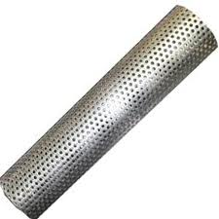

**CHARCOAL LAYER :**

The charcoal layer has more absorbing capacity because it has more surface area. This charcoal is called as ACTIVATED CHARCOAL. It is produced by heating the charcoal above 1500 ‘c foe several hours in a burner. Its surface area gets increased.

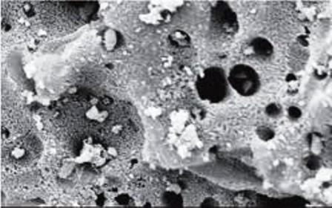

**OUTER SHELL :**

The whole setup was kept inside the outer shell. It is made up of iron or steel. The water inlet, outlet and exhaust tube was provided in the shell itself.

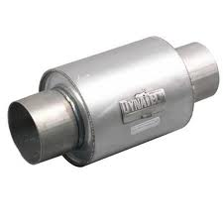

**NON RETURN VALVE :**

The non return valve is a mechanical device a valve, which normally allows fluid (liquid or gas) to flow through it in only one direction. Check valves are two-port valves, meaning they have two openings in the body, one for fluid to enter and the other for fluid to leave. An important concept in check valves is the cracking pressure which is the minimum upstream pressure at which the valve will operate. Typically the check valve is designed for and can therefore be specified for a specific cracking pressure.

The Aqua silencer was filled with water and it is directly connected to the exhaust pipe of the engine. There is a chance for the water to get enter into the engine cylinder. To avoid this, Non return valve is used. It allows the flow of fluid in one direction only.

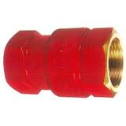

**FLANGE :**

A flange joint is a connection of pipes, where the connecting pieces have flanges by which the parts are bolted together. Here flange is used to connect the silencer to the engine.

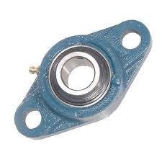

**H- NIPPLE :**

It is a device which is used to connect two pipes together. It consists of two threaded sides.

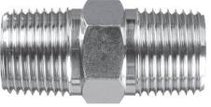

* **CONSTRUCTION :-**

Basically an aqua silencer consists of a perforated tube which is installed at the end of the exhaust pipe. The perforated tube may have holes of different diameters. The very purpose of providing different diameter hole is to break up gas mass to form smaller gas bubbles the perforated tube of different diameter .Generally 4 sets of holes are drilled on the perforated tube. The other end of the perforated tube is closed by plug.

Around the circumference of the perforated tube a layer of activated charcoal is provided and further a metallic mesh covers it. The whole unit is then placed in a water container. A small opening is provided at the Top of the container to remove the exhaust gases and a drain plug is provided at the bottom of the container for periodically cleaning of the container. Also a filler plug is mounted at the top of the container. At the inlet of the exhaust pipe a non-return valve is provided which prevents the back flow of gases and water as well.

* **WORKING :-**

As the exhaust gases enter in to the aqua silencer, the perforated tube converts high mass bubbles in lo low mass bubbles after that they passes through charcoal layer which again purify the gases. It is highly porous and posses extra free valences so it has high absorption capacity.

After passing over the charcoal layer some of the gases may dissolved in to the water and finally the. Exhaust gases escape through the opening in to the atmosphere. Hence aqua silencer reduces noise and pollution.

* **EFFECTS OF DISSOLVED GASES ON WATER :-**

The water is a good absorbing medium. In aqua silencer the gases are made to be dissolved in water. When these gases dissolved in water they form acids, carbonates, bicarbonates etc,

**Action of dissolved SO2 :**

When Sox is mixed in water, it form SO2, SO3, SO4, H2SO4, H2SO, i.e. sulfur Acid ( H2SO3,), it forms Hydrogen Sulphide which causes fol rotten egg smell, acidify and corrosion of metals.

**Action of dissolved CO2:**

The dissolved carbon dioxide forms bicarbonate at lower PH and Carbonates at higher PH. This levels 40-400 mg/liter. The form a scale in pipes and boilers. The carbon dioxide mixes with water to form Carbonic acid. It is corrosive to metals and causes green house effect.

**Effect of dissolved NOx:**

The Nitrogen in water under goes Oxidation to form ammonia, Nitrate, Nitrite, Nitric acid. This synthesis of protein and amino acids is effected by Nitrogen. Nitrate usually occurs in trace quantities in surface water. A limit of 10 mg per liters Nitrate is affordable in drinking water.

* **METHODS TO CONTROL THE WATER POLLUTION :-**

In aqua silencer the water gets polluted by the dissolved gases As in above topics said these gases are mixed with water to form carbonate, acids like carbonic acid, sulfuric acid, and Nitrous acid etc. the petroleum products contains phenols which gives suffocating smell. The sulfur gas mixes with water to form hydrogen sulfide, which give rotten egg smell. These should be controlled to minimum the water pollution.

There are two methods:

1) Lime water wash method

2) Adsorption process

* **LIME WATER WASH METHOD:**

The water is treated with the calculated quantities of slaked lime. One should have the quantitative analysis of water to go for this process. After mixing the heavy precipitates settle down as sludge at the bottom of the tank are removed from time to time. Lime can neutralize any acid present in the water. SO2, gases are removed from the flue gases forming calcium sulphate. The precipitates dissolved carbon dioxide as calcium carbonate and converts bicarbonate ions into carbonates. The equations are given below.

The SO2 gas is removed from the flue gases forming calcium sulphate

Ca(OH)2 + SO2. .. .. .. . CaSO3 +H2O

Neutralizes any acid present in water

2HCL + Ca(OH)2..........CaCl2 + 2H2O

H2SO4 + Ca (OH)2........... CaSO4 + 2H2O

Precipitates bicarbonate as calcium carbonate

CO2 + Ca(OH)2........CaCO3+2H2O

Precipitates bicarbonate as calcium carbonate

Ca(HCO3)2 + 2Ca (OH)2......... 2CaCO3 + 2H2O

Converts bicarbonate ions (Like NaHCO3, KHCO3 etc.) into carbonates.

NaHCO3+ Ca(OH)2............ CaCO3 + H2O + Na2 CO3

**LIMITATIONS OF LIME WATER WASH METHOD :**

* Amount of neutralization capacity is limited
* It is very difficult to handle
* Bridging and form are formed
* It is expansive
* Regeneration is possible
* Lime in any form it is difficult to handling.
* **ADSORPTION PROCESS:**

Activated charcoal is available in granular or powdered form. As it is highly porous and Possess free valences. So it posses high absorption capacity.

Activated carbon is more widely used for the removal of taste and odorous from the public water supplies because it has excellent properties of attracting gases, finely divided solid particles and phenol type impurities, The activated carbon, usually in the powdered form is added to the water either before or after the coagulation with sedimentation. But it is always added before filtration. Feeding devices are similar to those used in feeding the coagulants.

**ADVANTAGES OF ADSORPTION PROCESS:**

* It increases the coagulation power of the process.
* Its use reduces the chlorine demand.
* The excessive dose of activated carbon is not harmful.
* The treatment process is very simple and it requires nearly no skill
* The efficiency of removing color, odor and taste is quite high.
* It has excellent properties of attracting gases.
* **MERITS :-**
* No vibration when the engine is running.
* Start the engine easy.
* Control emission and noise in greater level.
* Carbon is precipitated.
* **DEMERITS :-**
* Frequent water filling is required.
* Silencer weight is more comparing to conventional silencer.
* Cost of activated charcoal is more.
* **SCOPE OF THE PROJECT :-**

There has been an increasing concern in recent years over the increasing of transportation and discharge of industrial waste waters into environment. The automobile emission contains air pollutants and other species. Almost all pollutants are toxic in nature. Some of the examples are CO, CO2, NOX, and Hydrocarbon. Among the air pollutants, all are most effective pollutants. Hence, the removal of pollutants was selected for the present study. Several expensive techniques are available in developed countries. But in developing countries like India is not applicable since adsorption technique is less expensive and economically feasible, it has been selected for the present study using some cheap cost chemicals as an effective adsorbent.

Therefore the objective of the present work was to test the ability of some chemicals in removing air pollutants from automobile emission.

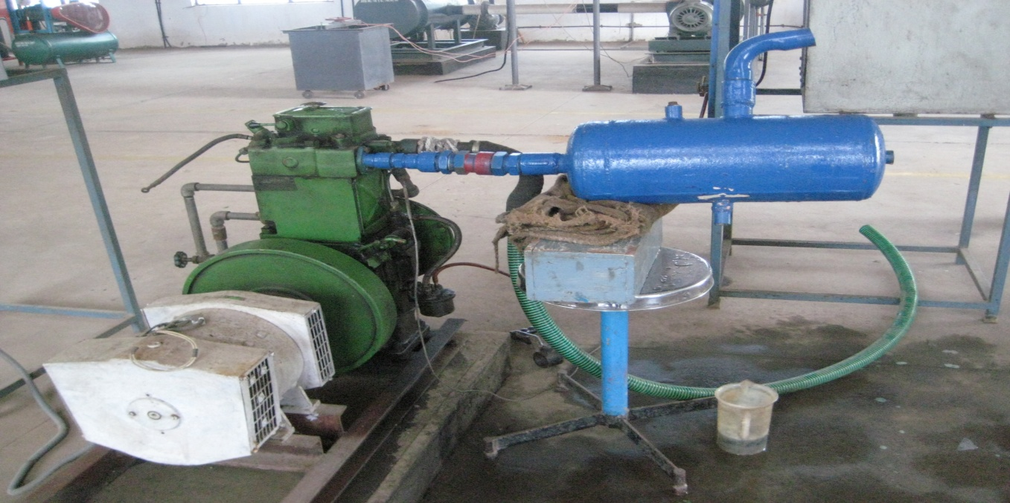

* **CONCLUSION:**

The aqua silencer is more effective in the reduction of emission gases from the engine exhaust using perforated tube and charcoal, by using perforated tube the backpressure will remain constant and the sound level is reduced. By using perforated tube the fuel consumption remains same as conventional system. By using water as a medium the sound can be lowered and also by using activated charcoal in water we can control the exhaust emission to a greater level. The water contamination is found to be negligible in aqua silencer. It is smokeless and pollution free emission and also it is very cheap. This aqua silencer performance is almost equivalent to the conventional silencer. It can be also used both for two wheelers and four wheelers and also can be used in industries.

* **REFERENCES:**
* Bansal T K and Sharma H R 1992 Chromium removal by adsorption on rice husk ash. Indian J. Environ. Prot. 12 (3): 198−201.
* Gupta M S, Bhargava D S and Varshney B S 1987 Removal of chromium through adsorption on saw dust. J. Inst. Engg. (India) Environ. Eng. 67: 64−69. Indian
* Prabavathi Nagarajan and Priscilla Prabavathi 2005 A Study of removal of Pb (II) by adsorption technique using carbonized tamarind seed and coast. Indian J. Environ. Prot. 25(5): 433 − 435.
* Gupta, R.K., et al. Ecology of polluted waters A.P.H. Publishing Corporation, New Delhi, p. 231-243, (2002).