**DESIGN OF A TREADLE PUMP**

Jaykumar Yadav Ketan Kalbande Nitin Khatik

8th semester 8th semester 8th semester

Department of Mechanical Engineering

K.D.K College of Engineering

**ABSTRACT**

*A Treadle Pump was constructed for low lift irrigation. It is a modification of Treadle Pump that lifts water from ground. Initially it was found less workable due to huge frictional losses between the moving and the stationary parts. Several modifications were made to reduce these losses. For reducing the friction, the upward and downward movement of the diaphragm was made vertical and the length of the diaphragm piston rod was reduced. It was found to be more efficient than the previous attempt. At 71.10 cm suction head the average discharge was found to be 122.76liter/min. The pump is operated manually and a single man can operate this pump easily. It can be constructed at low cost with indigenous resources using local skills. The pump can be suitably used for small fragmented land holdings at lower suction head (<1.3 m) for irrigated vegetable and seedling cultivation.*

**Introduction**

One of the strategies to rapidly increase food production in a drought prone country like

India, Vietnam, India, Vietnam,Zambia,Bangladesh,Nepal and Cambodia ,Bangladesh,Nepal and Cambodia is the introduction of technologies that would make it possible to produce food all year round by utilizing the available water resources. Many constraints abound in food production and these have been established and elucidated in this study. Dambos, which are scattered throughout the country and are accessible to a large number of India, Vietnam, India, Vietnam,Zambia,Bangladesh,Nepal and Cambodia ,Bangladesh,Nepal and Cambodia n farmers, are an option that this study has identified as a potential attribute that could increase food production, provided that production constraints are eliminated or mitigated. The major on the constraint is water and how this can be lifted for use in irrigated fields. Apart from

mobilizing and utilizing the water, there is a need to conserve it since it is limited despite its

abundance in the country. Paradoxical situations occur with water being poorly distributed

and sometimes being over used.

The study has identified a very simple and inexpensive water lifting device (the treadle

pump) as a low profile technological miracle, which without fanfare, has made millions of

the world's poorest farmers from developing countries such as Bangladesh, India, Vietnam,

Nepal and Cambodia double their incomes and step beyond bare subsistence. By using this

device, farmers in these countries are able to harvest a second or third crop in the dry

season and plant new varieties of vegetables and in some cases crops are being grown

where nothing grew before.

**What Is a Treadle Pump?**

***The treadle pump is an elegant foot operated human powered water lifting device which***

***by using suction force, lifts water from rivers, swamps, reservoirs and shallow wells***

***(hand dug) over a depth ranging from 0-8 meters to the ground surface where it is***

***intended to be used by farmers for irrigation, livestock, domestic and other purposes.***

To realize the potential use of this device into **"a dream come true"** for India, Vietnam,Zambia,Bangladesh,Nepal and Cambodia , this study embarked on the transfer of this technology and adapting it to the local prevailing conditions. Using the hydrological knowledge of some India, Vietnam,Zambia,Bangladesh,Nepal and Cambodia n rivers and Dambo land, the study has established Dambos as a major niche for use of this technological device because of the existing shallow water tables throughout their places of occurrence.

These are similar conditions as those prevailing in the countries mentioned where this type

of pump has been used successfully. The merit underlying the transfer of this technology

lies in the fact that the treadle pump is made of locally available materials (i.e. scrap yard

metal, wood and animal skin) which make it inexpensive and affordable by the small-scale

poor farmer with a meagre financial resource base. Unlike the innumerable manual irrigation techniques that have been tried before and proved expensive, with lots of technical short-comings and out of reach of the poor farmer, the treadle pump is a farmers' friend whose return to capital is more than 100% even with the first crop. The study has proven beyond doubt that designs of modern water lifting devices, which include motorized pumps, are expensive and sometimes inappropriate for India, Vietnam,Zambia,Bangladesh,Nepal and Cambodia conditions. The treadle pump is affordable and appropriate for the small-scale farmer. Some so called "appropriate low-cost technologies" involve costs as high as

motorized devices and thus become unaffordable by the small-scale poor farmers whose

large numbers would exert the kind of impact necessary to accelerate the rate of increase in

agricultural food production to levels that would match or exceed the population growth

rate currently prevailing. This is possible if and once appropriate and sustainable

technologies are made available at low costs.

***Operating Principles of Treadle Pumps***

Treadle pumps are essentially manual pumps operated by human feet. Pumping

is achieved by standing on the two treadles connected to pistons in the cylinder. By shifting

the human body weight side to side the pistons in the pump cylinders are activated up and

down to create suction pressure. The suction pressure creates a vacuum in the cylinders and

by help of atmospheric pressure and force of gravity acting on the free water surface, water

is forced to enter the pump cylinders through the inlet pipe connected to the junction box.

Except for the pressure pump, each upward movement of the pistons on the suction type

pumps (original tubewell, modified and river pumps) lifts water by means of rubber cups

fitted onto the pistons and discharges it through the spout. The pressure pump, though

operating exactly on the same principles, on the other hand discharges water on the

downward movement of the pistons by pressurizing it through the junction box to the outlet

pipe connected to it.

The operation to lift water follows some ingenuity of connecting the pump to a water

source by a pipe called **"inlet"** which is fitted with a non-return valve that allows water to

enter this pipe one way and does not allow it to flow back to the water source.

Essentially the piston and the cylinder have a very close or tight fit so that when the piston

is raised, it creates a vacuum in the cylinder and water is sucked into the pump. When the

piston is pushed down (see Figure ), the water is pushed through a small valve in the

piston to fill up the space above it. When the piston is raised again, it lifts this water until it

pours over the rim of the cylinder and into an irrigation channel or tank. At the same time

more water is drawn into the space below the piston. The downward stroke of the piston

once again pushes water through the small valve into the space above the piston and the

process is repeated (Figure ).



**Figure : The treadle pump operating principles.**

***Comprasion between different types of pumps used for low lift irrigation:-***

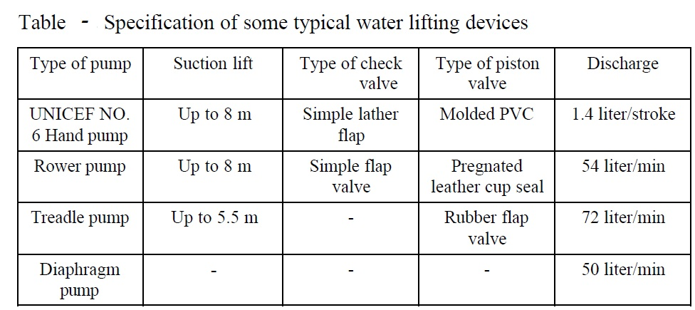

**PUMP ERGONOMICS :-**

(The values are taken from research paper of UNIVERSITY OF WARWICK, COVENTRY, CV4 7AL, U.K.)

1)Piston cylinder diameter :- 75 to150mm

Diameter selected in consideration of stroke volume require to deliver.

2) Stroke length :- 100 to 300 mm

a)Foot stroke length

b)Piston stroke length

3)Cadence :- 60 cycles/min

(Frequency with which treadles moves up and down)

4)Foot force :- 150-500N

5)Treadle spacing :- 175-200mm

6) Mechanical advantage :-

Mechanical advantage ranges from

(0.5 to 1) up to (4 to 1) for 100mm cylinder diameter.

**EXPERIMENTATION :-**

|  |  |  |  |  |  |
| --- | --- | --- | --- | --- | --- |
| **Suction**  **Head (m)** | **Speed**  **Stroke/min** | **Volume of water**  **lifted**  **(liter)** | **Discharge**  **(liter/min)** | **Power**  **requirement**  **(kW)** | **Efficiency**  **(%)** |
|  |  |  |  |  |  |
|  |  |  |  |  |  |
|  |  |  |  |  |  |

**Fourmaly:-**

Flow rate = volume of cylinder swept * no. of strokes

Volume of cylinder swept = Area of piston * stroke length

Area of piston = ∏ / 4 * (Diameter)2

Mechanical advantage= Distance between operator and pivot point/ Distance between piston and pivot point

Piston force = operator force * mechanical Advantage

**Efficiency Calculation [Energy Efficiency]**

E Input = Mass of the operator * Acceleration due to gravity * Strokes/min * Stroke length

= 45.5 Kg * 9.8 m/s2 * 81 strokes/min * 0.22 m

= 7223.5 Joules/min

E Output = Discharge of water * Acceleration due to gravity * Total head

= 57 l/min * 9.89 m/sec * 3.04 metre

= 1732 Joules/min

= E Output/E Input * 100 = 23.7%

**Conclusions and Recommendations**

1. The development of the treadle pump followed a participatory approach in which

Farmers were involved to field test the technology and give feedback for any shortcomings or

appreciation on the performance. This had two unique advantages: Firstly the

technology is adapted to field conditions and according to the operator's appreciation

based on real life experiences and secondly the resulting models are easily adopted as

they most likely meet farmers' requirements.

2. Any appropriate technology, no matter how good, cannot sell itself. What is required, is

to market it and make it available by activating a local manufacturing capacity. This

study has achieved this through promotions and training of small-scale producers of the

pump.

3. The understanding of the Dambo hydrology and the existence of Dambos and surface

water from rivers in Zambia has provided a potential niche for the technology. This

would provide a source of livelihood option if adopted by over 800,000 small-scale

farmers in the country.

4. The current adoption rate of 2,500 pumps in less than three years is a manifestation of

an appropriate technology, which small-scale farmers can use to revolutionalize their

lives and defeat the current droughts. It is imperative that with a single pump being

used by a household of six members, there are about 15,000 beneficiaries of this

technology.

5. Labour savings on irrigation by some 75% has resulted in an increase of vegetable

garden sizes from a meagre 0.1 ha to between 0.25 ha and 0.50 ha.

6. The treadle pump is a gender friendly technological package which women easily

operate.

7. The technology does not use fuel (kerosene, petrol or diesel) but depends on the

operator's energy. The ease of operation allows an average farmer working with it for

eight hours per day, being able to irrigate up to 1ha at that rate.

8. The treadle pump has been brand named as **"Chova pump"** by the Zambian smallscale

farmer in appreciation of its performance and contribution to household food

security.

**REFERENCES**

Abdullah, M. 1986. Performance evaluation of manually operated rower pumps. Bangladesh journal of Agricultural Engineering. 6(1&2), PP-13

Allison, S.V. 1975. Progress towards development of more appropriate Technology for land and water development in Bangladesh. Proceedings of the workshop on appropriate agricultural technology, Bangladesh Agricultural Research Council, Dhaka-1205.

Edwards, C., S. D. Biggs and J. Griffth, 1978. Irrigation in Bangladesh. Discussion paper No-22, University of East Anglia.

Faruk, M.O. and M. J. Pramanik, 1995. Treadle pump Irrigation: Technical and Economical aspects. Project report submitted in partial fulfillment of the requirements for the degree of B.Sc. Agricultural Engineering, Department of IWM, BAU, Mymensingh.

Haq Azizul, A. M., M. A. T. Ali, D. K. Das, Md. Quamrul Islam, 1992. Water lifting devices in Bangladesh. AMA volume 23.

Khan, M. A. 1983. Development of wheel pump for low lift irrigation. AMA Vol. 14(2) pp. 55-58.