SMT. RADHIKATAI PANDAV COLLEGE OF ENGINEERING

NAGPUR

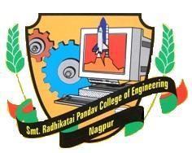

**DEPARTMENT OF MECHANICAL ENGINEERING**

Projected On Topic:-

**Recovery of Waste Heat from Domestic LPG**

Submitted BY:-

**Nilesh Gharpande Abhilash Kumbhare**

**Nikhil Nimbarte Chetan choudhari**

GUIDED BY:

**“Prof. S.S. PAWAR”**

***ABSTRACT***

As the energy demand in our day to day life escalates significantly, there are plenty of energies are shuffled in the universe. Energies are put in an order of low grade and high grade energies. ***The regeneration of low grade energy into some beneficial work is a fantastic job.*** One such low grade energy is heat energy. So it isimperative that a significant and concrete effort should be taken for using heat energy through waste heat

recovery. This paper concentrates on the theoretical analysis of production of hot water and reduction of LPG gas using waste heat.

**INTRODUCTION**

***Energy saving is one of the key issues not only from the view of energy conservation but also for the aegis of global environment.*** Waste heat is the heat generated all along most of the operations of system and then it is dumped into the surroundings even though it could be still utilized for some other beneficial and remunerative purposes. Waste heat is usually correlated with waste streams of air or water and it put into the environment. Recovery of waste heat is a hefty research area among majority of scientists. The temperature of the unthriftiness heat plays a hefty role in recovery of waste heat. Waste heat which is repudiated from a process at a temperature higher than atmospheric temperature can be dexterously and efficaciously procured and bestowed for some other profitable work. The technique of culling the waste heat relies upon the temperature of waste heat and the purpose for which the heat is extracted.

**Why this project needed?**

In our day-to-day life we need food. For those we have using LPG (liquefied petroleum gas )as fuel for burning and developing heat to cook food.

The heat supplied for the cooking pots for cooking food partially goanna be waste. Which otherwise can be utilised for other purpose like heating water.

This energy can be recovered easily by alteration in regular assembly of LPG burner. Following specification needed for recovering heat energy:-

* Heat transfer through small copper tube.
* Insulating linkage for passage.
* Reservoir (Insulating tank) with closed vessel.
* Other auxiliary LPG, burner, etc.

**Construction:-**

Round coil( copper tube) introduce in between the burner and cooling pot. This tube having two extended links (of tube) made of other material provided with insulation. Flowing hot and cold water in between them.

Round copper tube and insulating tank connected via. Extended links of round copper tube.

Insulating tank act as a reservoir, which contains cold water before process as well as hot water after the process. Also it is provided with knob to deliver hot water.

**DIAGRAM:-**

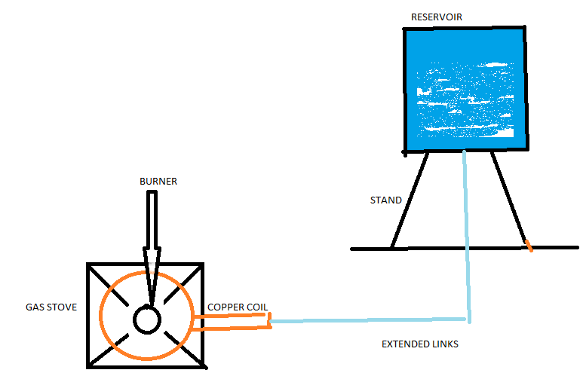

**Working:-**

Reservoir is placed on some height, which supplies water flow Into extended links of tube, by gravity to the round coil. Round coil absorbs wastage of heat while process of cooking. Due to which water molecule present inside the tube gets heated and again goes back to the reservoir. Because of this bouncy force set up(bouncy action takes place). The process is repeated again and again. so we get heated water at reservoir knob of reservoir opens to get heated water .