**Review- Innovative methods of modeling gear faults**

**Prashant Bagde, (enter your guide name)**

Enter your email id and guide id

***Abstract-*** The gearbox is an important element of any machine so it is very important to make study on that and finding out faults accouring in the gearbox. It is possible every time to observe the gearbox for its faults so the vibration changes in the gearbox is used for the possible faults. In this thesis the faults accouring in the gears are studied and how the vibrations are changes for a particular faults are studied. The modeling of the elements will be done on the CATIA and analysis on the Ansys software

**Key Words: Gearbox, vibrations, faults.**

**I. Introduction**

Gear box is a very important part of any mechanism so if any fault accour in the gearbox it will totally affect the working of machine so it is important to study the various faults occurring in the gear box and modeling of that faults. Gears and gearboxes are generally robust and reliable devices. However, problems do occur, and many are caused by unforeseen system interactions or consequences of the mode of operation. Detailed mathematical models of gear vibrations have appeared in recent years, but to utilize them requires a detailed knowledge of the gearbox components and their dynamic properties. The vibrations generated by gears can be modeled in various ways, some based on a fundamental analysis of the gear mechanism and dynamics others on an empirical measurement of the meshing error, either static or dynamic In cases where it is desired to infer something about internal stresses from a single measurement of vibration, e.g., in machine development, such a fundamental approach may be necessary, but there is a whole class of problems where a simpler approach is possible. This is the case, for example, in the monitoring of continuously operating machinery, where it is assumed that the initial condition is satisfactory, and it is only desired to detect deterioration and diagnose the likely source of the problem. This project will present an alternative approach which is applicable to the monitoring and diagnosis of gearbox faults based on an analysis of changes in the vibration signal, showing how these can be related back to various classes of fault. Most emphasis is placed on the effects of the various types of faults on the spectrum, but the applicability of two other techniques, viz., synchronous signal averaging and Spectral analysis is also discussed comparatively.

**II. Problem Identification**

1. Breakdown of machine: - If any fault accour in the gearbox it may lead to the breakdown of the machine which will increase the machining cost of product.

2. Maintenance cost: - The fault must be analyzed on its initial state otherwise total gearbox will be damage and it will increase the maintaince cost.

3. Efficiency of machine decreases: -If faults are not analyzing it will reduce the machine efficiency as it will consume more power to overcome the fault.

4. Time loss :- If total gearbox are damaged it will take more time for repairing so it is necessary to find out the faults at its initial state.

**III Earlier work done**

1. Wilfried Reimche, Ulrich Sudmersen, Oliver Pietsch, Christian Scheer.

The vibration problems associated with structures, which are more delicate and intricate, machines, which are faster and more complex, and production processes, which are automated and interlinked. The occurred problems are direct related with demands of lower investment, running and maintenance costs in coincidence with the requirements of increased productivity and efficiency, there has been the necessity for a better understanding of vibration causes and the dynamic response of complex machinery as well as single components. Shown are basics of comprehensive vibration analysis based on an aimed instrumentation of the unit to be supervised and the state of art in monitoring using statistical time values for general signal description and threshold comparison, envelope analysis and spectrum, phase and correlation analysis of multi sensor arrangements.

2. Dennis H. Shreve

Vibration detection and analysis techniques are used with maintenance. Making them work requires the proper vibration measurement and analysis equipment. Equally important, if not more so, is the vibration technician an individual properly trained to use the equipment effectively. Instruments provide the necessary information about a machine's vibration, but it is up to you to study, evaluate and interpret the data. It is up to you to pinpoint the problem and prescribe corrective action. To do this requires two important skills. The first is one that you already have: a basic knowledge and understanding of machines and how they work, the problems common to these machines, and how to correct them. The second skill is the ability to recognize and pinpoint mechanical and operational problems. Vibration measurement and analysis are key in developing this skill.

3. Rusmir Bajric, Denijal Sprecic, Ninoslav Zuber

They gives research in damage of gear and gear pairs using vibration signals is still very attractive, because vibration signals from a gear pairs are complex in nature and not easy to interpret. Predicting gear pairs defects by analyzing changes in vibration signal of gears pairs in operation is a very reliable method. Therefore, a suitable vibration signal processing technique is necessary to extract defect information usually covered under noise of other gear pairs dynamic factors. This paper presents the results of an evaluation of vibration analysis techniques as a method for the gear and gear pairs condition assessment. The origin of vibration in gear pairs and useful definition of damage identification techniques are presented. The detection and assessment capability of some of the most effective vibration techniques are discussed and experimentally compared, concerning a multistage industrial gearbox. In particular, the results of estimated vibration signal processing techniques are compared.

4. Cesar San Martin, Edgar Estupinan, Daniel San Martín

In this work, an effective methodology to detect early stage faults in rotating machinery is proposed. The methodology is based on the analysis of cyclostationarity, which is inherent to the vibration signals generated by rotating machines. Of a particularly interest are the second and higher orders cyclostationary components since they contain valuable information which can be used for the early detection of faults in rolling bearings and gear systems. The first step of the methodology consists in the separation of the first-order periodicity components from the raw signal, in order to focus the analysis in the residual part of the signal, which contains the second and higher order periodicities. Then, the residual signal is filtered and demodulated, using the frequency range of highest importance. Finally, the demodulated residual signal is auto-correlated, obtaining an enhanced signal that may contain clear spectral components related to the presence of a prospective localized fault. The methodology is validated analyzing experimental vibration data for two different cases. The first case is related to the detection of a crack in one of the teeth of a gearbox system.

5. R. B. Randall

Detailed mathematical models of gear vibrations have appeared in recent years, but to utilize them requires a detailed knowledge of the gearbox components and their dynamic properties. This paper presents an alternative approach which is applicable to the monitoring and diagnosis of gearbox faults based on an analysis of changes in the vibration signal, showing how these can be related back to various classes of fault. Most emphasis is placed on the effects of the various types of faults on the spectrum, but the applicability of two other techniques, synchronous signal averaging and cepstrum analysis, is also discussed comparatively, making use of practical examples.

6. Marcos Pellegrini Ribeiro

The research described in this thesis is focused on vibration monitoring in machinery whose location makes it difficult to gain direct access. In particular, interest is focused on electrical submersible pumps (ESPs) used in the petroleum industry, which are situated in deep petroleum wells. In this study, a signal processing technique has been developed for the purpose of analyzing vibration signals generated by ESPs and detected by remotely-located accelerometers. Analysis of vibration signals has been achieved by adapting the original Prony method to generate time-frequency representations that are able to handle signals containing stationary and non-stationary components with high levels of noise. Analysis were made applying the extended Prony time-frequency representation (PTFR) to simulated signals, and compared with the analysis resulted from the application of four other signal processing techniques: the Fourier transform, the Morlet wavelet transform, the Wigner-Ville and the pseudo Wigner-Ville distributions. The new method was also applied to signals generated by a small-scale experimental model which replicated, as closely as possible, the type of signals normally found in full-size ESP installations.

7. Hongyu Yang, Joseph Mathew and Lin Ma

The safety, reliability, efficiency and performance of rotating machinery are major concerns in industry. The task of condition monitoring and fault diagnosis of rotating machinery faults is significant but is often cumbersome and labour intensive. Effective and efficient feature extraction techniques are critical for reliably diagnosing rotating machinery faults. Various vibration feature extraction methods have been proposed for different types of rotating machinery during the past few decades. However, limited research has been conducted on synthesizing and analyzing these techniques, resulting in apprehension when technicians need to choose a technique suitable for application. This paper presents an updated review of a variety of vibration feature extraction techniques that have demonstrated success when applied to rotating machinery. The literature is categorized into the following groups: time domain, frequency domain, time frequency analysis. The paper will comment on future directions for research on vibration feature extraction for fault diagnosis of rotating machinery.

8. P. Vecer, M. Kreidl, R. Smid

Condition monitoring systems for manual transmissions based on vibration diagnostics are widely applied in industry. The systems deal with various condition indicators, most of which are focused on a specific type of gearbox fault. Frequently used condition indicators (CIs) are described in this paper. The ability of a selected condition indicator to describe the degree of gearing wear was tested using vibration signals acquired during durability testing of manual transmission with helical gears.

9. Amit Aherwar, Saifullah Khalid

Gears are important element in a variety of industrial applications such as machine tool and gearboxes. An unexpected failure of the gear may cause significant economic losses. For that reason, fault diagnosis in gears has been the subject of intensive research. Vibration signal analysis has been widely used in the fault detection of rotation machinery. The vibration signal of a gearbox carries the signature of the fault in the gears, and early fault detection of the gearbox is possible by analyzing the vibration signal using different signal processing techniques. In this paper, a review is made of some current vibration analysis techniques used for condition monitoring in gear fault.

10. Shawki A. Abouel-seoud, Mohamed S. Elmorsy

De-noising and extraction of the weak signature are crucial to fault diagnostics and prognostics in which case features are often very weak and masked by noise. The wavelet transform has been widely used in signal de-noising due to its extraordinary time-frequency representation capability. In this paper, a method for the fault diagnosis of the wind turbine planetary gearbox components is proposed based on wavelet transform analysis. Emphasis is given on the signal processing of the acquired vibration signal in order to extract novel parameters-features of potential diagnostic value from the monitored waveforms. Innovative wavelet-based parameters-features are proposed utilizing the continuous wavelet transform (CWT).

**IV. Techniques for Fault Detection**

The figure shows the various methods of gear faults detections

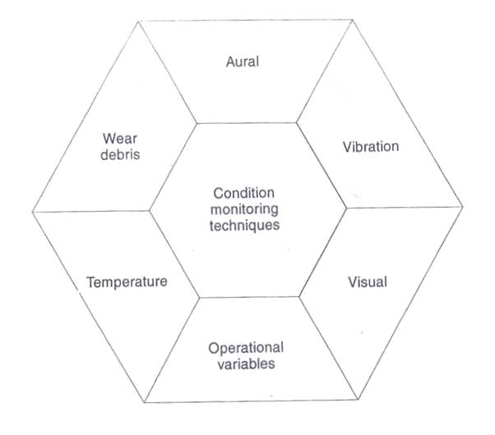

Figure 1. Techniques for faults detection

**V. Why Vibration Monitoring?**

* Almost all faults show themselves up in a changed vibration behavior For most structural and rotor parts gears, bearings, rotors, belts, cracks, couplings etc
* Vibration is very sensitive to fault severity
* Machine never required shutting down, stopped and inspected.
* The process of vibration measurement is online continuous and convenient.
* Non-intrusive, nondestructive.
* Offline inspections
* Most faults show up in vibration response
* convenient and most suitable to online diagnostics

**VI. Typical gear Faults and defects that can be detected by vibration analysis**

The various faults that can be detected by vibration analysis are listed below

* Tooth meshing fault
* Misalignment
* Crack or worm teeth
* Localized surface damage
* Wear or inadequate lubrication
* Tooth root cracks, missing tooth
* Pitch error
* Eccentricity

**VII. Principal Causes of gear failure are**

* An error in design: It may be caused due to improper gear geometry, use of wrong material, quality, and lubrication.
* An application error: It may cause due to Vibration, mounting, installation, cooling and maintenance.
* Manufacturing error: Mistake in machining or problem in heat treatment.

**VIII. Various gear faults**

The various gear faults accouring in the gears are listed in the following table.

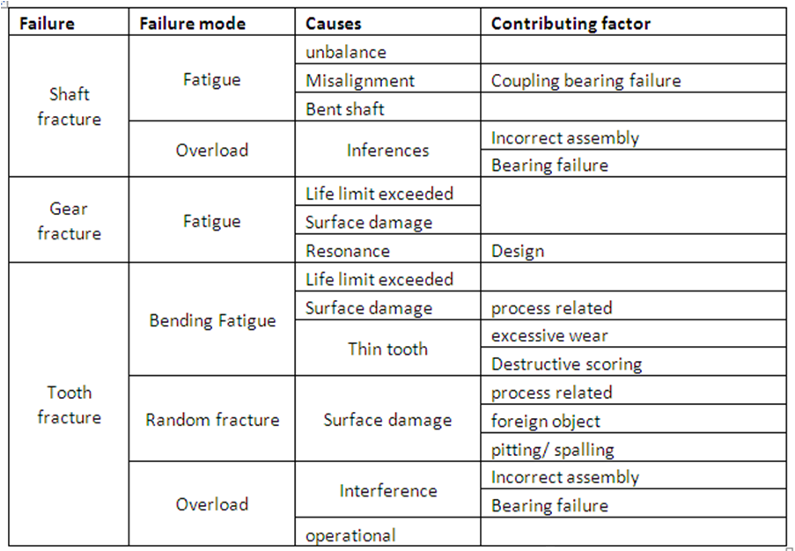

Table 1. Various faults detection

**IX. Five steps for vibration analysis**

1. Acquire noise or vibration signals and tachometer signal.
2. Preprocess the noise or vibration signals.
3. Process the tachometer signal to get the rotational speed profile.
4. Perform order analysis with the noise or vibration signals and speed profile.
5. Display the analysis results in different formats.

**Reference:**

[1] Wilfried Reimche, Ulrich Südmersen, Oliver Pietsch, Christian Scheer, Fiedrich-Wilhelm Bach, “Basics Of Vibration Monitoring For Fault Detection AndProcess Control”.

[2] Dennis H. Shreve, “Introduction to Vibration Technology”.

[3] Rusmir Bajric, Denijal Sprecic, Ninoslav Zuber “Review of vibration signal processing techniques towards gear pairs damage identification”.

[4] Cesar San Martin, Edgar Estupinan, Daniel San Martin,“A Methodology For The Detection And Diagnostic Of Localized Faults In Gears And Rolling Bearings Systems”.

[5] R. B. Randall, “A New Method of Modeling Gear Faults”.

[6] Marcos Pellegrini Ribeiro, “Inaccessible Equipment Monitoring Via Vibratory Signature Analysis Utilizing Data Collected By Remote Accelerometers”.

[7] Hongyu Yang, Joseph Mathew and Lin Ma, “Vibration Feature Extraction Techniques for Fault Diagnosis of Rotating Machinery-A Literature Survey**”.**

[8]Amit Aherwar, Saifullah Khalid, “Vibration Analysis Techniques For Gearbox Diagnostic: A Review”.

[9] P. Vecer, M. Kreidl, R. smid, “Condition Indicators for Gearbox Condition Monitoring Systems”.

[10] Shawki A. Abouel-seoud, Mohamed S. Elmorsy, “Enhancement of Signal Denoising and Fault Detection in Wind Turbine Planetary Gearbox Using Wavelet Transform”