Conceptual Design of Dual System Lilliput Gin
¹Rohan Parkar, ²Christina Antu
¹⁻² Students, Mechanical Engineering Branch, WCEM Nagpur
E-mail: ¹parkar.r@gmail.com / 08793645845

Abstract-As research and development progresses in the field of ginning till date, some small scale Gins such as, Single Roller Lilliput Gin, Double Roller Lilliput Gin, Cloy Gin etc., though they are smaller in appearance, they are very heavy and also require electric power for their operation. On the contrary the Dual System Lilliput Gin will be light in weight and also will be operated by dual means i.e. power operated as well as manually operated. This research paper will explain reason for selecting the concept of such a ultra light and dual system Gin in market which will be one of its own kind.
INTRODUCTION
Cotton crop has profound influence on India’s economy. India ranks first in area (Ca 8.5 m ha) under cotton cultivation and third in cotton production (2.5 million tonnes) but has very low productivity (Ca 300 kg lint / ha). During the 90s, India not only become self sufficient with respect to its total cotton requirements under different staple grades, but also had some exportable surplus of cotton. The commercial quality of cotton fibbers, as they develop in the balls, mainly depends on the pedigree of the strain and the Argo climatic conditions under which the plant is grown. The inherent quality can be improved upon by cross breeding, selection and adoption of appropriate agronomic practices, but no improvement is possible after the cotton bolls on the plant burst open. The important quality attributes being monitored by the cotton improvement scientist wile evolving new strain are 2.5% span length, length uniformity ratio, micronaire, bundle strength, braking elongation and maturity apart from ginning percentage (GP). The breeder has to ascertain the above fibre property for hundreds of small samples of seed cotton every year as accurately as possible in short time.
The cotton grower needs to access the monetary returns likely to accrue from the crop raised by him by knowing fibre properties and GP since seed cotton with higher GP and having good fibre properties is likely to fetch a better price. Furthermore, in cotton markets where transactions are done on seed cotton, the lint content is estimated by the purchaser / broker by the usual hand-and-eye method, which is bound to involve considerable personal bias. Most of the time seed available in the market contains a mixture of different varieties that takes place at cotton markets and ginners. As a result, availability of pure quality seeds for sowing becomes difficult not withstanding the high cost of seeds. Besides, commercial size roller and saw gins cannot be used for ginning small kapas samples for the purpose of seed production for small traders and marginal farmers or for trading activities by market yard personnel. Also the commercial machines are not portable and costly.
- Principle of operation
Dual System Lilliput Gin works on the principle of McCarthy’s Gin. A chrome leather roller, fixed knife and moving knife are the main components of the Gin. A spirally grooved roller is pressed against a fixed knife and is made to rotate at a definite speed. A moving knife reciprocates by means of a crank of eccentric shaft close to the leather roller. When seed cotton is fed to the machine in motion, fibres adhere to the rough surface of the roller and are carried in between the fixed knife and the roller such that they are partially gripped between them. The moving knife beats the seeds and separates the fibres, which are gripped from the seed end. This process is repeated number of times and due to the ‘push and pull’ action, the fibres are separated from the seed. The separated fibres carried forward on to the roller, while passing upward are dropped out of the machine. The Gin speed drop down through the grid slots provided. The principle of operation of Dual System Lilliput Gin is shown in fig.1. 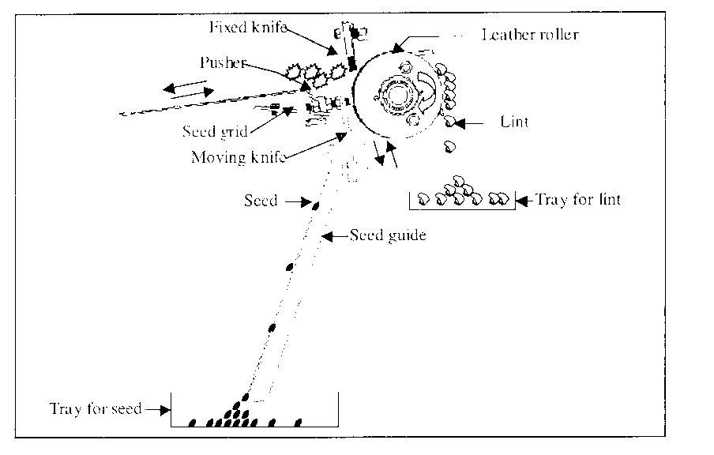
Fig.1 Principle of Operation of Dual System Lilliput Gin.
- Lilliput gin
The machine which separates cotton fibre from cotton seed is called as ginning machine. As stated in previous discussion there are many types of ginning machines available in market some of them are giants, and perhaps used for the mass production; The concept of Lilliput gin comes under the consideration where there is a small breeder or farmer comes under a very small land holding. For such farmer and breeder giant or mass-producing types of ginning machines are of no use. They need small, handy, user friendly, less power consuming, durable and cheapest kind of machine, which may meet their needs.
So Lilliput seems as answer to all their needs and worries. The word Lilliput stands for a dwarf creature; here before a man with a shorter height called as Lilliput, this same nomenclature is given to the gin for the same reason. That is the gin will be shorter in height, but on the contrary it will serves all the purpose of ginnery.
- Conceptual dual system lilliput gin
The Dual System Lilliput Gin will be designed in such a way that it will facilitate the user to easily carry it to the field as well as to the Research Centre by himself. That means this machine will be ultra light in weight. Another feature of this machine will be, it enable user to operate it manual as well as power operated means. That is it will solve dual purpose. For such dual purpose Gin a clutch arrangement will be there, to engage or disengage the drive system. Also some of the motives are there to introduce such a versatile ginning tool in this area, may be called as future perspective to explore more regarding ginning. These are, to introduce handy Ginning tool in the ginning area, overcome the limitation of ginning machines to be limited to power operation, launch an ultra light Ginning Machine in the market, produce a hybrid tool for ginning in the ginning area, create a cheaper and economic option for farmer and breeder, generate intermediate between manual and mechanized generation, make possible both man power as well as machine power together for Ginning, introduce collaborative mechanism in the Ginning area and unify the Ginning approach.
CONCLUSION
To overcome the problems faced by the cotton breeders, traders, seed industries and farmers, need of a portable ginning machine was felt for some time. In order to meet this demand a portable gin need to develop, which may carry easily to the field by a farmer and also by a scientist to the research centre. It should work in the condition where there is short of power and also if power is available. For such dual versatility a Dual System Lilliput Gin need to be developed, such that it involves both power as well as manual driving system in it.
BIBLIOGRAPHY
- Agrawal J. F., 2005,”Techno Economic Feasibility and Development of Mini Cotton Processing Unit” A Ph.D. Thesis submitted to VNIT, Nagpur.
- The Textile Institute, 1993, “Textile Progress-Cotton Ginning”, Vol. 24 No. 02.
- Sharma Vijay P., 198. “Cotton Production in India: Performance, Prospects and Constraints” Productivity Journal. Vol.39, No.3 pp 483-498.
- Jadhav S.B. 2002.”The study of effect of design modification on ginning out turn and lint quality in double roller ginned lint”, thesis submitted to Mumbai University for award of Ph.D. CIRCOT, Mumbai.
- Bodhe A. B., Agrawal J.F., 2009 ,“A Productivity Review of Cotton Ginning Process Through Techno-Economic Aspects ” 51st National Convention oof Industrial Engineers, Nagpur.
- Ralph M. Bannes., “Motion and Time Study-Design and Measurement of work”, Seventh Edition, John Wiley & Sons, Singapore.
- International Labour Office, “Work Study”.
- H.S. Shan, “Work Study and Ergonomics”, Dhanpaat Rai and Sons, New Delhi.
- Anne Webster, “Continuous Improvement Improved”, Work Study, Vol.48 Issue-4, 1999, pp.142-146.
- Anna Baines, “Productivity Improvement”, Work Study, Vol.48, Issue-2, 1997, pp.49-52.
- Murray R. Spiegel, (1980). “Probability and Statistics SI (Metric Edition)” McGraw-Hill Book Company, New Delhi. PP 218-220. Phillips J. Ross, 1980,”Taguchi Techniques for Quality Engineering”, McGraw Hill Book Company, New York, USA.
- Madhav S Phadke, 1989. “Quality Engineering Using Robust Design” Prentice Hall, New Jersey, USA.
- L. J. Chang and Powell, “Towards a Framework for Business Process Re-Engineering in Small and Medium Sized Enterprise”, Information System Journal Vol.8,1998,PP.199-215

