TWIN PARABOLIC SOLAR COLLECTOR WITH TRACKING SYSTEM
*Kishor Rambhad *Skumar Kumbhalkar *Vednath Kalbande
*Asst. Professor, G. H. Raisoni College of Engineering

ABSTRACT
This thesis presents experimental platform based on the design, development and performance characteristics of twin parabolic solar tracking system. The performance of the tracking system is experimentally investigated with the synchronous movement of parabolic collecter and the sun. The system is fabricated with highly reflective stainless steel sheet. The experimental setup is placed in open, and the tests were carried out. The collector’s efficiency was noted. The results are encouraging to provide the data for developing water heating for rural application. The concentrated heat is absorbed by a copper tube and it is fixed on solar trace path in which, it eliminates tracking the sun in the east west direction and optimal tracking of the sun in the north-south to obtain maximum solar energy. The experimental results are taken on summer and cloud free days. The test results were measured,efficiency is 60-70% .
Key Words: twin parabolic, solar concentrator, tracking system, worm and work gear, stepper motor
Corresponding author: kishorsrambhad@gmail.com

INTRODUCTION: Energy is considered a player in the generation of wealth and also a significant component in the economic development .Renewable energy is accepted as a key source for the future. It is generally accepted that renewable energy technologies contribute to the robustness and stability of an energy system; the system becomes more sustainable. In developing world shortage of fuel for conventional emphasizes the need for alternate energy sources and the most pollution-free, limitless source is solar energy and with the gradual depletion of fossil fuels on the earth, the study of solar energy has become a subject of renewed interest. It is said to be rapidly approaching the point where capital costs of solar energy system will be less than those of nuclear systems. It is unlike other sources of energy, solar energy allows independent systems to be constructed possessing a thermal conversion mode that necessitates a simple technology, which is adapted to this site and to the particular region for many applications. The implementation of solar power plants in regions of high isolation is a promising option for an environmentally compatible electricity supply strategy. The existing solar paraboloidal dish concentrators are used for power generation purpose heating and steam generation applications.
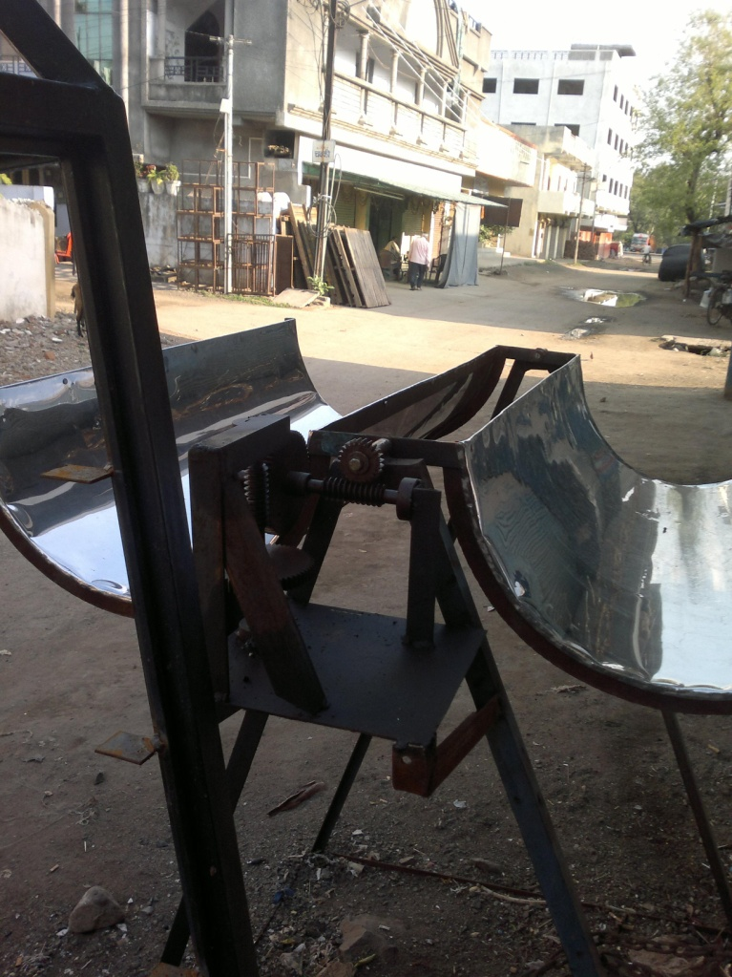
The heliothermal system in which the incident radiation absorbed is turned into heat [1]. There are three modes of solar energy utilized as helio thermal, helio chemical and helio electrical.
The heliothermal system is used for the conversion of solar radiation into heat. The availability of solar energy on the earth surface depends of geographical location. India is a favourable location for solar energy development
DISCUSSION:
Sun is the singular source of renewable energy that sits at the centre of the solar system. It emits the solar energy as electromagnetic radiation at an extremely large and relatively constant rate through out the year. This energy is released at the rate of 3.83 × 1026 W. The rate at which this energy is emitted is equivalent to the energy coming from a furnace at a temperature of about 6000 K. If the energy coming from just 10 hectares (25 acres) of the surface of the sun could be harvested, it would be enough to supply the current energy demand of the World. The rate at which solar energy reaches a unit area at the earth is called the solar irradiance or insolation. Solar irradiance is an instantaneous measure of rate and can vary over time. The maximum solar irradiance value is used in solar
system design to determine the peak rate of energy input into the system. The designer of solar energycollection systems is also interested in knowing how much solar energy has fallen on a collector over a period of time such as a day, week or year. This summation is called solar radiation or irradiation.
Fig.1. twin parabolic solar collector
The point focusing parabolic dish concentrator can have concentration ratios ranging from 100oC to a few thousand and can yield temperatures up to 3000ºC. These require continuous two-axis tracking. These involve surfaces of double curvature which reflects or refract incoming rays into a small region. A paraboloid is a surface produced by rotating a parabola about its optical axis. Owing to circular symmetry of the design, it produces a point image of a parallel beam of light on a particular period of a day. In the seventies the problem of ground based solar energy conversion started to grow to one of the greatest engineer’s challenges of this century. Among several other concepts, the farm system using high performing point focusing collectors was identified as a very promising solution in the lower power region up to 1 MW.
The solar energy conversion principle of high temperature and higher heat obtained by dish concentrator and on a focal absorber, the entire experimental setup called as solar parabolic dish concentrating system as shown in Fig. 1.
Fig.2. solar reflector
Many investigations has been carried out like mirror based booster; line based focusing and point based focusing are common practice [2]. A parabolic dish, with curve obtained on concentrated point and making it as a curve towards the movement of the sun and making as a trace it can be called as solar trace and focusing through this path is most advantages over other systems. In two axis tracking east-west and north-south are required and commonly used in practice, and this paper eliminates there is no tracking in east-west, optimized with intermittent tracking is needed in the south west directions and it is always placed normal to the incoming solar radiation rays to obtain higher efficiency and to get more energy to be captured throughout the year. It has been a fabricated dish concentrator from small elementary shapes from highly polished aluminum sheet. These elemental components are commonly called as reflecting materials. It is comparatively small unit which used to be a dish shaped reflector, concentrated sunray heats the water and super heated fluid to generate the steam for larger capacity plants, a number of dishes used.
The sun’s virtual motion at the chosen area was also determined using available empirical formulas. Design of a solar system adequate to meet the expected load was carried out using Bi -focal concentrating collectors. Mechanical sun tracker for the solar collectors was designed using clockwork mechanism. Construction of system parts using local technology, and assembly of the system, followed by the testing and performance evaluation
of the system.

Components used in the project are:
- Parabolic trough
- Receiver pipe
- Stepper motor
- Spur gears(4 nos.)
- Worm and Worm gear (2 nos.)

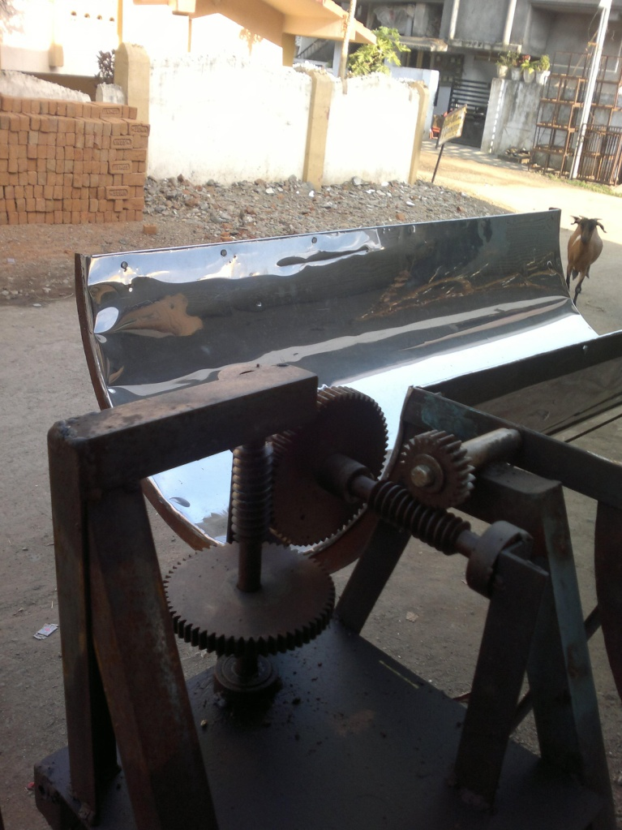
Fig.3. solar tracking gear mechanism

CONCLUSION:
The project aims to harvest and utilize the energy of the sun to covert the cold water into hot water for various industrial purposes. By tracking the movement of the sun throughout the day we achieve a very efficient model to heat the water or other liquid which may flow through the receiver pipe. Our main aim is to design the gear box in order to track the sun movement.
REFERENCES
- Continental J. Renewable Energy 2 (2): 19 - 33, 2011 Nigeria. Wilolud Journals
- Experimental Analysis of Non Tracking Solar Parabolic Dish Concentrating System for Steam Generation. Meenakshisundaram Arulkumaran1,* and William Christraj, Department of Mechanical Engineering, Oxford Engineering College, Tiruchirappalli, PIN: 620009, India
- Design, Development And Performance Studies Ofembedded Electronic Controlled One Axis Solar Tracking System, A. Valan Arasu and T. Sornakumar,Asian Journal of Control, Vol. 9, No. 2, pp. 163-169, June 2007.
- Advances in Parabolic Trough Solar Power Technology, Hank Price National Renewable Energy Laboratory, 1617 Cole Blvd., Golden, CO,

