**DESIGN AND FABRICATION OF AIR ENGINE**

**REPRESENTED BY**: - **1) SAGAR HEDAU 2) MANGESH RAUT**

**3) CHETAN GHUMADE 4) PORNIMA GODBOLE**

**ADDRESS: -** 1) [sagar.hed@gmail.com](mailto:sagar.hed@gmail.com) 2) [mangesh.raut21@gmail.com](mailto:mangesh.raut21@gmail.com)

3) [ghumde.chetan@gmail.com](mailto:ghumde.chetan@gmail.com) 4) pornima.godbole@gmail.com

**GUIDED BY: -Prof. H.N.PAWAR**

**DEPARTMENT OF MECHANICAL ENGINEERING**

**COLLEGE: - Smt. Radhikatai Pandav College of Engineering Nagpur.**

**RASHTRASANT TUKADOJI MAHARAJ NAGPUR UNIVERSITY, NAGPUR MAHARASHTRA. INDIA**

**ABSTRACT**

All automobile engines consume the petroleum fuel. Considering the demand of fuel and cost of fuel, other resources of energy is required to operate the vehicle. So that we are go for other type of energy like electric power, solar power etc… It may be noted that the air energy is readily available with free of cost. So we are considering that air engine in our project.

**INTRODUCTION**

A pneumatic motor or compressed air engine is a type of [motor](http://en.wikipedia.org/wiki/Engine) which does [mechanical work](http://en.wikipedia.org/wiki/Mechanical_work) by expanding [compressed air](http://en.wikipedia.org/wiki/Compressed_air). Pneumatic motors generally convert the compressed air to mechanical work through either linear or rotary motion. Linear motion can come from either a diaphragm or piston

actuator, while rotary motion is supplied by either a vane type air motor or piston air motor.

Pneumatic motors have existed in many forms over the past two centuries, ranging in size from hand held turbines to engines of upto several hundred horsepower. Some types rely on pistons and cylinders, others use turbines. Many compressed air Engines improve their performance by heating the incoming air, or the engine itself. Pneumatic Motors have found widespread success in the hand-held tool industryand continual attempts are being made to expand their use to the transportation industry. However pneumatic motors must overcome inefficiencies before being seen as a viable option in the transportation industry.

**WORKING PRINCIPLE**

In our project we have operate the vehicle without using the fuel. Inside of fuel we are using the compressed air supply, with the chain arrangement. Here the vehicle is consisting of the chain drive arrangement, pneumatic air motor, and control unit. In this the vehicle wheel shaft is coupled with chain drive and the pneumatic air motor. The air from the compressor it reaches the control unit and the pressure of air is controlled and it is passed through the flow control valve. The flow control valve supply the required amount of air to the pneumatic air motor and the motor shaft fixed with sprocket it will be rotate and the rotating sprocket is coupled to the wheel shaft sprocket to move the vehicle. The forced air passes into the inlet port to rotate the pneumatic air motor. Then the output shaft will coupled with the back wheel drive using chain drive arrangements which is clearly shown as in the above diagram.

**MODEL LINE DIAGRAM**

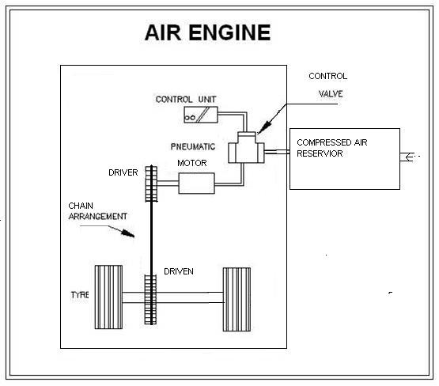

**COMPONENT TO BE USED**

RECTANGULAR HEIGHTED STAND

MAIN DRIVEN AXLE

DRIVEN SPROCKET

DRIVE SPROCKET

PEDESTAL BEARING

AIR MOTOR

AIR RESERVIOR

AIR LINE TUBE

WHEELS

GAUGE

REGULATOR

**CONSTRUCTION OF AIR MOTOR**

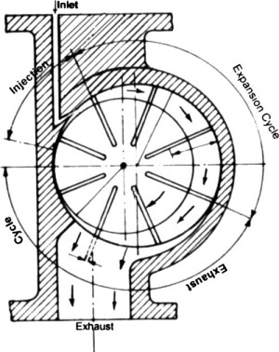

**WORKING OF AIR ENGINE**

The use of compressed air for running prime mover such as air turbine offers a potential solution to these issues as it does not involve combustion in producing shaft work. The great advantages such as availability of air as fuel and the absence of emissions are also apparent from air motor. Compressed air driven prime movers are also found to be cost effective compared to fossil fuel driven engines. Such prime movers have perennial compressed air requirement, which needs some source of energy for running the compressor. The overall analysis shows that the compressed air system is quite attractive option for light vehicle applications.

**ADVANTAGES**

* It is pollution free.
* Compressed-air technology reduces the cost of vehicle
* It is non-flammable.
* The engine can be compact in size.
* Lubrication is not required.
* Low manufacture and maintenance costs.

**LIMITATIONS**

* Tanks get very hot when filled rapidly. It very dangers it sometime bloused.
* Only limited storage capacity of the tanks. So we not take drive on long time

**BIBLIOGRAPHY**

1. en.wikipedia.org/wiki/Pneumatic motor
2. [www.ingersollrandproducts.com/am-en/products/air-motors](http://www.ingersollrandproducts.com/am-en/products/air-motors)
3. www.mdi.lu/english/produits.php
4. TEXT BOOK OF IDUSTRIAL FLUID POWER BY- D.V THAKUR
5. TEXT BOOK OF IDUSTRIAL FLUID POWER BY- PINCHES
6. TEXT BOOK OF IDUSTRIAL FLUID POWER BY- IYAS ALI KHAN
7. TEXT BOOK OF HYDAULIC AND PNEUMATIC BY H. L. HTEWART