**DESIGN AND FABRICATION OF SOLAR OPERATED RICE CUTTER**

**Shailesh Sonkusare , Anup Mahalle , Krunal Nandgaye**

**Department of Mechanical Engineering**

**KDK College Of Engineering, Nagpur**

**shaisoni25@yahoo.com**

**ABSTRACT:**

Rice is the most important crop in the tropical and sub-tropical regions where most of the [**developing countries**](http://www.scialert.net/asci/result.php?searchin=Keywords&cat=&ascicat=ALL&Submit=Search&keyword=developing+countries)are situated. It is the staple food for Asian people. The cultivation of rice can be traced back to 7,000 years in Asia and is an important part of Asian Culture.

Rice is primarily a wetland crop and due to this reason machines are widely used for land preparation, especially using cage wheels on small tractors or power tillers, but transplanting and harvesting machines are not widely used in low-income and fragmented farms. Rice harvesting is mostly done manually in this region by using hand sickle and the farmer has to keep on bending for cutting the plant, tremendous back pain is generated in the body. An affordable small machine would help to reduce this problem.

To develop a rotary cutting mechanism for rice harvesting and it worked well but its initial investment is very high. Also its break-even area is 37 ha which is very high in the context of [**developing countries**](http://www.scialert.net/asci/result.php?searchin=Keywords&cat=&ascicat=ALL&Submit=Search&keyword=developing+countries). The availability of [**human resource**](http://www.scialert.net/asci/result.php?searchin=Keywords&cat=&ascicat=ALL&Submit=Search&keyword=human+resource+management)**s** for critical operations in rice cultivation is decreasing and affordable technology is required for mechanization to increase the productivity.

Women play an important role in rice harvesting in Asia and provide a disproportionate amount of the labour on small farms. It has been seen that when an alternative source of farm power becomes available, it is usually the man in the family who uses it, which often leaves the women as disadvantaged and overworked as before. Availability of a small and light machine suitable for averaged sized woman to operate would boost their participation in farming activities.

**INTRODUCTION:**

Rice cutter is device which is used for harvesting rice. it is not only used for harvesting rice but also use for harvesting paddy, wheat, sugarcane, weeds, tall grass, etc.

It was 7.8 times faster than manual harvesting. It is portable and cheaper. It reduces labor cost. Operating cost is very low.

The machine was a modified brush cutter. The original cutter blade was replaced by a 25 cm diameter circular saw blade. A metal plate and rubber guard assembly was fitted behind the blade on the handle to guide the cut stalk to the left side.

**AIM:**

To provide portable harvesting facility at cheaper cost and provides fast means for harvesting crop with reduced labour cost. Also maximize grain yield (minimize losses) & minimize grain damage

**OBJECTIVES:**

* To evaluate technical operation of the developed rice harvesting machine
* To make study of design and working of existing paddy harvester installations.
* Detail study of principle working & mechanism.
* To study various parameters with respective modify model.
* Detailed design to check the performance parameters.

**WORKING PRINCIPLE:**

#### the sun helps to grow grass,

#### Now ,the sun is helps to cut grass.

The basic idea to convert older paddy cutter into solar operated by replacing engine with an electric motor to run from battery, this will be charge using photovoltaic panel.

An existing brush cutter was suitably modified to use to harvest rice. The brush cutter consisted of circular bush blade, safety cover unit, drive shaft with housing, handle, and hanging band for operational support, fuel tank, starter knob, choke lever and air cleaner. But this paddy cutter consist of only electric motor, solar panel, handle and circular blade.

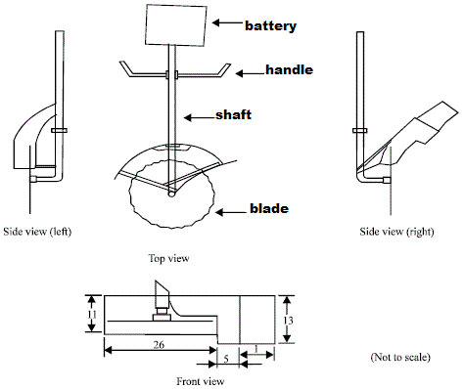

**Fig. Rice cutter**

**Plan of work:**

* Designing Motor size
* Designing Battery size
* Designing Solar charging station
* Designing Solar panel & charge control
* Designing Blade size

**Assembly plan:**

* Mounting of motor on shaft
* Wire connection
* Add switch & gauge

On-off switch

Battery level indicator

* Mounting battery in bracket
* Attaching blade to motor shaft
* Solar power charge station
* Testing

**CONCLUSION:**

Presently we have study all the design parameters of the rice cutter and the mathematical calculations has been carried out as shown in the above table. Modelling should be taken in pro-e software.

**REFERENCES:**

Anonymous, 1998. Instruction Manual of Robin Brush Cutter. FujiRobin Industries Ltd., Tokyo, Japan.  
  
Baruah, D.C. and G.C. Bora, 2007. Forecasting Energy Demand for Mechanized Agriculture in Rural India. American Society of Agricultural and Biological Engineers (ASABE) Paper No. 078037, St. Joseph, Michigan.  
  
Bautista, E.U., M.J.C. Regalado, A.S. Juliano, S. Ishihara and H. Monobe, 2004. A Rotary Cutting Mechanism for Rice Harvesting. International Rice Research Institute, Published in the Limited., Manila, Philippines.

Kuether, D.O. and J.B. Duff, 1981. Energy Requirements for Alternative Rice Production Systems in the Tropics. IRRI Research Paper series No. 59. International Rice Research Institute, Manila, Philippines.