Hydraulic Ram Pump

Working Principal

Shyam Rathod, Suhas nagrale, Vrushabh sahare

Mechanical engineering department

KDK College of engineering, Nagpur.

Shyamrathod91@gmail.com

**Abstract**— Hydraulic ram pump is an automatic and simple operative pump which can use the natural potential head of water to pump the same water .It is meant to lift water from certain depth with no other external energy source required .The overall cost of fabrication of this hydram shows that the pump is relatively cheaper than the existing pumps which can be economically be used in villages where electricity problems are wide. It has less number of moving parts which frees it from mechanical maintenance.

Introduction

The hydraulic Ram pump or hydram is a complete automatic device that uses the energy in the flowing water such as spring, stream or river to pump part of the water to a height above that of the source. With a continuous flow of water a hydram operates continuously with no external energy source. A hydram is a structurally simple unit consisting of two moving parts. These are the impulse valve (or waste valve) and the delivery (check) valve. The unit also consists of an air chamber and an air valve. The operation of a hydram is intermittent due to the cyclic opening and closing of the waste and delivery values. The closure of the waste valve creates a high pressure rise in the drive pipe. An air chamber is required to transform the high intermittent pumped flows into a continuous stream of flow. The air valves allow air into the hydram to replace the air absorbed by the water due to the high pressure and mixing in the air chamber.

DESIGN FACTORS

The ram pump consists essentially of two moving parts, the impulse and delivery valves. The construction, basically consist of pipe fittings of suitable designed size. The main parameters to be considered in designing a hydraulic ram include:

1. The difference in height between the water source and pump site (called vertical fall)
2. The difference in the height between the pump site and the paint of storage or use (life).
3. The quantity (Q) of flow available from the source.
4. The length of the pipe from the source to pump site (called the drains pipe).
5. The quantity of water required.
6. The length of pipe from the storage site (called the delivery pipe)

OPERATION PRINCIPLE

The energy required to make a Ram lift water to a higher elevation comes from water falling downhill due to gravity. As in all other water powered devices, but unlike a water wheel or turbine, the ram uses the inertia of moving part rather than water pressure and operates in a cycle based on the following sequences.

Sequence I

Water from the source flow through the drive pipe (A) into the ram pump body, fills it and begins to exit through the waste or “impulse” valve (B). The check valve (C) remains in its normal closed positions by both the attached spring and water pressure in the tank (D) and the delivery pipe (E) (no water in the tank prior to start up). At this starting point there is no pressure in tank (D) and no water is being delivered through exit pipe (E) to the holding tank destination.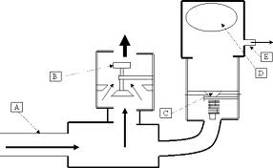

Sequence II

Water entering the pump through the drive pipe (A) has its velocity and pressure being directed out of waste valve (B)

Sequence III

Water has stopped flowing through the drive pipe (A) as a “shock wave” created by the “water hammer” travels back up the drive pipe to the settling tank. The waste valve (B) is closed. Air volume in the pressure tank (D) continues expanding to equalize pressure, pushing a small amount of water out of the delivery pipe (E).

Sequence IV

The shock wave reaches the holding tank causing a “gasp” for water in the drive pipe (A). The waste valve (B) opens and the water in the drive pipe (A) flows into the pump and out of the waste valve (B). The check valve (C) remains closed until the air volume in the pressure tank (D) has stabilized and water has stopped flowing out of the delivery pipe (E). At this point sequence 1 begins all over again.

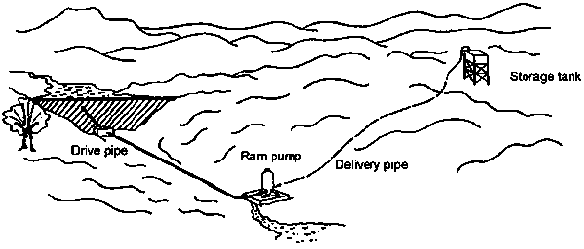

INSTALLATION

The installation of a hydram pump is such that the cycle of its operation is dependent upon the length of the drive pipe. It is recommended that the pump should complete a cycle every 1.5 to 2 seconds. If a cycle is either too fast or too slow the output performance will suffer. Too fast of a cycle is a symptom of either a drive pipe being too short or the waste valve needing more weight. Too long of a cycle is caused by an excessively long drive pipe or so much weight on the waste valve that the column of water takes a longer time to overcome, causing it to close suddenly. This creates a momentary high pressure “Water hammer” that in turn force the check valve to open allowing a high pressure “pulse” of water to enter the pressure tank. The air volume in the pressure tank is compressed causing water to begin flowing out of the delivery pipe and at the same time closing the check valve so as to prevent reverse flow. As the air volume in pressure tank continues to expand, water is forced out of the delivery pipe to the holding tank.

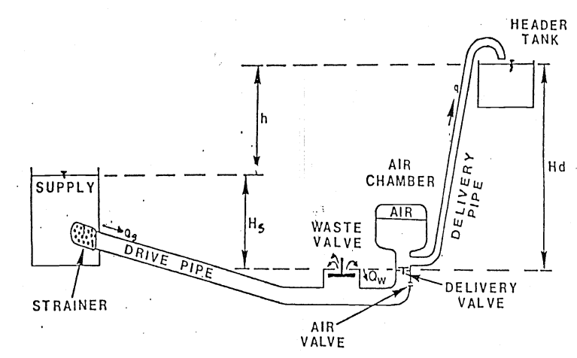

TECHNOLOGY AND USE

Ram pumps use the power available in water flowing down through drop of a few metres to lift a small percentage of that water through a much greater height, to where it is needed. The range of

ram pump is in between 1,500 and 72,000 litres of water a day, lifting it up to 200 metres.

The principle of operation of a ram pump is as follows:

1. water is allowed to flow down the *drive pipe* and out of the *waste valve*.
2. as the flow of water accelerates, the waste valve is forced shut, causing a pressure surge.
3. as the moving water is suddenly brought to a halt.
4. the pressure surge causes the check valve to open, allowing high-pressure water to enter.
5. out the pressure surges from the ram pump and ensure a continuous flow through the delivery pipe.
6. as the pressure surge subsides, the pressurized air in the air chamber causes the checkvalve to close, and forces water up the delivery pipe.
7. the sudden closure of the checkvalve reduces the pressure in the ram body, so that waste valve opens under its own weight.
8. the pump is returned to the start of its operation cycle.

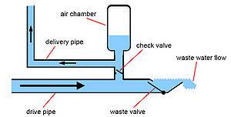

Conclusion

Presently all the pumping water action is dependent on electricity hence ram pump will be the better option for pumping in villages and other domestic usage. Its main advantage is that it doesn’t require any external power source and can be easily installed.

References

1. Krolj.automatic hydraulic pump PROC.I.mech.E.1954 164 p.103
2. Calvert N. G., *Hydraulic Ram*, THE ENGINEER, 1967.
3. Molyneux F., *The Hydraulic ram for Rival Water Supply*, Fluid Handling, 1960,
4. Watt S.B., *Manual on the Hydraulic for Pumping Water*, Intermediate technology publication, London, 1975.
5. Trip Report, Ram Pump Project in the Philippines, June 21 – July 22, 2010, Engineers for a Sustainable World, Northwestern University
6. Jeffery, T. D., "Hydraulic Ram Pumps - A Guide to Ram Pumps Water Supply System", *Intermediate Technology Publications*, 1992.
7. TefariTaye, "[Hydraulic Ram Pump](http://www.africantechnologyforum.com/ESME/hydram1/HydRam1.htm)", [*Journal of the Ethiopian Society of Mechanical Engineers*](http://www.africantechnologyforum.com/ESME/ESME.htm), Vol. II, No. l, July 1998.