**DESIGN AND FABRICATION OF AIR COOLER DIVERTER STRIP MFG. MACHINE**

**Sidhu Shelke, Surendra Agase, Kaustubh Kothekar**

**Mechanical engineering department**

**KDK College of engineering, Nagpur**

**surendraagase@gmail.com**

**ABSTRACT:**

The Air-Cooler diverter strip available have a typical aerodynamic profile and structure which is the most important operational requirement of the component. To manufacture the strips of this profile with economy precision and other details is a very tedious job to carry in an engineered way. Our project deals with the mfg. by incorporating drawing and rolling operation by presenting various parameters and calculations of the processes.

**INTRODUCTION:**

Air-Cooler diverter is the basic arrangement used in house-hold desert coolers to control the direction of flow of air.Depending on the type of particular design and employment, various manufacturing schemes are devised with varying degrees of merits and demerits. The project includes 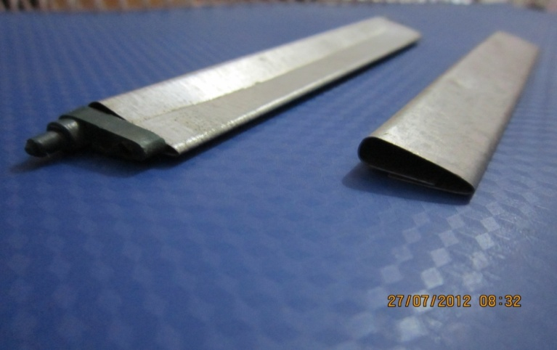the concept and overall assessment of one such manufacturing scheme employed.

The nature of the project has fabrication as its important aspect. So apart from design and related theoretical calculations, a set of trail experiments to test the operational efficiency of the model based on certain specific parameters have to be performed. The basis for assigning a particular parameter is quite objective in nature.

**AIM AND OBJECTIVES:**

* To make study of design and working of air diverters.
* Detail study of working principle drawing and roll forming operation.
* To study effect of various parameters with respect to deformation of sheet metal.
* To reduced the human effort leading towards automated aspects of process.
* To achieve the economic feasibility.

**PROCESS DETAILS**

There are two types of processes performed-

1. Drawing operation

2. Roll forming operation.

The drawing operation, strictly speaking, cannot be grouped under the forming operations, a separate analysis is to be carried out for the mentioned purposes. This operation is performed prior to rolling. This is mainly performed for the pre-setting of the sheet and a special provision for the upcoming rolling stages. The general layout of the process consists of two planes inclined at 45 degrees of which the punched sheet is incident on an inclined plane where a spring loaded pin is mounted to push the sheet into the rolling stages. A special set of latch stop to control the feeding of the sheet for punching and a knock-out mechanism is required which would suit the inclined nature of the press and to support and guide fragile punches. The knock-out mechanism is required to shed or eject a work-piece from within the die-cavity due to friction. It is to be mentioned that special techniques are to be employed to reduce cutting forces. This can be well achieved by having the bottom of the punch and the top of the die-block in parallel planes and that the blank is severed from the sheet-metal by shearing it simultaneously along the whole perimeter.

The major process to be carried out is that of rolling. In rolling, the job is drawn by means of friction through a regulated opening between two power-driven rollers. The shape and size of the product are decided by the gap between the rolls and their contours. This is a very useful process for the production of sheet metal and various common sections. All materials that can be bent can also be roll-formed. For e.g. cold and hot finished carbon steel, stainless steel, aluminium and copper can be used in roll forming. The thickness of the material being roll-formed may range from 0.1 mm up to 19 mm. The thickness of the material is usually limited by the size of available machinery. In length of the product there is no actual limit. The facilities that will handle the product limit the length of the production. Since roll-forming is a continuous process high production speeds can be attained. 25-30 m/min is the most widely used speed range in roll-forming. 0.5 and 240 m/min are the unusual extremes of the process. 

**CONCLUSION:** The aerodynamic profile of the strip has been developed and the manufacturing scheme has been suggested using drawing and rolling processes which has characteristics suitable for economic production and automation.

**REFERENCES:**

* Manufacturing Science- Ghosh and Mallik
* Production Engineering- P.C. Sharma
* Aluminium Rolling- R.V. Singh
* Various Cooler Industries