**Analysis of the Effect of Cutting Parameters on**

**Tool Life and Machining Time in Turning Operation**

**Sourabh Singh*, Vedprakash Dubey** , Prakash Mandal*** Shailendra Sao\*\*\*\***

***a Department of Mechanical Engineering, Rungta College of Engineering and Technology, Kohka- Kurud Road, , Bhilai, Chhattisgarh- 490024, India***

### ABSTRACT

A manufacturing engineer or machine setup technician is often expected to utilize experience and published shop guidelines for determining the proper machining parameters to achieve a specified level of surface roughness. This must be done in a timely manner to avoid production delays, effectively to avoid defects, and the produced parts monitored for quality. Therefore, in this situation, it is prudent for the engineer or technician to use past experience to select parameters which will likely yield a surface roughness below that of the specified level, and perhaps make some parameter adjustments as time allows or quality control requires.

Keywords; Cutting Speed ,Tool Life, Surface finish

**1. INTRODUCTION**

In this work, the tool life and machining timing of a mild steel piece produced by turning is analyzed. The main objective of this project work is to determine the optimal setting of The various cutting parameters (feed, depth of cut) and variation in Cutting speed of the tool to have a reduced machining time and increase tool life. In this work the experiment has been carried out in lathe dry turning of a commercially available 1018 mild(low carbon) steel as a work material and high speed steel tool . The dimensions of work piece is (30×100mm) are same in all operations. The range of process cutting parameters are cutting speeds(31.1, 19.8, 11.78, 6.12, 4.24m/min), feed rate(0.2mm/rev), and depth of cut(0.5mm). By this method time and cost savings were made, and the test results were optimized.

* 1. **TURNING OPERATION**

***Machining***can be defined as the process of removing material from a workpiece in the form of chips. The term metal cutting is used when the material is metallic. Machining is necessary where tight tolerances on dimensions and finishes are required.

Turning is the basic machining processes. Turning produces solids of revolution

which can be tightly toleranced. Turning is performed on a machine called a **lathe** in which the tool is stationary and the part is rotated.

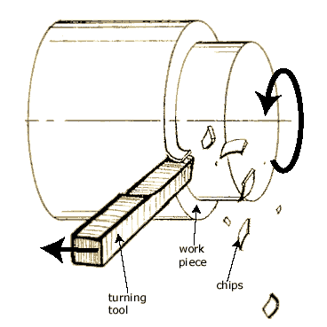

* 1. **CUTTING PARAMETERS**

**Cutting Speed(V*):***

It is the travel of a point on the cutting edge relative to the surface of cut in unit time in machining processes. Its unit is m/min.

**Feed(f):**

Feed is the amount of tool advancement per revolution of job parallel to the surface being machined. Its unit is mm/rev.

**Depth of cut:**

It is the thickness of the layer of metal removed in one cut or pass measured in a direction perpendicular to the machined surface. the depth of cut is always perpendicular to the direction of feed motion.

* 1. **WORKPIECE PARAMETERS**

***Workpiece material:*** 1018 Mild ( low carbon) steel

***Mechanical properties:***

Ultimate tensile strength :- 63,800 Psi (1Psi=6894.75 Pascal)

Rockwell Hardness:- B71

***Workpiece geometry:***

Length(L) = 100 mm

Diameter(D) = 30 mm

L/D Ratio = 3.33

**Fig.3 Workpiece parameter**

* 1. **TOOL PARAMETERS**

The Tool used in a lathe is known as a single point cutting tool. It has one cutting edge.

The lathe tool shears the metal rather than cuts it.

***Tool material:*** High Speed Steel (HSS)

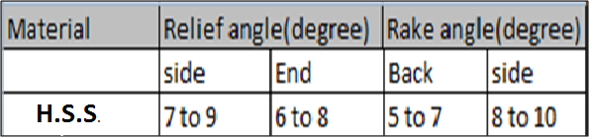

**Table 1. Tool Geometry**

**3. DATA COLLECTION**

**3.1 JOB 1**

**Speed =** 330 RPM

**Cutting Speed =** 31.1 m/min

**Workpiece setup time =** 20 min 10 sec

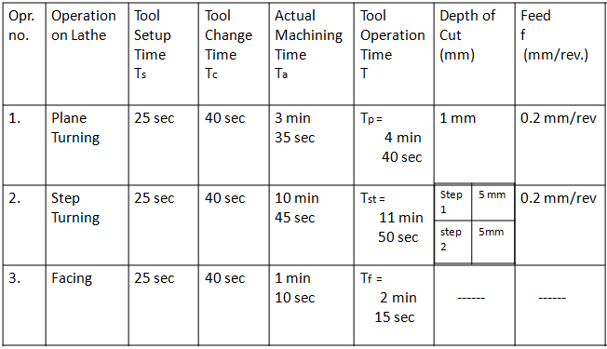

**Table 2.1 Data collection for job 1**

**Total Time Required** for **Job 1 :**

T = Tp+Tst+Tf = 38 min 55 sec

**3.2 JOB 2**

**Speed =** 210 RPM

**Cutting Speed =** 19.8 m/min

**Workpiece setup time =** 20 min 10 sec

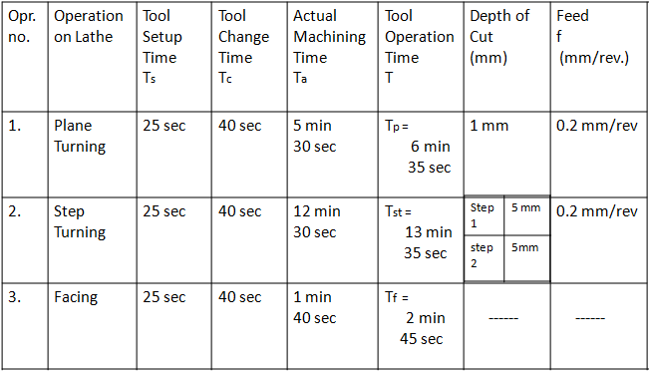

**Table 2.2 Data collection for job 2**

**Total Time Required** for **Job 2 :**

T = Tp+Tst+Tf = 43 min 05 sec

**3.3 JOB 3**

**Speed =** 125 RPM

**Cutting Speed =** 11.78 m/min

**Workpiece setup time =** 20 min 10 sec

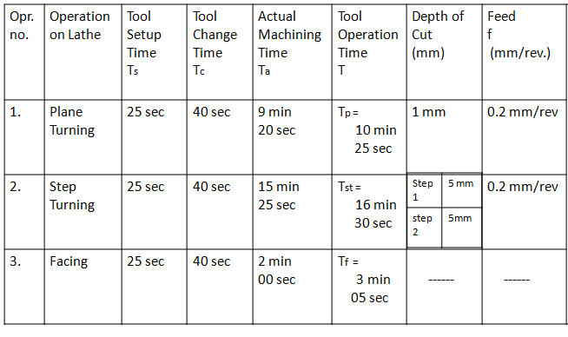

**Table 2.3 Data collection for job 3**

**Total Time Required** for **Job 3 :**

T = Tp+Tst+Tf = 50 min 10 sec

**3.4 JOB 4**

**Speed =** 65 RPM

**Cutting Speed =** 6.12 m/min

**Workpiece setup time =** 20 min 10 sec

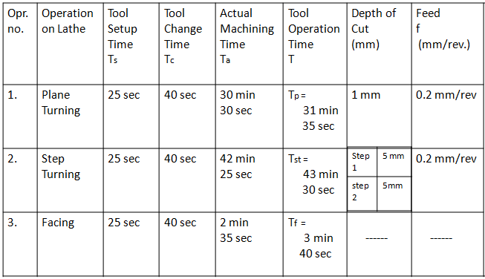

**Table 2.4 Data collection for job 4**

**Total Time Required** for **Job 4 :**

T = Tp+Tst+Tf = 98 min 55 sec

**3.5 JOB 5**

**Speed =** 45 RPM

**Cutting Speed =** 4.24 m/min

**Workpiece setup time =** 20 min 10 sec

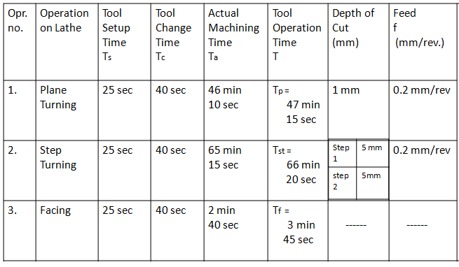

**Table 2.5 Data collection for job 5**

**Total Time Required** for **Job 5 :**

T = Tp+Tst+Tf = 136 min 30 sec

**4.CONCLUSION**

In this study, Mild steel workpieces were produced by machine turning which is an important form of metal fabrication. The machining time, surface quality and tool life of the workpiece were analyzed and the potential effects of variables such as workpiece size, workpiece diameter, cutting depth and feed rate on these dependent variables were investigated.

* Higher cutting speed will reduce machining time.
* High cutting speed will give better surface finish.
* Incorrect adjustment of the machining parameters feed rate and depth of cut etc will reduce the surface quality.
* Increasing in cutting speed and depth of cut decreases the tool life.
* For long life of cutting tool it is essential that the face of the tool should be as smooth as possible.

#### REFERENCES

1. Mohammed T. Hayajneh a,*, Montasser S. Tahat b, Joachim Bluhm c

“A Study of the Effects of Machining Parameters on the Surface

Roughness in the End-Milling Process”, Jordan Journal of Mechanical and Industrial Engineering *Volume 1, Number 1, Sep. 2007ISSN 1995-6665Pages 1 – 5*

*2. O.P. Khanna “Production Technology “.*