Design and Deveolpment of Bamboo Stripping Machine

Sufiyan Ahmad.

Prof. Dr. A.V. Vanalkar.

Prof. P.G.Mehar.

*Abstract –* In Present Bamboo stripping Process Number of steps aree involve to make incense sticks Are 1.Bamboo Cross Cutting 2.Bamboo spliting 3. Bamboo Slicking. 4.Bamboo stick making. So the basic aim of this approach is to make a unique machine which can perform all the above four process. This can be done by Pneumatic Cylinder which is used to reciprocates bamboo holder on the Horizontal blade which strips the bamboo in thin pieces by using Horizontal blade which further brakes in to incense sticks by vertical blade. Here Bamboo Holderis rectangular shape box which contains bamboos, Spring Pressure arrangement at the top of bamboo holder**,** As the bamboo strikes on horizontal blade it has to pressurized so that next subsequent bamboos pushed on the horizontal blade.

Key Words: Bamboo, Incense sticks and strikes

INTRODUCTION

Bamboo, commonly known as “cradle to coffin” timber is closely associatedwith life and livelihood of human being. Nearly one thousand five hundreduses of bamboo have been docu-mented so far. The diversified uses of bamboo ranges from farm equipments to storage device, from dolls to measuring tools, from furniture to decorative items. The credit of this varied utilization of bamboo goes to thebamboo artisans, who since centuries

have been engaged in shaping thebamboo strips into such varied uses.Though the number of bamboo arti-sans in Orissa enumerated is about 30000 in the year 2003 as quoted by Director of Handicraft and Cottage in-dustry, in actual the number is fairlybig and expected to cross one lakh if thoroughly surveyed. Apart from this,quite a large number of population ekeout their livelihood from bamboo cutting operation in the state.

**Domestic use:** Since time immemorial, bamboo products are extensively used in the ruralhouseholds in form of bhogai, tukli,kulei, koola, dala, pedi, binchana etc.Bamboo made artifacts; containers etc are indispensable in some of theHindu ceremonies. Bamboo productsare the pre- requisites in marriage ceremonies of many tribes and castes in Orissa.The population of the neighbouring state of Jharkhand and

Bihar also include bamboo products during many of their rituals. Bamboo has remained part and parcel of the cultural practices in the region. Moreover, the forest produce has also aided livelihood practices like agriculture. The agricultural sector still remains the largest consumer of bamboo products. Right from sowing to stocking of grains, bamboo articles find wide usage. Baskets, containers, ploughs, planks, winnowers and range of other articles are used in all the operations in agriculture.

In rural households, it is used in con-struction of houses and fences. Even it serves as a food item in most part of the country. Bamboo can be seen in t h e u r b a n h o m e s a s d e c o r a t i o n pieces, as furniture or handicrafts and is an essential feature in any celebration that requires a structure – be it marriage or religious festivities.

**Commercial use**: The rich bamboo forests of the statehad been a big attraction for paper in-dustries since long. The use of bamboo in the state took a turn when in the year 1936- 37 Messrs Heilgers and Company first started drawing its raw material for paper and pulp manufacturing from Orissa. From then onwardsa major portion of bamboo was consumed by the paper industries. Soon the Orient Paper Mills became operational in 1939 and the department finalized long-term leases of bamboo forests in their favour. Since then many mills were established, closed and revived. Keeping the convenience of paper mills to access raw materials in consideration, they had been permitted to operate in areas nearer to dense bamboo forest patches. Four mills held prominence in the state industrial scenario namely JK Paper Mills, Rayagada, Orient Paper Mills, Brajarajnagar, TPM (Now BILT), Choudwar and BILT (SEWA), Jeypore. Presently JK paper Mills and BILT (SEWA) are operational.At one time, 80 percent of the total annual production was consumed by these paper industries, which de- cline over the years with the closure of the units in the state. The system continued for six decades successfully till it suffered a setback with the back out of the paper industries.

**Existing Bamboo Processing Machine:-** The initial processes to be done on a bamboo to make it as a useful product is called as bamboo processing. The initial processes include Splitting, External and Internal Knot Removing, Slicing, Bamboo sticking making, Stick length setting, Stick Polishing. Bamboo and bamboo splits are used as the fencing material and for making various types of tool handles, ladders and scaffolding. In its natural form, bamboo as a construction material is traditionally associated with the cultures of South Asia, East Asia and the South Pacific, to some extent in Central and South America. Bamboo sticks are used for various purposes like building construction. Splits as well as slivers are used to make a wide range of products such as baskets, the core of incense-sticks, kites and toys, flutes and a large number of handicraft items. They are also use to make cages for poultry, drying, packaging and transport of grains. Bamboo splits are woven into mats and use to manufacture mat boards. Traditionally the bamboo is processed in different steps and for each step a different machine is required, the main aim behind this development of experimental set up of improved bamboo processing machine is to reduce the number of steps and also to reduce the number of machines required to do the desired work. So an improved bamboo processing machine is fabricated which can perform splitting and slicing on a single machine. The design involves a new concept of making a special purpose of die for splitting and slicing, the concept behind this project is that, the machine is kept common for both the operations;

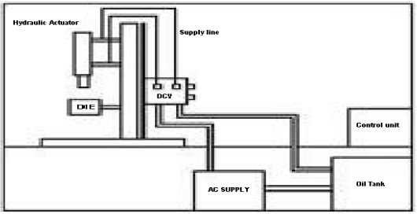

Figure-1 Bamboo Processing Machine

Concept of Research:-

Traditionally bamboo slicing is done manually, or by using a manually operated machine, there was always a need of hydraulically operated

bamboo slicing machine, so this brings us the idea of manufacturing different types of dies for slicing of bamboo on improved bamboo processing machine. The different options available with us were to change the tool for cutting or change the tool position for slicing purpose. The two tool materials available with us are HSS and O2; these are the two available tool materials which we can use. The other option available is to fabricate the die using different tool positions; the first option was to keep the tools straight one after the another andthe other die tools were kept in such a way that three tools were fixer parallel to each other and the other tool were fixed beneath them and in between the above three tools. The figures of all the dies are shown below.

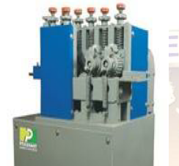

Bamboo Volume Weight Relationship for four Malaysian Bamboo.

Bamboo, belonging to the subfamily Bambusoideae, is distributed widelyin tropical and sub-tropical regions, and less so in temperate regions. Bamboosare of three classes: clump-forming (sympodial) with peripheral extension from rhizomes (caespitose), single culms scattered (monopodial) over a network of rhizomes (dumetose) (Huberman 1959), and mixed (having both scattered and clump-forming culms); the first two are more important in the world. Malaysian bamboos are clump-forming and most of them are found inlogged-over areas and disturbed forest (Burton 1979, Ng & Mohd Noor 1980). There are 50 cultivated or wild bamboo species in the forest (Wong 1989). Only12 types of bamboo are exploited for their culms and shoots.

In Malaysia, bamboo by virtue of its availability and versatility, isassociated with the traditional and rural lifestyles. It is used as supplementarymaterials in house construction and in the making of numeroushome utility items.Bamboo shoots are gathered, especially from Gigantochloa levis, G. ligulata and Dendrocalamus asper.Several industries use bamboo on an organized scale. These mainly use G.scortechinii, supplemented by G. wrayi, in the manufacture of poultry cages,

shade blinds and barbeque sticks, vegetable baskets, incense sticks and tooth picks (Wong 1989, Azmy 1989). Culms of Schizostachyum zollingeri are used for

vegetable and fish baskets. Internodes of severalspecies of Schizostachyum areJournal of Tropical Forest Science 4 (1): 87 - 93 88

used as containers to cook a Malay rice dish called 'lemang' and the broad leavesof S. grande are gathered as wrappers for Chinese rice dumplings. Bamboos vary considerably in size depending on the species, locality andvigour of the clump (Krishnaswamy 1956). Attributes of stem size and wallthickness influence the range of usage (Wong 1982). The strength, straightness,

lightness combined with hardness, variation in size, ease with which they can be propagated and the short period taken to mature and be available for harvesting have rendered bamboos of immense use (Sharma 1982). Research on bamboo is still at its infancy and deals mainly with the propaga- tion, silviculture, management and establishment of natural bamboo stand.

This study attempts to give comprehensive information on the characteristic qualities of four Malaysian commercial bamboos, such as Bambusa blumeana

(buluh duri), G. scortechinii (buluh semantan), S. grande (buluh semeliang) andS. zollingeri (buluh nipis). In addition, the weight-volume relationships using regression techniques for the different species were also determined.This information is important in determining the yield and use of the fourcommercial bamboos.

Significant positive linear relationships between green weight and solidvolume of the sample poles were observed for all the species studied.Knowledge of the given measured characteristics and weight-volume relationship for the four species studied is important in their yield determinationand use.

**Incense sticks,** colloquially called "Dhup" or "Agarbattt are used in most Indian households, and in substantial quantities in temples, and religious functions. Incense sticks are available in different fragrance. Production of incense sticks is a labor intensive process.

MARKET POTENTIAL of Incense sticks.

The total population of the north-eastern region is 365 lakhs. Considering an average family size of 5, thenumber of households is estimated at 73 lakhs. Assuming that15% of the households would use incense sticks and taking an average requirement of 5 packets per household per year, the demand potential for incense sticks is estimated at 54.75 lakh packets per year. Besides, there is a substantial demand for incense sticks in temples and religious functions. The total demand for incensesticks would thus be anywhere upto 105 lakh packets per year. There are several small units around Hpjai in Assam which have been set up with the assistance from the Khadi and Village Industries Commission (KVIC). There are a few registered units under DICC, Kamrup. The value of output of these unite is about Rs. 25 lakhs per year, which would correspond to about 12.5 lakh packets per year. However, bulk of the supply of incense sticks comes from outside, namely, Kamataka and Tamil Nadu. Assuming that new units can get a 20% market share, the demand potential for such units is estimated at 8 lakh packets per year. Considering the capacity of a typical tiny unit as 2 lakh packets per year, there is scope for about 4 Units

PROCESS to Make Incense Stick

The main process steps are:

a) Mixing the ingredient in proper proportion and preparing a pasts.

b) Applying paste to bamboo sticks and rolling on wooden planks manually.

c) Drying of raw sticks

d) Packing in bundles

RAW MATERIALS required for incense stick

The major raw materials are charcoal powder, Gigaty (a herb), white chips, sandalwood powder, bamboo sticks, camphor, perfume and Diethylpthalate. Agar oil is a material which is used by manufacturers of costly agarbatti. Use of agar oil is not envisaged since it is proposed to manufacture tow cost incense socks for mass consumption In north-eastern region. The annual requirement of raw materials is as under

Charcoal Powder,

Gigaty. White chips

Sandal wood powder, Bamboo sticks

Kuppam dust, Perfume,Diethylpthalate

Packing materials- Paper carton

Wrapping paper

Inner paper bags

**Agarbattis: A Sustainable Bamboo Cluster based Rural Enterprise Development in Northeast Region of India through P4 Approach**

The Northeastern States have ample capacity to set-up agarbattis enterprises at the community level in rural pockets through utilization of bamboo resources. It will create rural employment and sustainable livelihood opportunity among the community people.

As per the market survey conducted by the National Council of Applied Economic Research (1990), the total quantity of agrabattis produced in the country in 1990 was, 147 billion, valued at around Rs.7 billion. The production and market size of the sector is increasing tremendously in India and abroad. The consumers are highly concentrated among the rural pockets (61%) in India (INBAR-1992).

The present paper is an attempt to highlight the several dimensions to scale-up the community-led agarbattis enterprises in the region. Developing Bamboo cluster based agarbatti enterprises, it needs investment, logistic arrangement for the entrepreneurs and a suitable model namely P4 approach, so that all the partners comprising the enterprise may actively involve themselves for the development of the sector and in turn increase income for themselves. 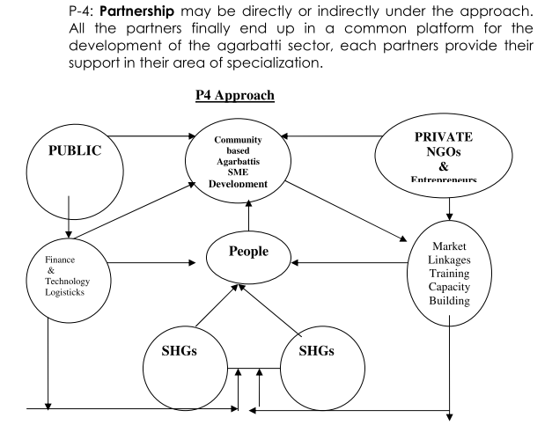

**Vana Samrakshana Samithis (2006) Forest Department, Government of Andhra Pradesh “AGARBATTI STICK PRODUCTION UNDER Andhra Pradesh Community Forest Management Project”**

Under the APCFM Project, the Forest Department started production of bamboo agarbatti

sticks through the VSS members as a value addition activity. It has now become a family-basedcottage industry wherein mostly women are engaged to do the work utilising their leisure time.In Devapally and Muthampally sections under Mancherial Forest Division, natural bamboogrowth occurs in five VSS allotted areas: Sonapur, Laxmipur, Salegudem, Gatraopally andVenkatapur. The members of these VSSs are supplying bamboo to other non-bamboo VSSareas at rates which are fixed for the Burud by the government

The bamboo poles are first cross-cut into 8-inch and 9-inch cylinders. These are then made into slats using a locally made hand tool, which costs Rs 350. The slats are made into agarbattis sticks using another hand tool that costs about Rs. 150. Approximately 600 sets of

these hand tools have been distributed among the five VSSs.

The slats are made at the CFC level and the women are given 4-kg bundles of slats against

which they supply back 3 kg of sticks: 1 kg is the estimated wastage. They are able to producean average of 6 kg per day after attending to their routine household activities. If they are fullyengaged in the activity, it is estimated that they would be able to produce 12 kg of agarbatti sticks per day.

**“Socio-Economic Benefits Derived by Poor Rural Producers from Bamboo Value Chain Up-gradation: A study of Tripura, Northeast India**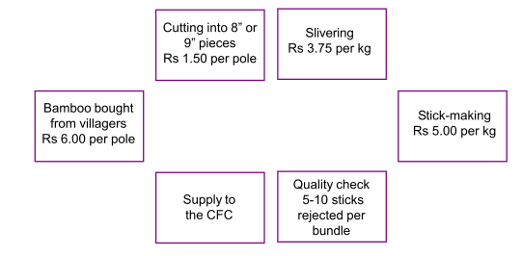

The value chain up-gradation as an approach is very much relevant for poverty reduction, women empowerment and environmental preservation in traditional as well as no-traditional sector. It helps to develop and upgrade the various nodes in the value chain and its direct impact could be observed in socio-economic development of rural poor and small producer groups. The policy makers, rural development professionals and related stakeholders could also find a better way of planning to give space to integrate the poor producers with market.

**Methodology:-** Under the study fifteen bamboo economic development clusters within Tripura state has taken for the whole study. Basically, it is an empirical study including socio-economic dimension of the poor rural small producers involved with the cluster in the state. Moreover, the study has also covered the bamboo small and budding entrepreneurs outside the cluster in the state. Sample: As part of the study, a total 1500 small producers belongs to self help groups (SHGs) which include 125 budding bamboo entrepreneurs outside the cluster were interviewed from the study area in the state. Out of that 375 respondents were selected as sample on random sampling procedure. Material: A structured interview schedule was used which consisted of opened and closed end questions. The interview schedule was previously pre-tested and finally printed for field use. Procedure: The study followed by observation for gathering the data, rapport building and the interview schedule was used for collecting data. In addition PRA/RRA tools have also used for assessing the value chain up-gradation in bamboo sector under the study.

**Concept Drawing of Present Work.**

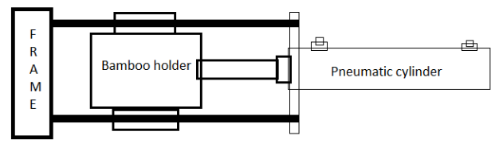

**Pneumatic Cylinder:** This mechanism is used to reciprocates bamboo holder on the Horizontal blade which strips the bamboo in thin pieces by using Horizontal blade which further brakes in to incense sticks by vertical blade.

**Bamboo Holder:** This is rectangular shape box which contains bamboos

**Spring Pressure arrangement at the top of bamboo holder:** As the bamboo strikes on horizontal blade it has to pressurized so that next subsequent bamboos pushed on the horizontal blade.

**Frame:** To Hold the complete Assembly of Mechanism, i.e ( Pneumatic cylinder, Bamboo Holder and spring Pressure Arrangement).

Reference

[1] K. G. Ahuja1, P. G. Mehar2, Dr. A. V. Vanalkar3 (2012) “Development Of Experimental Set Up Of Improved Hydraulic Bamboo Processing Machine” International Journal of Engineering Research

and Applications (IJERA) ISSN: 2248-9622 [www.ijera.com](http://www.ijera.com) Vol. 2, Issue4, July-August 2012, pp.1572-1576

[2] K. G. Ahuja1, P. G. Mehar2, Dr. A. V. Vanalkar3 Dr S.S. Khandare (2012) “Experimentation on various dies for slicing on improved hydraulic Bamboo processing machine International Journal of Engineering Research and Applications (IJERA) ISSN: 2248-9622 www.ijera.com Vol. 2, Issue 6, November- December 2012, pp.162-166

[3 V.G.Jenner & Md. Selim Reza ““Agarbattis: A Sustainable Bamboo Cluster based Rural Enterprise Development in Northeast Region of India through P4 Approach” (The author is the Director of Industry & Commerce and Additional Secretary cum State Bamboo Mission Coordinator Government of Tripura, Gurkhabasti, Agartala Tripura, India).

[4]Vana Samrakshana Samithis (2006) “AGARBATTI STICK PRODUCTION UNDER Andhra Pradesh Community Forest Management Project” Forest Department, Government of Andhra Pradesh.

[5] Dr. Md. Arshad & Selim Reza (2012) “Socio-Economic Benefits Derived by Poor Rural Producers from Bamboo Value Chain Up-gradation: A study of Tripura, Northeast India” Indian Streams Research Journal, Vol.2,Issue.IV/May; 12pp.1-4ISSN:-2230-7850

[6] Azmy Mohamed, Wan Razali Wan Mohd & Fauzidah Ahmad “Characteristics and volume weight relationship of four Malaysian Bamboo” , Journal of Tropical Forest Science4(l): 87 – 93