**STUDY OF GALVANISING PLANT**

**M.I.D.C, Buttibori, Nagpur**

**Mrs.R.S.TUPKAR**

**Asst.Professor**

**E-mail:** [**rupali_tupkar@rediffmail.com**](mailto:rupali_tupkar@rediffmail.com)

**Mob:-9420959437**

**Department of Mechanical Engg**

**Priyadarshini college of engineering, Nagpur**

Swapnil C. Nimje. Zakiruddin Shaikh.

E-mail: [swapnilnimje007@gmail.com](mailto:swapnilnimje007@gmail.com) E-mail: [zakir_9077@yahoo.com](mailto:zakir_9077@yahoo.com)

Mob :- 9096500355 Mob :-9096292557

ABSTRACT:-

This paper describes one of our research and development activities carried out for galvanizing plant. We are focusing towards eliminate the basic problems in processes and also to improve the quality of product and enforcing to make the relevant processes more working and effective.

INTRODUCTION:-

Galvanization is a metal coating process in which a ferrous part is coated with a thin layer of zinc. The zinc coating seals the surface of the part from the environment, preventing oxidation and weathering from occurring.

The primary method of galvanization is “hot dip galvanization”, which has been in use for over 150 years. While the idea of coating a part in molten zinc was first proposed by chemist Paul Jacques Malouin in 1742, the process was not put into practice until patented by chemist Stanislas Sorel in 1836. Sorel’s process has changed little since then, and still involves coating a part in molten zinc after cleaning it with an acid solution and coating the part in flux.

Hot dip galvanizing protects steel from corrosion by providing a thick, tough metallic zinc envelope, which completely covers the steel surface and seals it from the corrosive action of its environment. The galvanized coating provides outstanding abrasion resistance. Where there is damage or minor discontinuity in the sealing coat of zinc, protection of the steel is maintained by the cathodic action of the surrounding galvanized coating.Metallic zinc is strongly resistant to the corrosive action of normal environments and hot dip galvanized coatings therefore provide long-term protection for steel.

By contrast, most organic paint coatings used on steel need frequent renewal and when coatings are breached corrosion begins at the exposed area of steel, spreading rapidly beneath the coating fill.

BENEFITS OF GALVANISING PARTS:-

Galvanization helps to extend the life of steel parts by providing a barrier between the steel and the atmosphere, preventing iron oxide from forming on the surface of the steel. Galvanization also provides superior corrosion resistance to parts exposed to the environment.

Galvanization provides a cost-effective solution for coating steel parts, specifically those that will receive significant environmental exposure over their lifetime.

MANUFACTURING PROCESS (HOT DIP GALVANIZING PLANT)

* The manufacturing process in nutshell can be described as under:The structural steel,grating for galvanizing are procured.
* The steel articles are dipped into "Caustic Soda Solution" for **"Degreasing"**
* The load is rinsed in "Rinsing Tank" containing clean water
* The load is then preserved in "Pickling Tank" containing HCL 10-12% for first pickling
* Second pickling is performed in "Second Pickling Tank" which contains HCL - 10-32%
* The load is again rinsed in "Rinsing Tank" containing clean water
* Next step is "Pre-fluxing" wherein the material is dipped in "Pre-Fluxing" tank containing "Zinc Ammonium"
* The load is then dipped into molten zinc at 440-460 degree Celsius which is termed as **"Hot Dip Galvanizing"**
* The material then is **"Quenched"** by passing through running water
* The material is due for dispatch after **"Passivation"** and inspection formalities.

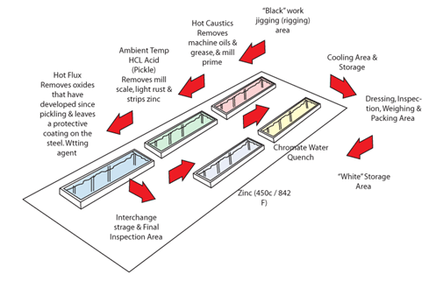

EXISTING PLANT SET UP:-

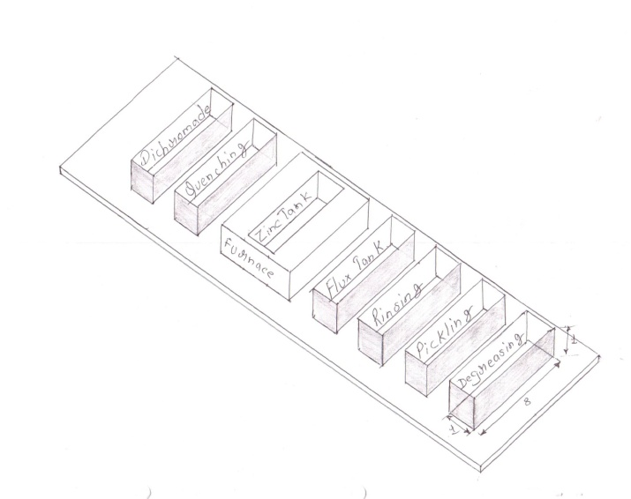

NEEDS OF CHANGES IN EXISTING PLANT SETUP:-

* Hot material extracted from zinc need to be hardened so quenching is to be done, but because of continue line of production the quenching water temperature rises too much to perform quenching action. Therefore need to cool the water is arises
* Before galvanizing. The material is to be prepared for reaction hence material is dipped in flux which temperature should be above 60 degree. Therefore it should be heated
* The surface of the material should be dry well to avoid spotting therefore before galvanized material has to stay over the furnace up to dry well.

SOLUTIONS SUGGESTED:-

1) To cool the quenching water and heat the flux we have taken a water pipe type coil arrangement from water tank and circulated the water coil from inside the flux tank.

2) Instead of keeping the material over furnace for drying we have suggested to construct a separate compartment between flux tank and zinc tank where the material kept for drying.

3) The fly ash produces at zinc surfaces because of continues heating of zinc this ash is collected and sold outside as a waste. But the fly ash contains amount of zinc particles so we suggested to collect the fly ash in filtering material and to collect the zinc by making vibrating arrangement.

PROPOSED MODIFICATION IN PLANT:-

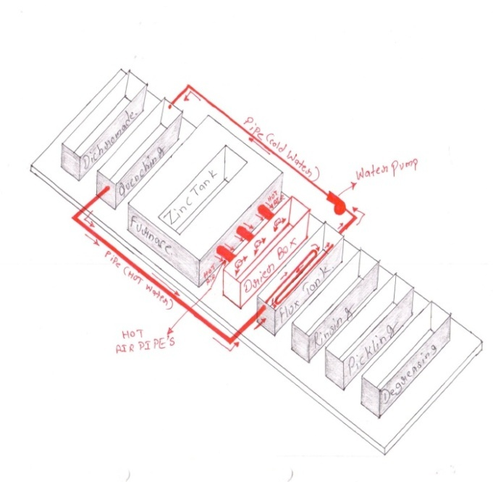

CONCLUSION:-

Here the study of galvanizing plant is successfully completed.

Number of defective pieces per lot is decreased.

Production process is comparatively faster and effective.

Proper significant of coating are maintained.

REFERENCES:-

I.S galva Standards:- 2629 , 2627, 2633 4759.

Websites:-

* http://suite101.com/article/introduction-to-galvanization-a70936

Galvanizing (Hot-Dip) by Heinz Bablick, 3rd Ed. Pub. by E. and fn Spon, Ltd., .... The text titled Galvanizing (Hot-Dip) by Heinz Bablik, 3rd Edition,

Curso de Zincagem por imersãoQuenteCurso de Zincagempor imersão a Quente 1976 Serra Negra^esp BABLIK H. Galvanizing (Hot Dip) Galvanizing (Hot Dip) ...  
artigos.scielo.br/S1517-707620070004.xml

Books:-

* Reaction mechanisms for the coatings formed during the hot dipping ...

A RP Ghuman, J I Goldstein - 1971 - Metallurgical and Materials Transactions

* B Hot-dip galvanized steel: surface structures and adhesion of paints

E Breval, M Rachlitz - 1988 - Journal of Materials Science

* Relation Between Base Metal Composition, Surface Composition ...

HN RAHN, EH MAYER, JW FRAME - 1962 - Journal of the American Ceramic Society

* 1. "Galvanic; Dictionary.com” Retrieved 2006-11-30.
  2. Process for protecting articles made of Iron or Steel from oxidation. Specification of patent granted to M. Sorel, of Paris, France, December, 1837. Journal of the Franklin Institute (Philadelphia, Pa.), Published by Pergamon Press, 1838, via Google Book Search.
  3. [1] Summary of XRF analysis conducted on or about 30 September 1999 by the royal  [Armouries](http://en.wikipedia.org/wiki/Royal_Armouries)Museum in Leeds and written up as part of a thesis by Helen Bowstead Stallybrass at the Department of Archaeological Sciences, Bradford University.
  4. Presentation on Thermal Diffusion Galvanizing:http://www.armycorrosion.com/past_summits/summit2009/09Presentations%5CDay3%5CMosheMoked.