**“DEVELOPMENT OF COMMERCIAL VEHICLE FOR CARRYING LOAD”**

**Submitted by**

**Tushar S. Perkunde**

**Nitish Y. Dekate**

**Nikhil S. Bhuyar**

**Manoj A. Shinde**

**Niketan N. Bhange**

**Guided by**

**Prof . N. P. Mungle**

**Deptt. of Mechanical Engg.**

**ABSTRACT**

A commercial vehicle is a type of motor vehicle Gas tanks fitted to motor vehicles designed for the direct use of gas as a fuel are considered to be standard fuel tanks.

The vast majority of rear-wheel-drive vehicles use a [longitudinally-mounted engine](http://en.wikipedia.org/wiki/Longitudinal_engine) in the front of the vehicle, driving the rear wheels via a [driveshaft](http://en.wikipedia.org/wiki/Driveshaft) linked via a [differential](http://en.wikipedia.org/wiki/Differential_%28mechanics%29) between the rear axles. This vehicle is economical so that it can be use in many purposes. The commercial vehicle is the integral part of human life. The thing related to the vehicle represents the human technological aspects. The construction and the working of that thing is providing very interesting and imagination nature of human life.

A commercial vehicle is a type of [motor vehicle](http://en.wikipedia.org/wiki/Motor_vehicle) that may be used for transporting goods or [passengers](http://en.wikipedia.org/wiki/Passenger). The [European Union](http://en.wikipedia.org/wiki/European_Union) defines "commercial motor vehicle" as any motorised road vehicle, which by its type of construction and equipment is designed for, and capable of transporting, whether for payment or not

Our commercial includes

* Chassis of vehicle
* Engine
* The auxillaries
* The controls
  + Steering System
  + Braking System
* The superstructure

**CHASSIS OF VEHICLE**

It is the back bone of the vehicle. A vehicle without body is called Chassis. The components of the vehicle like Power plant, Transmission System, Axles, Wheels and Tyres ,Suspension, Controlling Systems like Braking, Steering etc., and also electrical system parts are mounted on the Chassis frame.

**ENGINE**

It is important part of vehicle. Our commercial vehicle uses two stroke petrol engine. Because, Two-stroke engines often provide high power to work ratio, usually in a narrow range of rotational speeds called the "power band", and, compared to 4-stroke engines, have a greatly reduced number of moving parts. This is accomplished by the end of the combustion stroke and the beginning of the compression stroke happening simultaneously

**AUXILLARIES**

Auxillaries of our vehicle are headlight,light system etc.

**STEERING SYSTEM**

This system provides the directional change in the movement of an Automobile and maintain in a position as per the driver’s decision without much strain on him.

It keeps the wheel at all times in to rolling motion without rubbing on the road.

This system associates to control the speed.

**BRAKING SYSTEM**

Braking is the mechanism in the motor vehicle which is used to slowing down and stopping the vehicle to rest in the shortest possible distance. It is used to stop the vehicle.

It is used to control the speed where and when required.

**SUPERSTRUCTURE**

It is additional part which is attached to vehicle e.g.Load carrier

**IMPORTANT THINGS ABOUT PROJECT**

This project is based on the development of load carrying vehicle In industry, there are many load carrier vehicle which is used for different purposes like transport in different conditions .We are made load carrier commercial vehicle in such away that to get maximum efficiency.

We are used two stroke Internal Combustion petrol engine in order to maximum power generation .As we know that, two stroke petrol engine gives more power as compared to four stroke engine.

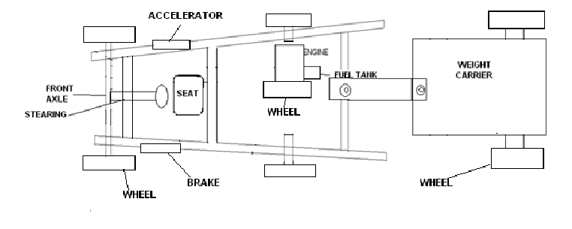

**Fig: Construction of vehicle**

We are used steering system of the rack and pinion type. We are avoiding use of Differential in the vehicle. We are used rear wheel drive because,it handles better in dry conditions - accelerating [force](http://wikicars.org/en/Force) is applied to the rear wheels, on which the down force increases, due to [load transfer](http://wikicars.org/wiki/en/index.php?title=Load_transfer&action=edit) in acceleration, making the rear tires better able to take simultaneous acceleration and curving than the front tires The engine is mounted directly on the wheel so there are no transmission losses. The vehicle can carry load upto 300 kg. This vehicle is easy to handle.

**ADVANTAGES**

* Power generation is more.
* It carry considerably high load.
* Average is about two times more.
* Single wheel drive.
* Better [handling](http://wikicars.org/en/Car_handling) in dry conditions.
* Less costly and easier maintenance
* Better braking