FEM Analysis of Spur Gear Tooth

1Vishwjeet V.Ambade.

2Prof. Dr. A.V.Vanalkar

3Prof.P.R.Gajbhiye

Abstract *–* The AGMA Standards set by American Gear Manufacturing Association are usually followed in design of Spur gear. the two parameters, tip radius and tooth width which play a key role in gear design will study. These parameters are varied and their effects on the final stress are observed at the root and mating regions of the gear. A gear will consider which will mating with similar kind of the gear and then FE Model will built in HYPERMESH or ANSYS. Using Lewis Equation and AGMA Standards the stresses will calculate with FEA model and results will compare. The results will optimize for best results with the variation of two parameters tip radius and tooth width.

I. INTRODUCTION

Spur gears are the simplest type of gear. They consist of a cylinder or disk with the teeth projecting radially, the edge of each tooth is straight and aligned parallel to the axis of rotation. These gears can be meshed together correctly only if they are fitted to parallel shafts. The main reason for selecting this gear for Optimization is the popularity of spur gears in their simplicity in design and manufacturing. In Spur gears the design parameters play a major role in determination of stresses. Different terms Used in Spur Gear as Shown Below.

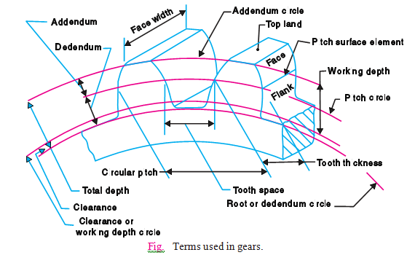

2. Lewis Equation to determine stress in Spur Gear.

The first equation used for the bending stress was the lewis equation. This is derived by treating the tooth as s simple cantilever and with tooth contact occurring at the tip a shown below. Only the tangent component (Wt) is considered. It is also assumed that only one pair of teeth is in contact. Stress concentrations at the tooth root fillet are ignored. It can be shown that the maximum bending stress occurs at the tangent points on the parabola shown above. Use of the standard equation for bending stress is given below.

$$σ=\frac{Wt P}{2Fxp/3}$$

Where

Wt = Tangential tooth load.

P = Diameter Pitch (T/D)

Y = 2xp/3 Lewis form Factor. [Has a fixed value depends on

Pressure Angle (ø )and Number of Teeth(T) on Spur Gear.

F= Face Width of tooth.

$$σ=\frac{Wt P}{FY}$$

1. AGMA: American Gear Manufacturing Association**.**

AGMA is accredited by the American National Standards Institute to write all U.S. standards on gearing. AGMA is also the Secretariat (Chairman) for Technical Committee 60 of the International Organization for Standardization (ISO). TC 60 is the committee responsible for developing all international gearing standards. In addition to the holding the position of Secretariat, AGMA convenes (chairs) the active ISO Working Groups related to gear inspection and testing.

1. FEM Analysis

Gears are one of the most critical components in mechanical power transmission system. Spur gears are mostly used in the applications varying from domestic items to heavy engineering applications. The contact stress and tooth stresses due to transmission depends on some parameters. In this thesis the effect of tip radius, tooth width is considered and how the contact stress results vary with these parameters are studied. The Gear design is optimized based on FE analysis and also finally the gear design is optimized based on the stresses. The stresses were calculated using the Lewis equation and then compared with the FE model. The Bending stresses in the tooth root and at mating region were examined using 3D FE model

**Finite Element model of the Spur Gear:**

A finite element model with a segment of one tooth is considered for analysis. The gear tooth was meshed with hexa and penta elements. The nodes were identified at pitch circle where the gear transmission force was applied. The nodes at the plane cut were considered for applying the symmetric boundary conditions.

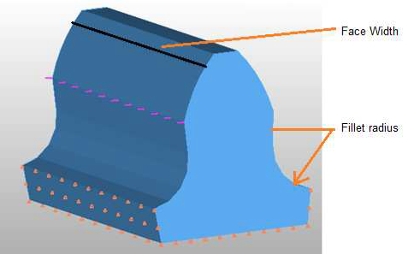

Fig 1. FE Model representation with Boundary conditions and CLOAD at Pitch Circle.

Lewis Equation:

This bending stress equation was derived from the Lewis equation.

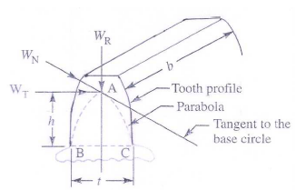

Fig .2 Forces acting on teeth

σ w  = M×y/I

M = Maximum bending moment at the critical section BC, = W T ×h

Wt = Tangential load acting at the tooth,

h = Length of the teeth,

y = Half the thickness of the tooth (t) at critical section BC, = t/2

I = Moment of inertia about the centre line of the tooth, = bt3/12

b = Width of gear face.

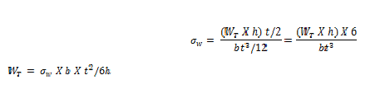

Calculations based on AGMA Standards:

The stress is calculated based on AGMA Standrds as follows

## 

## Where

## C p = Form factor

## K v = Velocity or Dynamic factor

## = (6+V)/6

## K 0 = Overload factor which reflects the degree of non-uniformity of driving and load torques.

## 

## Km = load distribution factor which accounts for non uniform spread of load across the face width.

## It depends on the accuracy of mounting, bearing, shaft deflection and accuracy of gear.

## Results and Discussion.

## 

## Results with the variation of face width and with change of fillet radius are represented below. The fillet

## radius of 4 , 3, 2 mm and no fillet are considered. The Results are presented as follows which shows the

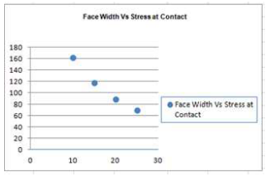

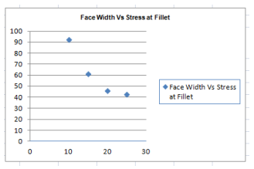

**AGMA Bending Stress Calculation**

These AGMA spur gear bending factors come from an

extensive collection of tables and charts compiled by AGMA. The material allowable bending strengths also come from an array of AGMA charts that are generally a function of the material Brinell hardness.

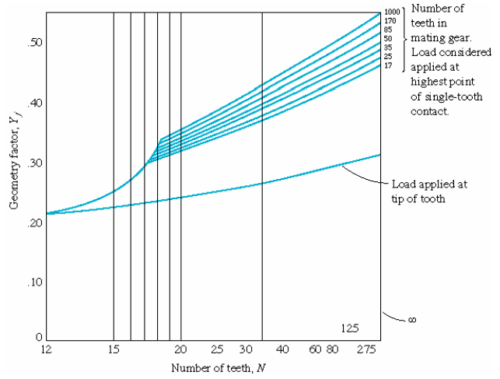

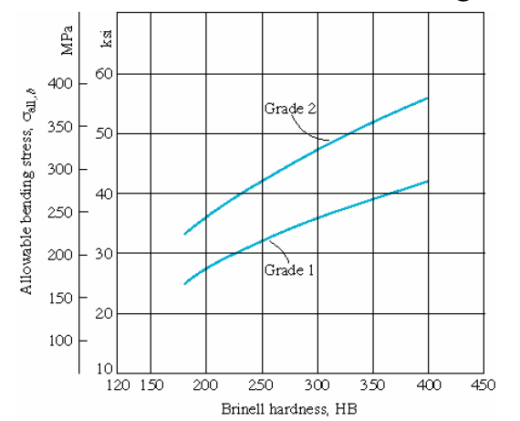

These allowables are generally for 10 million cycles of tooth loading at 99% reliability, and may be adjusted downward for longer life, higher reliability, or higher operating temperatures.

**Surface Stress**

Even though a gear tooth may not break due to bending stresses during its life, it could develop pits on the tooth face due to high contact stresses fatiguing the surface by compression. The contact pressure is intensified near the pitch circle, where the contact is pure rolling with zero sliding velocity. There the elastohydrodynamic oil film is minimal and the load is less distributed.This condition is modeled as a pair of cylinders in line contact, and a Hertzian contact stress.

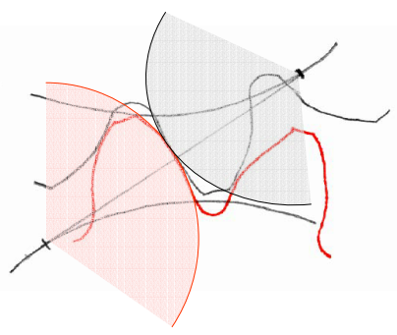

In use, the maximum surface stress is proportional to this maximum pressure. AGMA further refines the stress by adding modifying factors similar to those for bending stresses.

• Be aware that pitting is likely to be more damaging in the long run

than bending.

• Hardening the tooth faces increases the allowable contact stress and

can help contact life approach bending fatigue life.

• Larger gears have greater radii of curvature and therefore lower

stresses.

• Stresses need to be compared to representative,

experimentally determined surface fatigue

S-N curves.

1. Three Dimention Stress Analysis

In this section the tooth root stresses and the tooth deflection of one tooth of a spur gear is calculated using an ANSYS model. For the bending stresses, the numerical results are compared with the values given by the draft proposal of the standards of the AGMA in the next section. Figure shows how to mesh the 3D model and how to apply the load on the model. The element type “SOLID TETRAHEDRAL 10 NODES 187” was chosen. Because “SMART SET” was chosen on the tool bar there are many more elements near the root of the tooth than in other places. There are middle side nodes on the each side of each element. So a large number of degrees of freedom in this 3D model take a longer time to finish running.

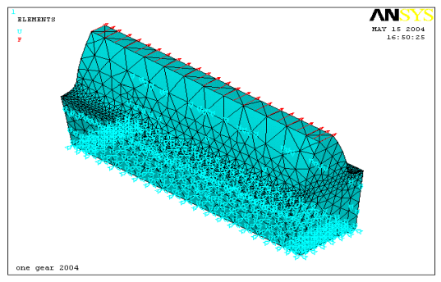

Figure FEM bending model with meshing

From the stress distributions on the model, the large concentrated stresses are at the root of the tooth. Figure shows large Von Mises stresses at the root of the tooth. They are equal to the tensile stresses. The tensile stresses are the main cause of crack failure, if they are large enough. That is why cracks usually start from the tensile side.From the Lewis equation if the diameters of the pinion and gear are always kept the same and the number of teeth was changed, the diametral pitch will be changed or the module of gear will be changed. That means that there are different bending strengths between the different teeth numbers. Different Maximum Von Mises with different numbers of teeth are shown below.

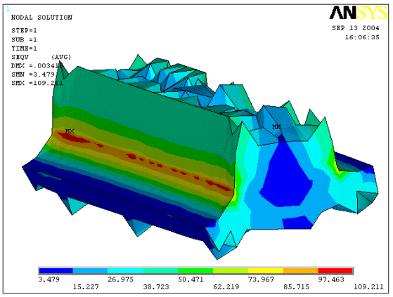

Figure Von Mises stresses with 28 teeth on the root of tooth

**Comparison with Results using AGMA Analyses**

In this section, a comparison of the tooth root stresses obtained in the three dimensional model and in the two dimensional model using ANSYS with the results given by the standards of the AGMA is carried out. Eq. is recommended by the AGMA and the other coefficients, such as the dynamic factor, are set at 1.2. Here

analysis of gears with different numbers of teeth are carried out. First, the number of gear teeth is 28. The meshing spur gear has a pitch radii of 50 mm and a pressure angle of 200 . The gear face width, b = 1.5 in (38.1mm). The transmitted load is 2500 N.

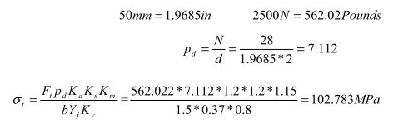

## Detailed investigations, including the effects with the two different numbers of teeth on the tooth root stress were carried out. If the number of teeth is changed from 28 to 23 and the other parameters were kept the same.

## 

## If the number of teeth is changed from 28 to 25 and the other parameters were kept the same.

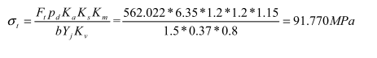

## The above calculations of the Von Mises stresses on the root of tooth were carried out in order to know if they match the results from ANSYS. The results are shown in Table 4.1. In this table, the maximum values of the tooth root stress obtained by the ANSYS method were given. For the number of teeth of 28, the ANSYS results are about 97% (2D) of the values obtained by the AGMA. For the cases from 23 teeth to 37 teeth, the values range from 91% to 99% of the value obtained by the AGMA. From these results, it was found that for all cases give a close approximation of the value obtained by the methods of the AGMA in both 3D and 2D models. These differences are believed to be caused by factors such as the mesh pattern and the restricted conditions on the finite element analysis, and the assumed position of the critical section in the standards. Here the gears are taken as a plane strain problem. 2D models are suggested to be use because much more time will be saved when running the 2D models in ANSYS. There are not great differences between the 3D and 2D model.

**Conclusion**

In the present study, effective methods to estimate the tooth contact stress by the two-dimensional and the root bending stresses by the three-dimensional and two-dimensional finite element method are proposed. To determine the accuracy of the present method for the bending stresses, both three dimensional and two dimensional models were built in this chapter. The results with the different numbers of teeth were used in the comparison. The errors in the Table 4.1 presented are much smaller than previous work done by other researchers for the each case. So those FEA models are good enough for stress analysis.

Table Von Mises Stress of 3-D and 2-D FEM bending model

## 

## .

**6. Effect of Tooth Profile Modification In Asymmetric Spur Gear Tooth Bending Stress By Finite Element Analysis**

In engineering and technology the term “gear” is defined

as a machine element used to transmit motion and power

between rotating shafts by means of progressive en-gagement of projection called teeth. Invention of the gear cannot be attributed to one indi-vidual as the development of the toothed gearing system evolved gradually from the primitive form when wooden pins were arranged on the periphery of simple, solid,wooden wheels to drive the opposite member of the pair. These wheels served the purpose of gears in those days. Although the operation was neither smooth nor quiet, these were not important consideration as the speeds were very low. The motive power to turn these systems was generally provided by treadmills, which were oper-ated by men, animals, water wheels or windmills. In recent times, the gear design has become a highly complicated and comprehensive subject. A designer of a modern gear drive system must remember that the main objective of a gear drive is to transmit higher power with comparatively smaller overall dimensions of the driving system which can be constructed with the minimum possible manufacturing cost, runs reasonably free of noise and vibration, and which required little mainten-ance. He has to satisfy, among others the above condi-tions and design accordingly, so that the design is sound as well as economically viable. Present day gears are subjected to the different types of failures like fracture under bending stress, surface failure under internal stress etc. These failures are mainly due to backlash, undercutting and interference. Backlash: The amount by which the width of a tooth space exceeds the thickness of the engaging tooth on the pitch circles. (Fig.) Undercut: A condition in generated gear teeth when any part of the fillet curve lies inside of a line drawn tangent to the working profile at its lowest point. (Fig. 1b) Interference: Important aspect of kinematics of gearing is interference. When the gear tooth tries to dig below the base circle of mating gear then the gear tooth action shall be non conjugate and violate the fundamental law of gearing this non conjugate action is called the inter-ference

##### 

# These defects can be eliminated by:

# • Under cutting can be avoided by increasing the pressure angle.

# • Backlash and interference can be avoided by in-

# creasing the addendum of mating gear

# • Another way of increasing the load capacity of

# transmissions is to modify the involute geometry.

# This has been a standard practice in sophisticated

# gear design for many years. The nomenclature de-

# scribing these types of gear modifications can be

# quite confusing with reference to addendum modifi-

# cation or profile shift.

# • An additional alteration that is very rarely used is to

# make the gears asymmetric with different pressure

# angles for each side of the tooth.

##### 

**Asymmetric spur gear teeth**

The two profiles (sides) of a gear tooth are functionally different for many gears. The workload on one profile is significantly higher and is applied for longer periods of time than for the opposite one. The design of the asym-metric tooth shape reflects this functional difference.

The design intent of asymmetric gear teeth is to improve the performance of the primary contacting pro-file. The opposite profile is typically unloaded or lightly loaded during relatively short work periods. The degree of asymmetry and drive profile selection for these gears depends on the application.

The difference between symmetric and asym-

metric tooth is defined by two involutes of two different

base circles D bd and D bc . The common base tooth thick-ness does not exist in the asymmetric tooth. The circular distance (tooth thickness) S p between involute profiles is defined at some reference circle diameter D p that should be bigger than the largest base diameter.

Asymmetric gears simultaneously allow an in-crease in the transverse contact ratio and operating pres-sure angle beyond the conventional gear limits. Asym-metric gear profiles also make it possible to manage tooth stiffness and load sharing while keeping a desira-ble pressure angle and contact ratio on the drive profiles by changing the coast side profiles. This provides higher load capacity and lower noise and vibration levels com-pared with conventional symmetric gears.

Profile shift

The height of the tooth above the pitch circle or the radi-

al distance between the tip diameter and the pitch diame-

ter is called addendum. When gears are produced by a generating process, the datum line of the basic rack pro-

file need not necessarily form a tangent to the reference

circle; the tooth form can be altered by shifting the da-

tum line from the tangential position. The involute shape

of the tooth profile is retained. The radial displacement

from the tangential position is termed addendum modifi-

cation factor or profile shift.

Conclusions

In modern usage of gear technology the correction fac-tors are being standardized for the purpose of interchan-geable gearing. Previously gears were corrected either to avoid undercutting or to achieve a predetermined centre distance. Although these reasons are still valid there are other beneficial effects which the positively corrected gear profiles offer. The advantages are

• Avoidance of undercutting.

• Attainment of predetermined centre distance.

• To increase the strength at the root and flank of the tooth. It can be shown that due to positive correction; the thickness of tooth at the root is increased,resulting in greater load carrying capacity of the teeth. By choosing the proper amount of correction, the designer is in a position to specify gear sets of higher capacity without entailing the corresponding cost increase for materials of higher strength.

• Betterment of sliding and contact relations.

• The analysis yields that by increasing the pressure

angle, the bending stress at the critical section de-

creases by 20-25% for a given profile shift value.

With the effect of positive shift there is a reduction

in the bending stress at the critical section by 20-

25%.with the implementation of both profile shift

and pressure angle modification, bending stress sig-

nificantly decreased by 35-40%.

**Reference**

[1] K Ruthupavam & Y Sandeep Kumar (2012) “Optimization of Design Based on Tip Radius and Tooth Width to Minimize the Stresses on the Spur Gear with FE Analysis”. HTC 2012

[2] Manoj Hariharan (2006) “spur gear tooth stress analysis and stress reduction using stress reducing geometrical features” Thesis Report Submitted to Thapar Institute of Engineering and Technology

[3] Namam M. Ahmed “Stress Distribution along the Involute Curve of Spur Gears” Thesis Report Submitted to Institute of Technology, Sulamani Iraq.

[4] W.H.Dornfeld (2004) “Gear Tooth Strength Analysis” Book.

[5] Zeping wei (2004) “stresses and deformations in involute spur gears by finite element method” Thesis Report Submitted to University of Saskatchewan.

[6] F. K.Gopinath & M.M.mayuram “spur gear - tooth stresses” Book

[7] Rixin Xu (2008)“finite element modeling and simulation on the quenching effect for spur gear design optimization” Thesis Report Submitted to University of Akron

[8] kristina marković – marina franulović (2011)“contact stresses in gear teeth due to tip relief profile modification” Eng. Rev. 31-1 (2011) 19-26

[9] Chuen-Huei Liou and Hsiang Hsi Lin (1992) “Effect of Contact Ratio on Spur Gear Dynamic Load” NASA AVSCOM Technical Memorandum 105606 Technical Report 91-C-025

[10] Ashwini Joshi, Vijay Kumar Karma (2011) “Effect on Strength of Involute Spur Gear by Changing the Fillet Radius Using FEA” International Journal Of Scientific & Engineering Research Volume2,Issue 9, September-2011, ISSN 2229-5518

[11] GD. Bibel, S.K. Reddy, and M. Savage (1991) “Effects of Rim Thickness on Spur Gear Bending Stress” NASA III0wIUIIII AVSCOM Technical Memorandum 104388 Technical Report 91-C-015

[12] Sweta Nayak and Swetleena Mishra (2007) “effects of addendum modification on root stress in involute spur gears” Thesis Report Submitted to National Institute of Technology Rourkela

[13] Sorin Cananau(2003) “3d contact stress analysis for spur gears” national tribology conference 24-26 september 2003

**[**14]G.Mallesh (2009) “Effect of Tooth Profile Modification In Asymmetric Spur Gear Tooth Bending Stress By Finite Element Analysis” NaCoMM-2009- ASMG18268

[15] Dr. Ir H.G. H. van Melick (2007) “Tooth-Bending Effects in Plastic Spur Gears Influence on load sharing, stresses and wear, studied by FEA” Gear Technology Pune-2007.

[16] M Koilraj, Dr G Muthuveerappan and Dr J Pattabi-

raman, “An Improvement in Gear Tooth Design

Methodology using Finite Element Method”, IE(I)

Journal MC, Volume 88, October 2007.