MECH-83

**“DESIGN AND DEVELOPMENT OF TRICYCLE DRIVE”**

**Name of Students:-**

YOGESH P. MOTEWAR (yogesh.motewar@gmail.com)

PRAMOD R. DABHADE (pramodrdabhade007@gmail.com)

PRATHMESH G. TUNDALWAR (prathtundalwar@gmail.com)

RAMESHWAR S. DUNTULWAR (ramduntulwar@gmail.com)

**College** :-

Smt. Radhikatai Pandav College of Engineering, Nagpur.

**ABSTRACT**

Recent application is used for increasing the efficiency of tricycle. The efficiency of tricycle is increased by chain drive, bearing, magnetic flywheel, are uses in our project, for increasing the efficiency of tricycle we use torque convertor i,e. Pascal’s law.

The first tricycle was built in 1680 by a disabled German manwho wanted to be able to maintain his mobility. The tricycles are used for disabled people.

The project is based on the properties of the magnet; the term magnetic moment normally refers to a system's **magnetic dipole moment**, which produces the first term in the [multipole expansion](http://en.wikipedia.org/wiki/Multipole_expansion) of a general magnetic field. **Chain drive** is a way of transmitting mechanical power from one place to another.

Tricycles were used by riders who did not feel comfortable on the high wheelers, therefore to reduce the human effort and to improve the efficiency of tricycle the modification in tricycle is important.

**HISTORY**

The first tricycle was built in 1680 by a disabled German manwho wanted to be able to maintain his mobility. Since he was a watch-maker, he was able to create a tricycle that was powered by hand cranks. In 1789, two French inventors, Blanchard and Maguier developed a tricycle.

In 1818, British inventor Denis Johnson patented his approach to designing tricycles. In 1876, James Starley developed the Coventry Lever Tricycle, which used two small wheels on the right side and a large drive wheel on the left side; power was supplied by hand levers. In 1877, Starley developed a new vehicle he called the Coventry Rotary, which was "one of the first rotary chain drive tricycles." Starley's inventions started a tricycling craze in Britain; by 1879, there were "twenty types of tricycles and multi-wheel cycles ... produced in Coventry, England, and by 1884, there were over 120 different models produced by 20 manufacturers.” The first front steering tricycle was manufactured by The Leicester Safety Tricycle Company of Leicester, England in 1881 which was brought to the market in 1882 costing £18. They also developed a folding tricycle at the same time.

Tricycles were used by riders who did not feel comfortable on the high wheelers, such as women who wore long, flowing dresses. In the UK, upright tricycles are sometimes referred to as "barrows". Many trike enthusiasts ("trikies") in the UK belong to the Tricycle Association, formed in 1929. They participate in day rides, tours and time trials. Massed start racing of upright tricycles is limited to one or two criteriums such as in Bungay, Suffolk each year.

**INTRODUCTION**

The first tricycle was built by a disabled manwho wanted to be able to maintain his mobility. The efficiency of that tricycle is much less. The tricycle drive includes the following Mechanisms:-

Chain & Sprocket Drive

Fixed & Moving Magnet

Pedestal Bearing

To reduce the human effort and to improve the efficiency of tricycle the modification in tricycle has done. The chain & sprocket drives with the addition of Fixed & Moving Magnet the tricycle drive is designed. The Magnetic flywheel adjustment improves the efficiency of mechanism. The magnetic principle i.e, “The **magnetic moment** of a [magnet](http://en.wikipedia.org/wiki/Magnet) is a quantity that determines the [force](http://en.wikipedia.org/wiki/Force) that the magnet can exert on [electric currents](http://en.wikipedia.org/wiki/Electric_currents) and the [torque](http://en.wikipedia.org/wiki/Torque) that a [magnetic field](http://en.wikipedia.org/wiki/Magnetic_field) will exert on it,” is used. The initial torque is given to mechanism, at a specific state or condition the mechanism runs continuously with less input torque due to rotation of magnetic flywheel or repulsive force between the magnets.

Chain and Sprocket mechanism is used to transmit the motion from pedaling to the rear wheel with the improved output.

The pedestal Bearings are used for the mounting purpose of shafts on the frame. The bearings are used to reduce rotational friction and support radial and axial loads. It achieves this by using at least two races to contain the ball and transmit the loads through the balls.

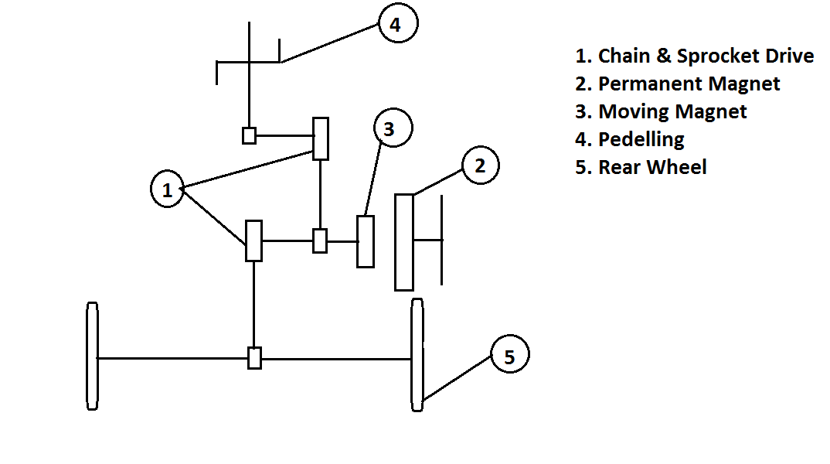

**Fig. Design and Development of Tricycle**

**WORKING**

In our project we are using Magnetic Flywheel, Chain & sprocket mechanism, pedaling, and Pedestal Bearing for mounting purpose.

The line diagram shows the systematic arrangement of the mechanism, when the Manuel effort is applying on the pedal, chain and sprocket drive transmits the power from running shaft to another shaft. On the same shaft the two magnets i,e. Magnetic flywheel one is Fixed magnet and another is Moving magnet.

The fixed magnet is mounted on the frame, and the moving magnet is mounted on the bearing and which maintain some distance in between them for rotating purpose.

When the power is transferred to running shaft the magnets mounted on them i.e, moving magnet also rotates but the arrangement is given in between the magnets that the same poles of magnets are given due to this magnetic property of repulsion in between the both the moving and fixed magnet the moving magnet moves continuous with improved efficiency and from this the another chain and sprocket arrangement is given to the rear wheel of tricycle.

From this property of magnet some amount of improved efficiency of mechanism gets. This mechanism is also implements in the wheel chair for disabled people to reduce their effort.

**CHAIN & SPROCKET DRIVE**

A **sprocket** or **sprocket-wheel** is a profiled [wheel](http://en.wikipedia.org/wiki/Wheel) with teeth, cogs, or even sprockets that mesh with a [chain](http://en.wikipedia.org/wiki/Roller_chain), [track](http://en.wikipedia.org/wiki/Caterpillar_track) or other perforated or indented material. The name 'sprocket' applies generally to any wheel upon which are radial projections that engage a chain passing over it. It is distinguished from a [gear](http://en.wikipedia.org/wiki/Gear) in that sprockets are never meshed together directly, and differs from a [pulley](http://en.wikipedia.org/wiki/Pulley) in that sprockets have teeth and pulleys are smooth.

Sprockets are used in [bicycles](http://en.wikipedia.org/wiki/Bicycle), [motorcycles](http://en.wikipedia.org/wiki/Motorcycle), [cars](http://en.wikipedia.org/wiki/Automobile), [tracked vehicles](http://en.wikipedia.org/wiki/Continuous_track), and other [machinery](http://en.wikipedia.org/wiki/Machine) either to transmit rotary motion between two shafts where gears are unsuitable or to impart linear motion to a track, tape etc. Perhaps the commonest form of sprocket is found in the bicycle, in which the pedal shaft carries a large sprocket-wheel which drives a chain which in turn drives a small sprocket on the axle of the rear wheel.

Sprockets are of various designs, a maximum of efficiency being claimed for each by its originator. Sprockets typically do not have a [flange](http://en.wikipedia.org/wiki/Flange). Some sprockets used with [timing belts](http://en.wikipedia.org/wiki/Timing_belt) have flanges to keep the timing belt centered. Sprockets and chains are also used for power transmission from one shaft to another where slippage is not admissible, sprocket chains being used instead of belts or ropes and sprocket-wheels instead of pulleys. They can be run at high speed and some forms of chain are so constructed as to be noiseless even at high speed.

**MAGNETIC FLYWHEEL**

The **magnetic moment** of a [magnet](http://en.wikipedia.org/wiki/Magnet) is a quantity that determines the [force](http://en.wikipedia.org/wiki/Force) that the magnet can exert on [electric currents](http://en.wikipedia.org/wiki/Electric_currents) and the [torque](http://en.wikipedia.org/wiki/Torque) that a [magnetic field](http://en.wikipedia.org/wiki/Magnetic_field) will exert on it. A loop of [electric current](http://en.wikipedia.org/wiki/Electric_current), a bar magnet, an [electron](http://en.wikipedia.org/wiki/Electron), a [molecule](http://en.wikipedia.org/wiki/Molecule), and a [planet](http://en.wikipedia.org/wiki/Planet) all have magnetic moments.

Both the magnetic moment and magnetic field may be considered to be [vectors](http://en.wikipedia.org/wiki/Vector_(mathematics_and_physics)) having a magnitude and direction. The direction of the magnetic moment points from the south to north pole of a magnet. The magnetic field produced by a magnet is proportional to its magnetic moment as well. More precisely, the term magnetic moment normally refers to a system's **magnetic dipole moment**, which produces the first term in the [multipole expansion](http://en.wikipedia.org/wiki/Multipole_expansion) of a general magnetic field. The [dipole](http://en.wikipedia.org/wiki/Dipole) component of an object's magnetic field is symmetric about the direction of its magnetic dipole moment, and decreases as the inverse cube of the distance from the object.

An electrostatic analogue for a magnetic moment: two opposing charges separated by a finite distance.

The sources of magnetic moments in materials can be represented by poles in analogy to [electrostatics](http://en.wikipedia.org/wiki/Electrostatics). Consider a bar magnet which has magnetic poles of equal magnitude but opposite [polarity](http://en.wikipedia.org/wiki/Polarity_(physics)). Each pole is the source of magnetic force which weakens with distance. Since [magnetic poles](http://en.wikipedia.org/wiki/Magnet#Two_models_for_magnets:_magnetic_poles_and_atomic_currents) always come in pairs, their forces partially cancel each other because while one pole pulls, the other repels. This cancellation is greatest when the poles are close to each other i.e. when the bar magnet is short. The magnetic force produced by a bar magnet, at a given point in space, therefore depends on two factors: on both the [strength](http://en.wikipedia.org/wiki/Magnetic_pole_strength) *p* of its poles, and on the vector **ℓ** separating them. The moment is defined as

\mathbf{m}=p\boldsymbol{\ell}.

**FLYWHEEL**

A **flywheel** is a rotating mechanical device that is used to store [rotational energy](http://en.wikipedia.org/wiki/Rotational_energy). Flywheels have a significant [moment of inertia](http://en.wikipedia.org/wiki/Moment_of_inertia) and thus resist changes in rotational speed. The amount of energy stored in a flywheel is proportional to the square of its [rotational speed](http://en.wikipedia.org/wiki/Rotational_speed). Energy is transferred to a flywheel by applying [torque](http://en.wikipedia.org/wiki/Torque) to it, thereby increasing its rotational speed, and hence its stored energy. Conversely, a flywheel releases stored energy by applying torque to a mechanical load, thereby decreasing its rotational speed.

Three common uses of a flywheel include:

* They provide continuous energy when the energy source is discontinuous. For example, flywheels are used in [reciprocating engines](http://en.wikipedia.org/wiki/Reciprocating_engine) because the energy source, torque from the engine, is intermittent.
* They deliver energy at rates beyond the ability of a continuous energy source. This is achieved by collecting energy in the flywheel over time and then releasing the energy quickly, at rates that exceed the abilities of the energy source.
* They control the orientation of a mechanical system. In such applications, the angular momentum of a flywheel is purposely transferred to a load when energy is transferred to or from the flywheel.

**BEARING**

* A **ball bearing** is a type of [rolling-element bearing](http://en.wikipedia.org/wiki/Rolling-element_bearing) that uses [balls](http://en.wikipedia.org/wiki/Ball_(bearing)) to maintain the separation between the [bearing](http://en.wikipedia.org/wiki/Bearing_(mechanical)) [races](http://en.wikipedia.org/wiki/Race_(bearing)).
* The purpose of a ball bearing is to reduce rotational friction and support [radial](http://en.wikipedia.org/wiki/Radius) and [axial](http://en.wikipedia.org/wiki/Axis_of_rotation) loads. It achieves this by using at least two races to contain the balls and transmit the loads through the balls. In most applications, one race is stationary and the other is attached to the rotating assembly (e.g., a hub or shaft). As one of the bearing races rotates it causes the balls to rotate as well. Because the balls are rolling they have a much lower [coefficient of friction](http://en.wikipedia.org/wiki/Coefficient_of_friction) than if two flat surfaces were sliding against each other.
* If a shaft is supported by two bearings, and the center-lines of rotation of these bearings are not the same, then large forces are exerted on the bearing that may destroy it. Some very small amount of misalignment is acceptable, and how much depends on type of bearing.
* **Advantages**

1) Increases the efficiency of Tricycle.

2) Minimum Power required.

3) It Reduces time

**REFERENCE**

AUTOMOBILE ENGG. – Dr. Kripal Singh

[Bicycle History, Chronology of the Growth of Bicycling and the Development of Bicycle Technology by David Mozer](http://www.ibike.org/library/history-timeline.htm). Ibike.org. Retrieved on 2012-09-01.

<http://www.vyconenergy.com/pq/VDCtech.html>

<http://www.mpoweruk.com/lithium_failures.html>

<http://www.intertrains.co.uk/glossary/m/mekydro-transmission.html>

<http://www.wikipedia.com/magnetinfo>.html

<http://www.autoworks.co.in/torque> converter.html