**Design and fabrication of Maglev turbine**

**With its application**

**Abhinav Chikate, Atul Sudame**

**Dayanand Dhote**

(Department of Mechanical Engineering, Smt. Radhikatai Pandav College of Engineering, India)

Email: [atulsudame90@yahoo.in](mailto:atulsudame90@yahoo.in)

**ABSTRACT**

Maglev turbine are a relatively new concept of renewable energy power plant. They would combine three proven technologies: Magnetisum, Magnetic levitation and the wind turbine. Maglev Wind Turbine is expected to bring wind power technology to the next level. Magnetic Levitation or Maglev is the most efficient means of transferring kinetic energy from wind power to generate electricity. The wind turbine floats on a magnetic cushion. In radial direction Halbach array can be used for magnetic cushion. To produce maximum power wind must be captured not deflect by rotor therefore design of maglev rotor able to capturing kinetic energy of wind. This technology eliminates all friction and delivers maximum wind energy directly to the power generators. Since the Maglev wind turbine blades capture all of the wind.

*Keywords:-* pressure difference, Turbine, wind energy, air flow, lift, halbach array.

# **INTRODUCTION**

Wind is known to be another form of solar energy because it comes about as a result of uneven heating of the atmosphere by the sun coupled with the abstract topography of the earth’s surface. Wind energy is the World’s fastest-growing energy source and will power industry, businesses and homes with clean, renewable electricity for many years to come. For improve the efficiency, better materials for rotor blades, aerodynamics of rotor blades; improved power semiconductors for power conditioning; superconducting power transmission lines are the required features for wind energy conversion to electricity.

Renewable energy is these sources have been coined renewable due to their continuous replenishment and availability for use over and over again. The popularity of renewable energy has experienced a significant upsurge in recent times due to the exhaustion of conventional power generation methods and increasing realization of its adverse effects on the environment. This popularity has been bolstered by cutting edge research and ground breaking technology that has been introduced so far to aid in the effective tapping of these natural resources and new technology to harvest energy from renewable energy source should be effective and efficient like maglev turbine which is more efficient than conventional wind turbine. In this paper a counter flow design of rotor is for capturing wind power through air is used and magnetic levitation arrangement for rotor in axial direction through neodymium magnet and for radial load halbach array arrangement used. Maglev can be used in various applications according to its size.

# **BASIC PRINCIPLE**

**A) The Bernoulli's Principle:-** states that as the speed of a moving fluid increases, the pressure within the fluid decreases.

**Fig:-1**



**Fig:-2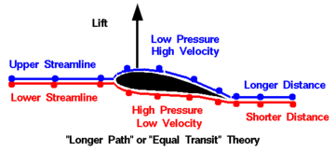Fig:-3**

To understand how Bernoulli's principle causes lift, we must first understand that air usually presses equally on all sides of an object. Suppose that as the plane flies forward, the approaching air splits up when it hits the leading (front) edge of the wing and rejoins at the trailing (back) edge of the wing. The airfoil shape causes the air to go faster over the top of the wing than under the bottom, both in the same amount if time.  This means the air on top of the wing must move faster. When air speeds up, its pressure gets lower.  Since the air pressure on top of the wing is lower than the air pressure on the bottom of the wing, the wing produces lift!  This phenomenon is called Bernoulli's principle.

**Lift:-** Lift is produced by a lower pressure created on the upper surface of an airfoil blade compared to the pressure on the blade lower surface, causing the blade to be "lifted" upward. The special shape of the blade (**airfoil**) is designed so that air flowing over it will have to travel a greater distance faster, resulting in a lower pressure area thus lifting the blade clockwise.

**Drag** :- Drag is produced when air flowing over the blade causes friction When the blade rotating, it must push oncoming air out of the way.

**B) Newtonian Explanation**

The famous scientist Sir Isaac Newton stated in his famous third law that ,"For every action, there is an equal and opposite reaction."  Newtonian lift largely depends on the tilt of the wing or "angle of attack".  If the leading edge of the wing is pointing upward, the bottom surface is deflecting oncoming air downward.  When this air bounces off the bottom surface of the wing (action), it pushes the wing upward (reaction)...or produces lift.

An airfoil-shaped body moved through a fluid produces an aerodynamic force. The component of this force perpendicular to the direction of motion is called lift. The component parallel to the direction of motion is called drag.

The lift on an airfoil is primarily the result of its angle of attack and shape. When oriented at a suitable angle, the airfoil deflects the oncoming air, resulting in a force on the airfoil in the direction opposite to the deflection. This force is known as aerodynamic force and can be resolved into two components: Lift and drag. Most foil shapes require a positive angle of attack to generate lift, but cambered airfoils can generate lift at zero angle of attack. This "turning" of the air in the vicinity of the airfoil creates curved streamlines which results in lower pressure on one side and higher pressure on the other. This pressure difference is accompanied by a velocity difference, via Bernoulli's principle, so the resulting flow field about the airfoil has a higher average velocity on the upper surface than on the lower surface.

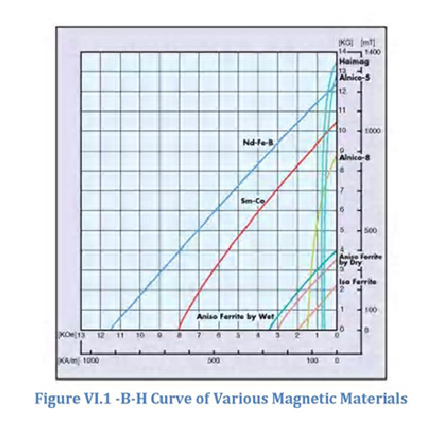 Rotor is divided in six partition and in each partition two blade are attach which are aerofoil shape and one partition plate, and three extended counter flow plate to divert the air in high pressure side. After passing air from aerofoil shape blade air counter flow in high pressure side to increase pressure therefore more pressure difference produce in between high pressure and low pressure side which increase lift force to the blade after passing air from blade it remove out from low pressure region apart from without disturbing law of continuity.

**III. Magnet Selection**

Some factors need to be assessed in choosing the permanent magnet selection that would be best to implement the maglev portion of the design.

The four different classes are Alnico, Ceramic, Samarium Cobalt and Neodymium Iron Boron also known Nd- Fe-B. Nd-Fe-B is the most recent addition to this commercial list of materials and at

properties of all of the magnetic materials. room temperature exhibits the highest

It can be seen in the B-H graph shown in Figure that Nd-Fe-B has a very attractive magnetic characteristic which offers high flux density operation and the ability to resist demagnetization. This attribute will be very important because the load that will be levitated will be heavy and rotating a high speeds which will exhibit a large downward force on the axis..

Fig:-5B-H Curve of Various Magnetic Materials

**IV. Halbach array**

A Halbach array is a special arrangement of permanent magnets that augments the magnetic field on one side of the array while cancelling the field to near zero on the other side. In the diagram, the magnetic field is enhanced on the bottom side and cancelled on the top side (a one-sided flux).

The rotating pattern of permanent magnets (on the front face; on the left, up, right, down) can be continued indefinitely and have the same effect. The effect of this arrangement is roughly similar to many horseshoe magnets placed adjacent to each other, with similar poles touching. A Halbach cylinder is a magnetized cylinder composed of ferromagnetic material producing (in the idealised case) an intense magnetic field confined entirely within the cylinder with zero field outside. The cylinders can also be magnetized such that the magnetic field is entirely outside the cylinder, with zero field inside. Several magnetization distributions are shown below:

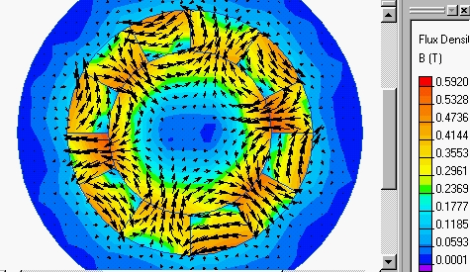

Fig:-6

**V) POWER OF WIND**

By extracting power, the turbine itself has an effect on the wind: downwind of the turbine the air moves more slowly than upwind. The wind starts to slow down even before it reaches the blades, reducing the wind speed through the “disc” (the imaginary circle formed by the blade tips, also called the swept area) and hence reducing the available power. Some of the wind that was heading for the disc diverts around the slower-moving air and misses the blades entirely. So there is an optimum amount of power to extract from a given disc diameter: try to take too much and the wind will slow down too much, reducing the available power. In fact the ideal is to reduce the wind speed by about two thirds downwind of the turbine, though even then the wind just before the turbine will have lost about a third of its speed. This allows a theoretical maximum of 59% of the wind’s power to be captured (this is called Betz’s limit). In practice only 40-50% is achieved by current designs

As mentioned earlier the effective functioning of a wind turbine is dictated by the wind availability in an area and if the amount of power it has is sufficient enough to keep the blades in constant rotation. The wind power increases as a function of the cube of the velocity of the wind and this power is calculable with respect to the area in which the wind is present as well as the wind velocity [1]. When wind is blowing the energy available is kinetic due to the motion of the wind so the power of the wind is related to the kinetic energy.

We know:

1. *Kinetic Energy:-* ½ MV2 (1)

*T*he volume of air passing in unit time through an area A, with speed V is AV and its mass M is equal to the Volume V multiplied by its density p so:

*M=* ρAV

Substituting the value of M in equation (1)

we get:

*Kinetic Energy* = *½* (ρAV)V2 (2)

*Kinetic Energy* = *½*ρAV3 (3)

To convert the energy to kilowatts, a non-dimensional proportionality constant k is introduced where,   
*k* = 2.14x 10-3 ,

Therefore  
Power in kW (P) = 2. 14ρAV3 ×10-3 (1.4)   
Where:   
Air density (ρ)= 1.2kg/m3   
Area(A)=area swept by the blades of the turbine  
 Velocity (V)=wind speed in mph

* Power directly proportional cube of velocity
* Power directly proportional air density
* Power directly proportional rotor swept area

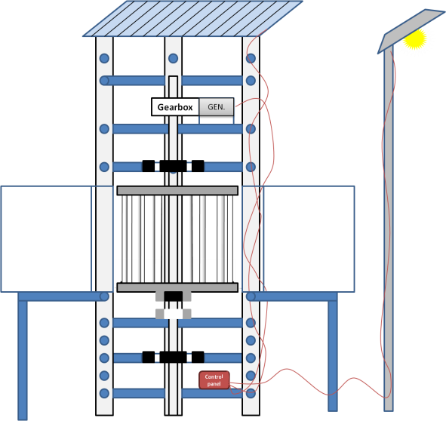

Fig. 7

perspective view of maglev turbine with application of Wind Solar Hybrid Street Light Feature.

**VI. CONCLUSION**

Energy consumption of world continue to grow with increasing population. Energy is prime mover of economic growth of any country, future econmic growth crucially depend on the long-term availability of energy from sources that are affordable, accessible & enviornmentally friendly. The fossil fuels are deplting in a rapid rate and are harder to rtieve. And therefor we can be facing an energy crisis in the future is we are not carefull today. The fossile fuel are widely used today are harmful for the environment which causes the global warming. Therfore we should shift towards RENEWABLE ENERGY SOURCES before facing crises. In that situation, Maglev Turbine are helpful to satisfy the need of alternative energy sources. Magnetic Levitation or Maglev is the most efficient means of transferring kinetic energy from wind power to generate electricity.

* The Competitive Advantages of the maglev wind turbine

1)Uses maximum wind energy.  
2) Cost 50-75% less to build per MW.  
3) Requires less time to build.  
4) ) Create energy independence   
5) Generate more electricity for less.

6) Insure national security.  
7) Require less maintenance.  
8) Major components at ground level.

9) Conserve natural resources.

10) Reduce the use of fossil fuels and pollution.  
13) Longer life span of turbine.  
15) Operates in low and high speed wind.  
17) Greater profit potential.  
18) Require considerably less land.  
19) Will not harm animal life.

**VII. ACKNOWLEDGMENT**

I wish to thanks - Prof. M.P. Mungle for for his encouragement & enlightened comments through out this paper work.

**VIII. REFERENCES**

1. Alternate energy source and management- samir chandrakant Nimkar, chapter no. 03
2. Non-Conventional Energy Resources- B.H. Khan Tata McGraw Hill publication 2nd publication
3. http://www.wwindea.org/home/images/stories/worldwindenergyreport2008_s.
4. <http://www.wind-energy-the-facts.org/en/scenarios-and-targets/chapter-5-global-scenarios>
5. [http://www.windtamerturbines.com](http://www.windtamerturbines.com/)
6. http://[www.wikipedia.org/wiki/RenewabIeenergy](http://www.wikipedia.org/wiki/RenewabIeenergy)
7. http://[www.megturbine.com](http://www.megturbine.com/)
8. http://[www.inhabitat.com](http://www.inhabitat.com/)
9. http://www.wikipedia.com.